基于文体、主题、逻辑、语言的阅读理解
2017届三模
第二节 完形填空（共20小题；每小题1分，满分20分）
请认真阅读下面短文，从短文后各题所给的A、B、C、D四个选项中，选出最佳选项，并在答题纸上将该项涂黑。
Findings
Research shows that when we are absorbed in an activity, even minor distractions (分心) can have a huge effect. According to a study, regaining our 36 initial drive following an interruption can take about 20 minutes.
Argumentation
(argument)Multitasking (多任务), as many studies have shown, is a myth (谬论).
(正面论证)A more accurate 37 account of what happens when we tell ourselves we are multitasking is that we’re rapidly 38 switching between activities, sucking our mental energy. And the 39 consequences can be surprisingly serious. An experiment found that we lose as many as 10 IQ points when we allow our work to be 40 interrupted by distractions like emails and text messages.
(反面论证)The 41 trouble is that multitasking is enjoyable. It’s fun to satisfy your curiosity. Who knows what that next email or text message holds 42 in store? Finding out provides immediate satisfaction. 43 In contrast, resisting distractions and staying on task requires 44 discipline and mental effort.
（solutions）So, what are we to do?
（solution 1）
(正面)Our strategy is to change the 45 environment to move temptation further away: shut down your email program or 46 silence your phone. It’s a lot easier to stay on task when you’re not 47 continuously fighting off mental desires.
(反面)The alternative, which most of us consider common, is 48 similar to dieting in a bakery. We all need the willpower to resist the temptations, but doing so comes with 49 considerable costs to our limited supply of willpower.
（solution 2）
(正面)Another worthwhile 50 approach is to collect similar activities together, keeping transition (转换) time to a 51 minimum point. Instead of spreading phone calls, meetings and emails throughout your day, try 52 grouping related tasks so that there are fewer transitions.
(反面)In some jobs, multitasking is 53unavoidable. Some of us truly do need to stay 54 connected to our clients, colleagues and managers. So it’s worth noting that limiting disruptions is the only solution.
Conclusion
Remember, the more you do to minimize task-switching over the course of the day, the more ability you’ll have for activities that actually 55matter. Even small changes can make a big difference.
- A. initial B. personal C. inner D. ambitious
- A. plan B. account C. prediction D. insight
- A. switching B. swinging C. swapping D. shuttling
- A. benefits B. reasons C. consequences D. challenges
- A. guided B. changed C. adapted D. interrupted
- A. advantage B. emphasis C. trouble D. practice
- A. in stock B. in store C. in check D. in possession
- A. As a rule B. As a result C. In short D. In contrast
- A. patience B. discipline C. courage D. attention
- A. expectation B. task C. environment D. vision
- A. replace B. silence C. answer D. pick
- A. continuously B. finally C. passionately D. directly
- A. similar B. relevant C. superior D. opposite
- A. affordable B. basic C. considerable D. modest
- A. research B. aspect C. reaction D. approach
- A. minimum B. maximum C. turning D. fixed
- A. analyzing B. grouping C. assigning D. undertaking
- A. disturbing B. annoying C. unavoidable D. unnecessary
- A. sympathetic B. loyal C. accustomed D. connected
- A. matter B. function C. work D. interfere
2017届二模
第二节 完形填空（共20小题；每小题1分，满分20分）
请认真阅读下面短文，从短文后各题所给的A、B、C、D四个选项中，选出最佳选项，并在答题纸上将该项涂黑。
Argument
Order is the best manager of time. It illustrates many subjects. Thus, obedience to the natural law is order. Virtue is order. The world began with it. 36 Chaos was once common before its establishment.
Argumentation
(正面)The merchant, the clerk and the laborer are all of the same 37 nature, born with the same expectations and affected by similar influences. They are, it is 38 true, born in different positions, but it 39 rests with themselves whether they shall live nobly or evilly. They may not have their choice of riches or poverty, but they have their 40 option of being good or evil.
(反面)People of the highest position, 41 in respect of culture and education, have often as great hardships as the common people. They have to make their incomes go much further. They have to 42 keep up their social status. 43 Though their incomes may be less satisfactory, they are desperate to 44 educate and bring the children up as gentlemen.
(example)Hume, a famous historian, was a man of good family but his 45 means were very small when he was young. In his autobiography, he uses his own case as a(n) 46 illustration of the advantages of frugality (节省). Despite a considerable debt, his mother, a widow, 47 bravely met the difficulties and eventually overcame them. Though her income was less than that of many highly paid men, she educated her children well and brought them up 48 virtuously.
Hume says, “While studying in France, I 49 made that plan of life which I have steadily and successfully pursued. I determined to make a 50 rigid frugality supply of my shortage of fortune and to 51 maintain my independence.” At thirty-six he thought himself rich. These are his own words: “My appointments, with my frugality, had helped me reach a fortune which made me 52 independent.”
Conclusion
(restatement)Goethe says, “It doesn’t matter within what circle an honest man acts, provided he knows how to 53 fit in that circle.” “What is the best government?” Goethe asks, “That which teaches us to 54 govern ourselves! Let every one only do the right in his place, without 55 troubling himself about the confusion of the world.”
- A. Chaos B. Offence C. Punishment D. Condemnation
- A. origin B. race C. nature D. interest
- A. hopeful B. strange C. vital D. true
- A. agrees B. rests C. corresponds D. conflicts
- A. idea B. option C. freedom D. intention
- A. in defence of B. in course of C. in anticipation of D. in respect of
- A. give up B. depend on C. look for D. keep up
- A. Since B. Though C. Unless D. When
- A. educate B. encourage C. blame D. spoil
- A. ambitions B. achievements C. means D. revenues
- A. assurance B. consequence C. illustration D. criterion
- A. bravely B. stubbornly C. sharply D. tentatively
- A. faithfully B. plainly C. gratefully D. virtuously
- A. proposed B. made C. discussed D. approved
- A. rigid B. casual C. liberal D. flexible
- A. balance B. restore C. value D. maintain
- A. attractive B. proud C. independent D. knowledgeable
- A. fit in B. move in C. end in D. engage in
- A. protect B. justify C. govern D. display
- A. questioning B. troubling C. scolding D. abandoning

训练题
What is happiness to you?
Argument
Are you happy? Do you remember a time when you were happy? Are you looking for happiness today?
Argumentation
(反面) Many people have 11 a variety of sources for their feelings of happiness. Some have put their heart and effort into their work. Too many have turned to drugs and alcohol. Untold numbers have looked for it in the possession of expensive cars, exotic vacation homes, and other popular “toys”. Most of their efforts have a 12 in one common fact: people are looking for a(n) 13 source of happiness.
(正面)Unfortunately, I believe that happiness escapes many people because they 14 the process and journey of finding it. I have heard many people say that, “I’ll be happy when I get my new promotion.” Or “I’ll be happy when I lose that 15 20 pounds.” The list goes on and on. You probably have a few of your own you could 16 if you wanted.
(反面) This thinking is 17 because it presupposes that happiness is a “response” to having, being or doing something. In life, we all 18 stimulus and response. Stimulus is when a dog barks at you and bares his teeth. Response is when your heart beats faster, your palms get sweaty and you 19 to run. Today, some people think that an expensive car is a stimulus. Happiness is a response. A great paying job is a stimulus. Happiness is a response. A loving relationship is a stimulus. Happiness is a response. This belief 20 us thinking and feeling: “I’ll be happy when …”
(正面)It has been my finding that actually the 21 is true. I believe that happiness is a stimulus and response is what life brings to those who are truly 22 . When we are happy, we 23 to have more success in our work. When we are happy, people want to be around us and enjoy loving relationships. When we are happy, we more 24 take better care of our bodies and enjoy good health. Happiness is NOT a response — 25 , it is a stimulus.
Conclusion
Happiness is a conscious 26 we make every day of our lives. For unknown reasons to me, many choose to be painful, unsuccessful and angry most of the time. Happiness is 27 .something that happens to us after we get something we want — we usually get things we want 28 we choose to be happy.
I have made only one 29 rule for my own happiness: Every day above ground is a GOOD day. 30 , I tend to have a lot of good and happy days continually.
11. A. owned B. valued C. ignored D. sought
12. A. sense B. root C. theory D. view
13. A. lasting B. confusing C. challenging D. existing
14. A. dislike B. mix C. misunderstand D. miss
15. A. valueless B. miserable C. visible D. extra
16. A. add B. make C. accept D. consider
17. A. interesting B. dangerous C. unbelievable D. unacceptable
18. A. refuse B. receive C. witness D. experience
19. A. fear B. forget C. prepare D. hesitate
20. A. stops B. suggests C. leaves D. prevents
21. A. belief B. statement C. idea D. opposite
22. A. honest B. happy C. lucky D. wise
23. A. tend B. mean C. hope D. wish
24. A. properly B. practically C. naturally D. possibly
25. A. rather B. though C. even D. also
26. A. decision B. judgment C. choice D. conclusion
27. A. just B. not C. perhaps D. almost
28. A. unless B. after C. until D. before
29. A. simple B. strict C. obvious D. acceptable
30. A. However B. Finally C. Fortunately D. Therefore
（11-15 DBACD 16-20 ABDCC 21-25 DBACA 26-30 CBBAD）

2017届三模
第三部分 阅读理解（共15小题；每小题2分，满分30分）
D
Example
Gus Wenner runs Rollingstone.com; his father gave him the job. But Jann Wenner, the magazine’s co-founder and publisher, was quick to assure critics of the appointment process that his son is terribly talented and had to prove himself before being given the post. Apparently Gus worked his way up from more junior positions with the company, and demonstrated, according to his father, the “drive and discipline and charm, and all the things that show leadership.” Gus Wenner is 22 years old.
He is certainly not the only kid out of college, or even out of high school, working at daddy’s firm. Family contacts are a common way of finding both temporary internships and longtime careers. Opportunities for the children of top 1 percent are not the same as they are for the 99 percent.
Argumentation
(argument)This is hardly a shock, but it is precisely the type of inequality that reveals the hard-to-define promise of the “Just Do It” version of the American dream and deepens our cynicism (愤世嫉俗) about how people get ahead. As a consequence, it weakens support for public policies that could address the lack of upward mobility among children born at the bottom, who ought to be given priority. （前提）A strong tie between adult outcomes and family background annoys Americans. （例子）When an organization conducted a nationally representative survey asking about the meaning of “the American dream,” some typical answers included: “Being free to say or do what you want” and “Being free to accomplish almost anything you want with hard work,” but also “Being able to succeed regardless of the economic circumstances in which you were born.”
(反面) This is exactly the reason that “the American dream” is not only a defining metaphor for the country, but also why Americans have long been willing to tolerate a good deal more economic inequality than citizens of many other rich countries. A belief in the possibility of upward mobility not only morally justifies inequality as the expression of talents and energies, but also extends a promise to those with lower incomes. After all, why would you be a strong advocate for reducing inequality if you believe that you, or eventually your children, were likely to climb the income ladder?
Hard work and perseverance (毅力) will always be ingredients for success, but higher inequality has made having successful parents, if not essential, certainly a central part of the recipe.
The belief that talent is something you are born with, and that opportunities are open to anyone with ambition and energy, also has a dangerous consequence. When the public policy is focused on the difficult situation of the poor, this belief can help the concept resurface that the poor are “undeserving” and are the authors of their own situation. Yet we actually know a good deal about why children of the poor have a higher chance of being stuck on poverty as adults.
(正面)The recipes for breaking this intergenerational trap are clear: a nurturing (培养) environment in the early years combined with accessible and high-quality health care and education promote the capacities of young children, heighten the development of their skills as they grow older, and eventually raise their chances of upward mobility.
Talent is nurtured and developed, and even genes are expressed differently depending upon environmental influences.
The 1 percent are the goal for these upper-middle-class families, who after all have also experienced significant growth in their relative standing. The graduate and other higher degrees that they hold, for which they put in considerable effort, have put them on the upside of the wave of globalization and technical change that has transformed the American job market.
An age of higher inequality gives them both more resources to promote the capacities of their children, and more encouragement to make these investments since their children now have all the more to gain.
For them, an American dream based on effort and talent still lives, and as a result they are less likely, with their considerable cultural and political influence, to support the reshaping of American public policy to meet its most pressing need: the future of those at the bottom.
65. What do we know about Gus Wenner?
A. He will prove himself competent in the future.
B. He has some work experience in the company.
C. He is the co-founder and publisher of the magazine.
D. He is too young to be in charge of the company.
66. The phenomenon illustrated by the appointment of Gus Wenner _______.
A. stops people from dreaming the American dream
B. encourages the government to carry out public policies
C. reduces the level of people’s tolerance of economic inequality
D. narrows the possibilities of people at the bottom moving upward
- By saying “Being able to succeed regardless of the economic circumstances in which you were born,” the respondents of the survey _______.
A. showed their upset about the inequality
B. expressed their gratitude for the fairness
C. indicated their determination to succeed
D. gave their satisfaction with the circumstances
68. Which of the following opinions does the author hold?
A. Lack of talent leads to people’s difficult situations.
B. When someone is born, his future has been decided.
C. The environment where one is brought up determines his fate.
D. Opportunities are open to anyone ambitious and energetic.
- We can infer from the passage that the public policy for the poor faces opposition from _______.
A. the lower class B. all classes of society
C. the top one percent D. the upper middle class
70. What is the best title for the passage?
A. How old are you? B. What is your talent?
C. Who is your daddy? D. Where is your future?
2017届二模
D
You’ve probably heard such reports. The number of college students majoring in the humanities (人文学科) is decreasing quickly. The news has caused a flood of high-minded essays criticizing the development as a symbol of American decline.
The bright side is this: The destruction of the humanities by the humanities is, finally, coming to an end. No more will literature, as part of an academic curriculum, put out the light of literature. No longer will the reading of, say, “King Lear” or D.H. Lawrence’s “Women in Love” result in the annoying stuff of multiple-choice quizzes, exam essays and homework assignments.
The discouraging fact is that for every college professor who made Shakespeare or Lawrence come alive for the lucky few, there were countless others who made the reading of literary masterpieces seem like two hours in the dentist’s chair.
The remarkably insignificant fact that, a half-century ago, 14% of the undergraduate population majored in the humanities (mostly in literature, but also in art, philosophy, history, classics and religion) as opposed to 7% today has given rise to serious reflections on the nature and purpose of an education in the liberal arts.
Such reflections always come to the same conclusion: We are told that the lack of a formal education, mostly in literature, leads to numerous harmful personal conditions, such as the inability to think critically, to write clearly, to be curious about other people and places, to engage with great literature after graduation, to recognize truth, beauty and goodness.
These serious anxieties are grand, admirably virtuous and virtuously admirable. They are also a mere fantasy.
The college teaching of literature is a relatively recent phenomenon. Literature did not even become part of the university curriculum until the end of the 19th century. Before that, what came to be called the humanities consisted of learning Greek and Latin, while the Bible was studied in church as the necessary other half of a full education. No one ever thought of teaching novels, stories, poems or plays in a formal course of study. They were part of the leisure of everyday life.
It was only after World War II that the study of literature as a type of wisdom, relevant to actual, contemporary life, put down widespread institutional roots. Soldiers returning home in 1945 longed to make sense of their lives after what they had witnessed and survived. The abundant economy afforded them the opportunity and the time to do so. Majoring in English hit its peak, yet it was this very popularity of literature in the university that spelled its doom, as the academicization of literary art was accelerated.
Literature changed my life long before I began to study it in college. Books took me far from myself into experiences that had nothing to do with my life, yet spoke to my life. But once in the college classroom, this precious, alternate life inside me got thrown back into that dimension of my existence that bored me. Homer, Chekhov and Yeats were reduced to right and wrong answers, clear-cut themes and clever interpretations. If there is anything to worry about, it should be the disappearance of what used to be an important part of every high-school education: the literature survey course, where books were not academically taught but thoroughly introduced—an experience unaffected by stupid commentary and useless testing.
The literary classics are places of quiet, useless stillness in a world that despises (鄙视) any activity that is not profitable or productive. Literature is too sacred to be taught. It needs only to be read.
Soon, if all goes well and literature at last disappears from the undergraduate curriculum—my fingers are crossed—increasing numbers of people will be able to say that reading the literary masterworks of the past outside the college classroom, simply in the course of living, was, in fact, their college classroom.
65. The author mentions “two hours in the dentist’s chair” in Paragraph 3 to indicate that _______.
A. the average literature class in college is two hours long
B. reading literary works is made unbearable by professors
C. it actually does not take long to read the classics of literature
D. college students don’t spend much time on literary masterworks
66. The sharp drop in the number of majors in the humanities _______.
A. has given rise to quite a shock in the intellectual world
B. promises the remarkable destruction of the humanities
C. shows more people read literature outside the classroom
D. has caused the author to reflect on the nature of literary creation
67. Which of the following opinions may the author hold?
A. The disappearance of literature should be strongly applauded.
B. Literature teaching can improve our critical thinking ability.
C. Reading literature doesn’t require specialized knowledge and skills.
D. Literature should be taught through analyzing different writing styles.
68. According to the author, the problem of literature teaching lies in the fact that _______.
A. it is a relatively recent phenomenon in education
B. literature teaching is not profitable or productive
C. people are interested in something more practical
D. it is turned into a soulless competition for grades
69. What is the author’s purpose in writing the passage?
A. To urge college students to read more literary classics.
B. To introduce the present situation of literature teaching.
C. To voice his opinion on the shrinkage of literature teaching.
D. To show his serious concern for college literature teaching.
70. The overall tone of the passage is _______.
A. skeptical B. sympathetic C. aggressive D. straightforward
65-70 BACDCD

第五部分 书面表达（满分25分）
- 请阅读下面材料，并按照要求用英语写一篇150词左右的文章。
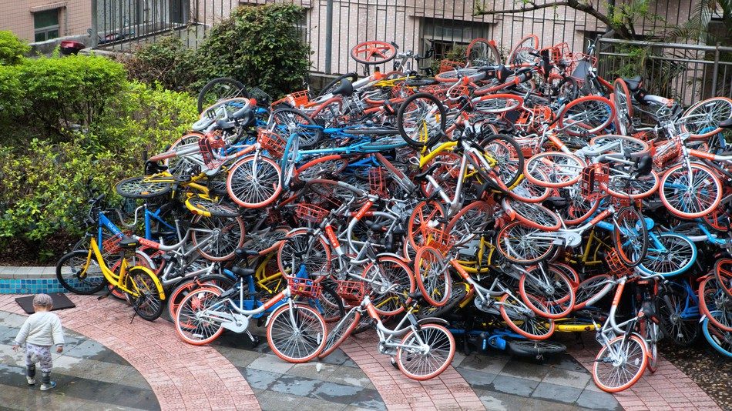
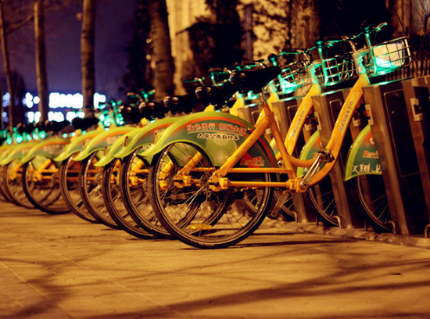

The promoting of the bike-sharing service is also
raising questions about profitability, wide-spread
bike vandalism (破坏) and theft, and growing government regulation. A Hong Kong man who was arrested for throwing several shared bikes into rivers said he had no regret destroying them because “the GPS devices in the bikes give away users’ personal information, such as their locations.”

Bike-sharing has taken off in China far faster than in
any other market. The market has become flooded
with new companies in recent months.The bike-sharing
companies operate in a similar way. They use apps that allow users, after paying a deposit, to unlock the wheels with their smartphones. After the journey, users can leave bikes anywhere in public and pay a little money for the use. The service is very popular as it provides an effective solution to “the last kilometer” problem.

【写作内容】
1. 用约30个单词概述上述信息的主要内容；
2. 用约120个单词发表你的观点，内容包括：
（1）支持或反对共享单车的推广；
（2）用2-3个理由或论据支撑你的观点。
【写作要求】
1. 写作过程中不能直接引用原文语句；
2. 作文中不能出现真实姓名和学校名称；
3. 不必写标题。
【评分标准】
内容完整，语言规范，语篇连贯，词数适当。

板块 | 评分点 | 分值
Summary | 现象、优点、问题 | 5分：每小点2分，缺2点不给分
Argumentation | 立场(statement) | 3分
Argumentation | 2个论据 | 各5分
Argumentation | 衔接手段 | 3分
Conclusion | 立场总结 | 4分

