读后续写教学设计Through the ice

主题语境：人与自然
语篇类型：故事性文章
授课时长：一课时（每课时40分钟）
文本分析
这是一篇围绕冰上救援展开的故事性文本，主题语境为“人与自然”。故事中，主人公 “我” 在兄弟Harry的鼓动下踏上冰面，却不慎坠入冰洞。在求救时，Harry的突然跑开成为情节的关键转折点 。
从教学价值来看，该文本是高考读后续写故事类型中的典型范例。通过引导学生从5W1H（Who, What, When, Where, Why, How）的角度梳理情节和人物情感变化，能有效锻炼学生构建故事框架的能力。同时，文中多处伏笔的设置，如穿过橡树林去扔石头的细节与Harry跑开行为的潜在联系，以及段首句之间的逻辑关联，不仅增添了故事的趣味性，还为学生预测情节发展提供了线索，有助于培养学生的逻辑推理和文本解读能力。此外，文本语言生动形象，对动作、环境等的描写细致入微，为学生在续写时的语言表达提供了良好的模仿范例。
学情分析
授课对象是高二年级文科（9）班的学生，他们对学习怀有较高的热情和认真的态度，课堂参与度值得期待。然而，在英语基础方面，他们在词汇量积累、语法运用熟练度以及复杂句式的理解上存在一定不足。在思维和想象能力层面，虽然具备一定的基础，但在将创意转化为有条理、连贯的英语表达时，还需要更多引导和训练。鉴于此，为确保课堂上能更高效地进行读后续写训练，大量的故事背景知识预习、情节梳理以及相关语料的储备工作，需要学生在课前完成，以便在课上能更深入地参与到情节预测和续写创作等核心教学环节中。
Teaching objectives:
By the end of this period, the students will be able to:
- analyze the narrative’s elements, the plot and the changes of the characters’ feelings;
- predict the plot based on the given sentences and skills of raising questions;
- use more specific body language and action language to express emotion vividly;
- end the story reasonably by standing in the characters’ position (age, feelings, etc.) and combine the story itself (an experience)
Teaching important points:
- Understand the clues of the plot and the changes of the characters’ feelings;
- Predict the development based on the given sentences, and develop the storyline by asking questions.
Teaching difficult points:
1. Analyze the plot and language features of the original text.
2. Guide students to write a reasonable and well-structured continuation according to the given beginning sentences.
Teaching materials:
1. Text materials: The printed handout of the original story and the requirements for reading-after writing.
2. Multimedia: PPT presenting pictures related to ice-falling and rescue, grammar and vocabulary explanations.
3. Whiteboard and markers for on the spot writing demonstration and correction.

Procedures & Teaching contents |  | Design intention | Methods and strategies
Step 1 Lead-in  Pictures and Questions |  | 创设情境，引出话题。 | 2min  TBT
Step 2 Reading for basic information  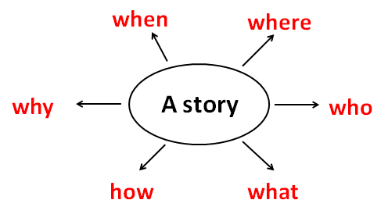 |  | 梳理故事基本信息，为进一步阅读做铺垫，培养学生在阅读故事时关注5W1H。 | 3min  TBT
Step 3 Reading for plot and feeling changes  - Plot  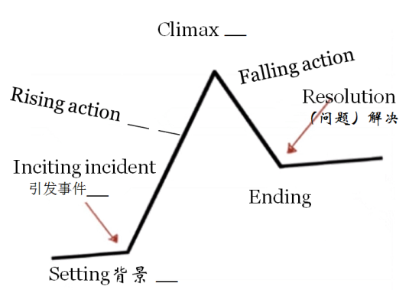  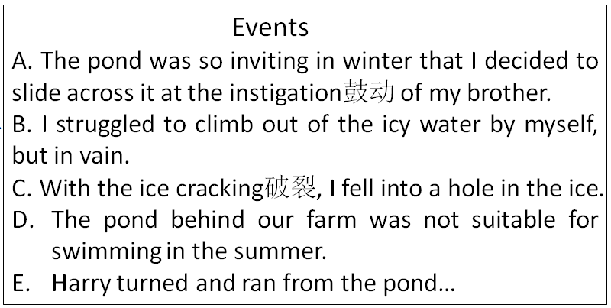  - Changes of feelings  - Before I slid across the pond I felt ______ but______.  - When I was in the middle of the pond I got ______ and______.  - When I tried to save by myself I was ______ and_______.  - When I looked at Harry I was______ but ______. |  | 梳理故事情节发展及人物情感变化，培养学生对整个故事的掌控能力，了解续写故事包含背景、引发事件、故事的起伏、高潮、解决办法等 | 6min  TBT
Step 4 Predicting the development of the story  - Predict the plot according to the two given sentences  Para1：  - What was my response to his leaving?  - Did he really leave me alone?  - How was I rescued?  - Raise questions about the development  Para2——Discussion:  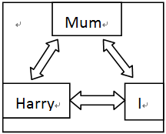  Questions? |  | 引导学生通过两个段首句预测信息；结合第一段老师抛出的问题链，组织学生讨论后续情节的发展；第二段，鼓励学生小组合作进一步思考助推情节发展的问题链。 | 8min  TBT&  CL
Step 5 Writing the story |  | 组织学生分别完成两段的续写。 | 8min  TBT
Step 6 Appreciating and reviewing  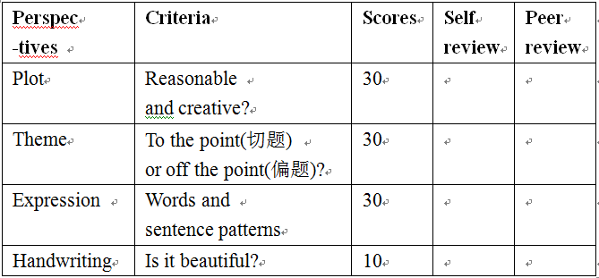 |  | 每段选1-2位同学展示，让其余学生评价，实现自评和互评，帮助学生了解写作时应关注的方面。 | 5min  FBT
Step 7 | Summary | 引导学生回顾总结本课所学，强化读后续写应关注情节、主题、表达及书写等方面的意识。 | 3min  FBT
Step 8 | Assignment  - Polish up your writing according to what you’ve learnt.  - Share your writing with your classmates.  - Try to learn from your classmates and try to give some advice on improving their writing. |  | 1min
(Methods and strategies: TBT---Task-based teaching method: Set tasks such as text analysis, plot prediction, and writing to promote students' active participation.
CL---Cooperative learning method: Group students to discuss and share ideas, enhancing their communication and collaborative abilities.
FBT: Feedback-based teaching method: Provide timely feedback on students' writing to help them improve.)

1. Knowledge and Skills Objectives

◦ Students can master relevant vocabulary and expressions related to ice - falling and rescue.

◦ Students are able to analyze the plot structure and language features of the given text.

◦ Students can write a coherent and logical continuation of the story with about 150 words.

2. Process and Methods Objectives

◦ Through group discussion and individual thinking, students can improve their ability to predict plot development.

◦ By peer - editing and teacher - feedback, students can learn to revise and improve their writing.

3. Emotional Attitudes and Values Objectives

◦ Cultivate students' awareness of safety in winter activities.

◦ Stimulate students' interest in English writing and enhance their confidence in writing.

VI.教学重点和难点 (Teaching Key Points and Difficulties)

1. Key Points

◦ Analyze the plot and language features of the original text.

◦ Guide students to write a reasonable and well - structured continuation according to the given beginning sentences.

2. Difficulties

◦ Help students create an interesting and logical plot development.

◦ Ensure students' writing is rich in details and shows proper language use.

VII.资源与工具 (Resources and Tools)

VIII.预设过程 (Expected Teaching Procedures)

1. Warming - up (5 minutes)

Show some pictures of winter activities on the ice and ask students to share their experiences or knowledge about ice - related safety. Lead in the topic of the story.

2. Text Analysis (10 minutes)

• Ask students to read the given text silently and summarize the main plot.

◦ Analyze the character traits of "I" and Harry, as well as the language features such as descriptive words and sentence structures.

3. Plot Prediction (10 minutes)

• Divide students into groups. Let them discuss what might happen next according to the two given beginning sentences.

◦ Each group presents their ideas to the class.

4. Writing (15 minutes)

• Students start to write their continuations of the story individually.

◦ The teacher walks around to offer guidance and answer questions.

5. Peer - editing (5 minutes)

• Students exchange their writings with their partners.

◦ They check each other's writings for grammar, spelling, and logical errors, and give suggestions for improvement.

6. Presentation and Feedback (5 minutes)

• Select some students to share their writings with the class.

◦ The teacher and other students give positive feedback and constructive suggestions.

IX.教学内容、方法与策略 (Teaching Content, Methods and Strategies)

1. Teaching Content

◦ Vocabulary and expressions: skip stones, solid, hesitate, urge, etc.

◦ Plot analysis: character, conflict, and development.

◦ Writing skills: using descriptive language, creating a logical plot.

2. Methods and Strategies

◦ Task - based teaching method: Set tasks such as text analysis, plot prediction, and writing to promote students' active participation.

◦ Cooperative learning method: Group students to discuss and share ideas, enhancing their communication and collaborative abilities.

◦ Feedback - based teaching method: Provide timely feedback on students' writing to help them improve.

X.学习评价与作业设计 (Learning Evaluation and Homework Design)

1. Learning Evaluation

◦ Formative evaluation: Evaluate students' performance in class discussion, participation, and peer - editing.

◦ Summative evaluation: Evaluate students' written works based on criteria such as content, language, and organization.

2. Homework Design

◦ Ask students to revise their writings according to the feedback received in class.

◦ Find another short story and write a continuation for it as extra practice.

