**【单元目标**】

By the end of the unit, We will be able to:

1.Form a brief impression of *Out of this world* by reading related passages and resources and the achievements China has made in space exploration.

2.Explore and conclude the qualities that are needed to be an astronaut and develop interest in space exploration.

3.List the reasons for human exploration of the universe and summarize the knowledge of the space

4.Reconstruct the unit as a whole and form your overall recognition about the importance of travelling by Group Article Reading and Unit Test.

**【单元任务】**

Exploring unknown is the nature of humanity, space exploration helps human understanding the origin, evolution and future development of the universe, and the technological progress made in space exploration can be used to solve certain major problems facing humanity, space.

**【学习导航&课时安排】**

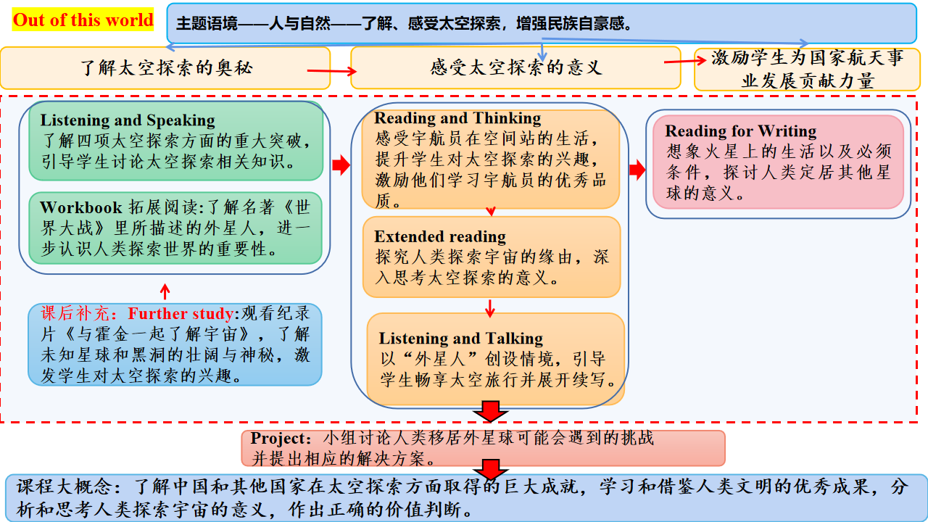

|  |  |  |  |  |
| --- | --- | --- | --- | --- |
| Stage | **Overall Perception** | **Exploration& Construction** | **Application& Transfer** | **Reconstruction & Extension** |
| Period | 1 | 5 | 1 | 2 |

**【单元学习目标追求】**



**Overall Perception**

**Out of this world**

**--Explore the major breakthroughs in space exploration China has made**

**【Learning Objectives】**

1. Recognize the worksheet and textbook as a whole to form unit overall cognition and search the vocabulary related to the theme of this unit;

2.Explore the major breakthroughs in space exploration China has made;

3.Figure out the achievements China has made in space exploration after reading the background information.

**【Context and Task】**

The three Chinese astronauts or taikonauts carried into space aboard the Shenzhou-13 spaceship entered the Tianhe core module of China's space station on October 16, the China Manned Space Agency (CMSA) said. The trio, Zhai Zhigang, the commander, and Wang Yaping and Ye Guangfu, entered Tianhe hours after the spaceship successfully docked with the core module, becoming China's second crew stationed there. How much do you know about the development of our aerospace career? If you want to know more, try to learn it in this unit.

**Activity 1. Construct the theme-related vocabulary**

Preview the words and the supplies on 271BAY to activate your vocabulary about space exploration.

Space station related vocabulary:

**Out of this world**

Space exploration related vocabulary:

Aliens related vocabulary:

## Activity 2. There have been many exciting breakthroughs in the history exploration.

1.What other breakthroughs in space exploration do you know about?

________________________________________________________________

2.if you have the chance, would you like to go into space? Why or why not?

________________________________________________________________

## Activity 3. Background information

**The Three-body Problem Hits**

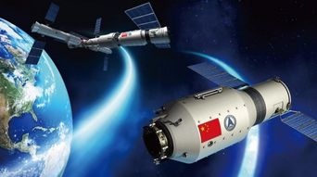

Do you like science fictions?Whether your answer is yes or no,I am sure you have heard about the famous novel The Three Body Problem whose Chinese name is San Ti.

Liu Cixin is the author of The Three Body Problem. He is called "the one who raises Chinese science fiction to the world level".

The three body trilogy tells the story of the rise and fall of the earth civilization in the universe. The novel involving human history, physics, astronomy, social science and philosophy, deeply discusses the humanity from the perspective of science fiction. The novel has a huge structure and lofty conception, and is known as the most prominent contemporary science fiction in Chinese. It is a milestone in the Chinese science fiction literature, and will push China's science fiction to the world. At the end of 2014, the novel which was translated into English published in the United States, receiving a warm response. In 2015, it won the U.S. science fiction fantasy Association, nebula award and other five awards nominations. In August 23, the "three body" won the Hugo Award for the best novel awarded by the seventy-third world science fiction conference. This is the first time that an Asian win the Hugo prize.

The Three Body Problem is a story about Ye Wenjie in the "Cultural Revolution" who exposed the coordinate of the earth to aliens on three bodies. At that time the alienswere in trouble. So they dispatched a large interstellar fleet to attack the earth. At this time, human beings have discovered that the universe is in the "dark forest" state, any civilization that exposed their position will soon be destroyed. With this discovery, human beings have threatened to release the position coordinates of the three bodies to the whole universe. This strategy makes the earth and the three body to establish a fragile strategic balance. But at last, the balance was eventually broken by the earth itself.

The Three Body Problem can arouse our passion of the universe exploration and thinking of human fate and humanity. Let’s read this novel and enjoy its wonderfulness!

**Exploration & Construction**

**Out of this world**

**----****Appreciate the qualities of astronauts in the space station**

**【Learning Objectives】**

1.Identify the structure and summarize the main idea of the two passages

2.Explore the reasons for human exploration of the universe and summarize the knowledge of the space.

3.Conclude the qualities that are needed to be an astronaut and appreciate great astronauts’ admirable qualities.

**【Context and Task】**

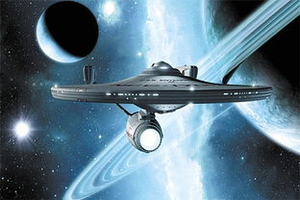The three Chinese astronauts or taikonauts carried into space aboard the Shenzhou-13 spaceship entered the Tianhe core module of China's space station on October 16, the China Manned Space Agency (CMSA) said. The trio, Zhai Zhigang, the commander, and Wang Yaping and Ye Guangfu, entered Tianhe hours after the spaceship successfully docked with the core module, becoming China's second crew stationed there. How much do you know about the development of our aerospace career? If you want to know more, try to learn it in this unit.

**Activity 4.Free talk**

1. What famous astronauts do you know about?

____________________________________________________________________

1. What do you think astronauts on a space station do everyday?

____________________________________________________________________

**Activity 5.Read the lecture transcript and complete the chart below**

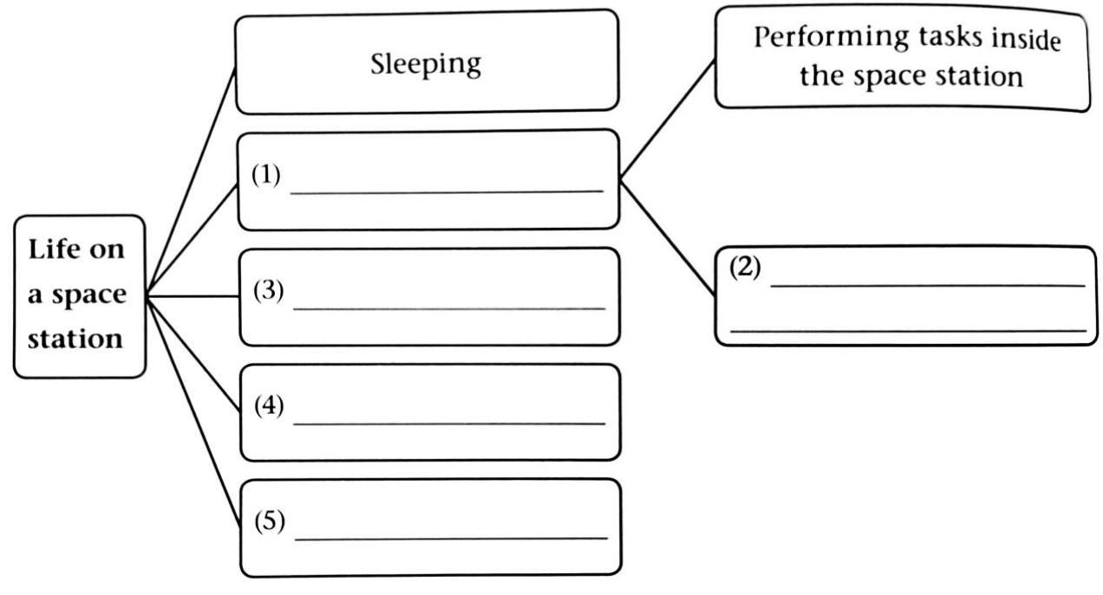

**Activity 6.Read the lecture transcript and answer the following questions.**

1 How do astronauts sleep in space?

____________________________________________________________________

2 What routine tasks do astronauts do on the space station?

____________________________________________________________________

3 What do spacesuits allow astronauts to do?

____________________________________________________________________

4 How do astronauts drink water or any other liquids?

____________________________________________________________________

5 Why do astronauts need to spend some time in the gym?

___________________________________________________________________

**Activity 7.Discussion.**

1. At the end of the lecture, what questions would you like to ask the astronaut?

2.What qualities do you think are needed to become an astronaut?

Good Qualities

3.Write a summary of the lecture transcript in no more than 80 words.

**Activity 8.Read the magazine and answer the following questions.**

**1.Why do human beings explore space?**

**2.Read the article and complete the chart below.**

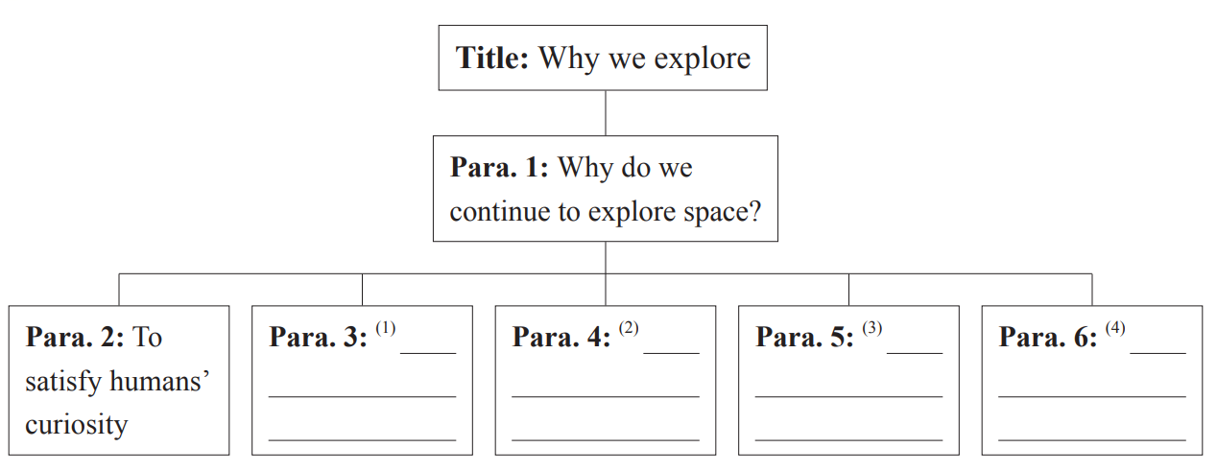

**Activity 9.Summarize the reasons for space exploration mentioned in the article.**

|  |  |
| --- | --- |
| **Reasons for space exploration** | |
| **1** |  |
| **2** |  |
| **3** |  |
| **4** |  |
| **5** |  |

**Activity 10: As a group, discuss the following questions.**

**1.Why does the author tell a true story at the beginning of the first paragraph?**

|  |  |
| --- | --- |
| **Writing techniques** | **Examples** |
|  |  |
| **Giving examples** |  |
|  |  |

**2. Find out the writing techniques the author uses to make his or her argumentation more persuasive and give some examples.**

**3.What is the author’s purpose of writing article?**

**Out of this world**

**Application** **&** **Transfer**

**Out of this world**

**------Provide solutions for living beyond the Earth**

**【Learning Objectives】**

1. Gather and sort information about a certain heavenly body.
2. Brainstorm the challenges the heavenly body will present and provide.
3. Make a profile on how to live beyond the Earth.

**【Context and Task】**

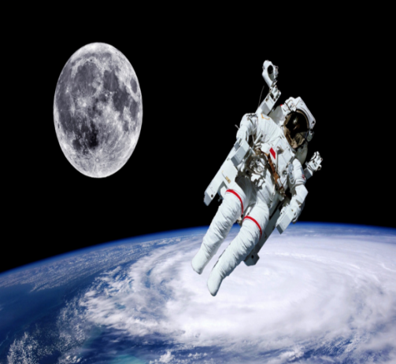Exploring unknown is the nature of humanity, space exploration helps human understanding the origin, evolution and future development of the universe, and the technological progress made in space exploration can be used to solve certain major problems facing humanity, space.

**Activity 11.Make a profile on how to live beyond the Earth.**

**1.Group discussion:**

**Have you ever thought about the possibility of living on another planet? If so, where do you think humans could possibly move to live?**

**2.Choose one heavenly body to research and then gather some basic information about it, including its size, distance from the Sun/Earth, surface features, climate, water, atmosphere, etc.**

**3.Read the sample and discuss the following questions.**

(1) What does the sample mainly focus on?

(2) What are the challenges people have to overcome on Mars?

(3) What solution does the sample give?

(4) What do you think of the sample?

3. Brainstorm the possible challenges people have to overcome when moving to live on the chosen heavenly body, including the resources, food supply, cold, radiation, communication with the ground, etc.

4. Discuss in groups how to overcome the possible challenges when living on their chosen heavenly body.

5. Proofread the draft to make sure there are no mistakes. When the profile is finished, each group member should read it carefully and give suggestions on how to improve it.

6. Present their work to the whole class.

**Reconstruction & Extension**

**Out of this world**

**-----Reconstruct as a whole about this unit**

**【Learning Objectives】**

1. Reconstruct the mind map of this unit in order to have a better understanding of the whole unit.

2. Broaden your horizons by reading the provided extensive reading materials.

3.Strengthen their desire to further explore the unknown field in science.

**【单元重构】**

Review the unit and reconstruct the 4 structures of “Out of this world”.

**【单元拓展】**

**A(Space exploration)**

字数： 397 文体： 说明文 摘自： 百度百科 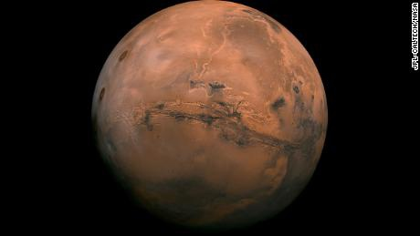

For centuries,explorers have risked their lives venturing into the unknown for reasons that were to varying degrees economic and nationalistic,Columbus went west to look for better trade routes to the Orient and to promote the greater glory of Spain.Lewis and Clark journeyed into the American wilderness to find out what the U.S.had acquired when it purchased Louisiana,and the Apollo astronauts rocketed to the moon in a dramatic show of technological muscle during the cold war.

Although their missions blended commercial and political-military imperatives,the explorers involved all accomplished some science simply by going where no scientists had gone before.

Today Mars looms as humanity's next great terra incognita(未探明之地).And with doubtful prospects for a short-term financial return,with the cold war a rapidly fading memory and amid a growing emphasis on international cooperation in large space ventures,it is clear that imperatives other than profits or nationalism will have to compel human beings to leave their tracks on the planet's reddish surface.Could it be that science,which has long played a minor role in exploration,is at last destined to take a leading role?The question naturally in vites a couple of others:Are there experiments that only human could do on Mars?Couldthose experiments provide insights profound enough to justify the expense of sending people across interplanetary space?

With Mars the scientific stakes are arguably higher than they have ever been.The issue of whether life ever existed on the planet,and whether it persists to this day,has been highlighted by mounting evidence thatthe Red Planet once had abundant stable,liquid water and by the continuing controversy over suggestions the bacterial fossils rode to Earth on a meteorite(陨石)from Mars.A mor conclusive answer about life on Mars,past or present,would give researchers invaluable data about the range of conditions under which a planet can generate the complex chemistry that leads to life.If it could be established that life arose independently on Mars and Earth,the finding would provide the first concrete clues in one of the deepest mysteries in all of science:the prevalence of life in the universe.



1.For What purposes did the explorers go the unknown places in the past?

2.In the exploration of Mars,**_______________________**still remains uncertain.

3.What has long been regarded as unimportant in the past explorations?

4.What has been found on a meteorite from Mars?

5.The conditions under which life originates would be revealed with the proof of**_________________**on Mars.