

**Unit 1 The mass media**

**Reading教学设计**

教学目标：

1. Identify the key information in the two news reports and the differences between them;
2. Understand the reasons for the differences between news reports and the ways to be a critical news reader.
3. grasp the language features and writing techniques of a news report
4. know about how to become a good journalist.

教学过程：

一、Pre-reading

1. Greeting

2. Lead-in

Ask students to think about the following questions:

（1）How could we get the latest updates about an event??

（2）Is mass media 100% reliable?

Show students a couple of news and ask them to decide whether they are fake news or not.

活动目的：调动学生学习积极性，同时引入文章主题。

1. While-reading

1. Have a review of the inverted pyramid structure of news report

• Read the two news reports and complete the following table to figure out the structure

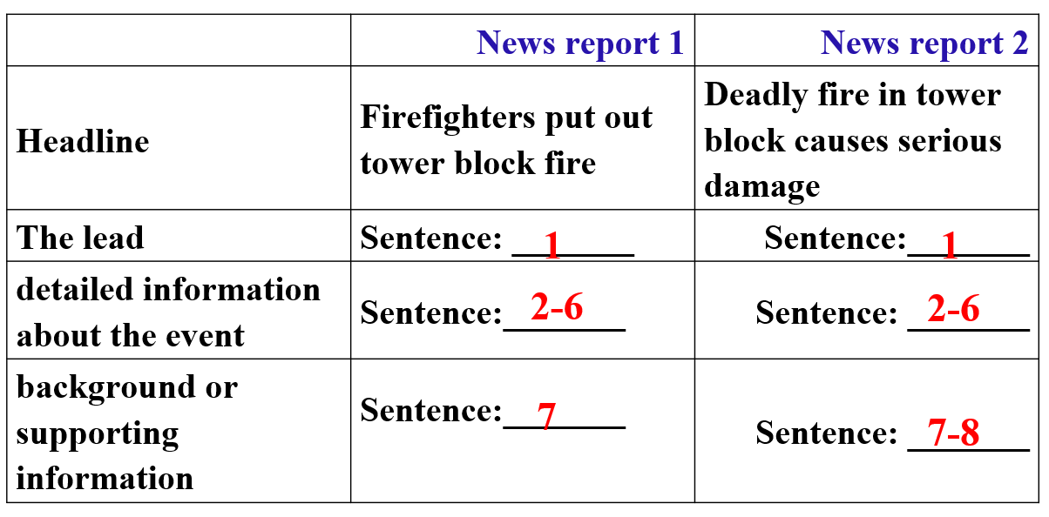

2. 学生活动：略读文章，完成P4活动A1。

|  |  |  |  |  |  |
| --- | --- | --- | --- | --- | --- |
|  | Time | Place | Deaths and injuries | Rescue efforts | Cause |
| News report 1 | Sunday night | Henderson Tower | About 12 dead | Fire engines and ambulances reached the scene within 15minutes. Firefighters controlled the situation. |  |
| News report 2 | Sunday night | Henderson Tower | 4 confirmed dead and dozens of people injured |  | A dropped cigarette on the carpet started the fire and the fire alarms didn't go off quickly enough. |

|  |  |
| --- | --- |
| **Reading news reports critically** | |
| Why do news reports differ from or even contradict each other? | • News reports are written by journalists who may have different priorities  • News reports may be written at different stages of an event.  • Journalists may approach figures differently |
| How can we be critical news readers? | • Read different news reports on the same event written from various perspectives and at different stages.  • Be critical about the information and use our own judgement |

3. 学生活动：仔细阅读文章，完成活动A2。

答案：

1. How long did it take the firefighters to get the situation under control according to the first news report?

Around 75 minutes.

2. How did Lisa feel about the fire according to the second news report?

Terrible and awful.

3. What should we not do when we come across factual differences in different news reports?

Do not rush to the conclusion that one of the news reports gives false information.

4. What may different journalists do when an estimate of a number is given?

Journalists may approach figures they get from research or interviews differently.

4. 教师活动：教师让学生组成小组讨论A3的问题。

三、After-reading

Critical thinking:

1. What else can we do to be critical news readers?

2. Besides reading news, what other mass media content should we be critical about as well?

Group work:

1. Work in groups of 4 and discuss on the topic

“How to view Tik Tok/Bilibili/Wechat/Weibo/.. critically”.

2. The following points should be included:

1) the advantages and disadvantages of the mass media

2) how can we be critical about it?

四、Summary

总结课上所学，梳理文章结构。