Unit 3 Careers and skills
Reading (I)
教学目标：
By the end of this section, students will be able to:
- interpret the quote highlighting the significance of all occupations;
- share their understanding of the spirit of craftsmanship;
- summarize why people need to work;
- provide an answer to the question of working and living.
教学重难点：
- Summarize why people need to work;
- Identify the techniques the writer uses and their functions.
教学过程：
Step 1 Free talk
What is a career? What job would you like to take in future?
What are the most important occupations in your opinion?
Step 2 Appreciating a quote
Read the quote from Huang Yanpei and talk about your understanding about it.
Step 3 Watching a video
T has students watch the video and fill in the blanks on page 29.
T asks Ss the following questions:
1) What is your understanding of the spirit of craftsmanship?
2) Why do some people choose to be an art restorer? Do you want to become one of them?
3) What do you expect from your future career?
Step 4 Global reading
Read the magazine article and complete the chart below with the main idea of each paragraph.
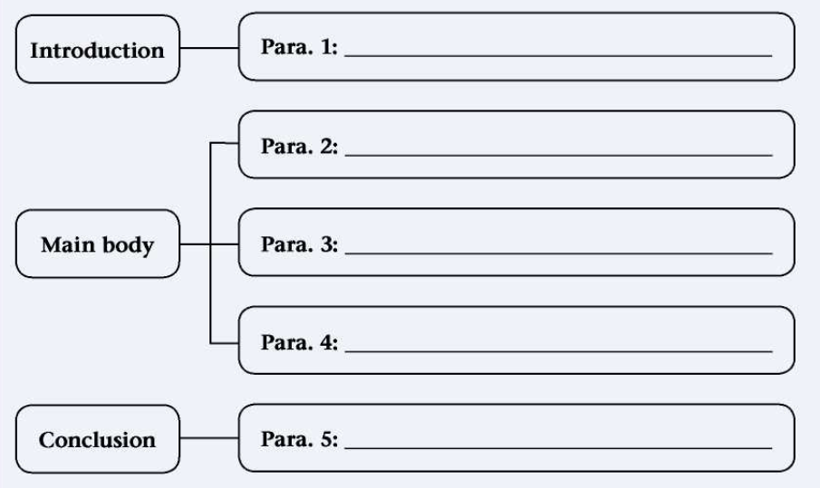
Step 5 Detailed reading
Read the magazine article again carefully and answer the following questions.
1 According to the first paragraph, why do we have to work?
2 What helped Yang Liwei become a pilot and later an astronaut?
3 What should we do to adapt to a rapidly changing workplace?
4 What can we take pride in according to the last paragraph?
Step 6 Post reading
1. Why does the article begin with a question?
2. How does the author explain the contributions of various jobs to the health of society? What is the advantage of this writing technique?
3. How does the author illustrate the main idea of paragraph 2?
4. Do you agree with the writer’s opinion? What is your answer to the question of whether to work to live or live to work? Give your reasons.
Step 7 Homework
According to the passage and your understanding of working and living, write a short passage about your dream job and give your reasons.

