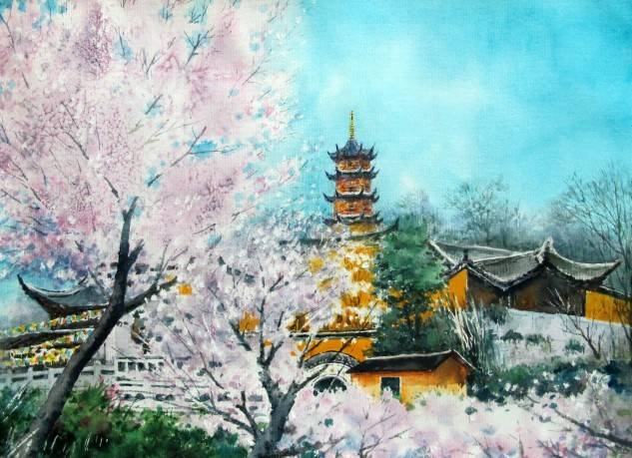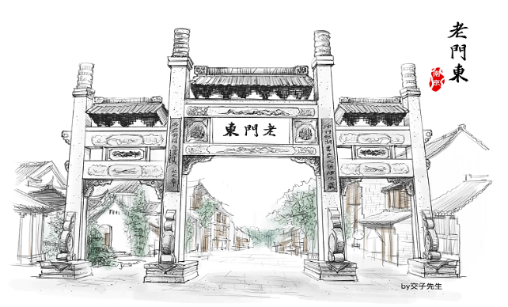

Jiming Temple Laomendong

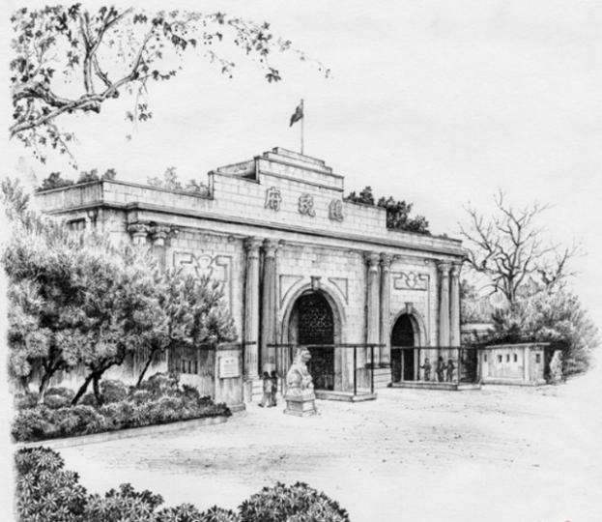 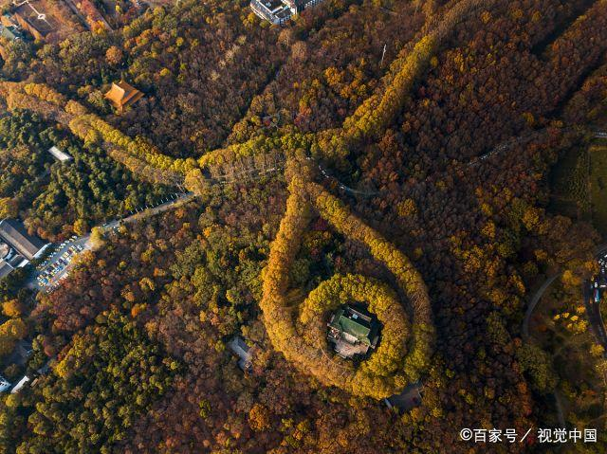

Nanjing Presidential Palace Purple Mountain

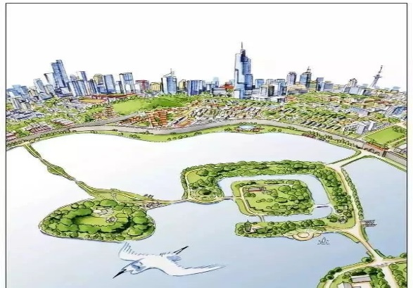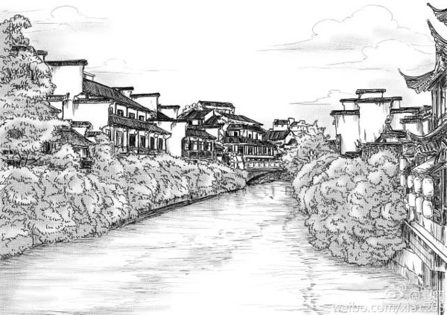

Xuanwu Lake Qinhuai River

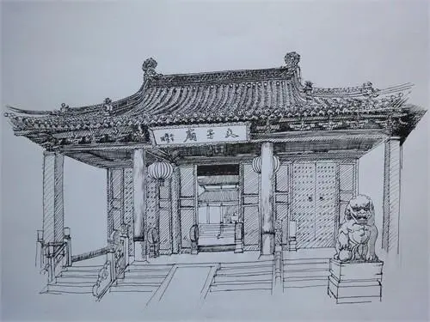 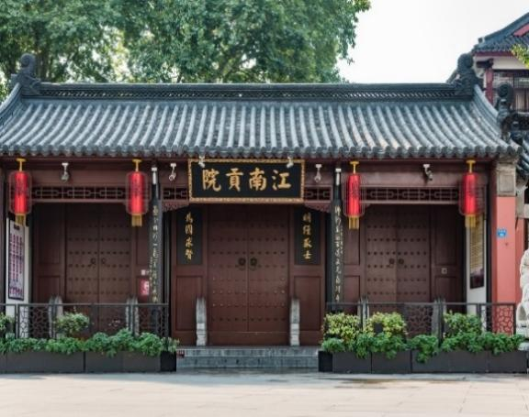

Confucius Temple Jiangnan Examination Hall

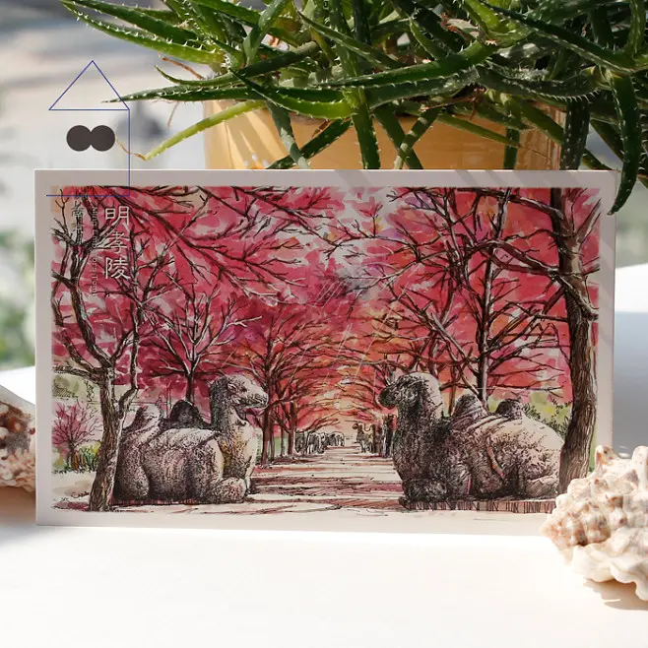 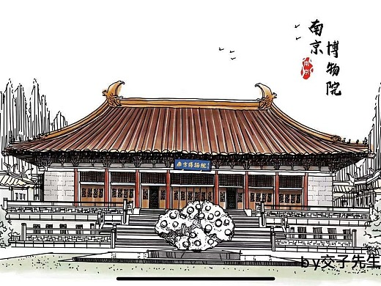

Mausoleum of the Ming Emperor Nanjing Museum

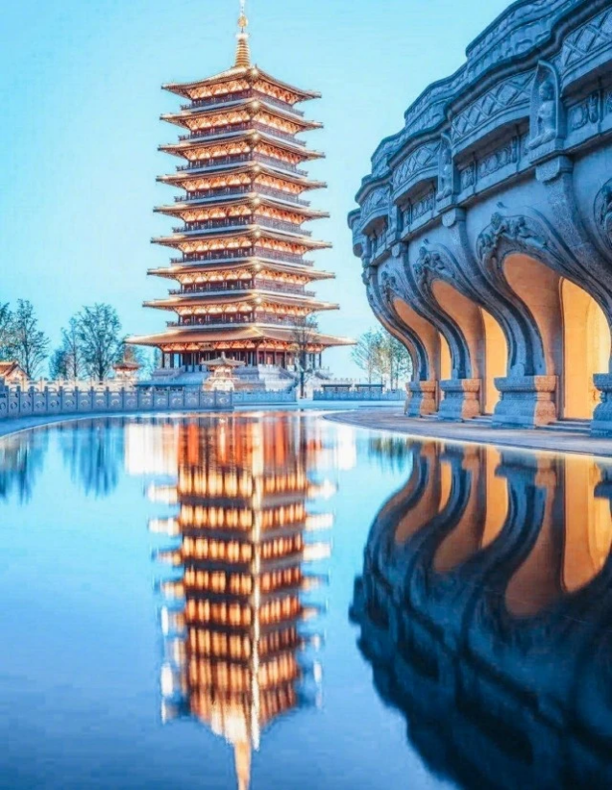 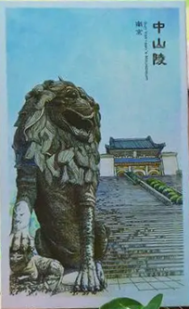

Niushou Mountain Sun Yat-sen Mausoleum

Dear Mr. Smith,

I’m Li Hua, President of Student Union. ________________________________

_____________________________________________________________________

_____________________________________________________________________

_____________________________________________________________________

_____________________________________________________________________

_____________________________________________________________________

_____________________________________________________________________

_____________________________________________________________________

_____________________________________________________________________

_____________________________________________________________________

_____________________________________________________________________

_____________________________________________________________________

_____________________________________________________________________

_____________________________________________________________________

Yours,

Li Hua

**XB3 Unit 1 Integrated skills**

——Teaching plan

Teaching objectives:

1. Practise the skills of listening, speaking, reading and writing;
2. Have a good knowledge of travel plans;
3. Get familiar with Nanjing;
4. Enhance the students’ pride in local culture;

Teaching process:

Step 1: Lead in

Some foreign guests will come to visit our school next week.

1. Listen to the announcement and fill in the blanks.
2. Read the email from Mr. Smith and extract useful information.

Step 2: Reading & discussing

1. What should be included in the travel plan?
2. Read a 2-day Shanghai travel plan and discuss about it in details.
3. Discuss in pairs: how to make a 2-day travel plan in Nanjing?

Step 3: Writing——write an email in reply to Mr. Smith

Step 4: Homework

Complete your email and attach a specially-designed tourist map with vivid illustrations.