教案

课题：B1U3

Of Friendship

课时：第一课时

Teaching aims:

By the end of the class, students will be able to:

1. Identify the structure of the article
2. Summarize Bacon’s ideas on friendship
3. Explain the importance of friendship

Teaching key points:

1. To enable students to identify the structure and main idea of the article.

2. To enable students to summarize Bacon’s ideas on friendship.

Teaching difficulties:

1. How to enable students to understand the importance of friendship.

**Step1 : Lead-in**

Show students a short video on friendship and ask them to fill in the blanks with proper phrases.

What’s real friend ?

The real friend is someone __________________

_______; someone _______________________, even when times are tough.

**Step 2: Pre-reading**

Introduce the writer Francis Bacon and identify the text type.

**Step 3: While-reading**

Fast-reading:

Read the passage for the first time and find out the topic sentence of each paragraph.

Based on the topic sentence, students try to summarize the structure.

Careful-reading:

Read the passage paragraph by paragraph to find out detailed information.

Read para.1 and answer the question:

Why may we hope to be alone sometimes in our life?

Read para.3-5to find out the three ‘fruits’ of friendship and finish the mind map.

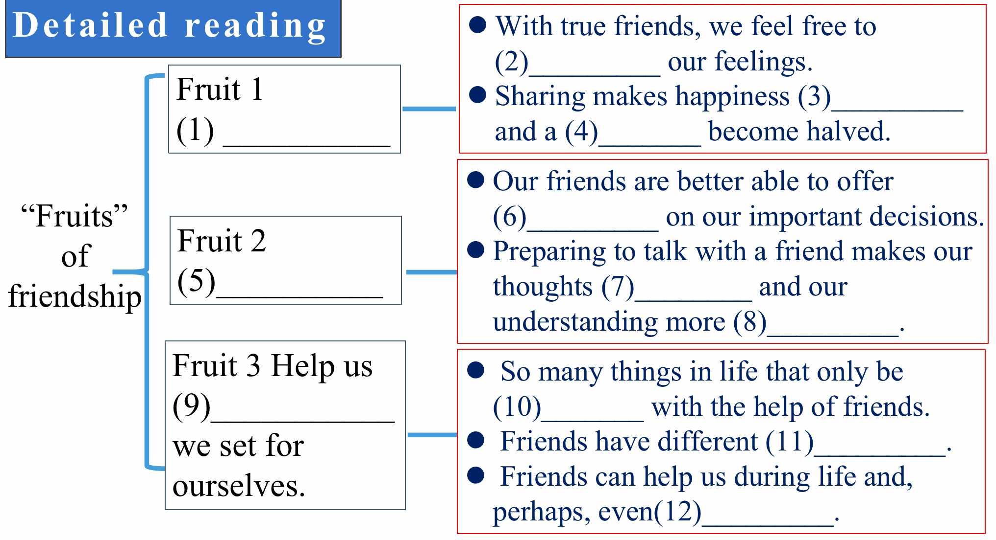

**Step 4. Post-reading**

Critical thinking:

What are the differences between staying with a crowd and being with true friends?

Read the tips on writing a summary first and write a summary of the passage in 60 words.

Peer review: exchange their summaries with desk-mates and evaluate each other’s summary.

教学总结

本堂课的授课内容是必修一第三单元的Extended reading第一节课，授课对象是高一15班的学生。本单元的主题语境是“与他人相处”。本堂课涉及的语篇是弗朗西斯·培根的议论文《论友谊》。本节课的教学目标是：首先，总结文章结构和培根关于友谊的看法。其次，学生通过阅读文章理解友谊的重要性。课程设计主要围绕教学目标展开，首先，引入部分通过关于“什么是真朋友”的视频引入友谊这个话题。读前，向学生介绍作者以及文章的体裁，帮助学生为阅读做好准备。读中，首先略读课文，寻找段落关键句，快速划分文章结构。然后，学生按段落详细阅读，完成关于“友谊三大果实”的思维导图。读后活动，让学生思考什么是真正的朋友。最后，根据文章写一篇60字的总结。写完后进行同伴互评。

在实际授课过程中，我发现了以下几个问题：

1. 最后的同伴互评环节应该有更详细的评价标准。
2. 课堂内容安排过多，导致最后没能留给学生足够的时间进行讨论。
3. 对学生问题的回答评价应该更丰富多样一些，课堂评价过于简单，未能提供很多的有效信息，充分引导学生。

综上所述，在今后的教学中要进一步的了解学生，了解教材，合理规划好课堂时间，加强对学生的引导。