Strategies for a narrative cloze test of new NCEE
——新高考完形填空记叙文解题策略
Teaching aims:

After learning the class, you will be able to :

1. Know the latest question setting of NCEE(高考)

2. Master some basic problem-solving strategies for a narrative cloze test

3. Apply the tricks to improve the ability of solving problems

4. Summarize the strategies of doing a cloze test.

Teaching important and difficult points:
1. The strategies of solving a narrative cloze
2. The skills of getting the main idea and following the main plot and the emotion line
3. The abilities of applying some skills according to the context.

Teaching methods and aids:
Teaching with the help of multi-media and blackboard
Cooperative learning
Task-based teaching and learning

Teaching procedures:

Step 1: Warming-up tasks
- Introduce some information of the latest three year’s NCEE(高考).

Q: What’s a common feature of these articles?
- Analyse the latest question setting of NCEE(高考)

(1).把握考查方向——知考情

句内层次考查：

句内层次题是指那些通过阅读翻译空格处就能找出答案的题目，解决这类问题主要是对句子的准确理解和对四个选项的意思的准确把握。

句组层次考查：

句组层次题是指那些通过阅读翻译空格处所在的句子，不能找出正确答案，需要结合内容才能推断出答案的题目。解决这类题目必须要整体阅读，结合上下文的意思，根据创设的情境和故事合理推断发展过程。

(2).熟练解题流程——提效率

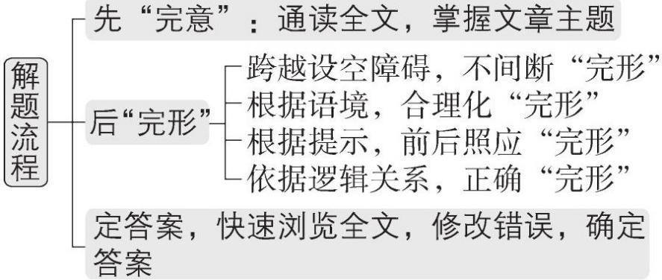

Step 2: skills for the cloze text
Task1: Do some practices to understand what are these 5 skills?
Skill1: logical relationship
Skill2: attitudes and emotions of the writer or the characters in the narrative story
Skill3: contextual implication
Skill4: reappearance of a word
Skill5: background knowledge

Task2: Check the homework
- Know of the basic information of the cloze test
Q1: What is the main idea of the passage?
Q2: Who are the main characters(人物) in the passage?
2.Apply the strategies and some skills to analyze the text and choose the answer to every blank.

Step 3.Practice
Apply the strategies and some skills to do a cloze test.

Step 4.consolidation
Review some Tricks:
1.2-3分钟内进行缺词阅读，密切注意首尾段，弄清文章的情节线及感情线。
2.Look back and forward瞻前顾后
3.Use your grammar knowledge运用语法知识
4.Use your common sense运用常识知识

Step 5.Homework
1.Summarize the skills and strategies used in dealing with a cloze test.
2.Finish a cloze test.

