## B5U3　Extended reading

Ma Jingying

2022.10.24

**Teaching objectives**

At the end of this class, students should be able to:

1.have a good understanding of the article about acupuncture;

2.express their ideas about how to preserve traditional Chinese cultural heritages like acupuncture;

3.master some useful expressions used in the article.

**Teaching process**

**Step 1 Lead-in**

**What does ‘TCM’ refer to and what do you know about it?**

**Step 2 Pre-reading**

Look at the title and the picture on P39 and predict what the passage is talking about.

I guess this passage is talking about because I can see the picture of and the title is “ ”．

**Step 3 While-reading**

Ⅰ.**Fast-reading for main ideas**

1．Match the main idea with the right paragraph.

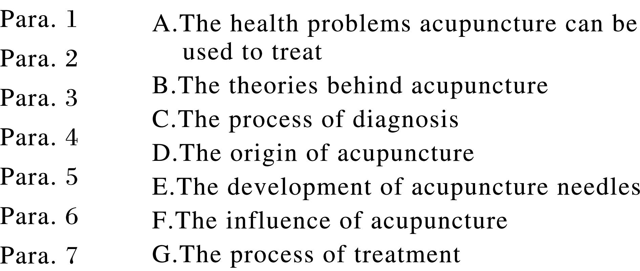

2．What is the main idea of the passage?

A．The comparison between acupuncture and other treatments. B．The future of acupuncture.

C．The function of acupuncture. D．A traditional Chinese medical treatment：acupuncture.

**Ⅱ.Careful-reading for details**

**Activity 1**　**Detailed reading**

1．What is the evidence indicating acupuncture dates back to the Stone Age?

A．The stone needles. B．Complex medical instruments.

C．Stone tools called *bian* . D．Metal needles.

2．Why should the acupuncturist check the pulse on each wrist?

A．To find out which pulse is stronger. B．To find out which pulse is connected with a major body organ.

C．To find out more questions about the pulse. D．To figure out which energy channel is weak.

3．What does “it” in Paragraph 6 refer to?

A．A theory. B．An acupuncturist. C．Acupuncture. D．An agreement.

4．What can we infer from the passage?

A．360 acupuncture points have been identified. B．Acupuncture has a widespread use in treatment.

C．Acupuncture is only popular in China. D．How acupuncture works is clearly understood.

**Activity 2**　**Deep understanding**

1．What’s the main purpose of the passage?

A．To present a study result about acupuncture. B．To introduce an art of “magic needles”．

C．To explain a way to treat patients. D．To propose new means to treat patients.

2．Where is the passage most likely from?

A．A magazine. B．A guidebook. C．A novel. D．A diary.

3．What is the attitude of the author towards the development of acupuncture?

A．Positive. B．Pessimistic.

C．Skeptical. D．Indifferent.

**Step 4** **Post-reading**

**Activity 1**　**Discussion**

3．How can we preserve traditional Chinese cultural heritages such as acupuncture?

**Activity 2**　**Blank-filling**

Chinese acupuncture, which 1. (date) back to the Stone Age, is one of the the most famous Chinese medical 2. (treatment)．

As acupuncture developed, metal needles replaced stone needles,3. (arise) out of the simple *bian* stones.Even though metal needles, such as gold and silver are still 4. use，the majority have now switched to stainless steel ones.Apart from the changes in material，the shapes of the needles 5. (change) over time as well.

During a visit to the acupuncture clinic, the acupuncturist examines the patient, asks questions and checks the pulse in three positions, each 6. (connect) with a major body organ.After the check-up, selected acupuncture points are 7. needles are pushed into the skin.Acupuncture can be used 8. (treat) a wide variety of health problems, including 9. (physics) problems and mental ones.

Despite the fact that 10. acupuncture actually works is not clearly understood, acupuncture has become a popular form of treatment, spreading to many other countries.With doubts about its safety disappearing gradually, interest continues to grow.

**Step 5 Homework**

Complete the exercises in the workbook. (P97~99)