Period 3 Writing
INCLUDEPICTURE "三言两语A.TIF" \* MERGEFORMAT 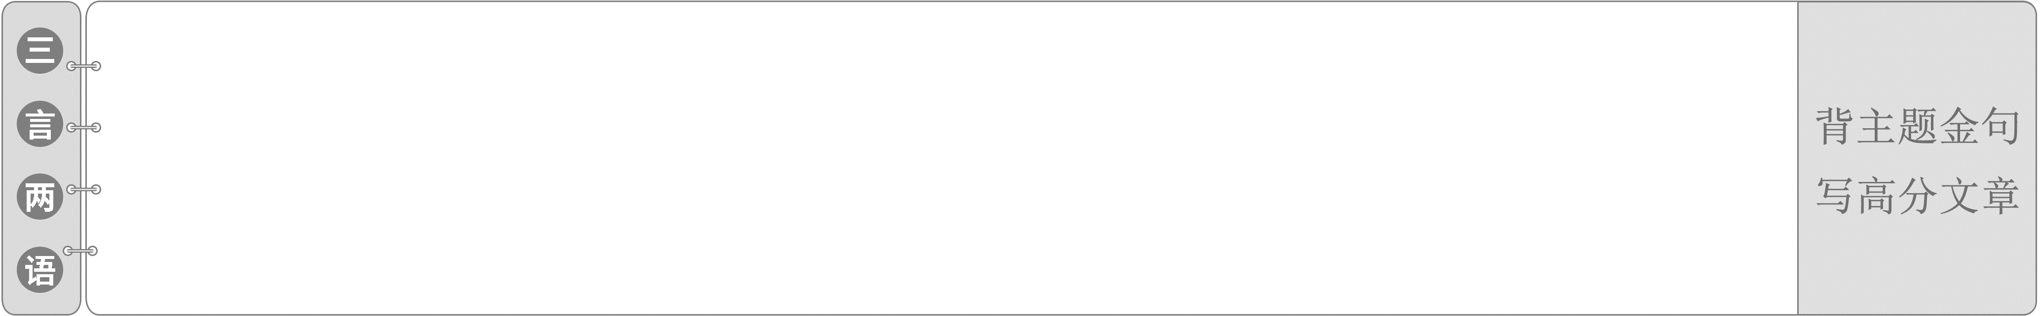
1.Scientific progress depends on the labour and the value of the inventions of scientists.
科学的进步取决于科学家的劳动和他们的发明的价值。
2.Every single grain on your plate is the result of hard work.
谁知盘中餐，粒粒皆辛苦。
农业类的英语短文
INCLUDEPICTURE "集腋成裘LLL.TIF" \* MERGEFORMAT
INCLUDEPICTURE "写作指导LLL.TIF" \* MERGEFORMAT 
INCLUDEPICTURE "灰.tif" \* MERGEFORMAT  文体感知
农业类的英语短文主要体现在农业领域取得的进步、新技术对农业的贡献、有机农业和传统农业的区别、基因工程对农业带来的变化上等，这一类文章主要属于说明文范畴。
写说明文应目的明确、材料准确翔实、语言简练。说明文的写作结构应遵循引子、正文、结束语三部分的要求。引子部分点出主题，正文部分引证说明主题，结束语部分重申主题，以起到强调的效果。
INCLUDEPICTURE "灰.tif" \* MERGEFORMAT 增分佳句
1．The table/chart shows that...
2．As can be seen from the chart...
3．From the table/chart/forms we can see...
4．There was a great/slight increase/rise in...
5．There has been a sudden /slow/rapid fall/ drop in...
6．It is 20% lower/higher than...
7．The number/rate has nearly doubled, as against that of last year.
8．The number is...times as much as that of...
9．It increases/rises/decreases/reduces by...times/...percent...
10．The reason for...is that...
11．One may think of the change as a result of...
12．The change in...largely results from the fact that...
13．There are several causes for this significant growth in...
14．This brings out the important fact that...
15．In summary, it is important that...
16．From what has been discussed above, we may draw the conclusion that...
17．Obviously, if we want to..., it is necessary...
18．There is no doubt that attention must be paid...
INCLUDEPICTURE "高屋建瓴LLL.TIF" \* MERGEFORMAT
INCLUDEPICTURE "典题精析LLL.TIF" \* MERGEFORMAT 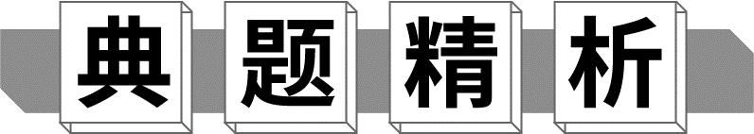
INCLUDEPICTURE "灰.tif" \* MERGEFORMAT 写作要求
转基因技术已经应用于农业、医疗等各个领域，但是对于这一技术的运用，人们持有不同的意见。请结合自己的观点，根据下表写一篇短文。
支持者的理由 | 反对者的理由 | 你的观点
1.可以提高农产品产量和质量，解决粮食不足的问题。  2.可以用来治愈更多疾病。  …… | 1.威胁人类健康，引发不可预知的风险。  2.可能会改变人类基因，造成生物灾难。  …… | ……
注意：1.必须包含以上要点，可适当增加细节；
2．词数80左右。
参考词汇：转基因技术transgenic technology
Should Transgenic Technology Be Used or Not?
_________________________________________________________________
_________________________________________________________________
_________________________________________________________________
_________________________________________________________________
_________________________________________________________________
_________________________________________________________________
INCLUDEPICTURE "灰.tif" \* MERGEFORMAT 审题谋篇
第一步：审题构思很关键
INCLUDEPICTURE "23BTA1.TIF" \* MERGEFORMAT 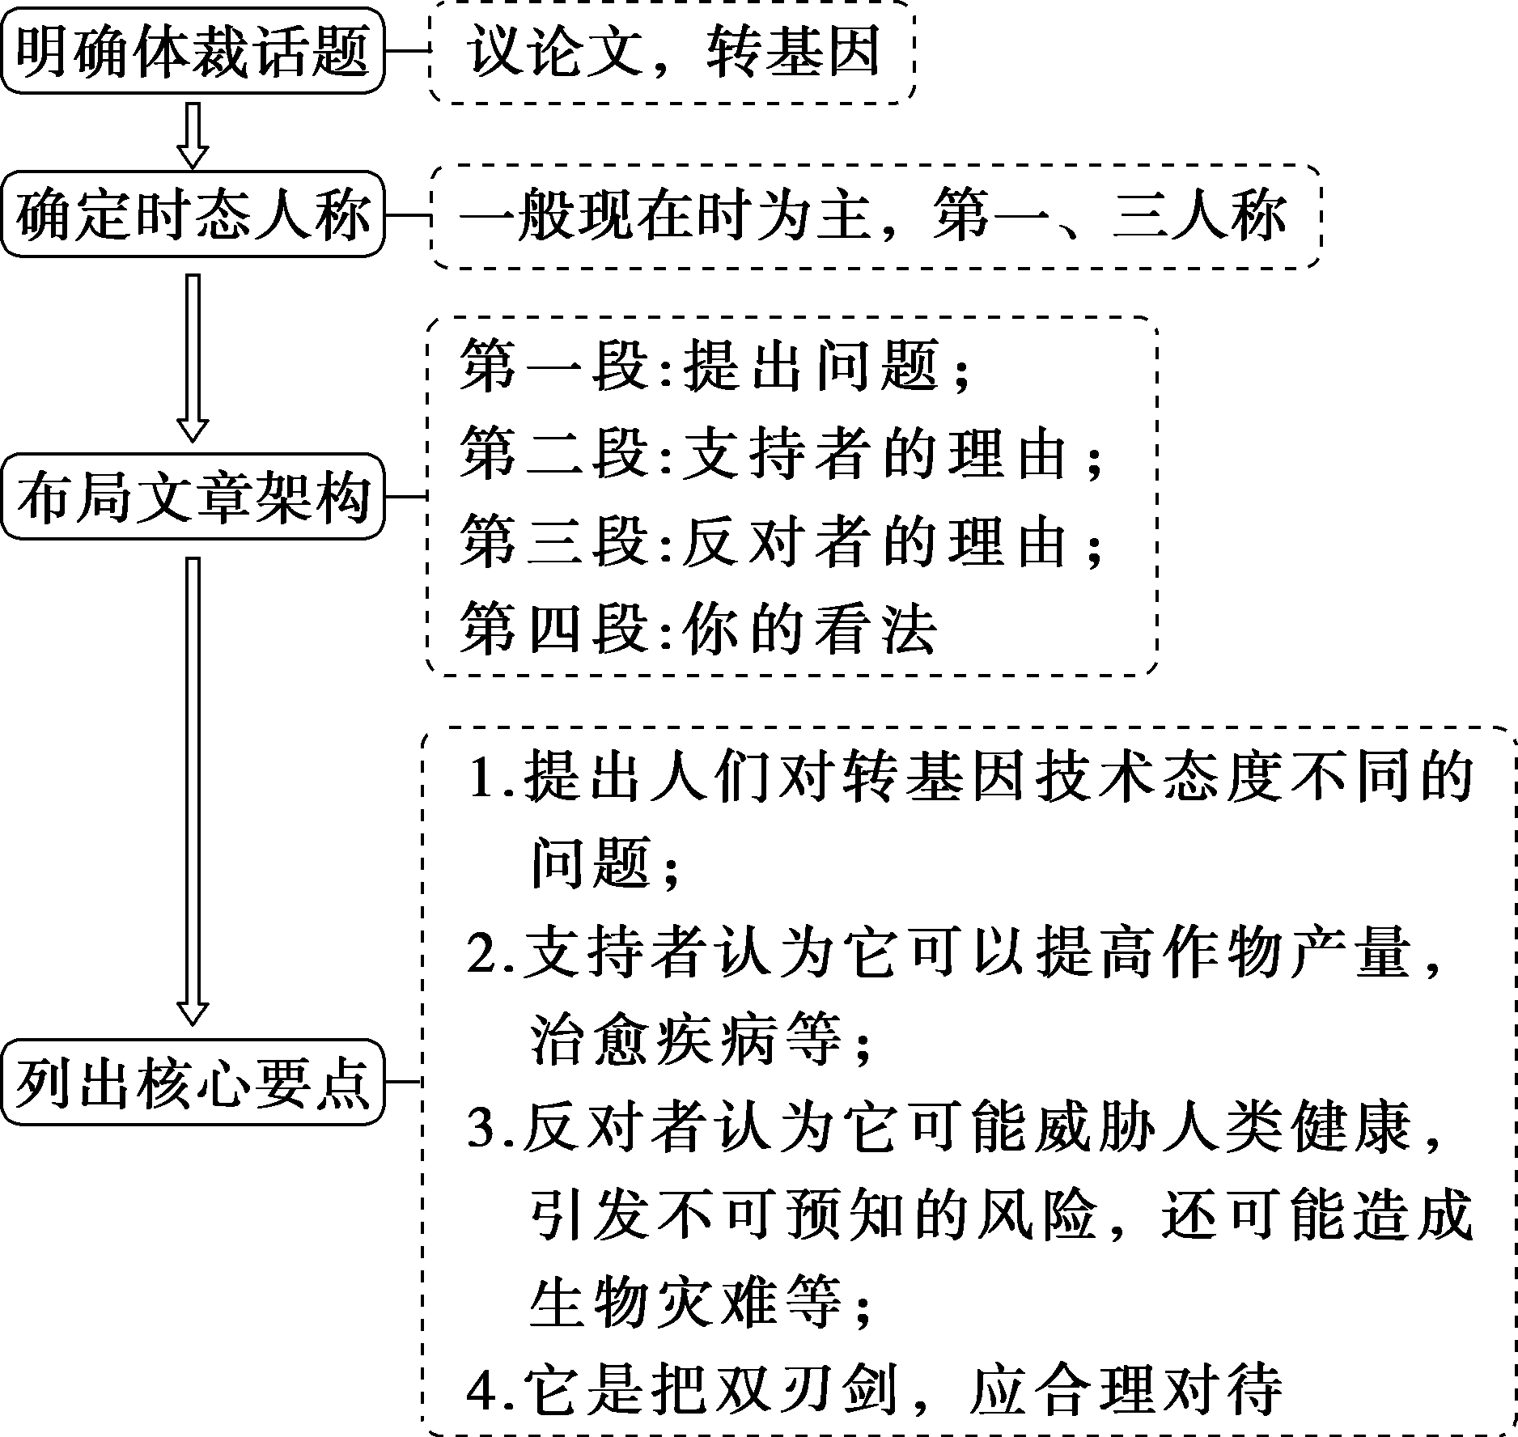
第二步：核心词汇想周全
1．at__the__dawn__of__the__21st__century
在21世纪初
2．get__into__our__life 融入我们的生活
3．in__favour__of 赞成
4．improve__crop__production 提高作物产量
5．no__doubt 毫无疑问
6．cure__people__of__more__diseases
治愈人们的更多疾病
7．in__case 以防万一
8．each__coin__has__two__sides 事物都有两面性
第三步：补全句子雏形现
1．转基因技术已经进入我们的生活，但人们对它的态度仍然不同。
Transgenic technology has got into our life，but people's__attitudes__towards__it__are__still__different．
2．他们认为它已经并将继续为提高作物产量做出巨大贡献。
They think it has done and will continue to do a great job to__improve__crop__production．
3．这无疑可以为迅速增长的人口提供更多的食物。
This__no__doubt__can__provide__more__food for the rapidly rising population.
4．它可能有助于治愈人们的更多的疾病，让每个人都可以享受长寿和幸福的生活。
It may help to cure__people__of__more__diseases and everyone can enjoy__a__long__and__happy__life．
5．有些人反对它是因为他们认为它可能威胁人类健康并引发不可预知的风险。
Some people are__against__it because they believe it may threaten human health and pose__unpredictable__risks．
6．其他人持有这种观点。
Others hold__the__belief．
7．转基因食品不应被允许进入人类食物链，以防人类基因发生变化，造成生物灾难。
Transgenic food should not be allowed to enter the human food chain in__case__mankind__genes__may__be__changed__and__cause__creature__disasters．
8．我们应该以合理、科学的方式对待和利用它。
We should treat and use it in__a__reasonable__and__scientific__way．
第四步：句式升级造亮点
9．用定语从句连接第三步中的句2和句3
They__think__it__has__done__and__will__continue__to__do__a__great__job__to__improve__crop__production，which__no__doubt__can__provide__more__food__for__the__rapidly__rising__population.
10．用同位语从句连接第三步中的句6和句7
Others__hold__the__belief__that__transgenic__food__should__not__be__allowed__to__enter__the__human__food__chain__in__case__mankind__genes__may__be__changed__and__cause__creature__disasters.
第五步：过渡衔接连成篇
_________________________________________________________________
_________________________________________________________________
_________________________________________________________________
_________________________________________________________________
_________________________________________________________________
_________________________________________________________________
_________________________________________________________________
One possible version：
Should Transgenic Technology Be Used or Not?
At the dawn of the 21st century，transgenic technology has got into our life，but people's attitudes towards it are still different.
Some people are in favour of it.They think it has done and will continue to do a great job to improve crop production，which no doubt can provide more food for the rapidly rising population.Moreover，it may help to cure people of more diseases and everyone can enjoy a long and happy life.
However, some people are against it because they believe it may threaten human health and pose unpredictable risks. Others hold the belief that transgenic food should not be allowed to enter the human food chain in case mankind genes may be changed and cause creature disasters.
I think each coin has two sides.We should treat and use it in a reasonable and scientific way.
INCLUDEPICTURE "课后巩固LLL.TIF" \* MERGEFORMAT
Ⅰ.阅读理解
The team of researchers from the University of Lincoln, UK, is designing and building an app to help farmers in hot climates identify and record the spread of locusts (蝗虫) on their land.
By recognizing locusts through the smartphone's camera, the app will be able to identify the stage of the insect's growth and record its location.This information can then be utilized so that the farmers can use pesticides more accurately in the early stages of their life time, greatly reducing the amount of crop damage.
This approach could also reduce remaining pesticide levels, leading to increased food safety while maintaining food security and protecting nearby water systems.
“Each year, approximately 18 million hectares of land are damaged by locusts, influencing hugely farmers and their productivity，” explains Dr.Bashir Al-Diri from the School of Computer Science at the University of Lincoln. Their monitoring techniques currently rely on field surveys by people through digging insect eggs, but this information only helps farmers to make mid and long-term forecasting decisions and can delay effective management measures.By digitally recording the exact number, age and location of locusts, we hope this new app will put more knowledge and more power into the hands of the farmers.
Dr.Al-Diri and his team of computer scientists work with the Lincoln Institute for Agri-food Technology at the University of Lincoln, aiming to support and improve productivity, efficiency and farming through research, education and new technology.
With advanced technology, the developers hope that the app will also be used for a wide range in the future to capture and document information about the natural world.For example, it could easily be adapted to help individuals identify plant diseases or to digitally capture the number and type of birds and wildlife in specific locations as part of national and international surveys.
【解题导语】 本文是一篇说明文。文章主要讲述了英国的一个研究小组正在设计一个应用程序，用来帮助检测蝗虫数量和更精确地使用杀虫剂使用量，从而帮助农民更好地提高生产力。
1．What do we know about the app mentioned in the passage?
A．It has helped farmers record the spread of locusts.
B．It will be of great use for farmers in hot climates.
C．It may cost the farmers more than they expect.
D．It will remind farmers of what the locusts look like.
B 解析：细节理解题。根据第一段以及第二段中“By recognizing locusts...identify the stage of the insect's growth and record its location.”可知，这个应用程序将对于气候炎热地区的农民非常有用。
2．Which can replace the underlined word “utilized” in the passage?
A．Accessed. B．Controlled.
C．Arranged. D．Progressed.
A 解析：词义猜测题。根据下文“so that the farmers can use pesticides...reducing the amount of crop damage”可知，农民利用这些信息可以在蝗虫的生命早期更准确地使用杀虫剂，大大减少作物的损失。故画线词与access的意思最为接近，表示“利用，使用”的意思。
3．What can we know according to Dr.Bashir Al-Diri?
A．Farmers don't know how to deal with locusts.
B．Their techniques can be used to dig insect eggs.
C．Farmers suffer greatly because of locusts.
D．Some steps must be taken before using the app.
C 解析：细节理解题。根据第四段中巴希尔·艾尔迪尼说的话可知，每年约有1800万公顷的土地被蝗虫破坏，对农民及其生产力产生巨大影响。由此可知，蝗虫给农民们带来巨大损失。
4．What is the purpose of Al-Diri and his team?
A．To check if the app is useful in killing locusts.
B．To educate farmers on how to protect themselves.
C．To assist in raising agricultural production level.
D．To direct farmers to change their farming methods.
C 解析：推理判断题。根据第五段可知艾尔迪尼博士和其团队的目的是通过研究、教育和新技术来支持和提高生产力、效率和耕作，即协助农民提高农业生产水平。
Ⅱ.七选五
It's easy to stick to eating the same foods every day, especially if you love them. 1.________
Eating the same foods can lead to nutritional shortage.Our bodies need a wide range of nutrients, and eating a wide variety of foods can help us meet our body's needs. 2.________ Almost everyone would agree that “eat the rainbow” is a good rule of thumb.Don't forget frozen vegetables are just as healthy as fresh and they don't spoil as quickly.
Your immune (免疫) system will get hurt if you keep eating the same foods.According to a study published in the British Journal of Nutrition, the enhanced nutrition from a varied diet seems to boost immunity. 3.________ People whose diets have little variation are more likely to get sick due to a weakened immune system.
Sticking to eating the same foods leads to food boredom. 4.________ It should be something you look forward to.Changing up what you eat exposes you to great new foods and new recipes, and helps bring back the fun in eating.
5．________ We see a lot of people focus on a single nutrient or food because it attracts media fame.And while all foods are to be celebrated for their unique nutritional quality, assigning yourself to a limited list of foods because they are the most well-known or well described will box you in and close you off from various other vital nutrients.
A．Food should be fun!
B．This helps people resist infections.
C．But it may not be the best thing for your health.
D．You should eat a plant-based diet and eat less meat.
E．Eating the same foods restricts your nutritional sources.
F．Though tasty, they can't provide the nutrition you need.
G．Eat the colors of the rainbow when it comes to fruit and vegetables.
【解题导语】 本文是一篇说明文。文章主要介绍了吃单一食物的坏处和吃各种各样食物的好处。
1．C 解析：上文“It's easy to stick to eating the same foods every day, especially if you love them.”讲到你很容易只吃同一种食物，下文“Eating the same foods can lead to nutritional shortage.”讲到一直吃同样的食物的坏处，空处起着承上启下的作用。C项符合语境。
2．G 解析：下文“Almost everyone would agree that ‘eat the rainbow’ is a good rule of thumb.”讲到吃多姿多彩的食物是一个法则，即建议我们要吃各种各样的不同颜色的食物，G项符合语境，rainbow与空后的eat the rainbow中的rainbow是同词复现。
3．B 解析：上文“the enhanced nutrition from a varied diet seems to boost immunity”讲到来自不同种类食物的营养能增强我们的免疫力，即它能帮助我们抵抗感染，B项顺承上文，符合语境。
4．A 解析：下文“Changing up what you eat...helps bring back the fun in eating.”讲到接触新的食物帮你找回饮食的乐趣，即食物或饮食应该是有趣的，A项符合语境。
5．E 解析：空后内容说明单一饮食会限制你的营养来源，E项符合语境。
Ⅲ.应用文写作
请你根据下面提示为“绿叶”有机蔬菜生产基地写一篇80词左右的介绍性海报。
1．坐落在城西；
2．历经20年现已经发展成占地1 000多亩的大农场；
3．配备有现代化的设施；
4．生产过程中不使用任何化肥；
5．富含营养；
6．产品出口几十个国家；
7．联系方式：Tel：666-888-123
Email：GreenLeaf@GreenLeaf.com
_________________________________________________________________
_________________________________________________________________
_________________________________________________________________
_________________________________________________________________
_________________________________________________________________
_________________________________________________________________
One possible version：
Have you ever dreamt of eating green vegetables without chemical fertilizer every day? Please go to Green Leaf—an organic vegetable base.
Located in the west of the city, it has expanded to a farm covering an area of more than 1，000 mu in the past two decades.It has been equipped with advanced facilities.What makes it different from others is that the vegetables here are grown without any chemical fertilizer.It is the rich soil that makes these vegetables full of nutrition.As a result, they are exported into many countries in the world.
If you are interested，please contact us in the following ways.
Tel：666-888-123
Email：GreenLeaf@GreenLeaf.com
Ⅳ.读后续写
阅读下面的材料，根据其内容和所给段落开头语续写两段，使之构成一篇完整的短文。
Kareem sighed as he counted his money again. He was still short of fifty dollars to buy the latest Speedster X bike. In order to save his pocket money to replace his old bike, he had been packing sandwiches to school the last three months.
“How can I get that fifty dollars？” he thought to himself. His mind was wondering when Mother's voice disturbed his thoughts. “Kareem, I just ran into Aunty Kim, our neighbour who just moved in next door. Her son, Shawn, will cycle to school next week. Could you show him the shortcut to school later? It's Saturday anyway！” Hearing this, Kareem had no option but to obey it. He knew Mother had probably already volunteered his service to Aunty Kim. “Oh, here's a mail from your Grandma. Open it！” added Mother.
Kareem's grandmother lived abroad and she would send him photos and cards. He opened the envelope and pulled out a greeting card. Incredibly, a fifty dollar note slipped out as well! Kareem was wild with joy. Waving the note in the air, he shouted happily, “Enough money for my bike！”
At 2 p．m. Kareem met Shawn as arranged by their mothers. The sooner he finished this task, the sooner he could go to the bike shop. While the boys were cycling, a squirrel (松鼠) appeared behind a parked car and dashed across the road so suddenly that the boys knocked into each other and fell down heavily. Kareem said regretfully, “I forgot to warn you about the squirrel population here.” As Kareem was lifting up his broken bike, Shawn cried anxiously, “Oh, my poor bike! It's completely broken.”
Watching Shawn carrying the disabled bike home in silence, Kareem hurried to the bike shop for his dream bike. The sign “Half Price for Old Models” in the shop attracted his eyes.
注意：续写词数应为150左右。
“A Speedster X bike or two old models？” Kareem hesitated.
_________________________________________________________________
_________________________________________________________________
_________________________________________________________________
_________________________________________________________________
_________________________________________________________________
_________________________________________________________________
_________________________________________________________________
“Hi！” Kareem appeared at Shawn's door cheerfully and asked, “Want to ride together？”
_________________________________________________________________
_________________________________________________________________
_________________________________________________________________
_________________________________________________________________
_________________________________________________________________
_________________________________________________________________
_________________________________________________________________
_________________________________________________________________
One possible version：
“A Speedster X bike or two old models？” Kareem hesitated. He thought to himself, “Whatever happened was not my fault. I'm buying Speedster X anyway.” However, as the image of Shawn and his disabled bike flashed before him repeatedly, he felt a shiver running down his body. An inner voice insisted that he should reach out a helping hand. Just at that moment, his initial guilt gave way to a sense of responsibility. After a quick mental calculation, he decided to buy two old models.
“Hi！” Kareem appeared at Shawn's door cheerfully and asked, “Want to ride together？” Shawn got annoyed at the silly question. He moved his lips as if to say something but before he could say anything, Kareem took a stride to the side, revealing two shiny identical bikes magically. “What...How come? No, it couldn't be...” Shawn beamed with excitement, tears clouding his eyes. Mother, who had witnessed the scene from the window, walked up to Kareem and patted his shoulder gently and playfully, “Son! I'm really proud of you.”

