Period 4 Grammar and composition, Integrated skills,
Extended reading & Other parts
INCLUDEPICTURE "三言两语A1.TIF" \* MERGEFORMAT 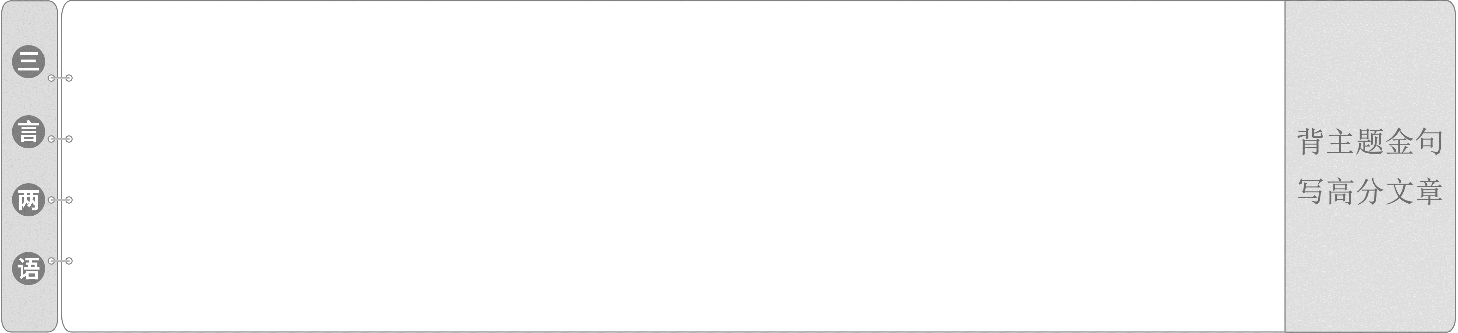
1.The reason why I can succeed in science lies in my love for science and long-term exploration with perseverance.
我之所以能在科学上成功，是因为我热爱科学，并坚持不懈地进行长期探索。
2.The hybrid rice developed by Yuan Longping has been planted on the farmland all over China, playing an important role in increasing China's grain production.
袁隆平培育的杂交水稻已遍布全国农田，为提高中国粮食产量发挥着重要作用。
INCLUDEPICTURE "精读课文LLL.TIF" \* MERGEFORMAT
INCLUDEPICTURE "TASK1ALLL.TIF" \* MERGEFORMAT
Read the text on Pages 25－26 carefully and then choose the best answer.
1．What is the main idea of the text?
A．The process of tea making.
B．The origin of tea and its process to the world.
C．People's understanding of tea.
D．Tea's contribution to the world.
2．What does the phrase “cup of tea” mean in the first paragraph?
A．A container for holding tea.
B．A kind of drink.
C．Something that is easy to do.
D．Something people are really fond of.
3．Which of the following statements is TRUE?
A．People have known the origin of tea drinking.
B．Tea became a drink for all social classes from the beginning.
C．In the Tang Dynasty, tea was spread to Japan.
D．It was Americans that shipped tea to Europe.
答案：1－3.BDC
INCLUDEPICTURE "TASK2ALLL.TIF" \* MERGEFORMAT
Tea is currently the world's most popular drink.1.While/Though/Although we know that tea drinking started in China, its true origin remains something of 2.a mystery. Legend has 3.it that Shennong came across tea when dried leaves blew into a pot of boiling water.Later tea was used as medicine and then as a 4.refreshing(refresh) drink.Eventually, tea became a common drink 5.enjoyed(enjoy) and embraced by all Chinese people and tea drinking became an important part of China's rich culture.It is not surprising that the beauty of tea was finally revealed to a 6.wider(wide) world.In the Tang and Song Dynasties, tea enjoyed enormous 7.popularity(popular) among the Tibetan people.Over time, the gift of tea 8.was__delivered(deliver) to Western Asia.Meanwhile, different sea 9.routes(route) also helped spread tea to other parts of the world.Around the 1600s, tea was shipped to Europe from China by Portuguese and Dutch sea traders. Tea drinking is not just about refreshing the mind and body 10.but also about appreciating the harmony between man and nature.
INCLUDEPICTURE "自查语基LLL.TIF" \* MERGEFORMAT
Ⅰ.核心词汇·练通
根据汉语提示写出正确的单词
1．drip n. 水滴；滴落，滴水声；(静脉)滴注
vt.& vi. 滴下；滴水
2．pest n. 害虫；讨厌的人(或物)
3．downside n. 缺点；不利方面
4．bee n. 蜜蜂
5．conquer v. 在(某地)很受欢迎；克服；击败
6．legend n. 传说，传奇故事；传奇人物
7．nobleman n. 贵族成员；出身高贵的人
8．porter n. 搬运工，行李员；护工；门卫，门房
9．monk n. 僧侣，修道士
10．contemplation n. 深思；沉思；凝视，默默注视
11．humid adj. 温暖潮湿的
12．steep adj. 陡的；陡峭的；大起大落的；
过高的，不合理的
13．bush n. 灌木
14．bud n. 芽；苞；未长大的叶
15．exclusion n. 排除在外，排斥；排除，认为不可能
Ⅱ.拓展词汇·用活
根据提示写出相应的单词
1．irrigation n．灌溉→irrigate v．灌溉；冲洗
2．abundance n．大量，充裕→abundant adj.大量的，充足的
3．Egyptian adj.埃及的，埃及人的n.埃及人→Egypt n．埃及
4．maturity n．成熟；完全长成→mature adj.成熟的；成年的
5．powdered adj.研成粉末的；干燥成粉的→powder n．粉；粉末
6．cultivation n．耕种，种植；培养→cultivate v．培养；种植
Ⅲ.重点短语·再现
根据汉语提示写出合适的短语
1．refer__to...as 把……看作……
2．take__advantage__of 利用
3．protect...from... 保护……免于……
4．in__terms__of 从……角度；用……措辞；
根据……来说
5．break__down 分解；垮掉；出故障
6．apart__from 除……之外
7．cause__damage__to 伤害……
8．the__pros__and__cons 事物的利与弊
9．cup__of__tea 喜爱的人或事物
10．come__across 偶遇
11．trade...for... 交换……
12．sum__up 总结
Ⅳ.重点句型·呈现
根据课文语境及汉语提示补全句子
1．动名词短语作主语
Understanding__more__about__the__advantages__and__disadvantages__of__using__chemicals__in__farming(进一步了解在农业中使用化学制品的利弊) will help you decide...
2．since引导原因状语从句
Since__they__release__nutrients__quickly(由于化肥能迅速释放养分), chemical fertilizers enrich poor soil rapidly.
3．It is commonly acknowledged that...
It__is__commonly__acknowledged__that(众所周知) chemicals are an important tool for farmers.
INCLUDEPICTURE "创意课堂LLL.TIF" \* MERGEFORMAT [词汇知识过关]
INCLUDEPICTURE "圈1.TIF" \* MERGEFORMAT  refer to...as... 把……看作……
(1)refer to 查阅；参考；提到；指的是；
关系到
refer...to... 把……提交给……；把……
介绍给……(以求帮助)
(2)reference n. 提及；涉及；参考；参考书
for reference 以备查阅；以供参考
①The Chinese refer to their language as Han, as it became popular among the people during the Han Dynasty.
中国人把他们的语言称为汉语，因为它在汉代开始流行。
②The sample is for reference only, and is not actually used during activation.
这个示例仅供参考，在激活期间并没有实际使用它。
[练通]——写出下列句中refer to的含义
(1)Complete the exercise without referring to a dictionary.查阅
(2)When I said some people are stupid，I wasn't referring to you.指的是
(3)Your notes are excellent materials to refer to when you are studying for a test.参考
(4)The new law does not refer to the land used for farming.涉及；提到
[写美]——完成句子
(5)我的医生让我去找一位专家诊治，但由于缺钱我放弃了。
My doctor referred__me__to__a__specialist,__but I gave up for lack of money.
INCLUDEPICTURE "温馨提示A.tif" \* MERGEFORMAT 
“查词典”的表达有turn to a dictionary、refer to a dictionary、consult a dictionary、look...up in a dictionary等。
INCLUDEPICTURE "圈2.TIF" \* MERGEFORMAT  abundance n.大量，充裕
(1)in abundance 大量(地)；丰富(地)
an abundance of 丰富的……
(2)abundant adj. 大量的，充裕的
be abundant in...(＝be rich in)
……很丰富；富含……
①If you travel in the sea, you will see an abundance of marine creatures.
如果你在海上旅行的话，你会看到很多海洋生物。
②One quality the team possessed in abundance was fighting spirit.
该队的一大特点是斗志昂扬。
[练通]——单句语法填空
(1)Many of us love July because it's the month when nature's berries and stone fruits are in abundance.
(2)Moreover, by doing the part-time job I can get abundant(abundance) experience so that I can better adapt to the development and changes of society.
[写美]——同义替换
(3)The country has an abundance of natural resources.
→The country is__abundant__in natural resources.
INCLUDEPICTURE "圈3.TIF" \* MERGEFORMAT  take advantage of 利用
(1)have/gain/win an advantage over 比……占(获得)优势/处于有利地位；
胜过；优于
to one's advantage 对某人有利
(be) at an advantage 处于有利状态
(2)disadvantage n. 不利条件；不便之处
①My suggestion is that you (should) take advantage of the opportunity to join sports teams.
我的建议是你利用这个机会加入运动队。
②They weighed the advantages and disadvantages before making the decision.
他们权衡利弊之后才做出决定。
[练通]——单句语法填空
(1)To his advantage, he is smart, hard-working and has potential.
(2)If you can speak English fluently, you will have an advantage over others when you apply for a job.
[写美]——完成句子
(3)如果你已经提前预测了考试题目，你就会处于优势。
You will be at__an__advantage if you have predicted the test questions in advance.
背诵点 | 应用文写作之建议信
INCLUDEPICTURE "圈4.TIF" \* MERGEFORMAT  in terms of 就……而言；在……方面；从某个角度上看
be on good/bad/friendly terms with sb. 与某人关系好/不好/友好
come to terms with...
对……让步，接受(不愉快的事)
in the long/short term
就长期/短期而言
①(2019·江苏卷)With a large brain, human beings beat other beings in terms of intelligence.
我们的大脑比动物大，在智力方面击败了其他动物。
②Learning is not always easy, but it is beneficial to us in the long term.
学习并不总是容易的，但从长远来看，它对我们是有益的。
[练通]——单句语法填空
(1)She had come to terms(term) with the fact that her husband would always be crippled.
(2)People aren't really worried about their personal impact on the earth in terms of wasting resources.
[写美]——完成句子
(3)牢记拥有幽默感，你就能总是和其他人保持友好关系。
Bear in mind that with humor sense, you can always be__on__good__terms__with__others．
背诵点 | 应用文写作之建议信
INCLUDEPICTURE "圈5.TIF" \* MERGEFORMAT  break down 出故障；垮掉；分解；(谈判)破裂
break in 破门而入；打断
break into 强行闯入：突然……起来
break out (战争、火灾等)爆发；突然……起来
break away from 脱离；挣脱
break up 打碎；粉碎；破碎；解散，驱散；
结束；分手；拆开；放假
①(2020·天津卷7月)The “HAPPY TO CHAT” benches help break down the invisible social barrier that keeps people from saying hello.
“快乐聊天”长椅帮助人们打破阻碍人们打招呼的无形的社会障碍。
②She is trying to break away from the bad habit，which makes her parents happy.
她正在努力摆脱坏习惯，这让她的父母很开心。
[练通]——用break的相关短语填空
(1)In order to get some money, the man broke__up that old machine and sold some parts.
(2)The workers were at work in the factory that afternoon when a big fire broke__out．
[写美]——同义替换
(3)Hearing the bad news that their son wasn't found in the earthquake, the couple broke into tears.
→Hearing the bad news that their son wasn't found in the earthquake, the couple broke__out__crying．
[经典句式过关]
“There was a time when...”意为“有一段时间……”
(教材P₂₅)However, there was a time when tea was known only to the Chinese.
然而，有一段时间，茶只为中国人所知。
a time表示“一段时间”，相当于a period of time，后接when引导的定语从句。
(1)It/This/That/There was a time when...
曾经一度(那时)……
(2)It is/was the first/second...time that...
是某人第一/二……次做某事。
(3)It is time that sb.did/should do sth.
是某人该做某事的时候了。
①There was a time when I loved writing so much that I dreamed of becoming a writer.
有一段时间我如此喜欢写作，以至于我梦想成为一名作家。
②It was the second time that he had been elected their monitor.
这是第二次他被选为班长。
[练通]——单句语法填空
(1)It is time that they got/should__get(get) down to doing their work.
(2)It was a time when he was disappointed and wanted to leave here.
[写美]——完成句子
(3)这是我第一次写申请和个人履历，因此我不知道是否有什么需要注意的。
This__is__the__first__time__that__I__have__written__an__application__and__the__personal__resume,__so I don't know if there is something to pay attention to.
背诵点 | 应用文写作之求助信
INCLUDEPICTURE "课堂微练LLL.TIF" \* MERGEFORMAT
Ⅰ.品句填词
1．His fields of ice supply perfectly timed irrigation(灌溉) water.
2．(2020·全国卷Ⅱ) Bamboo plants are associated with health, abundance(富裕) and a happy home.
3．Researchers are finding that pests(害虫), such as aphids, are starting to hatch earlier in the year.
4．Encouraging this kind of thinking has a downside(缺点).I ran the risk of losing those students who had a different style of thinking.
5．However, this desire to conquer(克服) has become so strong that we have begun to travel in the wrong direction.
6．(2019·浙江卷6月)They began as a modestly successful musician group and ended the year as show business legends(传说).
7．It has a warm and humid(潮湿的) tropical climate on its Indian Ocean coastline.
8．As we went further down the valley the sides became even steeper(陡峭的).
Ⅱ.完成句子
1．众所周知，学好英语对我们大家都大有益处。
It__is__commonly__acknowledged__that learning English well will be of great benefit to us all.
2．(2019·全国卷Ⅱ)曾经有一段时间，人们可能会因为要一张一人桌而感到尴尬，但那些日子已经过去了。
There__was__a__time__when__people__may__have__felt__awkward about asking for a table for one, but those days are over.
3．我为利用他的同情感到羞愧，最后向他道歉了。
I felt ashamed of taking__advantage__of__his__sympathy,__and I finally apologized to him.
4．虽然蜜蜂和蚂蚁在生理上有很大的不同，但它们在社交行为上有很多共同点。
Although bees and ants are quite different physically, they have a lot in common in__terms__of__their__social__behavior．
5．男孩渐渐地自信心更足了，没有看讲稿就完成了演讲。
The boy gradually became more confident, finishing his speech without__referring__to__his__notes．
INCLUDEPICTURE "课后巩固LLL.TIF" \* MERGEFORMAT
[过基础 知识巩固]
维度一 品句填词
1．High schools should lay emphasis on the cultivation(培养) of students' interpersonal communication skills.
2．He was disappointed with his exclusion(排除) from the England squad.
3．I climbed and climbed.There was nothing but just green bushes(灌木丛) and these steps.I had to reach the top!
4．Mr.Smith took a lot of baggage with him, so a porter(搬运工) came up to give him a hand.
5．Legend(传说) has it that more than 2，000 years ago, Emperor Wu of Han was very depressed about the death of his favorite concubine.
6．I can only concentrate on reading for a short time and I will conquer(克服) this problem by spending more effort on concentration practice in future.
7．Last year there was an abundance(大量) of rain and the trees were abundant in fruits.
8．Taking responsibility for something that went wrong is a mark of great maturity(成熟).
维度二 固定用法和搭配
1．(2020·新高考全国卷Ⅰ)He realized that it was because there weren't enough trees to protect them from/against the heat.
2．He hesitated for some time to decide which he would choose from all the books referred to．
3．The old farmer was very upset because the stones caused great damage to his wheat.
4．She wanted to trade her posters for his CD, but he refused.
5．I sat near the window side by side with my friend, reading a book, which came out last month.
6．She has a good command of English so she has an advantage over other applicants.
7．It is known to us that the rise in global temperature will result in serious consequences.
8．It took us several hours to make the old man convinced of the safety of travelling by air.
维度三 完成句子
1．曾经有一段时间，保护意味着让人们远离自然。
There__was__a__time__when conservation meant keeping people away from nature.
2．据传说这个湖是一位神仙的眼泪积聚而成的。
Legend__has__it__that the lake was formed by the tears of a god.
3．除了学术研究之外，我总是设法抽出时间做我感兴趣的事情。
Apart__from__my__academic__studies,__I always manage to find time for what I'm interested in.
4．地震后，电力供应中断，导致冷却系统故障。
After the earthquake, the electricity supply failed, making__the__cooling__system__break__down．
5．众所周知，财富并不一定意味着幸福。
It__is__commonly__acknowledged__that wealth doesn't necessarily mean happiness.
[过能力 综合提升]
Ⅰ.阅读理解
A
Contributing to climate change efforts and biodiversity conservation have been the priority of the ongoing work for global beverage leader the Coca-Cola Co.in China, as it has operated more than 50 water management programs in the country.
INCLUDEPICTURE "YLX110.TIF" \* MERGEFORMAT 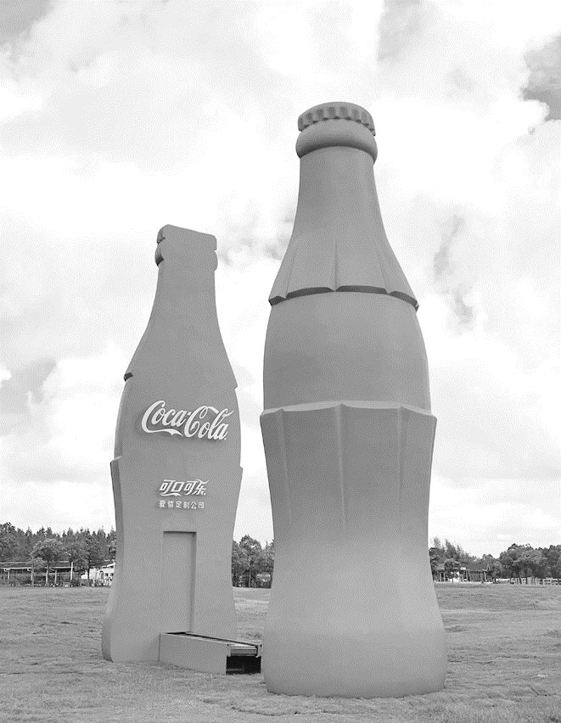
Since 2007, Coca-Cola has been working with the WWF, UNDP and other partners to protect the freshwater resources of the Yangtze River, in which rare species such as pandas, snow leopards, white cranes, porpoises and Chinese dragonflies were bred.Coca-Cola's actions over a decade have effectively contributed to the protection of more than 200，000 hectares of high-ecological value are, as part of the efforts to conserve the biodiversity and communities of 2 million hectares of wetland ecosystems in the basin.
Coca-Cola China has also been working on responsible agriculture.Since 2012, together with the UNDP, Coca-Cola China has helped double the production of sugar cane in Chongzuo, Guangxi Zhuang autonomous region, by establishing an irrigation system for the first time, which uses wastewater byproducts to irrigate the fields.
“The water coming from the sugar processing facility needed to be treated, but once it's treated it can be used，” Goltzman said.“You don't have to withdraw from the ecosystem to water those crops.”
The Coca-Cola Company used a smart “golden triangle” model in all sustainability proposals.The innovative (创新) model gives full play to the advantages and expertise of governments, businesses, nongovernmental organizations and other sectors of society, to meet the increasingly serious environmental challenges, and protect water and biological diversity.
Zhang said, “We act in ways to create a more sustainable and better shared future.Sustainability remains core to what we do.”
【解题导语】 本文介绍了全球饮料领导者可口可乐公司在中国开展了50多个水资源管理项目，为气候变化和生物多样性保护做出贡献一直是该公司当前工作的重点。
1．Which of the following can best describe the Coca-Cola Co.?
A.Peace-conscious. B．Fully-equipped.
C.Earth-friendly. D．Recently-built.
C 解析：推理判断题。根据第一段内容可知，全球饮料领导者可口可乐公司在中国开展了50多个水资源管理项目，为气候变化和生物多样性保护做出贡献一直是该公司当前工作的重点。由此可知，可口可乐公司是环保的。
2．Why is the production of sugar cane in Chongzuo doubled?
A.Processed wastewater byproducts are used.
B.The sugar processing facility is set up.
C.The irrigation system has been changed.
D.The ecosystem has been improved.
A 解析：细节理解题。根据第三段和第四段第一句可知，可口可乐中国通过建立滴灌系统，利用废水副产品灌溉农田，帮助广西壮族自治区崇左市的甘蔗产量翻了一番。
3．What can be learned about “golden triangle” model?
A.It consists of new conservation proposals.
B.It is created by nongovernmental organizations.
C.It is employed to solve the problem of water shortage.
D.It makes the most of social resources to help nature.
D 解析：细节理解题。根据倒数第二段可知，这一创新模式充分发挥了政府、企业、非政府组织和社会各界的优势和专长，充分利用社会资源来帮助大自然。
4．Where can the passage be found?
A.In an essay.
B.In a fashion magazine.
C.In a newspaper.
D.In a biology book.
C 解析：文章出处题。根据第一段以及下文可知，文章主要讲述了全球饮料领导者可口可乐公司在中国开展了50多个水资源管理项目，为气候变化和生物多样性保护做出贡献一直是该公司当前工作的重点。由此可推知，该文应该出现在报纸上。
B
Frustrated by an increase in wild boar(野猪) attacks, officials in Hong Kong used bread to attract and trap some of the animals in a district close to the city, Press reported.Wild boars can be seen frequently along Hong Kong's hiking trails.People often refuse to obey orders from authorities to stop feeding them because they can gather in large groups and pass along diseases.Attacks by wild boars have also become an increasingly common issue.In an attack last week, a wild boar knocked down a police officer and bit his leg before the animal fell from a residential car park and died.
INCLUDEPICTURE "YLX111.TIF" \* MERGEFORMAT 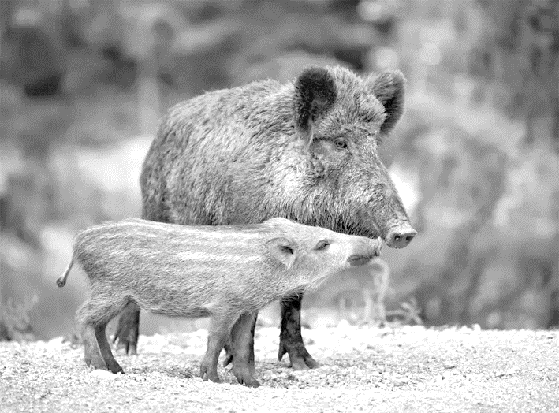
Government data indicates that there are roughly 3，000 wild boars in Hong Kong.They are not a protected species.Though Hong Kong authorities have attempted to naturally cut down the boar population, the Agriculture, Fisheries and Conservation Department said it “could not effectively control the wild boar disturbance.” “A large group of wild boars continued to wander and gather at the site, posing threats to members of the public and road users，” a statement from the department read.
Since the attack on the police officer, Hong Kong Chief Executive Carrie Lam has cautioned that the city could impose more severe punishment against people who continue to feed the boars.“I understand that a lot of Hong Kong people love the wetlands and nature.However, we also need to protect public safety.We can't simply sit__on__our__hands while things worsen，” she added.
Philanthropic group ADM Capital Foundation, the Hong Kong Veterinary Association and other animal rights organizations have since sent an open letter to the government criticizing its shift in policy to kill the boars. A request by groups including Hong Kong Animal Post and Hong Kong Wild Boar Concern Group said that the measures announced by the agriculture department to regularly capture and put down wild boars “ignore their right to live.This approach is extremely unreasonable and contradicts previous animal management policy principles.”
Hong Kong needs legislative reform to deal with the current gaps in existing laws, so that wildlife feeding is an illegal activity, punishment is severe and can be enforced effectively.
【解题导语】 本文是一篇新闻报道。文章主要以“入侵香港的野猪”为话题展开了讨论，并对整治野猪的措施和各方态度进行了陈述。
5．What do you know about the wild boars in Hong Kong?
A.They do not hurt human beings unless they are attacked.
B.They are endangered species with a very small population.
C.If gathering in groups it is easy for them to spread diseases.
D.They are seen frequently close to the city's financial center.
C 解析：细节理解题。根据第一段中的“because they can gather in large groups and pass along diseases”可知，野猪会成群聚集，传播疾病。
6．What does the underlined phrase “sit on our hands” mean in paragraph 3?
A.Keep cautious.
B.See before acting.
C.Take immediate actions.
D.Look on indifferently.
D 解析：词义猜测题。根据画线短语所在句及上文中的“However, we also need to protect public safety.”可知，文章旨在呼吁人们对野猪伤人的行为不能坐视不理，应对其采取行动。由此可推知，画线短语应是“坐视不理；无动于衷”含义，与D项表达含义一致。
7．What is the attitude of some animal rights organizations towards killing the boars?
A.Neutral. B．Worried
C.Favorable. D．Disapproval.
D 解析：观点态度题。根据第四段中的“other animal rights organizations...to kill the boars”以及“ignore their right to live. This approach is extremely unreasonable”可推知，他们不仅仅是担忧而是立场鲜明地坚决反对杀死野猪。
8．What may be the most reasonable measure to take based on the whole passage?
A.Making severe laws to ban wildlife feeding.
B.Naturally cutting down the boar population.
C.Regularly capturing and putting down wild boars.
D.Calling on citizens to keep distance from wild boars.
A 解析：推理判断题。根据尾段内容可知，对喂食野生动物的行为进行严惩才能避免人们因其而导致的自身受伤或被攻击。因此，A项是可采取的最合理的措施。
Ⅱ.完形填空
I once coached volleyball for a group of kids for the Special Olympics.One particular Tuesday night, after warming up, the kids began their __1__. Brian was sitting in the __2__ by himself, as usual, __3__ between watching the other kids and resting his head on his knees.
His family __4__ greatly with what they referred to as his “condition.” __5__， this caused him a lot of anger and sadness.With a __6__ ability to fully understand and deal with the negativity in his life, Brian often __7__ and wouldn't communicate with others.Working with Brian each week, I knew I had to be __8__．
On this particular Tuesday night, as I had done so many times before, I simply told him that we'd love to have him__9__ us, and made my way over to the other kids.
As the volleyball lesson __10__， I saw Brian come out of his corner and was moving closer, __11__ in the fun the other kids were having.Hesitantly, he __12__ me and asked if he could play.On this night, Brian had finally decided to move past his __13__ and take part in the fun.
At the end of that Tuesday night, as I watched Brian and the other kids leave the volleyball court __14__， I knew that I was making at least a small __15__ in these kids' lives.
【解题导语】 本文是一篇记叙文。文章讲述了作者在特殊奥林匹克运动会上担任儿童排球教练时，通过自己的努力帮助一个名叫布莱恩的孩子打开心结，使他融入团体之中的故事。
1．A.discussions B．studies
C.moves D．preparations
C 解析：根据上文“I once coached volleyball for a group of kids for the Special Olympics.”可知，作者担任排球教练，在进行完热身后，孩子们便开始了活动(move)。
2．A.chair B．corner
C.darkness D．crowds
B 解析：根据第四段中的“I saw Brian come out of his corner”可推知，布莱恩应该是喜欢蜷缩在角落(corner)里。
3．A.exploring B．comparing
C.emerging D．alternating
D 解析：根据下文“Brian often ______ and wouldn't communicate with others”可推知，布莱恩不与他人交流，所以在他人进行活动时，他并不参与其中，而是时而看其他孩子，时而把头放在膝盖上休息。alternating意为“交替的”。
4．A.struggled B．competed
C.agreed D．integrated
A 解析：根据上文中“Brian was sitting...his head on his knees.”可知，布莱恩的状态一直不好，不愿与他人交流，可推知，他的家人应该是对其做了很大努力(struggle)。
5．A.Naturally B．Obviously
C.Literally D．Unfortunately
D 解析：根据下文“this caused him a lot of anger and sadness”可知，这给他带来了气愤和悲伤，是不幸(unfortunately)的。
6．A.limited B．unique
C.remarkable D．permanent
A 解析：根据下文“Brian often ____ and wouldn't communicate with others”可知，布莱恩不与他人沟通，因此推断他处理生活消极情绪的能力有限(limited)。
7．A.looked down B．shut down
C.slowed down D．calmed down
B 解析：根据本句中 “wouldn't communicate with others”可知，布莱恩经常沉默寡言(shut down)。
8．A.strict B．accurate
C.patient D．efficient
C 解析：根据上文“With a ______ ability to fully understand...wouldn't communicate with others.”可知，布莱恩的性格很难与他人沟通，并且完全理解和处理生活中的消极情绪的能力有限。所以对他应该有耐心(patient)一些。
9．A.join B．help
C.choose D．support
A 解析：根据上文“Brian often ______and wouldn't communicate with others”可推知，布莱恩不愿意与他人交流，所以此处教练是想让布莱恩加入(join)团体中，不再像之前那样封闭自己。
10．A.ceased B．started
C.suspended D．progressed
D 解析：根据本句中的“As the volleyball lesson”可推知，布莱恩是在排球课进行(progress)中时从角落出来的。
11．A.hidden B．engaged
C.interested D．involved
C 解析：根据下文 “Hesitantly, he ______ me and asked if he could play.” 可知，布莱恩询问作者他是否也能玩。由此可推知，布莱恩也对这个游戏很感兴趣(interested)。
12．A.excited B．hugged
C.approached D．encountered
C 解析：根据上文“I saw Brian come out of his corner and was moving closer”可知，布莱恩离作者有一段距离，此处指他靠近(approach)作者然后再询问作者。
13．A.anger B．fear
C.pride D．doubt
A 解析：根据第二段中的“this caused him a lot of anger and sadness”可推知，布莱恩此时应该已经放下了自己的愤怒(anger)。
14．A.behind B．together
C.fast D．late
B 解析：根据上文“On this night, Brian had finally decided to move past his ______ and take part in the fun.”可知，布莱恩已经能主动融入团体中，与别人开始交流，所以此处应该是布莱恩和其他孩子一同(together)离开排球场。
15．A.contribution B．promise
C.chance D．difference
D 解析：根据文章内容可知，作者通过努力使之前一直不与他人交流、常常坐在角落的布莱恩开始融入团体中，对他的生活产生了影响(make a difference)。
Ⅲ.语法填空
A Second Life for Chopsticks
There are approximately 600 sushi restaurants in Vancouver, 1.____________(consequent) making it the sushi capital of North America.Before the pandemic, over 100, 000 chopsticks and other wooden tools 2.____________(use) once and thrown out every day, according to a 2018 study by Metro Vancouver.In 2016, Felix Bock was 3.____________ 27-year-old young man, studying sustainable construction materials at the University of British Columbia.It was when he was sitting in a sushi restaurant 4.____________ he realized he was holding an underused resource in his own hand. Thus Chop Value was born.
Bock's start-up recycles used wooden chopsticks and 5.____________(transform) them into household objects, from chessboards to bookshelves.The company makes about 30 such products, as well as other custom projects, with each 6.____________(employ) a varying number of chopsticks.So far, the company, 7.____________ products can be found in department stores in other major Canadian cities, has collected and repurposed almost 33 million chopsticks nationwide.The company's reforms don't end there, however. 8.____________(produce) in “micro-factories” with workers that collect chopsticks from local restaurants, Chop Value's items are mainly sold by local 9.____________(businessman).There are three so far in Canada—in Vancouver, Calgary and Montreal—and Bock would like to get to 10 by the end of the year.“We're trying to expand in the 10.____________(fine) way of all times，” he says.“We never want to do things the way they were done before—We're onto something great here, something inspiring.”
【解题导语】 本文是一篇说明文。文章介绍了27岁的年轻人菲力克斯·博克创建公司回收使用的木制筷子，并将它们转变成家庭用品的故事。
1．consequently 解析：考查副词。设空处后为动词，副词修饰动词，设空处应用副词的形式。
2．were used 解析：考查动词的时态、语态和主谓一致。设空处在句中作谓语，和句子的主语chopsticks and other wooden tools之间是被动关系，根据时间状语before the pandemic可知，设空处应为一般过去时的被动语态，且主语为复数，应用were used。
3．a 解析：考查冠词。man为可数名词，此处表示泛指，且27-year-old的发音以辅音音素开头，需用不定冠词a修饰。
4．that 解析：考查固定句型。根据强调句的结构：It is/was＋被强调部分＋that/who＋其他，可知此处强调 when he was sitting in a sushi restaurant，故设空处应用that。
5．transforms 解析：考查动词的时态和主谓一致。设空处在句中作谓语且和and前的谓语“recycles”并列，可知句子的时态为一般现在时，主语为Bock's start-up，为单数形式，应用transforms。
6．employing 解析：考查非谓语动词。此处为“with＋宾语＋宾补”的复合结构，设空处在句中作非谓语，employ和each之间是逻辑上的主动关系，应用现在分词形式。
7．whose 解析：考查定语从句。设空处引导非限制性定语从句，且在句中作products的定语，先行词为the company，应用whose。
8．Produced 解析：考查非谓语动词。设空处在句中作非谓语动词，和句子的逻辑主语Chop Value's items之间是逻辑上的被动关系，应用动词的过去分词形式。
9．businessmen 解析：考查名词复数。设空处前为形容词，设空处应为名词形式，设空处前无限定词修饰，应为复数形式。
10．finest 解析：考查形容词的比较等级。空前为the，可知空处应用形容词的最高级形式。

