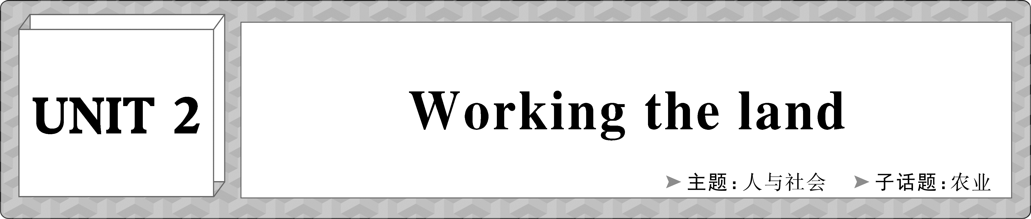
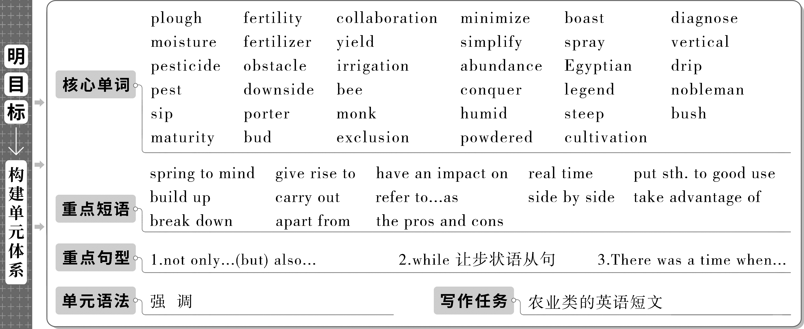
Period 1 Welcome to the unit & Reading
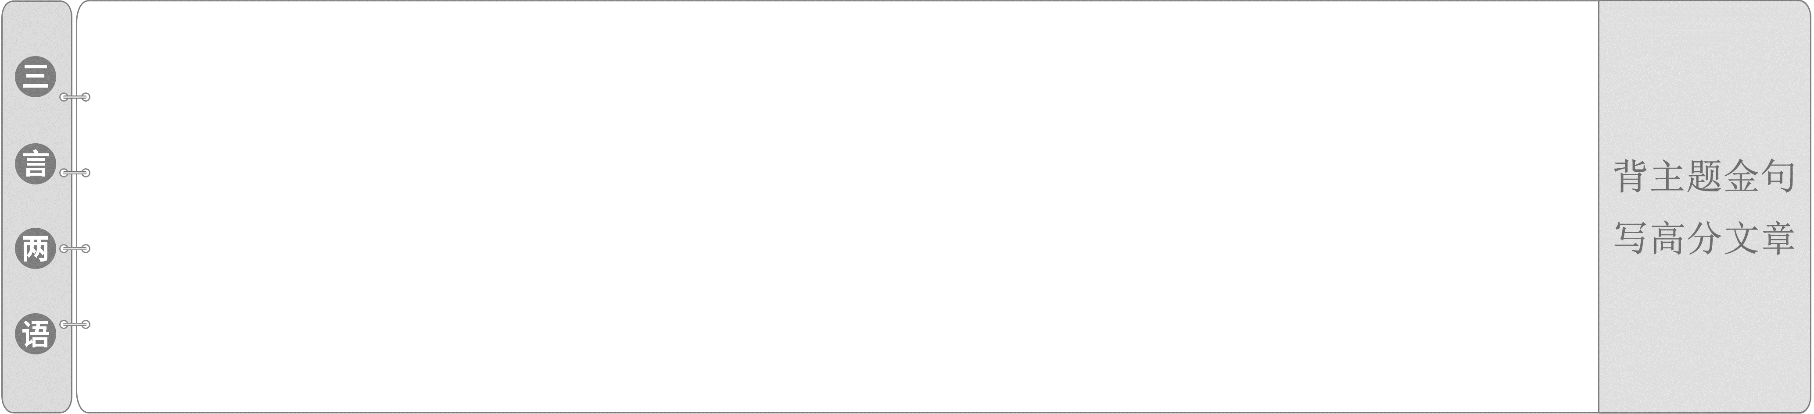
1.We all know no food equals no lives. Therefore, agriculture is of great importance for the lives.
我们都知道没有食物就没有生命。因此，农业对于生命来说至关重要。
2.Besides, buying more organic products is also a practice of going green.
此外，购买更多的有机产品也是一种绿色环保的行为。
Ⅰ.明主旨大意
What is the text mainly about?
A．How precision farming methods are being used to bring great benefits.
B．The role of science and technology in precision farming.
C．How precision farming developed.
D．The prospect of precision agriculture.
答案：A
Ⅱ.知层次结构
Para. | Main idea or Topic sentence
1 | The practice of farming is changing thanks to the development of precision farming.
2 | The advent of modern technology has turned farming into a highly precise industry.
3 | Precision farming boasts a diverse range of application capabilities at different stages of food production.
4 | With the application of artificial intelligence, precision farming can reach a much higher level.
5 | Thanks to precision farming's close relationship with technology, the farming industry's capabilities can develop even further.

Read the text on Pages 16－17 carefully and choose the best answer.
1．What's the purpose of precision farming?
A．To reduce the economic burden of farmers.
B．To improve work efficiency.
C．To save agricultural costs.
D．To improve food production and conserve the environment.
2．Which CANNOT be used to gather information in farming?
A．Satellites. B．Drones.
C．Spacecraft. D．Sensors.
3．Which of the following statements is RIGHT about soil sampling?
A．It will make agricultural production simpler and laborsaving.
B．With it, farmers can create the ideal conditions for crops to grow and manage resources effectively.
C．It can greatly save the cost of agricultural production.
D．It contributes to the prevention and control of crop diseases and insect pests.
4．What can we infer from the last paragraph?
A．Precision farming will benefit the Earth.
B．Precision farming has been brought into full play.
C．Traditional farming methods will no longer exist.
D．The trend of precision agriculture is not clear.
答案：1－4.DCBA
1．The collaboration between farming and technology has given rise to precision farming, an approach that equips farmers with the tools and data they need to make reliable decisions with remarkable accuracy.

本句中名词短语an approach that...作precision farming的同位语；“that equips farmers with...”是定语从句，修饰先行词approach；they need是省略了关系词的定语从句，修饰先行词 the tools and data。
[翻译] 农业与科技之间的合作催生了精准农业，这种方法为农民提供了所需的工具和数据，使他们能够非常准确地做出可靠的决策。
2．As the data library builds up, the big picture of the soil is revealed so that farmers are able to accurately assess the condition of the soil in real time, identify potential problems and work out solutions accordingly.

本句中as引导时间状语从句，so that引导结果状语从句。
[翻译] 随着数据库不断扩充，土壤的整体情况被揭示出来，这样农民就能够准确地实时评估土壤条件，发现潜在的问题，并相应地制订解决方案。
It is the collaboration between farming and technology 1.that has given rise to precision farming, 2.whose aims are to improve food production and conserve the environment by reducing a farm's input and increasing its output.The advent of modern technology has turned farming into a highly precise industry.With massive 3.amounts(amount) of data on the state of their farmland gathered, processed and analysed in real time, farmers are able to give the best possible care to the crops that most need it at the most appropriate time and put their resources to the 4.best(good) use.Precision farming 5.boasts(boast) a diverse range of application capabilities at different stages of food 6.production(produce)．For example, soil sampling makes 7.it possible for farmers to create the ideal conditions for their crops to grow and manage their resources 8.effectively(effective) at the same time.With the application of artificial intelligence, precision farming can reach a much higher level.When 9.used(use) in farming machines, AI does contribute to increased crop yields as well as simplified crop tracking, harvesting and processing.Therefore, the push for future developments in precision farming will benefit all of us—it will contribute 10.to a greener, healthier and betterfed planet.
Ⅰ.核心词汇·练通
根据汉语提示写出正确的单词
1．plough vt.& vi. 犁(田)；耕(地)
n. 犁
2．boast vt.& vi. 有(值得自豪的东西)；
自夸，自吹自擂
3．diagnose vi.& vt. 判断(问题的原因)；诊断(疾病)
4．moisture n. 水分，潮气
5．fertilizer n. 肥料
6．yield n. 产量；产出
vt. 出产(作物)，产生(收益等)
vi. 屈服，让步；变形，弯曲
7．spray vt.& vi. 喷，喷洒；向……扫射(或抛洒)
n. 浪花，水花；喷剂；喷雾器
8．vertical adj. 竖的，垂直的；纵向的
9．pesticide n. 杀虫剂
10．obstacle n. 障碍，阻碍；障碍物，绊脚石
Ⅱ.拓展词汇·用活
根据提示写出相应的单词
1．collaboration n．合作，协作；合作成果→collaborate v．合作，协作
2．minimize vt.使减少到最低限度；降低，贬低；(尤指在计算机屏幕上)使最小化→minimum n．最小值；最少量adj.最小的；最低的
3．simplify vt.使简化，使简易→simple adj.简单的→simply adv.简直；只；不过
Ⅲ.重点短语·再现
根据汉语提示写出合适的短语
1．spring to mind 突然想起
2．give rise to 产生；引起
3．have an impact on 对……有影响
4．put sth. to good use 有效使用
5．build up 建立；逐步增长
6．work out 锻炼；想出；计算出，解出
7．carry out 执行，实行；贯彻
8．large amounts of 大量的
Ⅳ.重点句型·呈现
根据课文语境及汉语提示补全句子
1．强调句型
It is the advent of modern technology that(正是现代技术的出现) has turned farming into a highly precise industry.
2．not only...(but) also...意为“不但……而且……”
For instance, if the soil is found to be poor in nutrients, not only do farmers know that fertilizer is needed, they can also calculate the exact amount(农民不但知道需要施肥了，而且还可以计算出肥料的确切数量)．
3．while引导让步状语从句
While such applications are of enormous benefit(虽然这样的应用有巨大的好处), precision farming can reach a much higher level with the application of artificial intelligence.
[词汇知识过关]
 spring to mind 突然想起
come to mind 突然想到
make up one's mind 下决心；决定
change one's mind 改变主意
read one's mind 看出某人的心思
fix/focus one's mind on... 把注意力放在……上
bear/keep sth.in mind 记住某事
①The first thing that sprang to mind is that visitors to those historic buildings can learn history in a vivid way. 进入脑海的第一件事是古建筑可以让访问它的人生动地了解历史。
②(2019·天津卷)—I guess you want to go play tennis.
—You read my mind. That's exactly what I was thinking too.
——我猜你想去打网球。
——你猜透了我的心思。那就是我正在想着的事情。[练通]——单句语法填空
(1)Encouraged by the speech, the young people made up their minds to take up the struggle.
(2)We should be responsible for the work and keep teamwork spirit in mind.
[写美]——完成句子
(3)结果，我别无选择只好完全投入到我的学习中去，我为此感到非常遗憾。
As a result, I had no choice but to completely fix/focus my mind on my study, for which I am very sorry.
背诵点 | 应用文写作之道歉信

表示“某人突然想起/到……”的其他常用表达：
(1)It hit(s) sb.＋从句
(2)It occurs to/comes to sb.that...
(3)It strikes sb.that...
 approach vt.& vi.靠近，接近；走近；接洽n.方法；接近；通道，路径；建议
(1)an approach to... (做某事的)方法/途径；接近，靠近
at the approach of... 在快到……的时候
(2)be approaching 正在/将要接近
with...approaching 在……快到的时候
①With Mother's Day approaching, I wanted to buy my mother a gift, using my own money.
母亲节快到了，我想用自己的钱给母亲买件礼物。
②All the approaches to the airport were blocked by the police. 通往机场的所有通道都被警察封锁了。
[练通]——单句语法填空
(1)China's approach to protecting(protect) its environment while feeding its citizens offers useful lessons for agriculture and food policymakers worldwide.
(2)Approaching(approach) the vehicle，they saw that a woman was trying to get out of the broken window.
[写美]——句式升级
(3)The time for graduation is approaching and we are busy with our papers.
→At the approach of graduation, we are busy with our papers.(approach n．)
→As the time for graduation is approaching，we are busy with our papers.(as引导时间状语从句)
 put sth. to good use 有效使用
(1)in use 在使用中
out of use 不再使用的
make use of 利用
come into use 开始被使用
be of (no) use 没有用
It is no use doing... 做……没用。
(2)use up 用完
①Have you ever thought about how these things can actually be put to good use?
你有没有想过这些东西怎样才能真正得到很好的利用？
②Once the new technology comes into use, we can improve our system in use.
一旦这项新技术开始被使用，我们就能够改进正在使用的系统。
[练通]——单句语法填空
(1)Seriously damaged, the bridge is no longer in use.
(2)It is no use operating(operate) on this woman.She ought to have been sent here two hours ago.
(3)I have to buy a pet before you use up all the money.
[写美]——同义替换
(4)This medicine is useless to your cold.
→This medicine is of no use to your cold.
 contribute to 有助于；导致
(1)contribute...to...(to为介词)
把……贡献给……；
把(时间等)投入到……；捐款；投稿
(2)contribution n. 贡献；捐献；稿件
make a contribution/contributions to...
对……做出贡献；捐款
①(2021·全国卷乙)Besides, making a schedule is a must, for good time management will contribute to our efficiency.
此外，制定时间表是必须的，因为良好的时间管理将有助于提高我们的效率。
背诵点 | 应用文写作之建议信/演讲稿
②It was generous of her to contribute such a large sum to the charity.
她很慷慨，给慈善机构捐助了这么一大笔钱。
背诵点 | 应用文写作之人物描写
[练通]——单句语法填空
(1)We hope your suggestion will contribute to solving(solve) the problem.
(2)Einstein was awarded the Nobel Prize for his contribution(contribute) to Quantum Theory.
[写美]——完成句子
(3)环境保护从我做起，每个人都能为环保做贡献。
Environmental protection starts with me，and everyone can make a contribution/contributions to the cause．
背诵点 | 应用文写作之环境保护

表示“造成；导致”的常见短语还有bring about、result in、lead to、give rise to、be responsible for等。
 distinguish v．区分；辨别；分清；显示……的差别；使……有所不同
(1)distinguish...from...(distinguish between...and...)
区分……和……
distinguish oneself (as) (作为……而)出名；
使自己出众
(2)distinguished adj. 著名的；卓越的；高贵的
be distinguished for 因……而出名
be distinguished as 作为……而出名
①(2021·浙江卷6月)Dogs may indeed be able to distinguish between happy and angry human faces, according to a new study.
根据一项新的研究，狗可能确实能够区分快乐和愤怒的人脸。
②Over the next few years he was distinguished as a leading constitutional scholar.
在随后的几年中，他作为宪法学的权威学者而享有盛誉。
[练通]——单句语法填空
(1)(2021·浙江卷6月)Nielsen always felt he should be doing comedy but his good looks and distinguished(distinguish) voice kept him busy in dramatic roles.
(2)He distinguished himself as a pianist at the age of 20.
[写美]——句式升级
(3)He was distinguished for his knowledge of economics and was elected as head of the economic school.
→Distinguished for his knowledge of economics, he was elected as head of the economic school.(形容词短语作状语)
[经典句式过关]
“not only...(but) also...”意为“不但……而且……”
(教材P₁₇)For instance, if the soil is found to be poor in nutrients, not only do farmers know that fertilizer is needed, (but) they can also calculate the exact amount.
例如，如果发现土壤养分不足，农民不但知道需要施肥了，而且还可以计算出肥料的确切数量。
not only...(but) also...意为“不但……而且……”，用于连接两个表示并列关系的成分，着重强调后者。
(1)连接两个并列的句子时，若not only位于句首时，not only后面的句子要用部分倒装，but also后面的句子不倒装。
(2)连接的两个成分作主语时，其谓语动词的单复数采取“就近原则”。
①They are not only experienced and knowledgeable, but also patient and understanding.
他们不仅经验丰富、知识渊博，而且有耐心、善解人意。
②Not only do smartphones take up our valuable time, but they also do great harm to our health.
智能手机不仅占用我们宝贵的时间，而且对我们的身体健康非常有害。
[练通]——单句语法填空/补全句子
(1)Not only Tom but also his classmates are(be) coming to visit the museum.
(2)Not only will this opportunity make you happy(这一机会会让你开心)，but it will also satisfy your interest in Chinese operas.
while引导让步状语从句
(教材P₁₇)While such applications are of enormous benefit, precision farming can reach a much higher level with the application of artificial intelligence.
虽然这样的应用有巨大的好处，但通过人工智能的应用，精准农业可以达到更高的水平。
while的用法：
(1)意为“当……的时候”，作从属连词，引导时间状语从句。
(2)意为“然而，而”，作并列连词，表示对比或转折。
(3)意为“虽然，尽管”，作从属连词，引导让步状语从句(从句常置于句首)。
①(2019·全国卷Ⅰ)While the sun's rays can age and harm our skin, they also give us beneficial VitaminD．
阳光虽然会老化和伤害我们的皮肤，但也会给我们提供有益的维生素D。
②(2021·新高考全国卷Ⅰ)While you're in China, Mount Huangshan is a must to visit!
当你在中国的时候，黄山是你必游之地！
背诵点 | 应用文写作之建议信

[练通]——单句语法填空
(1)Some of them spoke pleasantly and were well behaved, while others were impudent and insulting.
(2)He fell asleep while watching(watch) TV.
[写美]——完成句子
(3)尽管我愿意帮忙，但是没有多少时间。
While I am willing to help, I do not have much time available.
Ⅰ.品句填词
1．Farmers have always relied on seasonal workers to plough(耕地) the fields and pick the crops.
2．(2021·全国卷乙)Minimize(降低) the impact of visiting the place.
3．(2019·全国卷Ⅰ)“Boasting(夸耀) about yourself, and your best qualities，” Whaley says, “is very difficult for a child who came into the classroom not feeling confident.”
4．As a researcher, he was devoted to finding an approach to boosting yields(产量) without expanding the area of land.
5．It's good news that the passport application policy has been simplified(简化)．
6．(2021·浙江卷6月)He explained our basic task, the tractor fired up and we were off, riding down the field looking for weeds to spray(喷) with chemicals.
7．Chemical pesticides(杀虫剂) and artificial fertilisers have been in widespread use in farming since the middle of the 20th century.
8．During the process，she overcame a number of obstacles(障碍) in nursing her business to the success it is today.
Ⅱ.完成句子
1．现在不仅约翰和汤姆，而且他们的妹妹玛丽也对钢琴课很感兴趣。
Not only John and Tom but also their sister, Mary, takes great interest in the piano lessons now.
2．最后一点要考虑的是，虽然出国留学确实有潜在的好处，但在中国学习的年轻人也有值得期待的美好未来！
A final point to consider is that while studying abroad does have potential benefits, young people who study in China also have a great future to look forward to!
3．从这次经历中，你应该学会如何分辨是非。
From this experience, you should learn how to distinguish right from wrong．
4．我相信诚实的重要性，这将有助于建设一个温暖和谐的社会。
I am convinced of the importance of honesty, which will contribute to building a warm and harmonious society．
5．随着高考的临近，一些学生变得越来越紧张。
With the college entrance examination approaching, some students are getting more and more nervous.
[过基础 知识巩固]
维度一 品句填词
1．Though some workers are certainly more skilled than others, they are expected not to boast(自夸) about it.
2．When the soil is dry, more moisture(水分) is lost from the plant.
3．(2020·浙江卷7月)New power machinery and artificial fertilizers(化肥) have now totally transformed a way of life that started in the Stone Age.
4．Carmen yielded(屈服) to general pressure and unwillingly took the child to a specialist.
5．I've heard from and talked to many people who described how Mother Nature simplified(简化) their lives for them.
6．For some buildings a vertical(垂直的) section is more informative than a plan.
维度二 固定用法和搭配
1．If any other questions spring to mind，don't hesitate to contact me.
2．These submarine earthquakes sometimes give rise to seismic sea waves.
3．It was years of hard work that has made him successful today.
4．It's important to distinguish reality from dreams in our daily life.
5．At that time, small amounts of land were used(use) for keeping animals.
6．A great decline in young work force is likely to occur in China, for instance.
7．We will be exploring different approaches to gathering(gather) information.
8．The king was at first very unwilling to let him go, but at last yielded to his wish.
9．Having a good knowledge of table manners of China will be of great benefit to you.
维度三 完成句子
1．参观这个剪纸展览，我们不但能欣赏到民间艺术作品，而且会学到很多。
Visiting this papercutting exhibition, we will not only enjoy the folk art works, but also learn a lot．
2．尽管在日常生活中塑料袋给我们带来了很多便利，它们也导致了一种严重的环境污染。
While plastic bags bring us much convenience in our daily life, they also lead to a kind of serious environmental pollution.
3．敢于面对你的问题而不是逃避它们是解决事情的最好办法。
Facing up to your problems rather than running away from them is the best approach to working things out．
4．让生活愉快的不是做我们喜欢的事情，而是喜欢那些我们不得不做的事情。
It's not doing the things we like, but liking the things we have to do that makes life happy.
5．正如研究中提到的，新开发的药物会影响由细菌引起的感染。
As mentioned in the research, it is confirmed that the newlydeveloped drug has an impact on infections caused by bacteria.
[过能力 综合提升]
Ⅰ.阅读理解
A
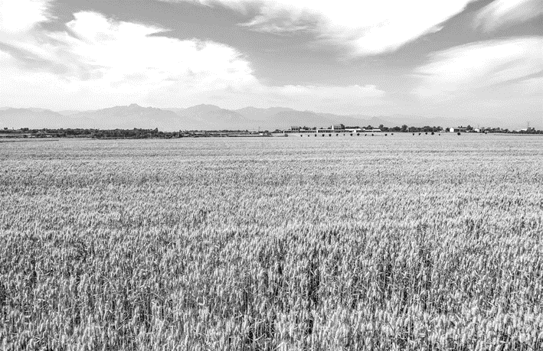
Thirtyfive years ago, with just one acre of land, a couple of seeds and a bucket of hope, one Nigerianborn scientist began his mission to defeat famine (饥荒) on his continent.
News of the drought across Africa in the early 1980s troubled Nzamujo.Equipped with a microbiology PhD and his faith, he travelled back to Africa.There, he found a continent ecologically rich, diverse and capable of producing food.He believes drought wasn't the only reason for widespread hunger, and that sustainability had been left out.
Nzamujo began designing a “zero waste” agriculture system that would not only increase food security, but also help the environment and create jobs.In 1985, he started his sustainable farm “Songhai” in the West African country of Benin.
Nzamajo lives on the farm and constantly updates his techniques.He credits his degrees in science and engineering for Songhai's success.But he also thanks his spiritual and cultural roots, and his father—a driving force in his life who encouraged him to pursue his studies to the highest degree and to use Songhai to share his knowledge.
Songhai has several “ecoliteracy” development programs.They range from 18month training courses for farmerenterprisers, to shorter stays to learn techniques like weeding.People come from all over the world to study Nzamujo's methods.
After seeing success on his first zero waste farm, he expanded throughout Benin and western Africa.Today, the Songhai model is applied across the continent, including Nigeria, Uganda, Sierra Leone and Liberia. Nzamujo says they've trained more than 7，000 farmerenterprisers and more than 30，000 people in total since it began.
Nzamujo believes zero waste agriculture is now steadily tackling the issues he set out to defeat, hunger, unemployment and environmental declines.And he wants to see it go further.
【解题导语】 本文是一篇记叙文。学识渊博且有责任心的Nzamujo博士回到非洲，设计“零浪费”农业系统，创立“松海”农场，帮助那里的人们缓解饥荒问题。
1．Which factor related to famine was unnoticed in Nzamujo's eyes?
A．Poor soil. B．Water shortage.
C．Lack of resources. D．Unsustainability.
D 解析：细节理解题。根据第二段最后一句可知，在Nzamujo看来，可持续性是人们所忽略的造成饥荒的一个原因，换句话说，人们没有注意到农业的不可持续性问题。
2．What does the author intend to do in paragraph 3?
A．Introduce a solution.
B．Give examples to the readers.
C．Add some background information.
D．Summarize the previous paragraphs.
A 解析：推理判断题。根据第三段内容可推知，第三段介绍Nzamujo的解决方案，即“零浪费”农业系统。
3．How does Songhai help to ease the problem of famine?
A．By offering land.
B．By trading seeds.
C．By educating farmers.
D．By selling technology.
C 解析：细节理解题。根据第五段内容可知松海项目通过培训农民来帮助缓解饥荒问题。
4．Which of the following best describes Nzamujo?
A．Critical and careful.
B．Learned and responsible.
C．Optimistic and generous.
D．Considerate and ambitious.
B 解析：推理判断题。根据第二段前两句可知，获得微生物学博士学位的Nzamujo在得知非洲人民遭受饥荒后，带着自己的知识和信仰回到非洲，去帮助那里的人们。由此可推知，Nzamujo不但学识渊博而且有责任心。
B
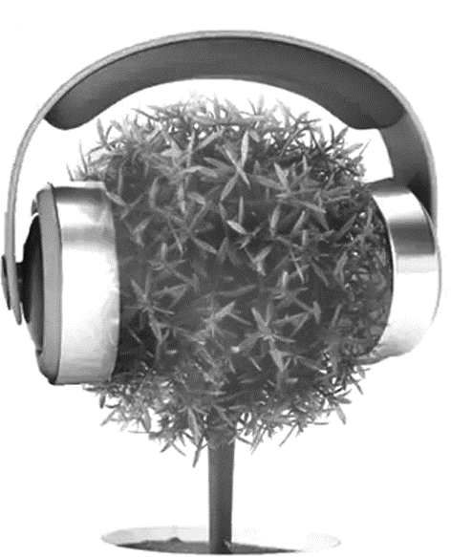
Plants don't have ears or a central nervous system, but new research out of the University of Missouri has demonstrated that they might still have the ability to “hear”．More specifically, plants have been shown to exhibit an immune (免疫) response to the mere sound of a hungry insect.
For the study, researchers played the sound of a caterpillar chewing to a group of plants, which caused slight vibrations (振动) on the plants' leaves.The plants were able to recognize these vibration patterns as danger, and responded by mounting the appropriate immune response.In other words, it appears that plants can “hear” themselves being chewed on.
Researchers assume that plants achieve this remarkable ability thanks to proteins that respond to pressure found within their cell membranes.Vibrations cause pressure changes within the cell, which can change the behavior of the proteins; however, additional study will be required to confirm or deny this theory.
Once researchers identify the exact mechanisms at play in this process, it could lead to advances in crop protection.Farmers could potentially learn to use sound to cause a plant's natural chemical defenses against insect threats, rather than turning to poisonous chemicals.
“We can imagine applications of this where plants could be treated with sound or genetically engineered to respond to certain sounds that would be useful for agriculture，” said study author Heidi Appel.
The study adds to the growing list of ways that plants have been shown to sense their environments.They are not the boring organisms that many people assume they are.For instance, some plants are able to communicate with each other and signal upcoming danger to their neighbors by releasing chemicals into the air.Plants can respond to light (think about sunflowers) and temperature.Some can even respond to touch, such as the Venus flytrap (捕蝇草), which snaps shut when an insect stimulates its hairs.
【解题导语】 本文是一篇说明文。密苏里大学的一项新研究表明，植物可能有“听”的能力，对饥饿昆虫的声音有免疫反应，这项发现可以应用于农业以保护庄稼。
5．Why did researchers carry out the study?
A．To find out if plants can react to sounds.
B．To learn how plants recognize dangers.
C．To discover if plants can shake their leaves.
D．To see how plants improve immune systems.
A 解析：细节理解题。根据第一段第二句及第二段的研究过程可知，这项研究的目的是查明植物对声音是否有反应。
6．What's the potential use of researchers' discovery?
A．To remove insects.
B．To protect crops.
C．To treat plant diseases.
D．To produce chemicals.
B 解析：细节理解题。根据第四段内容可知，研究人员的这一发现的潜在用处是保护庄稼。
7．What does the author intend to tell us in the last paragraph?
A．There are more plants than we know.
B．Plants are more active than we think.
C．Plants fit in well with their environments.
D．Lots of secrets about plants remain unclear.
B 解析：推理判断题。根据最后一段内容可知，植物并不是乏味的生物体，它们能够互相交流，能对自然界作出反应，所以本段想要告诉我们植物比我们想的更加活跃。
8．What can be the best title for the passage?
A．Can Plants “Talk” with Each Other?
B．How Do Plants Make Use of Sounds?
C．Can Plants “Hear” Themselves Being Eaten?
D．How Do Plants Defend Themselves Against Attacks?
C 解析：标题归纳题。通读全文并结合第一段第一句可知，本文主要讲述了一项表明植物可能有“听”的能力的新研究，并讲述了这项发现的潜在应用。故C项“植物能‘听到’自己被吃掉的声音吗”适合作为本文标题。
Ⅱ.完形填空
From the age of eight, I had to contribute my share of labor along with my father.Our family was too 1 to afford paid laborers.Working in the rice fields was no easy job, especially in summer.The 2 sun would beat upon my arched back.With only a hat, a shirt and a pair of shorts as my 3 ， I would be sweating like a pig within seconds.
One day, while resting beside the field, I 4 my present life: My family was tied to land, doing 5 jobs every day.How could we and farmers like us have 6 to a better life? Thinking of this, I was suddenly 7 with great pity and great respect for them, and the focus of my 8 began to extend beyond myself and my family.A voice inside me 9 that I should do something to help that.It was right then that I 10 to pursue useful knowledge and technology to 11 their burden of labour.This undeniable 12 pushed me hard to go to a university on a scholarship and 13 earn a degree on agriculture.
Although now I went into academic research, I would always 14 what working in the rice fields had taught me: Your hard work will be 15 if you plant your feet firmly on the ground, for being downtoearth is an unbroken truth.
【解题导语】 本文是一篇夹叙夹议文。作者年少贫穷，在田间劳作时突然思考起与自己一样的农民的境遇，下定决心学习有用的知识和技术帮助他们。现在，他在进行学术研究，却一直十分珍惜在稻田里耕耘的经验：脚踏实地，苦尽甘来。
1．A.desperate B．wise
C．poor D．proud
C 解析：根据上文中的“contribute my share of labor along with my father”可知，作者年少时家境贫穷(poor)。
2．A.blinding B．amazing
C．rising D．burning
D 解析：根据“especially in summer”和语境可知，作者在田间劳作时，夏季炙热的(burning)太阳刺痛了他弓起的背。
3．A.preference B．protection
C．purchase D．priority
B 解析：根据“With only a hat, a shirt and a pair of shorts”可知，这些装备是保护(protection)自己抵御炙热的太阳的。
4．A.puzzled over B．worried about
C．believed in D．complained about
A 解析：根据“How could we and farmers like us have ______ to a better life？”可知，作者在田野上休息时，对现在的生活陷入了思考(puzzle over)。
5．A.highpaying B．heartbreaking
C．backbreaking D．risktaking
C 解析：根据“tied to land”可知，作者每日的生活都是累人的(backbreaking)。
6．A.reactions B．contributions
C．access D．addiction
C 解析：根据“a better life”可知，作者想知道农民们如何能过上更好的生活。have access to意为“有……的机会”。
7．A.consumed B．provided
C．confused D．troubled
A 解析：根据“with great pity and great respect for them”可知，此处指作者沉思后，突然对农民充满了怜悯和尊敬。be consumed with意为“充满(某种强烈的感情)”。
8．A.career B．schedule
C．interest D．concern
D 解析：根据“to extend beyond myself and my family”可知，作者的关心(concern)开始延伸到自己和家人之外。
9．A.protested B．insisted
C．warned D．predicted
B 解析：根据“A voice inside me ______ that I should do something to help that.”可知，作者内心的声音坚持认为(insist)自己应该有所作为。
10．A.attempted B．promised
C．resolved D．agreed
C 解析：根据“pursue useful knowledge and technology”可知，就在那个时候作者下定决心(resolve)要用知识和技术帮助农民。
11．A.lighten B．quicken
C．distribute D．shoulder
A 解析：根据“their burden of labour”可知，作者下定决心想要为农民减轻(lighten)劳动负担。
12．A.curiosity B．outcome
C．fact D．urge
D 解析：根据空处前两句内容可知，作者下定决心要为同他一样的农民做些什么，因此，这种冲动(urge)促使他上了大学并最终(ultimately)获得农业学位。
13．A.immediately B．ultimately
C．definitely D．rarely
B 解析：参见上题解析。
14．A.treasure B．doubt
C．adopt D．acquire
A 解析：根据语境可知，虽然作者现在在进行学术研究，但他仍然珍惜(treasure)年少时在田间劳作中所获得的经验。
15．A.facilitated B．relieved
C．challenged D．rewarded
D 解析：根据“if you plant your feet firmly on the ground”可知，脚踏实地，就会得到回报(reward)，苦尽甘来。

