Period 1 Welcome to the unit & Reading—Comprehension
INCLUDEPICTURE "F:\\课件2021\\2022课件\\同步英语\\英语译林版选择性必修4\\三言两语A.TIF" \* MERGEFORMATINET INCLUDEPICTURE "F:\\课件2021\\2022课件\\同步英语\\英语译林版选择性必修4\\三言两语A.TIF" \* MERGEFORMATINET INCLUDEPICTURE "F:\\课件2021\\2022课件\\同步英语\\英语译林版选择性必修4\\三言两语A.TIF" \* MERGEFORMATINET INCLUDEPICTURE "F:\\课件2021\\2022课件\\同步英语\\英语译林版选择性必修4\\三言两语A.TIF" \* MERGEFORMATINET
INCLUDEPICTURE "F:\\课件2021\\2022课件\\同步英语\\英语译林版选择性必修4\\TASK1.TIF" \* MERGEFORMATINET INCLUDEPICTURE "F:\\课件2021\\2022课件\\同步英语\\英语译林版选择性必修4\\TASK1.TIF" \* MERGEFORMATINET INCLUDEPICTURE "F:\\课件2021\\2022课件\\同步英语\\英语译林版选择性必修4\\TASK1.TIF" \* MERGEFORMATINET INCLUDEPICTURE "F:\\课件2021\\2022课件\\同步英语\\英语译林版选择性必修4\\TASK1.TIF" \* MERGEFORMATINET
Ⅰ.明主旨大意
What's the main idea of the text?
A．What effective communication is.
B．Why we should make effective communication.
C．How to make effective communication.
D．The benefit of effective communication.
答案：C
Ⅱ.知层次结构
INCLUDEPICTURE "F:\\课件2021\\2022课件\\同步英语\\英语译林版选择性必修4\\YLQ1.TIF" \* MERGEFORMATINET INCLUDEPICTURE "F:\\课件2021\\2022课件\\同步英语\\英语译林版选择性必修4\\YLQ1.TIF" \* MERGEFORMATINET INCLUDEPICTURE "F:\\课件2021\\2022课件\\同步英语\\英语译林版选择性必修4\\YLQ1.TIF" \* MERGEFORMATINET INCLUDEPICTURE "F:\\课件2021\\2022课件\\同步英语\\英语译林版选择性必修4\\YLQ1.TIF" \* MERGEFORMATINET INCLUDEPICTURE "F:\\课件2021\\2022课件\\同步英语\\优化方案 英语 必修第四册（YL）（新教材）（成盘）\\3、教师用书Word\\YLQ1.TIF" \* MERGEFORMATINET 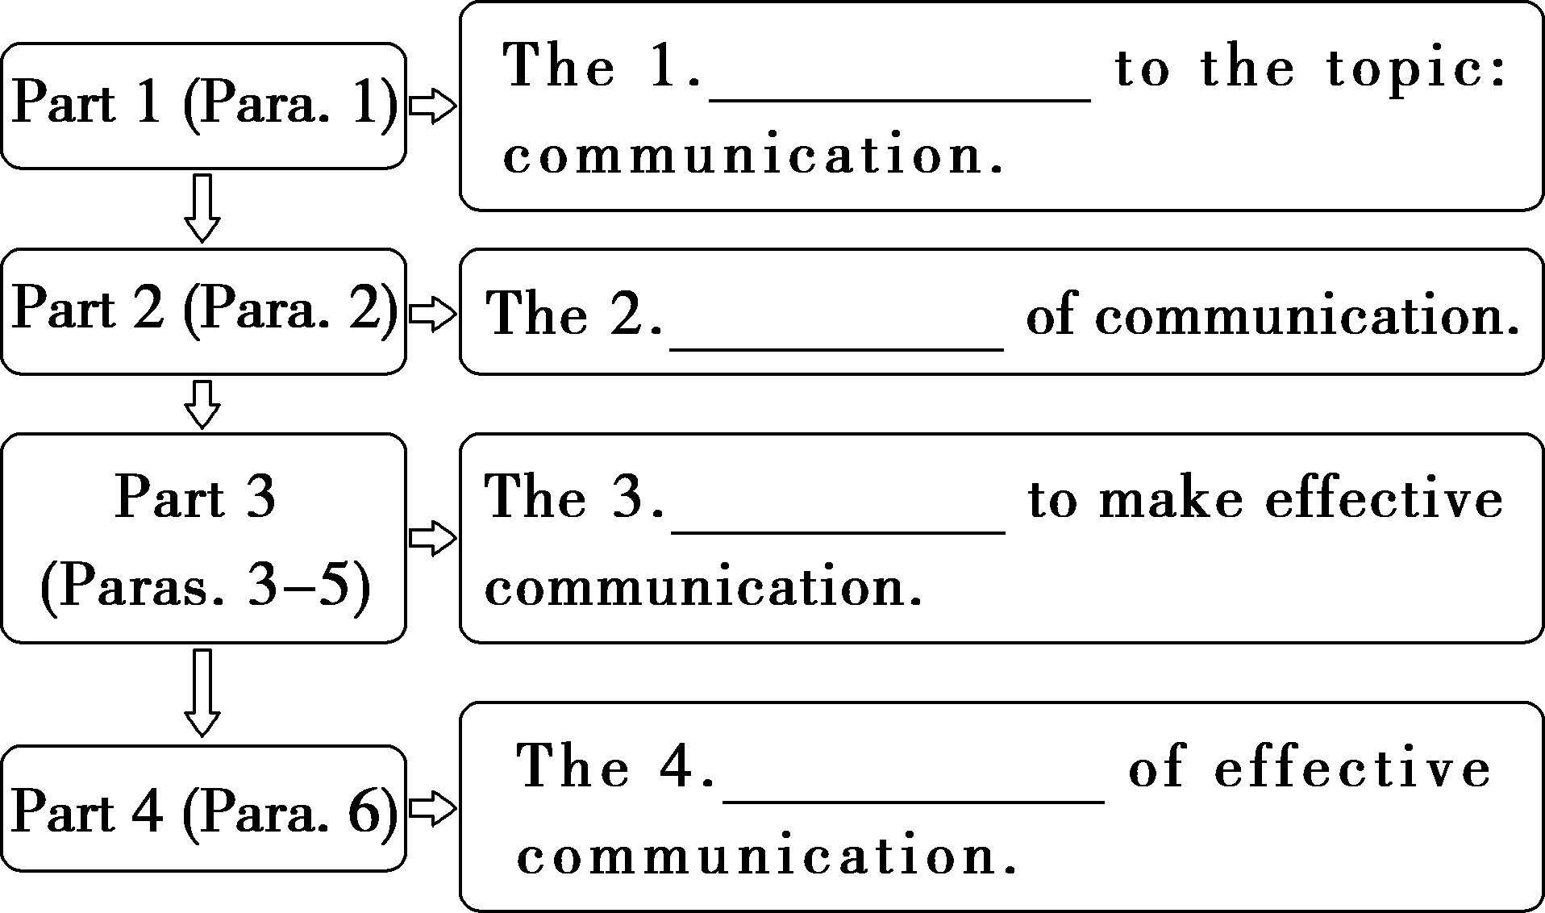
答案：1.introduction 2.definition 3.ways 4.benefits
INCLUDEPICTURE "F:\\课件2021\\2022课件\\同步英语\\英语译林版选择性必修4\\TASK2.TIF" \* MERGEFORMATINET INCLUDEPICTURE "F:\\课件2021\\2022课件\\同步英语\\英语译林版选择性必修4\\TASK2.TIF" \* MERGEFORMATINET INCLUDEPICTURE "F:\\课件2021\\2022课件\\同步英语\\英语译林版选择性必修4\\TASK2.TIF" \* MERGEFORMATINET INCLUDEPICTURE "F:\\课件2021\\2022课件\\同步英语\\英语译林版选择性必修4\\TASK2.TIF" \* MERGEFORMATINET INCLUDEPICTURE "F:\\课件2021\\2022课件\\同步英语\\优化方案 英语 必修第四册（YL）（新教材）（成盘）\\3、教师用书Word\\TASK2.TIF" \* MERGEFORMATINET
细读课文，完成下列各题
1．Which of the following statements is CORRECT according to the text?
A．Communication only depends on the words we use.
B．Communication involves both the information sender and receiver.
C．The communication process is an easy process to handle.
D．You need to choose a communication channel depending on what you want to get.
2．Which of the following is NOT an effective communication?
A.Using the proper communication channel and style depending on who you are communicating with.
B．Pay attention to the other person's body language while communicating.
C．Emphasizing the value of empathy while communicating．
D．Always approving of the other person's ideas when communicating.
3．Why should you pay attention to the other person's body language?
A．It indicates much about your thoughts and attitudes.
B．It gives you clues about if the conversation is going well or not.
C．It's the only way to understand the person's message.
D．It can help you gain the other person's respect.
4．How can you understand the other person's emotions?
A．By tackling differences and disagreements appropriately．
B．By adjusting the way you are communicating accordingly.
C．By putting yourself in their shoes and looking at the situation from their perspective.
D．By making adjustments to your own tone and choice of words.
答案：1－4.BDBC
INCLUDEPICTURE "F:\\课件2021\\2022课件\\同步英语\\英语译林版选择性必修4\\TASK3.TIF" \* MERGEFORMATINET INCLUDEPICTURE "F:\\课件2021\\2022课件\\同步英语\\英语译林版选择性必修4\\TASK3.TIF" \* MERGEFORMATINET INCLUDEPICTURE "F:\\课件2021\\2022课件\\同步英语\\英语译林版选择性必修4\\TASK3.TIF" \* MERGEFORMATINET INCLUDEPICTURE "F:\\课件2021\\2022课件\\同步英语\\英语译林版选择性必修4\\TASK3.TIF" \* MERGEFORMATINET INCLUDEPICTURE "F:\\课件2021\\2022课件\\同步英语\\优化方案 英语 必修第四册（YL）（新教材）（成盘）\\3、教师用书Word\\TASK3.TIF" \* MERGEFORMATINET
1．For example, if you are a business person negotiating with a large enterprise about a deal, you should do it face to face, using formal language in a straightforward manner.

本句是一个复合句，其中if引导条件状语从句；negotiating with a large enterprise about a deal是现在分词短语作定语；face to face、 using formal language和in a straightforward manner分别是名词短语、现在分词短语和介词短语作方式状语。
[翻译] 例如，如果你是一个商人，正与一家大型企业洽谈一笔生意，你应该面对面地使用正式语言，以直截了当的方式进行沟通。
2．A smile shows you are attentive to the issues being discussed, while looking away with your arms folded can indicate disinterest and create distrust or friction.

本句是一个由while连接的并列复合句，while表示对比之意；第一个分句中谓语动词shows后跟省略了关系词的宾语从句；being discussed是现在分词的被动形式作定语修饰the issues; with your arms folded是with复合结构作方式状语。
[翻译] 微笑表明你对正在谈论的问题很关注，而双臂交叉看向别处则表明你不感兴趣，这样会造成不信任或摩擦。
INCLUDEPICTURE "F:\\课件2021\\2022课件\\同步英语\\英语译林版选择性必修4\\TASK4.TIF" \* MERGEFORMATINET INCLUDEPICTURE "F:\\课件2021\\2022课件\\同步英语\\英语译林版选择性必修4\\TASK4.TIF" \* MERGEFORMATINET INCLUDEPICTURE "F:\\课件2021\\2022课件\\同步英语\\英语译林版选择性必修4\\TASK4.TIF" \* MERGEFORMATINET INCLUDEPICTURE "F:\\课件2021\\2022课件\\同步英语\\英语译林版选择性必修4\\TASK4.TIF" \* MERGEFORMATINET INCLUDEPICTURE "F:\\课件2021\\2022课件\\同步英语\\优化方案 英语 必修第四册（YL）（新教材）（成盘）\\3、教师用书Word\\TASK4.TIF" \* MERGEFORMATINET
Communication is the process of exchanging information between a sender 1.and a receiver.They use different means to exchange messages.The communication process is 2.challenging(challenge), but there are several ways to make effective communication.Firstly, change the communication ways and styles according 3.to the communication object.With practice and 4.patience (patient), you can become a 5.highly(high) competent communicator.
Secondly, pay attention to body language, because your body language can reveal a lot about your thoughts and attitudes.6.Additionally(addition), you should not ignore the other person's body language, 7.which will show how the conversation is going.Thirdly, you should emphasize the value of empathy.Try to understand the other person's emotions and in order to make your communication 8.more__effective(effect), express your sympathy to the other communicator.
In 9.conclusion (conclude), good communication skills will help you improve your interactions with others and build trust, gain respect, 10.allowing (allow) relationships to become more positive and productive.

