Period 3 Writing
INCLUDEPICTURE "../../../英语译林选修1/三言两语A3.TIF" \* MERGEFORMAT 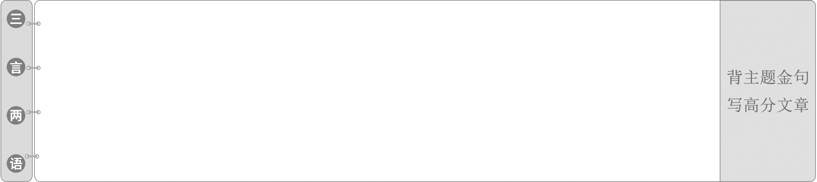
1.Protect rare animals and pay attention to the Earth's ecology.
保护珍稀动物，关注地球生态。
2.The number of wild animals is declining faster than ever before.
野生动物的数量正在以前所未有的速度减少。
3.The government should punish those who do harm to wildlife.
政府应该惩罚那些给野生动植物造成危害的人。
演讲稿
INCLUDEPICTURE "../../../英语译林选修1/集腋成裘LLL.TIF" \* MERGEFORMAT [学生用书P ]
INCLUDEPICTURE "../../../英语译林选修1/写作指导LLL.TIF" \* MERGEFORMAT 
文体感知
演讲稿是一种进行宣传和思想交流的重要方式，写该类文体时应注意：明确演讲对象，观点鲜明，立场明确，不可含糊其辞、模棱两可；同时语言要符合口语的表达习惯，句子不宜过长。
具体写作结构：首段：点明演讲主题；中段：演讲的具体内容；尾段：总结演讲。
增分佳句
1．I feel honored to do sth./It is my honor to do sth.
2．I'm very glad to have the opportunity to make the speech.
3．What I am talking about today is.../The topic of my speech is...
4．What I want to stress/emphasize is...
5．Ladies and gentlemen, I am/feel greatly honored to speak here on behalf of my school/class.
6．It is a great honor for me to make a speech on behalf of...My topic is...
7．Thank you for giving me the opportunity to make a speech about...
8．I'd like to tell you something about...
9．I'm going to talk about something that is vitally important to all of us.
10．Thank you for your listening/attention. I hope you will find what I said/mentioned helpful/useful/practical.
INCLUDEPICTURE "../../../英语译林选修1/高屋建瓴LLL.TIF" \* MERGEFORMAT [学生用书P ]
INCLUDEPICTURE "../../../英语译林选修1/典题精析LLL.TIF" \* MERGEFORMAT 
写作要求
假定你是星光中学的李华，将参加主题为“Let's Ride Bicycles”的英语演讲比赛。请你用英语写一份演讲稿，主要内容包括：
1.目前汽车带来的空气污染和交通堵塞等问题；
2.骑自行车的益处，如节能环保、有利健康等。
注意：1.词数80左右；
2．演讲稿的开头和结尾已给出，不计入总词数。
Good morning, everyone. I am Li Hua from Xingguang Middle School. The topic of my speech is“Let's Ride Bicycles”．
__________________________________________________________________
__________________________________________________________________
__________________________________________________________________
__________________________________________________________________
__________________________________________________________________
__________________________________________________________________
Thank you for your listening!
审题谋篇
第一步：审题构思很关键
INCLUDEPICTURE "../../../英语译林选修1/MP1.TIF" \* MERGEFORMAT 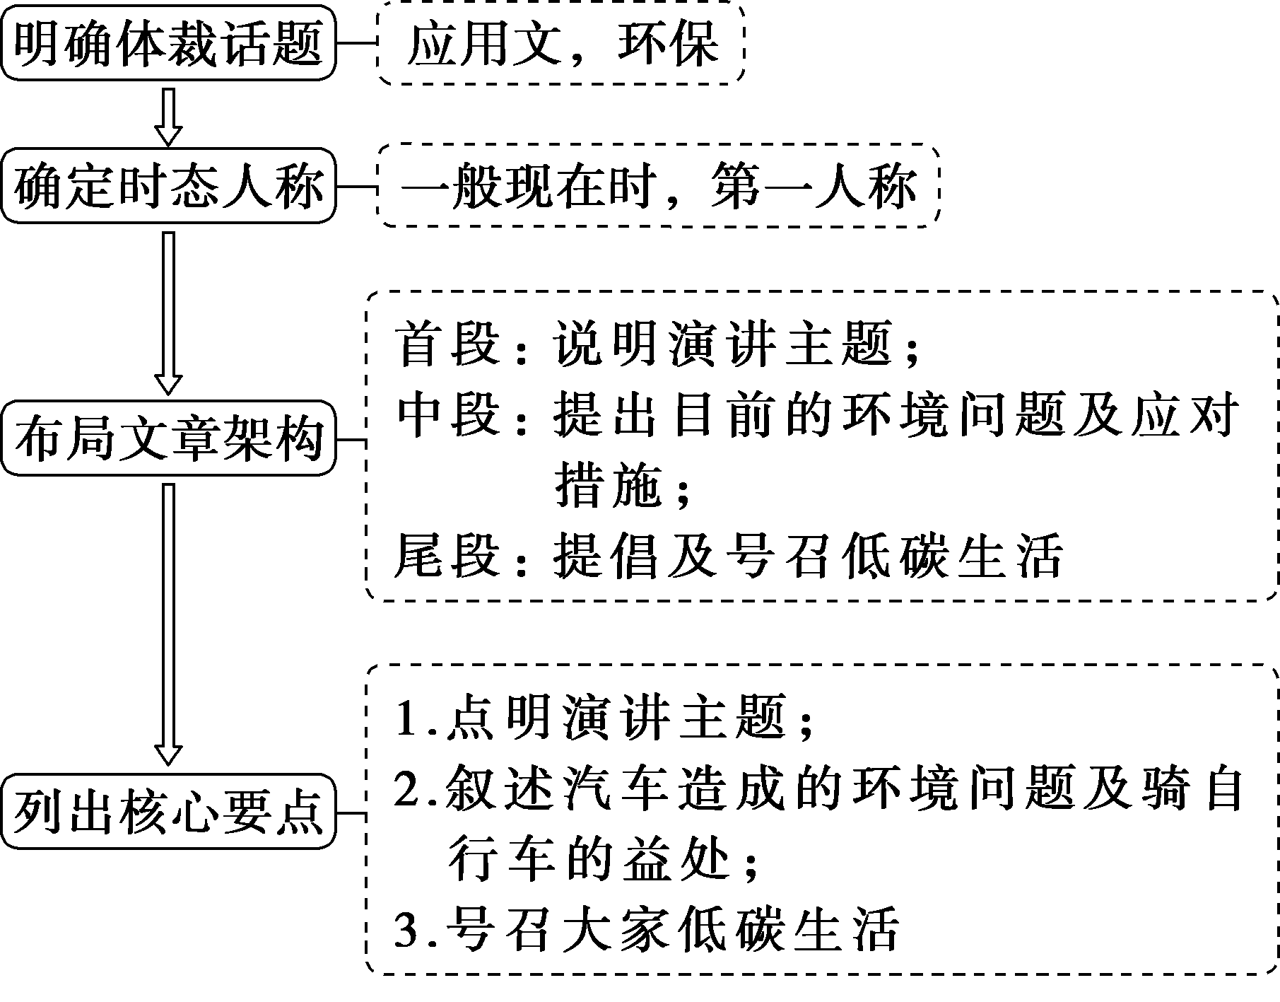
第二步：核心词汇想周全
1．with__the__improvement__of__people's__living__standards
随着人们生活水平的提高
2．as__far__as__I__am__concerned 据我所知
3．for__one__thing...for__another...
一方面……另一方面……
4．energysaving adj. 节能的
5．give__off__waste__gas 排放废气
6．be__beneficial__to 对……有益
7．take__the__responsibility 承担责任
8．lowcarbon adj. 低碳的
第三步：补全句子雏形现
1．众所周知，随着人们生活水平的提高，汽车已经成为一种很受欢迎的交通方式。
It's__known__to__all__that with the improvement of people's living standards, cars have become a popular means of transport.
2．它们还造成了一些问题，如空气污染和交通堵塞。
They have also caused__some__problems such as air pollution and traffic jam.
3．自行车不需要任何汽油，而且节能。
Bicycles don't__need__any__petrol and they are energysaving．
4．骑自行车很环保，因为它们不排放废气。
Bicycles are environmentally__friendly because they don't give__off__waste__gas．
5．骑自行车是我们锻炼身体的好方法，对我们的健康有益。
Riding bicycles is a__good__way__for__us__to__exercise and it is good for our health.
6．让我们承担起骑自行车过低碳生活的责任。
Let's take__the__responsibility__to__live__a__lowcarbon__life by riding bicycles.
第四步：句式升级造亮点
7．用定语从句改写第三步中的句1
As__is__known__to__all,__with__the__improvement__of__people's__living__standards,__cars__have__become__a__popular__means__of__transport.
8．词汇升级第三步中的句5
Riding bicycles is a good way for us to exercise andit__is__beneficial__to__our__health．
第五步：过渡衔接连成篇
______________________________________________________________
______________________________________________________________
______________________________________________________________
______________________________________________________________
______________________________________________________________
______________________________________________________________
______________________________________________________________
One possible version：
Good__morning,__everyone.__I__am__Li__Hua__from__Xingguang__Middle__School.__The__topic__of__my__speech__is__“Let's__Ride__Bicycles”．
As is known to all, with the improvement of people's living standards, cars have become a popular means of transport. However, they have also caused some problems such as air pollution and traffic jam.
How can we solve these problems then? As far as I'm concerned, riding bicycles is a good solution. For one thing, bicycles don't need any petrol and they are energysaving. For another, bicycles are environmentally friendly because they don't give off waste gas. What's more, riding bicycles is a good way for us to exercise and it is beneficial to our health.
Therefore, let's take the responsibility to live a lowcarbon life by riding bicycles. Come on and join us!
Thank__you__for__your__listening!
INCLUDEPICTURE "../../../英语译林选修1/课后巩固LLL.TIF" \* MERGEFORMAT [学生用书P (单独成册)]
Ⅰ.阅读理解
INCLUDEPICTURE "../../../英语译林选修1/YLX13.TIF" \* MERGEFORMAT 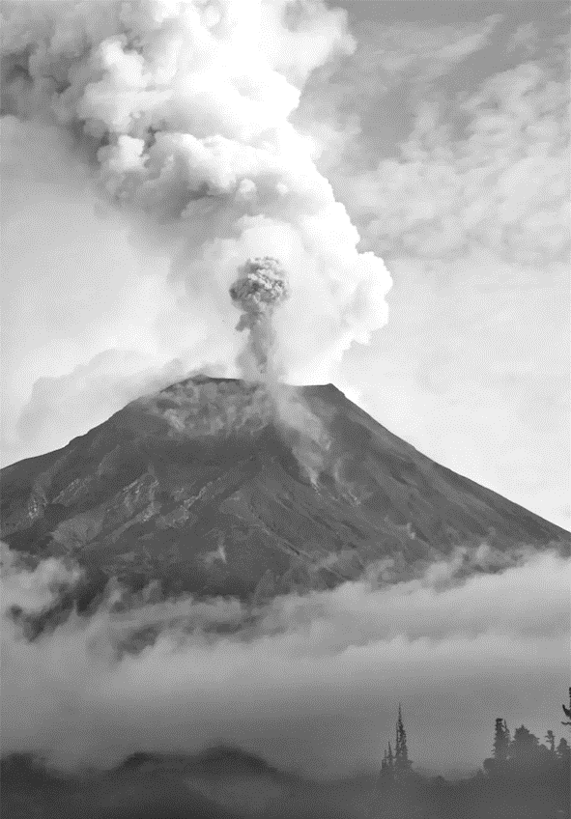
On Friday January 14, 2022, blast was heard 2，000 km away in New Zealand and 3，300 km away in Australia. Boats crashed into a quiet harbor in Southern California, a remote island was battered in Japan by 4foot waves and two women were swept to their deaths on a beach in Peru—some 6，000 miles from an undersea volcanic eruption so powerful that the tsunami which it set off stirred ocean waters halfway across the globe.
But on Sunday, as reports of the volcano's effect crowded in from farflung countries, there was little word from Tonga, the island nation just 40 miles from the site of the extraordinary explosion. As concerns from all over the world grew, the nation of about 100，000 people remained largely cut off from the rest of the world, its undersea internet cables knocked out__of__commission by the volcano.
In Tonga on Sunday, many residents lost not only communication channels but electric power. Up to 80，000 people there could be affected, the International Federation of Red Cross and Red Crescent Societies told the BBC.
New Zealand and other nations in the region pledged to give Tonga aid to recover. But with heavy concentrations of airborne ash making flights impossible, just like the Iceland volcano eruption in 2021, it was difficult even to know what was needed. Ardern, the New Zealand prime minister, said flights over Tonga were planned for Monday or Tuesday, depending on ash conditions.
Tonga has experienced a succession of natural disasters in recent years. In 2018, more than 170 homes were destroyed and two people were killed by Cyclone Gita, a Category 5 tropical storm. In 2020, Cyclone Harold caused about $111 million in damage.
【解题导语】 本文是一篇新闻报道。文章讲述了汤加受到火山喷发的影响而与世界其他地区基本隔绝。
1．Which country wasn't affected by Tanga undersea volcanic eruptions?
A.America. B．Japan.
C.Peru. D．Iceland.
D 解析：细节理解题。根据第一段第二句可知，美国，日本和秘鲁都受到了汤加海底火山爆发的影响，冰岛没有。
2．How much area of the seawater did the volcano stir?
A.20%. B．30%.
C.50%. D．70%.
C 解析：细节理解题。根据第一段中的“an undersea volcanic eruption so powerful that the tsunami which it set off stirred ocean waters halfway across the globe”可知，火山搅动了50%的海水。
3．Which phrase can replace the underlined part “out of commission”？
A.Out of action. B．Out of range.
C.Out of existence. D．Out of account.
A 解析：词义猜测题。根据第二段中的“the nation of about 100，000 people remained largely cut off from the rest of the world”可知，这个国家与世界其他地区基本隔绝了，所以其海底互联网电缆因火山爆发而中断，因此画线部分的意思是“不能使用的”，是out of action。
4．What can be inferred from the passage?
A.The Iceland volcano eruption in 2021 made nearby flights delayed.
B.New Zealand as well as other nations in the region gave Tonga aid timely.
C.Flights could reach Tonga two days after the eruption.
D.The undersea volcanic eruption caused severer damage to Tonga than ever before.
A 解析：推理判断题。根据倒数第二段第二句可推断出，2021年冰岛火山爆发导致附近航班延误。
Ⅱ.七选五
Humans have been known to develop strong connections with dangerous animals. Werner Freund, aged 79, has spent the last 40 years of his life in the company of wolves. While why the former soldier became attached to these beautiful wild animals is a little unclear, he has been caring for them since 1972. 1.________ Thus, Werner has the great ability to survive in the period of entering this group of animals and getting along with these coldblooded creatures.
2．________ They touch him with noses, and play with him. What's more, they are generally very submissive when he is around, just like they would be around a head wolf!
This, however, does not happen by chance. 3.________ Whenever it's feeding time, he calls his pack to come for the raw meat by howling. As the hungry animals rush to get their food, they always meet with this scene. Werner sinks his teeth into the raw meat first.
What may sound a little cruel is how the position of hierarchy (等级制度) is built in the animal world. 4.________ When he signals, the rest of the pack can join in. Werner's wolves know this rule quite well and never challenge his authority.
Wolves, the largest member of the dog family, are mistakenly believed to be dangerous. 5.________ They are beautiful gentle souls, whose reputation has been spoiled by fairy tales like Red Riding Hood!
A.But in reality they rarely attack humans.
B.They are considered as the smartest beasts.
C.Werner works on it with a simple act every day.
D.Werner seems to know where wolves come from.
E.It is always the strongest male that gets the first meal.
F.The wolves treat Werner as if he were one of their own.
G.Army experience leaves him a strong body and energetic state.
【解题导语】 本文是一篇记叙文。文章讲述了老兵维尔纳与狼和谐共处的故事。
1．G 解析：根据空处前后内容可知，空处承上启下，说明以前的从军经历对于与狼一起的生存能力的影响，空前的“former soldier”呼应选项G中的Army experience，空后的“Thus” “the great ability”呼应选项G中的“a strong body and energetic state”。G项符合语境。
2．F 解析：根据空后内容可知，空后的They指代的是F项中提到的wolves，本段最后的“just like they would be around a head wolf”呼应选项F中的“as if he were one of their own”。F项符合语境。
3．C 解析：根据上文“This, however, does not happen by chance.”可知，发生的这件事并非偶然，呼应选项C中的“every day”。C项符合语境，说明并非偶然的原因。
4．E 解析：根据上文内容可知，空前说，动物之中有等级制度，选项E承接上文，继续讲等级制度的具体表现。E项符合语境。
5．A 解析：根据空处前后内容可知，空处与上文形成转折关系，说明其实狼并不是很危险。A项符合语境。
Ⅲ.应用文写作
在成长的过程中，我们总是对未来从事的职业充满憧憬，你们班将以 “My Dream Career”为题举办演讲比赛。请你根据以下要求，写一篇英语演讲稿。要点如下：
1．你的理想职业； 2.选择的理由；3.实现的途径。
注意：1.词数80左右；
2．开头和结尾已给出，不计入总词数；
3．可以根据内容要点适当发挥，使行文连贯。
Good morning, everyone！
______________________________________________________________
______________________________________________________________
______________________________________________________________
______________________________________________________________
______________________________________________________________
______________________________________________________________
______________________________________________________________
______________________________________________________________
Thank you for your listening!
One possible version：
Good__morning,__everyone! Today, please allow me to deliver a brief speech on the career I will take up in the future. Undoubtedly, I have great expectations for the future job as everyone else does. My dream career is to be a tour guide.
Since my early age, I have been admiring tour guides who travel worldwide, enjoying the spectacular scenery, appreciating different cultures and enriching their life experience at the same time. Besides, this career is financially rewarding as well so that I can live a welloff life. Additionally, I will have more opportunities to meet people from all walks of life, which is both challenging and interesting.
To be a good guide is no easy job, for it requires years of arduous practice and continual learning. It is the wide range of knowledge, professionalism and dedication that make a highly qualified tour guide. Therefore, my dream cannot be fulfilled without industrious work to pave the way.
Thank__you__for__your__listening!
Ⅳ.读后续写
阅读下面的材料，根据其内容和所给段落开头语续写两段，使之构成一篇完整的短文。
It was four weeks before New Year, and our youth group wanted to do something together as a New Year project for our community. The concept was great, but none of us seventeenyearolds had any idea what to do.
“Maybe we could have a food drive to help the homeless，” John suggested at our Sunday night meeting. “But we have done that many times，” answered Brian with a frown.
Ten minutes passed without any proposal good enough to win our hearts. Finally I decided to speak. “Why don't we think about our project for a few days and then come back with three or four suggestions we can vote on？” Everyone agreed to wait a week before deciding.
I knew time was running out to get something going before New Year, but I had no clue what we should do. During the following week, one idea after another ran through my mind, but I was still indecisive.
Thursday after school, I wandered into the kitchen as my dad prepared for dinner. Sensing my uneasiness, he asked what troubled me without even looking up. “Well...it...” I let out a long breath. “Our youth group wants to do something for New Year, but we don't know what to do...”
“Hmm.” My dad spoke out loud. “There's a seniors' home I've worked with close to St. Joseph's Hospital. The residents don't get out much around New Year with the snow and ice. It might be an idea to take them out to see the New Year lights around here.”
I stood still for a few moments thinking of all the spectacular (绚丽的) New Year light displays in our neighborhood. To be honest, I never thought about that, but it might just work.
注意：续写词数应为150左右。
Next Sunday evening, our youth group met.___________________________
______________________________________________________________
______________________________________________________________
______________________________________________________________
______________________________________________________________
______________________________________________________________
______________________________________________________________
On New Year's Day, the bus we rented arrived at the seniors' home in the snow.______________________________________________________________
______________________________________________________________
______________________________________________________________
______________________________________________________________
______________________________________________________________
______________________________________________________________
______________________________________________________________
______________________________________________________________
One possible version：
Next Sunday evening, our youth group met. My fellows put forward several suggestions and I also contributed Dad's idea for discussion. To my pleasant surprise, the New Year lights tour won their hearts. We called the seniors' home and they were thrilled about our proposal. The following weeks, we were busy lining up everything for the tour, including the bus to drive the seniors along the planned route.
On New Year's Day, the bus we rented arrived at the seniors' home in the snow. Despite the cold, the snow added a magical white blanket to the neighborhood. All residents slowly found seats on the bus and the tour began. The spectacular light displays lit up their faces and I even saw some eyes filling up. Returning to the seniors' home, they couldn't stop talking about all they'd seen and thanked us again and again. Looking at their excited and grateful faces, we'd never felt warmer.

