Period 2 Grammar
INCLUDEPICTURE "../../../英语译林选修1/三言两语a3.TIF" \* MERGEFORMAT 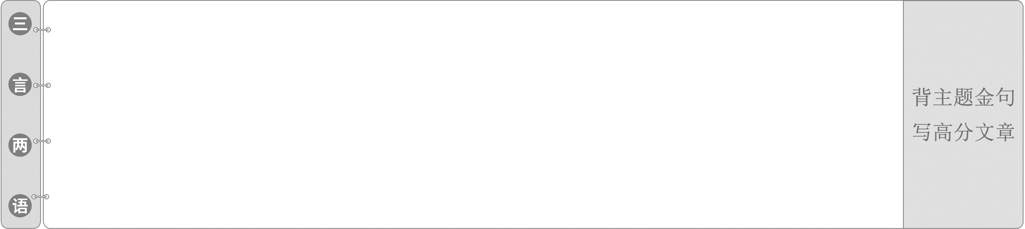
1.With the advancement of technology and development of the times, the exploration of the ocean has entered a new era.
随着科技的进步和时代的发展，对海洋的探索进入了一个新的时代。
2.In 28 years of travelling, Zheng He had managed to share the glory of China with many different countries.
在长达28年的旅行中，郑和成功地与其他很多不同的国家分享了中国的荣耀。
倒 装
INCLUDEPICTURE "../../../英语译林选修1/自主领悟LLL.TIF" \* MERGEFORMAT [学生用书P ]
INCLUDEPICTURE "../../../英语译林选修1/经典例句LLL.TIF" \* MERGEFORMAT 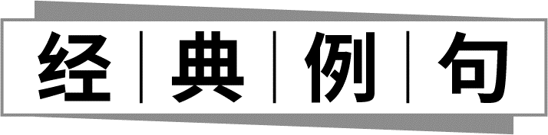
①(教材P₂)Here lives much of the marine life we know about, such as dolphins, corals and seaweeds.
②(教材P₂)Most of the fish living here are small filter feeders which swim up at night to feed in the nutrientrich waters above.
③(教材P₂)Also living in the twilight zone are hunters with telescopic, upwardpointing eyes that can easily spot a meal in the waters above.
④(教材P₃)Of the many strange geological formations to be found here are rock bridges which cross the Trench, some reaching a height of 2，500 metres above the Challenger Deep.
INCLUDEPICTURE "../../../英语译林选修1/语法体悟LLL.TIF" \* MERGEFORMAT 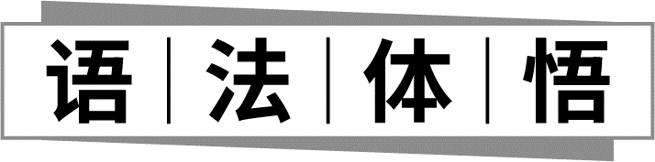
1．当某些副词置于句首且主语为名词时应用全部倒装形式，如句①。
2．为了强调或句子衔接方便有时把表语提前，构成倒装，如句②、③、④。
INCLUDEPICTURE "../../../英语译林选修1/要义详析LLL.TIF" \* MERGEFORMAT [学生用书P ]
英语中主语在前，谓语在后这种语序一般较为固定，为自然语序。但是在一些句子中，由于语法、修辞强调或句子结构的需要，谓语动词置于主语之前，构成倒装语序。
一、全部倒装
将句中的谓语动词全部置于主语之前，为全部倒装。
1．up、down、away、off、in、here、there、now、then、thus等副词置于句首，核心动词常用be、come、go、lie、run、stand、have、fall、happen、occur、remain、rise、follow、exist等。
◆There goes the bell.
铃声响了。
◆Not very long after that, there occurred a sudden fight in the village.
从那以后不久，该村突发了斗殴事件。
◆Here is your letter.
这是你的信。
◆Ahead sat an old gentleman.
前面坐着一个上了年纪的绅士。
2．表示地点的介词短语置于句首，主语是名词时，用全部倒装。
◆On the wall are famous paintings.
＝Famous paintings are on the wall.
在墙上有几张著名的油画。
◆On the stairs was sitting a poor little girl.
一个可怜的小女孩正坐在楼梯上。
INCLUDEPICTURE "../../../英语译林选修1/温馨提示A.tif" \* MERGEFORMAT 
全部倒装结构的主语必须是名词，若主语是人称代词时，不倒装。
◆Here you are. 给你。
◆Away they went. 他们出去了。
[即时演练1]——用倒装完成下列句子
(1)在这一章里能找到部分答案。
In this chapter will__be__found__a__partial__answer．
(2)然后，主席就来了。
Then came__the__chairman．
(3)一枚导弹从轰炸机下面发射出来。
Out rushed__a__missile from under the bomber.
(4)山脚下有一个村庄。
At the foot of the mountain lies__a__village．
二、 部分倒装
将谓语的一部分(如助动词、情态动词)置于主语前构成的倒装为部分倒装。若句中谓语没有助动词、情态动词，则需添加助动词do、does或did，并将其提前；若为系动词，提前即可。
1．否定词置于句首时倒装
常用的否定词有little、few、never、nothing、nowhere、hardly、seldom(很少)、rarely(不常，罕见)、barely(几乎不)、scarcely(决不)、not only...but also...、hardly/scarcely...when/before...(刚刚……就……)、no sooner...than...、never before、not until...、in no way(决不)、at no time(决不)、in no case(无论如何不)、by no means(决不)、on no account(绝不，切莫)、under no circumstances(决不)。
◆Never have I seen such a good performance.
我从来都没见过这么好的表演。
◆Not only was Einstein a worldfamous scientist, but he also was a fairly good violinist.
爱因斯坦不仅是一位世界闻名的科学家，而且还是一位相当不错的小提琴家。
◆Not until the manager arrived did we enter the office.
直到经理来，我们才进办公室。
◆No sooner had I reached home than it began to rain heavily.
我刚到家就开始下大雨。
INCLUDEPICTURE "../../../英语译林选修1/温馨提示A.tif" \* MERGEFORMAT
(1)当not only...but also...连接两个分句时，第一个分句用倒装；当not only...but also...连接两个并列词语时，不用倒装。
◆Not only you but also I am fond of music.
不仅你而且我都喜欢音乐。
(2)not until所在的从句不倒装，倒装的一律是主句。
◆Not until the child fell asleep did the mother leave the room.
直到孩子入睡了，妈妈才离开房间。
2．“only＋状语”置于句首时倒装
“only＋状语”置于句首时句子要用部分倒装。强调主语、宾语，句子不倒装。
◆Only then did I know the truth.
直到那时我才知道真相。
◆Only in this way can you work out this question.
只有用这种方法你才能解决这个问题。
◆Only after his mother came back was he able to go to school.
只有他母亲回来后，他才能够去上学。
INCLUDEPICTURE "../../../英语译林选修1/温馨提示A.tif" \* MERGEFORMAT
only开头，无论何时，都是主句倒装，切勿倒装only开头的时间、条件等状语从句。
3．so、such、neither、nor开头的倒装
so、such用于肯定句，指上文情况也适用；neither、nor用于否定句，指上文的否定情况也适用。
◆She enjoys teaching English. So does my sister.
她喜欢教英语。我姐姐也喜欢。
◆Such are the fortunes of war.
这些就是战争的机会。
◆I don't know where he lives, and neither does she.
我不知道他住哪儿，她也不知道。
INCLUDEPICTURE "../../../英语译林选修1/温馨提示A.tif" \* MERGEFORMAT
(1)当so引出的句子用以对上文内容加以证实或肯定时，不用倒装结构，意为“的确如此”。
(2)当so作代词，代替上述内容时，不用倒装结构，意为“于是做了此事”。
◆Tom asked me to go to play football and so I did.
汤姆喊我一起去踢足球，并且我的确去了。
◆Tom asked me to go to play football and I did so.
汤姆喊我一起去踢足球，于是我去了。
4．as、though引导的让步状语从句
在as引导的让步状语从句中，被突出、强调的部分须前置，即将表语、状语或动词提前。though引导的让步状语从句可前置，也可用正常语序。
◆Child as he is, he can solve the problem.
尽管还是一个孩子，但他能解决这个问题。
◆Much as I like the table, I don't want to buy it.
尽管我很喜欢这张桌子，但我不想买它。
◆Try as he might, he failed to pass the exam.
尽管他尽力了，他还是没能通过考试。
◆Search as they would, they couldn't find the man in the forest.
尽管到处搜查，他们还是没能在森林中找到那个人。
5．so/such...that...句型中的so/such位于句首，so/such后的句子倒装。
◆So frightened was she that she did not dare to move an inch.
她如此害怕，以至于一寸也不敢动。
◆Such an interesting novel is this that I decide to buy it.
这是一本如此有趣的小说以至于我决定买下来。
6．were、had、should等词开头的虚拟条件句中，常省去if把were、had、should放到主语前，构成倒装。
◆If you had asked me, I would have told you everything.
＝Had you asked me, I would have told you everything.
假如你问过我，我就会把一切都告诉你了。
◆If you should change your mind, let me know.
＝Should you change your mind, let me know.
如果你真改变了主意，就告诉我。
7．may放句首表“祝愿，恭贺，希望”等。
◆May you all be happy. 祝你开心。
◆May you long live！ 祝您长寿！
[即时演练2]——把下列句子改为倒装句
(1)Man didn't know what heat is until the early years of the 19th century.
→Not__until__the__early__years__of__the__19th__century__did__man__know__what__heat__is.
(2)The computer was used in teaching. As a result, teachers' energy was not only saved, but students became more interested in the lessons.
→The computer was used in teaching. As a result, not__only__was__teachers'__energy__saved,__but students became more interested in the lessons.
(3)Though he is tallest in my class, he runs slowest yet.
→Tallest__as/though__he__is__in__my__class,__he runs slowest yet.
(4)(2019·天津卷)The professor warned the students that they should on no account use mobile phones in his class.
→The professor warned the students that on__no__account__should__they__use__mobile__phones in his class.
(5)If it were not for the support of the teachers, the student could not overcome her difficulty.
→Were__it__not__for__the__support__of__the__teachers,__the student could not overcome her difficulty.
INCLUDEPICTURE "../../../英语译林选修1/课堂微练LLL.TIF" \* MERGEFORMAT [学生用书P ]
Ⅰ.把下列句子改为倒装句
1．A professor sits in a lecture hall of a university in England.
→In__a__lecture__hall__of__a__university__in__England__sits__a__professor.
2．The children rushed out.
→Out__rushed__the__children.
3．We can learn English well only in this way.
→Only__in__this__way__can__we__learn__English__well.
4．He didn't make a single mistake.
→Not__a__single__mistake__did__he__make.
5．I hardly think it possible to finish the job before dark.
→Hardly__do__I__think__it__possible__to__finish__the__job__before__dark.
6. He didn't fall asleep until 4：00 in the morning.
→Not__until__4：00__in__the__morning__did__he__fall__asleep.
7．He walked so fast that none of us was his equal.
→So__fast__did__he__walk__that__none__of__us__was__his__equal.
8．The days when my heart was young and gay are gone.
→Gone__are__the__days__when__my__heart__was__young__and__gay.
Ⅱ.语法与写作
1．那会儿，什么都没发生。之后大家一起欢呼起来。
For a moment nothing happened.Then__came__voices__all__shouting__together.
2．如果他赶上了早班火车，他开会就不会迟到了。
__Had__he__caught__the__morning__train,__he would not have been late for the meeting.
3．只有当你内心平静时，你才能与他人保持良好的关系。
Only__when you can find peace in your heart will__you__keep__good__relationships__with__others．
4．校长不允许也不考虑改变课程。
The headmaster will not permit the change in the course, and nor/neither__will__he__even__give__it__a__thought．
5．这些游客对那个古镇如此感兴趣以至于他们决定在那里再待几天。
So__interested__in__the__ancient__town__did__the__visitors__get__that they decided to stay there for another few days.
INCLUDEPICTURE "../../../英语译林选修1/课后巩固LLL.TIF" \* MERGEFORMAT
[学生用书P (单独成册)]
维度一 把下列句子改为倒装句
1．They reached a decision only after they had discussed the matter for several hours.
→Only after they had discussed the matter for several hours did__they__reach__a__decision．
2．I had never had such a special drink before!
→Never__before__had__I__had such a special drink!
3．Though she might try, Sue couldn't get the door open.
→Try__as/though__she__might,__Sue couldn't get the door open.
4．I had hardly found the key to the car when my boss came towards me. Finally I could drive him home as usual.
→Hardly__had__I__found__the__key__to__the__car when my boss came towards me. Finally I could drive him home as usual.
5．Hearing the bell ringing, the children rushed out.
→Hearing the bell ringing, out__rushed__the__children．
6．His leg was hurt so seriously in the car accident that he was sent to hospital at once.
→So__seriously__was__his__leg__hurt in the car accident that he was sent to hospital at once.
7．Our team wearing blue suits walk behind the coach.
→Behind__the__coach__walk our team wearing blue suits.
8．If he had studied hard, he would have passed the exam.
→Had__he__studied__hard,__he would have passed the exam.
维度二 语法与写作
1．直到三年前退休，他才考虑去国外度假。
Not__until__he__retired__three__years__ago__did__he__consider__having__a__holiday__abroad.
2．当他到达茶馆时才意识到那是他去年去过的地方。
Only__when__he__reached__the__teahouse__did__he__realize it was the same place he'd been in last year.
3．我们不但应该知道理论，而且我们应该学会如何把理论应用于实践。
Not__only__should__we__know__the__theory,__but also we should learn how to apply it to practice.
4．在山顶上有一座这位老人曾经住过的寺庙。
On__the__top__of__the__hill__stands__a__temple where the old man once lived.
维度三 语法填空
Macao, located on the Pearl River Delta on the southeast coast of China, is a scenic city. Small 1.____________ it is, Macao has a rich history and cultural heritage. Although it is often grouped together with Hong Kong, Macao has its own strange charm. Macao is considered 2.____________(get) its name from AMa Temple, a temple to the Chinese seagoddess Mazu in the 16th century.
Today, the city is classical and modern at the same time. It is a harmonious 3.____________(combine) of Chinese and Western elements. One can enjoy 4.____________(history) attractions such as the Ruins of Saint Paul's and Macao Rose Hall. 5.____________ on the other side of the city stand various grand, luxury hotels, and modern shopping malls, telling you the modern story of Macao. Macao has made improvements in economic development. 6.____________ the past decades, local residents have lived and worked 7.____________(peaceful).
As a worldfamous tourist destination, Macao attracts nearly 40 million inbound tourists every year. It is said to be a place which makes you 8.____________(forget) your age and fatigue and feel so absorbed 9.____________ you won't leave once you're there. The past two decades have witnessed great changes in Macao. Now it is a world center of tourism and leisure and a service platform for business cooperation between China and Portuguese speaking countries. Looking to the future, Macao will continue to move forward together with 10.____________(it) motherland.
【解题导语】 本文是一篇说明文。文章介绍了中国城市澳门，包括名字的由来和城市特色等。
1．as/though 解析：根据句子结构可知，该句为让步状语从句，句子为倒装句，强调表语，将Small提前了，故应用as或though引导从句，意为“虽然，尽管”。
2．to get/to have got 解析：根据句意可知，句中涉及固定短语“be considered to do”，意为“被认为做……”，get意为“得到”，动词词性，不定式符号to后接动词原形，应用to get或不定式的完成式to have done，强调不定式动作发生在谓语动词动作之间，即get的动作发生在consider的动作之前，get的过去分词为got，故空格处也可填to have got。
3．combination 解析：harmonious为形容词，后接名词，combine意为“结合”，动词词性，对应的名词为combination，意为“结合”，根据空格前不定冠词a可知，空格处应用combination的单数形式。
4．historic 解析：attractions为名词，前面应用形容词修饰，history意为“历史”，名词词性，对应的形容词为historic，意为“历史的”，在句中作定语。
5．But/Yet 解析：根据句意可知，上文的“历史名胜”和下文的“大型豪华酒店和现代购物中心”之间为转折关系，故空格处应用连词but或yet连接上下文，表示转折关系，句首单词首字母大写。
6．Over/In/During 解析：句中涉及固定短语“over/in/during the past＋一段时间”，意为“在过去的一段时间里”，故空格处应用介词over/in/during，句首单词首字母大写。
7．peacefully 解析：分析句子可知，worked为动词，后面应用副词修饰，peaceful意为“平静的”，形容词词性，对应的副词为peacefully，意为“平静地”，在句中作状语。
8．forget 解析：分析句子可知，句中涉及固定短语“make sb. do sth.”，意为“让某人做某事”，forget意为“忘记”，动词词性，故空格处应用forget的原形。
9．that 解析：根据句意和句子结构可知，句子为结果状语从句，根据句意可知，应用so...that...引导从句，意为“如此……以至于……”，故空格处应用that。
10．its 解析：分析句子可知，motherland为名词，前面应用形容词性物主代词修饰，it对应的形容词性物主代词为its，意为“它的”。
[学生用书P (单独成册)]
Ⅰ.阅读理解
A
Despite Kyle Tianshi being only a 15yearold US high schooler, he has published five scifi novels. His fifth book Eventide was released in July. However, this may not be his most impressive achievement as Kyle just received the “Hero Award”， a $20, 000 grand prize. It is the top honor in the California Youth Sustainability Awards. The competition aims to encourage and support young community leaders who are making a difference for sustainability in their communities by taking action for the planet.
Kyle, a sophomore from the Cambridge School in the US, received the honor for his portable invention called NEREID. The device can detect microscopic particles (粒子) in water by using a laser and microscope. These particles can be harmful to people and the environment.
Kyle came up with the idea for the invention based on his experience growing up in San Diego, California, US. People had no access to unpolluted drinking water and his parents asked him not to drink tap water. Kyle spent about $60 buying the tools needed to analyze the tap water: a laser, a microscope and a microcomputer. “It's incredibly powerful for the price，” Kyle said. Then he used their family's garage as his laboratory, doing research on the pollution of drinking water caused by microplastics.
Kyle hopes to bring to market a lowcost alternative tool for detecting microplastic pollution levels in drinking water. In this way, he can offer help to people who don't have access to water filtration (过滤) systems. He has applied for a patent.
Kyle said his sister Emily, a freshman at Stanford University, inspired his interest in environmental research. She was recognized nationally for developing a water collection device. They have founded the Clearwater Innovation program to advocate for clean water through social media platforms and organize community cleanup events.
【解题导语】 本文是一篇记叙文。文章讲述了15岁的凯尔发明了检测水中有害的微观粒子的设备，获得了加州青年可持续发展奖的最高荣誉。
1．What do we know about Kyle?
A.He is good at adapting scifi works.
B.He entered many novel contests.
C.He received an award for his invention.
D.He's found microscopic particles in water.
C 解析：细节理解题。根据第二段第一句“Kyle, a sophomore from the Cambridge School in the US, received the honor for his portable invention called NEREID.”可知，凯尔因他的发明而获奖。
2．What led to Kyle's creation of NEREID?
A.People's lack of clean drinking water.
B.People's poor living conditions.
C.His desire to be a community leader.
D.His family's encouragement.
A 解析：细节理解题。根据第三段前两句可知，凯尔发明NEREID是由于人们缺乏干净的饮用水。
3．Which of the following best describes Kyle?
A.Considerate and brave.
B.Optimistic and honest.
C.Determined and humorous.
D.Responsible and creative.
D 解析：推理判断题。根据文章内容可知，凯尔发明NEREID，使人们能够喝到干净的饮用水，并通过实际行动倡导清洁用水，保护环境，因此他有责任心且有创意。
4．What's the passage mainly about?
A.The introduction of NEREID.
B.A boy's contribution to literature.
C.The harm of polluted water.
D.A US schooler's water solution.
D 解析：主旨大意题。通读全文可知，文章讲述了15岁的凯尔发明了检测水中有害的微观粒子的设备，使人们能够喝到干净的饮用水，还创立清水创新项目，倡导清洁用水，故D项“一位美国学生对于水的解决方案”能够概括文章大意。
B
INCLUDEPICTURE "../../../英语译林选修1/YLX12.TIF" \* MERGEFORMAT 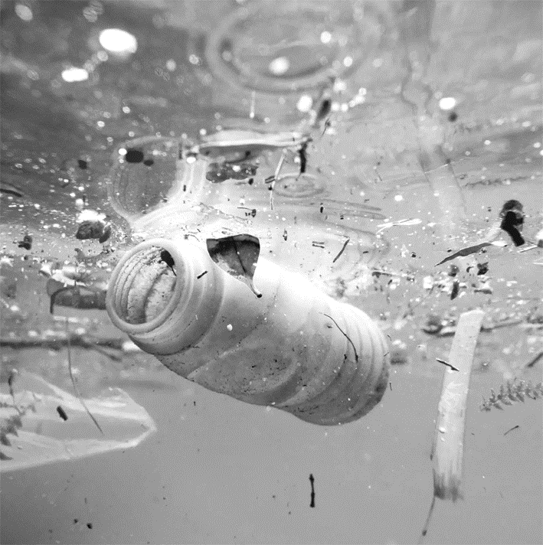
Scientists have come up with a new way to measure ocean trash (垃圾) and the numbers are even worse than thought. In 2010, eight million tons of plastic trash ended up in the ocean from coastal countries far more than the trash floating on the surface of the ocean. That's bad news. The even worse news is that the tonnage may increase by as much as ten times in the next decade unless the world finds a better way to improve how trash is collected and managed.
The new study identifies the major sources of plastic trash and names the top 20 countries producing the greatest amount of ocean trash. The United States is 20th. The rest of the list includes 11 Asian countries, Turkey, five African countries, and Brazil.
The size of the difference is huge—20 to 2，000 times more than the amount of floating trash. To make the figure eight million tons understandable, Jenna Jambeck, who led the study, compares it to lining up five grocery bags of trash on every foot of coastline around the globe. “And by 2025, those five grocery bags of plastic are going to be ten bags，” she says. That would be 155 million tons a year if present trash management practices remain the same.
Ocean plastic has turned up everywhere. It has been found in the deep sea and buried in Arctic ice with terrible consequences for some 700 species of wildlife in the ocean.
The study has also created a new mystery. Because what flows into the ocean is so large, scientists now have to figure out where else it collects and in what amounts. “But what we need to do now is close the__gap，” says Richard Thompson, a scientist from the U．K.
【解题导语】 本文是一篇说明文。文章介绍了科学家们想出了一种测量海洋垃圾的新方法，测试结果比想象的还要糟糕。科学家们通过研究发现了塑料垃圾的主要来源，并且科学家们现在必须弄清楚塑料垃圾还能从哪里收集，收集多少。
5．What is the most serious problem concerning ocean trash?
A.There is no way to get rid of it.
B.Eight million tons of trash go into the ocean.
C.A lot more trash may be put into the ocean in the future.
D.The way to measure ocean trash hasn't been found.
C 解析：细节理解题。根据第一段最后一句可知，最令人担忧的问题是将来垃圾的数量还可能会增加。
6．How does Jenna Jambeck explain the seriousness of ocean trash?
A.By showing the causes.
B.By describing a process.
C.By making comparisons.
D.By making a classification.
C 解析：推理判断题。根据第三段第二句可知，詹娜·詹贝克是通过做对比的方法来说明垃圾数量的严重性。
7．The underlined part “the gap” in the last paragraph refers to the difference between ________．
A.what is harmless and what is dangerous
B.what is on the surface and what is in the deep sea
C.what is found and what can be recycled
D.what is from America and what is from other countries
B 解析：词义猜测题。根据最后一段第二句可知，此处的where包括海洋表面和海底，所以the gap指的就是“海洋表面和海底”垃圾数量的差异。
8．Which of the following can best describe the author's tone in writing the passage?
A.Doubtful. B．Hopeless.
C.Critical. D．Concerned.
D 解析：推理判断题。根据文中作者描述的数据以及尤其是两位科学家说的话可知，作者对于海洋垃圾增加还是非常关心的。
Ⅱ.七选五
What's better: private school vs public school? Choosing which school to send your children to can be a very hard decision to make. 1.________
Ask about testing scores. Students at private schools tend to outscore public school students on standardized tests, which can affect your child's ability to get into college. 2.________ Researchers have used the same data to come to conflicting conclusions. Other factors like socioeconomic status, can influence students' scores, regardless of where they are educated.
3．________ In general, public schools tend to have larger class sizes than private schools. If you need a school that can give more attention to individual students, you might consider a private school or a smaller public school.
Tour the school. Before you even begin to choose between a public or private one, you'll need to schedule a tour of the school you're interested in. Do the students look happy and engaged? Are the learning spaces bright and clean? 4.________ Taking your children along gives them the chance to see the school and decide if it feels like a comfortable environment to them.
Don't put too much stock in online ratings. 5.________ But they could also have fantastic teachers and principals. Talking to others helps you figure out if this is true. Therefore, don't write a school off just because its ratings are a little low.
In a word, knowing what matters to you in terms of the differences between public and private education can make your decision a little easier.
A.The final decision is yours.
B.Take into account class size.
C.Some practical actions can help a lot.
D.However, there is some debate about this.
E.You can learn a lot about these when you visit.
F.Same schools might have unfavorable comments.
G.Decide how important private schools are to your child.
【解题导语】 本文是一篇说明文。文章介绍了公立学校和私立学校之间的一些差异，以及在选择公立学校和私立学校上的一些建议。
1．C 解析：上文指出，在公立学校和私立学校做选择是一件困难的事，下文“Ask about testing scores.”以及“Tour the school.”提出了一些辅助选择的实际行动。C项“Some practical actions can help a lot.”承上启下，符合文意。
2．D 解析：空前内容指出，私立学校的学生成绩较高，可能会对学生考大学造成影响，下文内容说明，上私立学校不是学生取得好成绩的决定性因素，也不是影响学生考大学的唯一因素。D项“However, there is some debate about this.”承上启下，符合文意。
3．B 解析：下文介绍了公立学校和私立学校不同的班级规模，针对学生家长的需求给出了具体的选择建议。B项“Take into account class size. (考虑班级规模)”引出下文，符合段意。
4．E 解析：空前内容建议读者在为孩子选择学校前先考查一下学校，带着一些问题去思考该学校是否合适。E项“You can learn a lot about these when you visit.”承接上文，符合文意。
5．F 解析：上文内容指出，关于学校的网络评价不可尽信，通过下文内容可推知，此处与设空处呈转折关系，指的是有些学校的网络评价可能不好，但是他们可能并不像网上说的那样。F项“Same schools might have unfavorable comments.”承上启下，符合文意。
Ⅲ.语法填空
At 1.____________ Tokyo Olympic Games, Chinese Olympic athletes made great 2.____________(achievement). However, tired 3.____________ some Chinese Olympic athletes are, they have to go on 4.____________(work). They take another profession—teaching at university.
A photo of the course schedule 5.____________(discuss) on the Internet said that Lang Ping would become a college teacher after she resigned as the head coach of the Chinese women's volleyball team. Recently the incident 6.____________(confirm) by Beijing Normal University where Lang Ping was once a student. She once said: “I wish I 7.____________(give) back to my alma mater (母校) as a teacher”， which makes people feel 8.____________(extreme) heartwarming. Some people joked that Lang Ping, 9.____________ title, iron hammer, was not just a casual call, would be the 10.____________(fierce) teacher.
【解题导语】 本文是一篇说明文。本文介绍了郎平在卸任中国女排主教练之后将到北师大任教的事情。
1．the 解析：the Tokyo Olympic Games为专有名词，指“东京奥运会”，前面需要用定冠词the。
2．achievements 解析：因为主语Chinese Olympic athletes是可数名词复数，他们的“成就”也应用复数形式。
3．as/though 解析：as在引导让步状语从句时，句子必须使用倒装结构，将此处的形容词tired提前，构成形式上的倒装句；though在引导让步状语从句时，句子可以使用倒装结构也可以不用。
4．to work 解析：go on to do意为“继续做另外一件事”，go on doing意为“继续做同一件事”；根据下文“They take another profession—teaching at university.”可知，奥运运动员要继续做另外一件事，用go on to do结构。
5．discussed 解析：discuss在句中作后置定语修饰名词photo，且与photo之间为被动关系，意为“被讨论的”，应用过去分词形式。
6．has been confirmed 解析：根据本句中的Recently，可知，时态为现在完成时。同时，根据confirm与句子主语incident的关系，应用被动语态。has been confirmed意为“已经被证实了”。
7．would/could give 解析：动词wish后面的宾语从句表示的是将来的愿望，应用would give或者could give。
8．extremely 解析：此处用副词修饰后面的形容词heartwarming。
9．whose 解析：分析句子可知，空后是定语从句，修饰先行词Lang Ping，先行词在定语从句中作定语，修饰名词title，意为“她的头衔”，应用表示所属关系的关系代词引导该定语从句。
10．fiercest 解析：空前为形容词最高级的提示词the, fiercest意为“最严厉的”。

