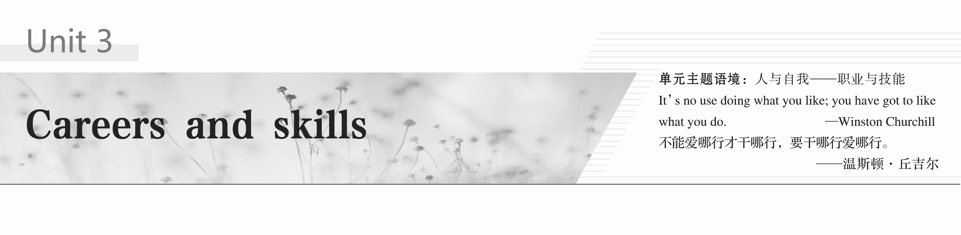

### 类文赏读　话题导入

**Meet the New Boss**：**You**

Up until the 1980s，people in many countries regularly **followed in their parents’ footsteps**1 by working in the family business or joining the same profession as them.You’d follow your father to sea，onto the farm or into the workshop.You’d follow your mother into the kitchen or sewing room.In your grandparents’ time，there was the **prospect**2 of doing the same job from graduation until retirement.How times have changed! Most people now have no intention of following in their parents’ footsteps or even staying at one job for very long.

In fact，planning to work in the same field or industry for your entire working life just isn’t practical anymore.One reason for this is technology.The skills you have now are unlikely to remain relevant and be enough to help you through your entire career.In fact，they will probably be out of date very soon.And then what will you do？Work hard？Win the lottery？Hope for the best？You might be lucky.These strategies might bring you a nice，comfortable life：working at a job you like，earning a decent salary and retiring while you’re still young and healthy.But most of us today have to look beyond the little box called “career”．

If you think you can work eight hours a day and build a career，think again.You might be able to keep your job if you finish what you are asked to do，but this is hardly a recipe for great career success.Instead，you’d better keep looking for smarter ways to do your work.You’ll need to be a risk taker，an **innovator**3，a problem solver，and a hard worker.Keep doing this，and you can become an expert or a specialist in something one day.You have a chance to choose to build a career，rather than being told to stay or to go.

Jobs and **occupations**4 come and go at an amazing pace these days.If you think you can’t be replaced by software，or your job can’t be outsourced to some robots on the moon，you are wrong.What if your job disappears after working for 10 years in the field？You may have to go back to the classroom and be retrained in order to **qualify**5 to work in another field.In fact，in all **likelihood**6，you will have to do this multiple times.But you can be prepared for developments and changes before you are thrown out of a career.It is entirely your choice to learn，or to be forced to learn.

In short，if you want to succeed in a 21st century career，you will have to develop new essential skills.Lifetime security from one employer is no longer certain or even likely.The truth is that you are the boss of your career，and it is up to you to decide what you can do and how well you can do it.Are you ready for this？(选自北师大版新教材选择性必修第三册**UNIT 7**)



1．follow in one’s footsteps继承某人的事业，步某人的后尘

2．prospect /'prɒspekt/ *n*．可能性，希望

3．innovator /'ɪnəveɪtə/ *n*．革新者，创新者

4．occupation /ˌɒkjə'peɪʃən/ *n*．工作，职业

5．qualify /'kwɒlɪfaɪ/ *vi*.& *vt*.(使)有资格，有权利；取得资格，达到标准

6．likelihood /'laɪklihʊd/ *n*．可能，可能性



1．The skills you have now are unlikely to remain relevant and be enough to help you through your entire career.

你现在拥有的工作技能不可能一直有用，也不足以支撑你的整个职业生涯。

[句式分析]　you have now为省略了关系代词that/which的定语从句，修饰先行词The skills。

2．The truth is that you are the boss of your career，and it is up to you to decide what you can do and how well you can do it.

实际上，你才是自己职业生涯的老板，也只有你才能决定自己能做什么、能做多好。

[句式分析]　that引导表语从句；what和how引导的从句作decide的宾语。

## Period One　Welcome to the unit & Reading—Comprehending

**Learning Aims**(学习目标)

1．Learn some new words

2．Grasp the general idea of the passage(重点难点)

3．Learn some important sentences(重点难点)



阅读下列课文原句，写出句中加黑词汇的汉语意思

1．Some might say that we work because we have to，not least because we need the **salary** that enables us to be financially independent.薪金，薪水

2．Yang Liwei，for example，driven by his **passion** for flying，became a pilot and then China’s first astronaut in space.酷爱

3．Twenty years ago，positions in social technologies or energy efficiency did not even exist，and it is difficult to **anticipate** the new positions which will emerge twenty years from now.

预计(并做准备)；预料

4．In a successful，stable and productive society，all jobs are equally important and no one is **superior** to another，so we should not have **prejudice** against any of them.

好的，占优势的　偏见，成见

5．Whether we are scientists，lawyers，doctors，**public servants**，consultants，clerks，**receptionists** or butchers，we all make our **respective** contributions.

公务员，公职人员　接待员　分别的，各自的



**Task 1**　宏观架构　整体理解

Ⅰ.Read the passage quickly and then fill in the blanks.

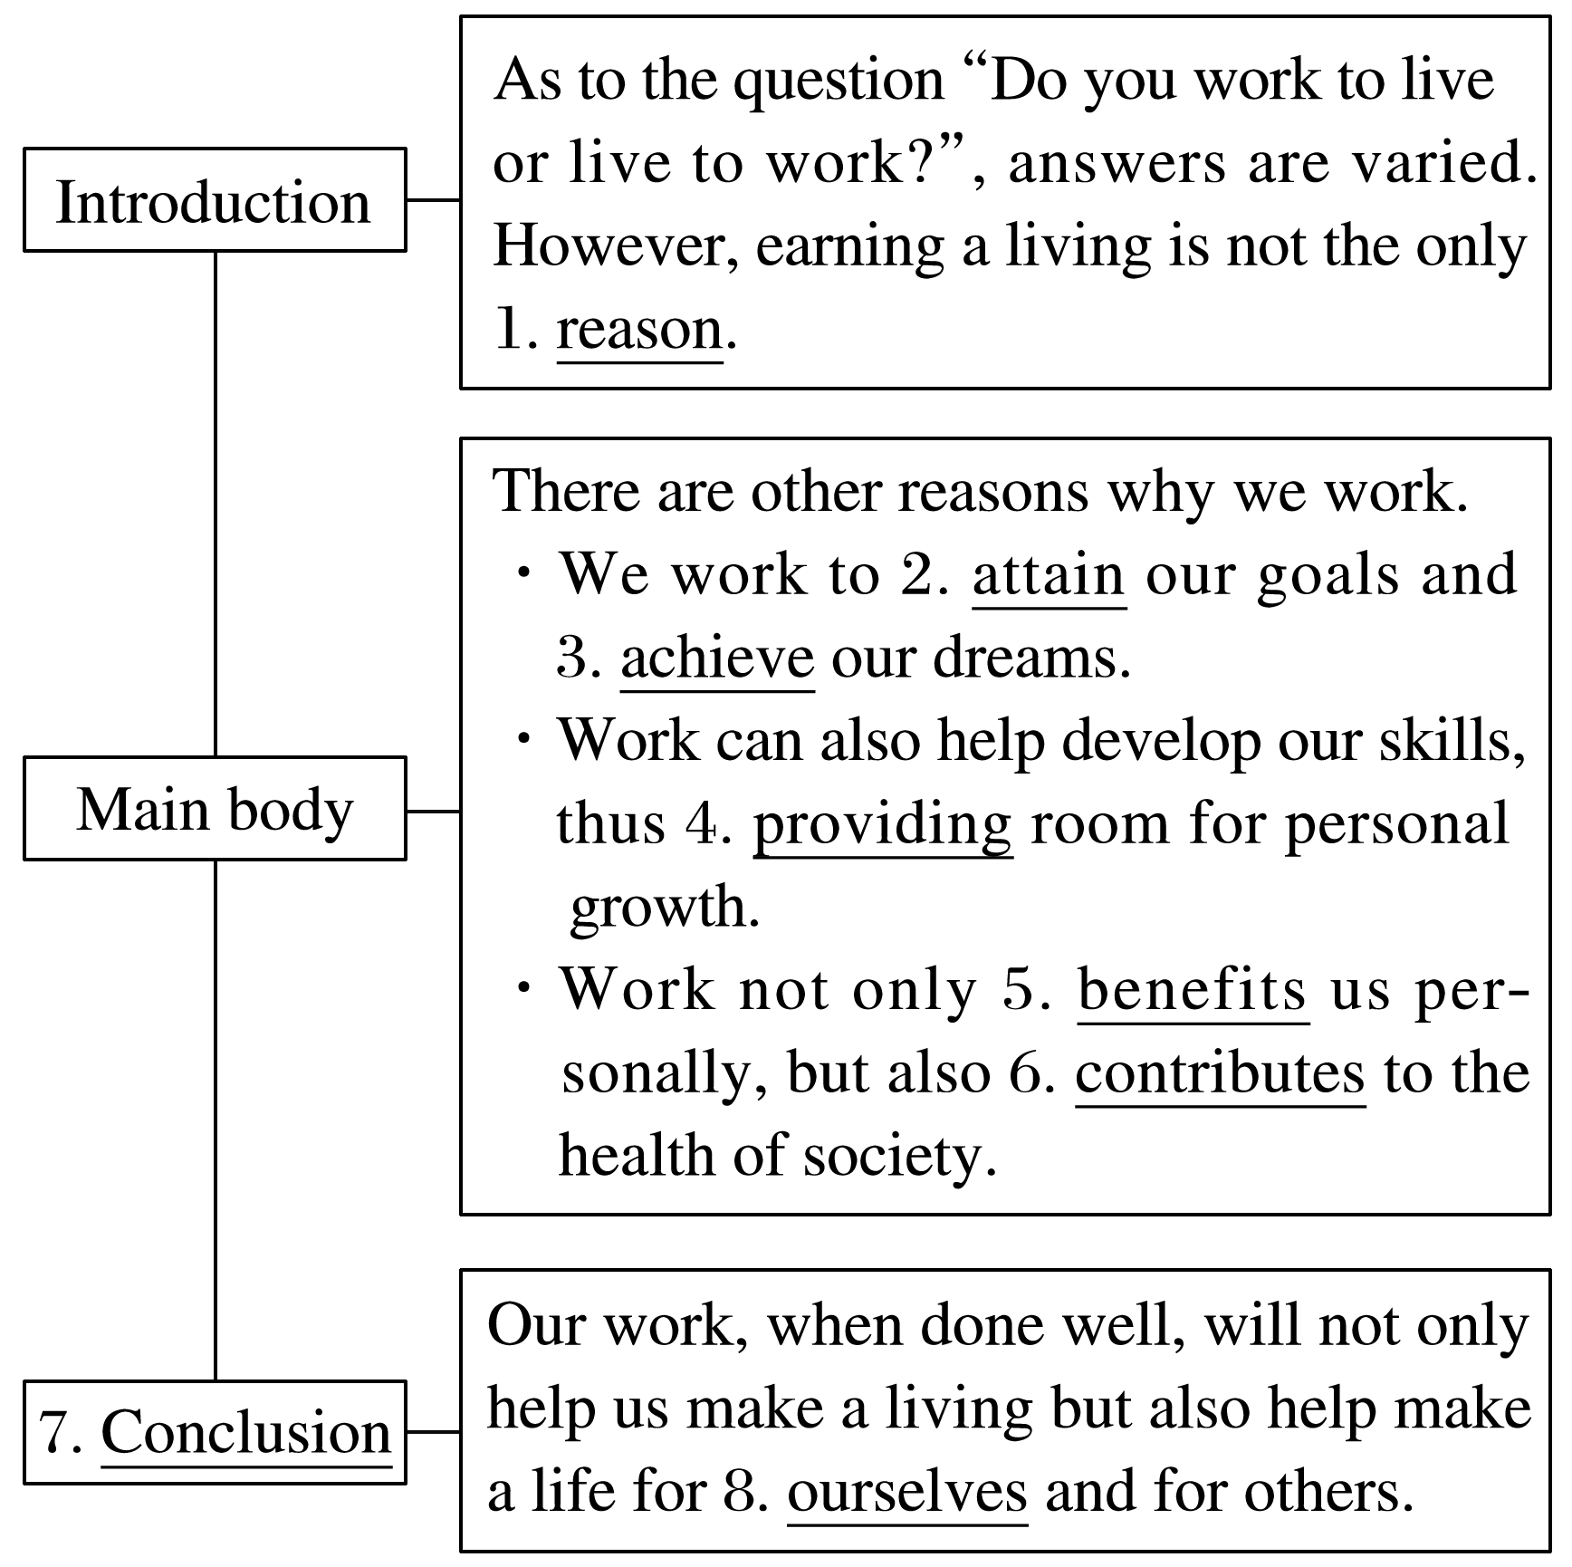

Ⅱ.The main idea of the passage is some of the important reasons why we work.

**Task 2**　微观剖析　细节把握

Read the passage carefully and choose the best answer.

1．The word “motivate” in the first paragraph can be replaced by “ ”．

A．encourage B．increase

C．prohibit D．discourage

答案　A

2．What’s the function of the quotation in Paragraph 2?

A．To support the idea “work enables us to pursue dreams”．

B．To stress the importance of having dreams.

C．To make clear the function of dreams in leading to our success.

D．To prove success is usually unexpected.

答案　A

3．Why is it necessary for us to keep up and develop new skills in the workplace?

A．The status quo is satisfying.

B．Positions are continuously changing.

C．We are willing to acquire new skills.

D．The knowledge we have is enough.

答案　B

4．Which is NOT the similarity between jobs and gears in a machine?

A．All the parts are equally important.

B．They all make their respective contributions.

C．They altogether ensure the “machine” functions properly.

D．Some of them are superior to others.

答案　D

5．The writer uses the following writing techniques EXCEPT .

A．quoting

B．listing data and analyzing

C．drawing analogies(类比；比拟)

D．giving examples

答案　B

**Task 3**　读后升华　思维品质

**Activity 1**　美句欣赏**——**多样的语篇标记方式

本篇文章中使用了一些语篇标记(或称之为话语标记)来使行文连贯，富有逻辑性。语篇标记指的是能够使行文具有逻辑性的词汇和短语。它们展示出不同的想法或者观点是如何关联在一起的：“on the whole/in general”用来归纳；“moreover/furthermore”用来增补信息；“for instance/for example”用来举例。请从本文中找出相应的句子并欣赏背诵。

答案　1.Yang Liwei，**for example**，driven by his passion for flying，became a pilot and then China’s first astronaut.

2．**Moreover**，there are people who choose to step out of their comfort zone and commit themselves to working for the benefit of others.

...

**Activity 2**　文本讨论

1．In the passage，the writer has used some writing techniques，such as examples and a quotation.Can you give some reasons why both writers and students prefer to use these techniques when writing?

2．Whether live to work or work to live is acceptable，and the significance of work is detailedly illustrated in the passage.Please take yourself as an example to say something about the advantage of work.

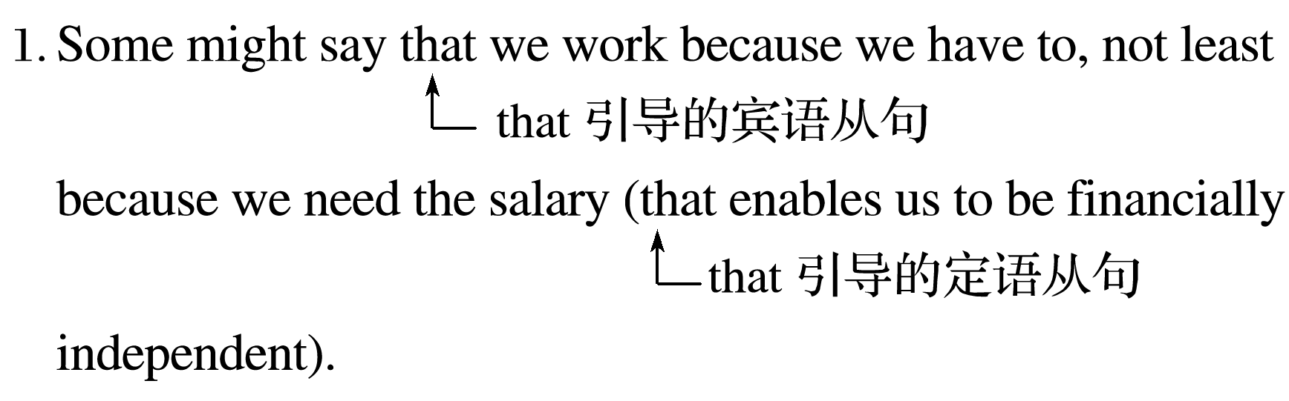

译文：有些人可能会说，我们工作是因为我们不得不工作，尤其是因为我们需要薪水来实现经济独立。

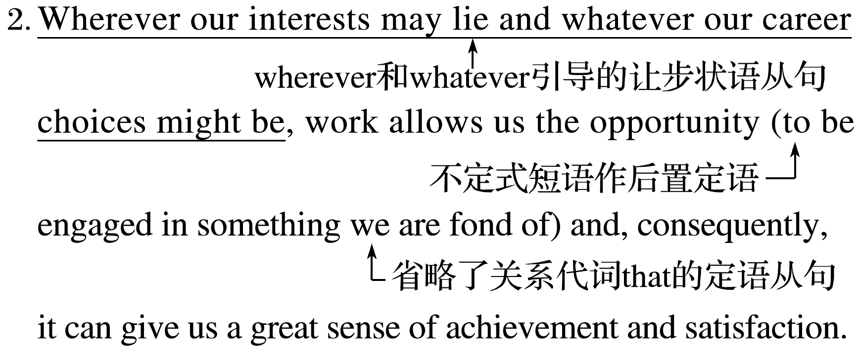

译文：无论我们的爱好在于何处，无论我们的职业选择是什么，工作使得我们有机会做我们喜欢的事情，并且因此能带给我们巨大的成就感和满足感。

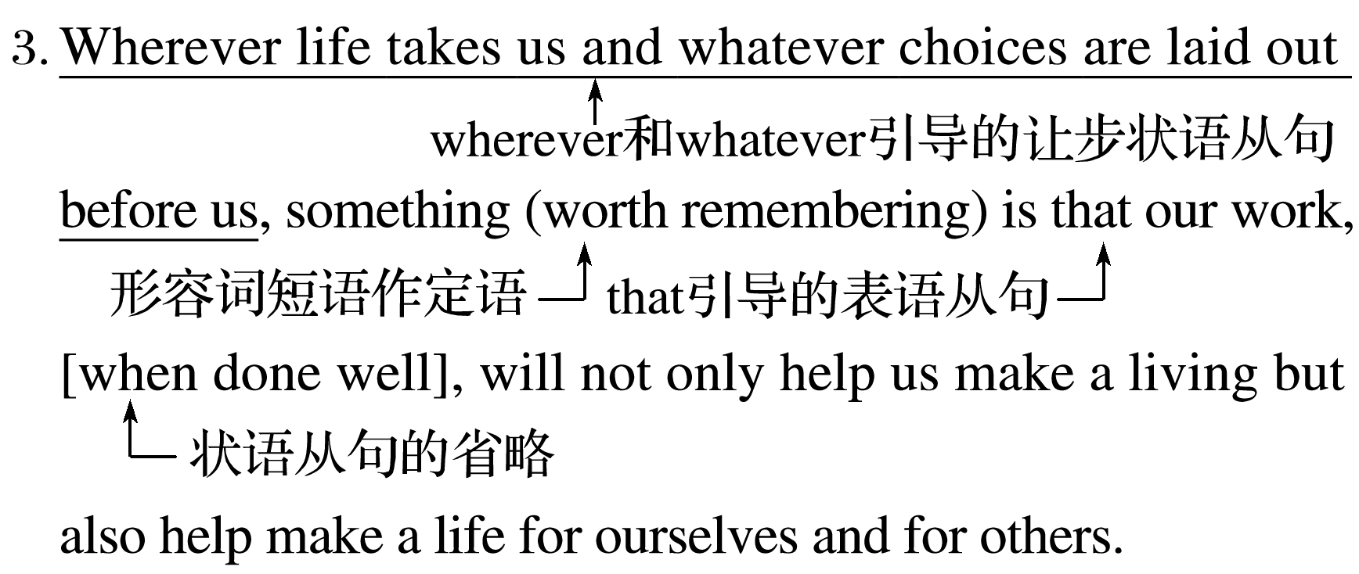

译文：无论生活把我们带到哪里，无论摆在我们面前的选择是什么，值得记住的是，当工作做得好时，它不仅会帮助我们谋生，还会帮助我们为自己和他人创造生活。

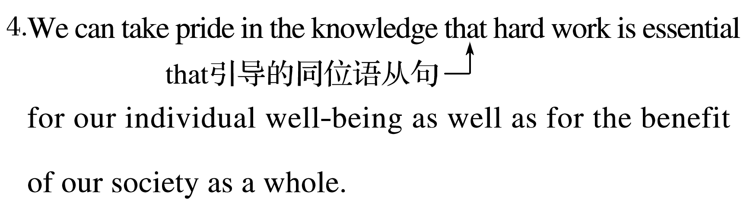

译文：我们能够自豪于有这样的认知，即努力工作对于我们个人的健康幸福和整个社会的利益都是必不可少的。



课文语法填空

The question 1.whether we work to live or live to work may have different answers.It is certainly true that we need the money from work 2.to live(live)．However，there are other reasons why we enter the world of work.

Work enables us to have our goals attained and our dreams 3.achieved(achieve)．Just as Henry David Thoreau once put 4.it，advancing confidently in the direction of the dreams and living the imagined life could lead to a success out of 5.expectation(expect)．Besides，work can also help us develop our skills.The changing workplace requires us to acquire new skills and abilities to be 6.more adaptable(adaptable) to new circumstances.What’s more，work is 7.beneficial(benefit) to us personally and the health of society as well.In a successful，stable and productive society,8.where all jobs are equally important，we all make our respective contributions.Some people even 9.are committed(commit) to working for the benefit of others.

All in all，through work，we individuals can have access to 10.a better life and our society can function properly.

## 课时跟踪练一

Ⅰ.阅读理解

**A**

**Sales Representative—Immediate Hiring**

Do you like meeting new people？Do you enjoy closing deals every day？Are you looking for a dynamic and high energy industry？THIS COULD BE THE CAREER FOR YOU！

Fast Growing and Very Successful Credit Card Processor is looking for a dynamic outside salesperson to sell credit products and check processing services in the local area.

**What we need you to do**：

·Attend 3－5 appointments daily

·Sell into small-sized to middle-sized businesses

·Work closely with the sales manager in Dallas TX(by phone)

·Have the ability to manage paperwork

**We offer**：

·Medical benefits eligibility(资格) after 90 days

·One of the strongest compensation programs in the industry

·Monthly bonuses

·A jump start bonus of up to $750

Successful applicants often have experience in customer services，inside sales，outside sales，sales support，management roles，or other customer-facing positions.

We are an equal opportunity employer.We do not discriminate on the basis of race，religion，color，sex，age，national origin or disability.

Please reply with a resume today!

There is a difference.Experience Great Work！We have been servicing North East Ohio for more than 20 years with offices located in Akron，Canton，Lakewood，Streetsboro and Wadsworth.Apply online at *www*.*greatwork*.*cc* and make a call to our Lakewood location to discuss our great career opportunities at 440-663-0050.

|  |
| --- |
| 语篇解读　本文是一篇招聘广告，招聘销售代表。文章详细介绍了工作内容、工作待遇、应聘者所需条件等。 |

1．According to the text，the sales representative the company is looking for should .

A．sell into big businesses

B．be able to manage paperwork

C．meet over 5 customers each day

D．see the sales manager in Dallas TX frequently

答案　B

解析　细节理解题。根据文中的“Have the ability to manage paperwork”可知，该职位需要销售代表有处理文书工作的能力，故B项正确。

2．If hired，you can .

A．receive a monthly salary of $750

B．get a special customer-facing position

C．enjoy a strong compensation program

D．gain medical benefits eligibility within 90 days

答案　C

解析　细节理解题。根据文中的“One of the strongest compensation programs in the industry”可知，该职位可以享受业内非常强大的补偿金项目，故C项正确。

3．Which of the following can help you apply successfully?

A．The experience in shopping.

B．The experience in management.

C．The experience of using a credit card.

D．The experience of talking with a sales manager.

答案　B

解析　细节理解题。根据文中的“Successful applicants often have experience in customer services，inside sales，outside sales，sales support，management roles，or other customer-facing positions.”可知，该岗位需要管理经验，故B项正确。

**B**

About a month after I joined Facebook，I got a call from Lori Goler，a highly regarded senior director of marketing at eBay.She made it clear this was a business call.“I want to apply to work with you at Facebook，” she said.“Instead of recommending myself，I want to ask you：What is your biggest problem，and how can I solve it？”

My jaw hit the floor.I had hired thousands of people over the previous decade and no one had ever said anything remotely like that.People usually focus on finding the right role for themselves，with the implication that their skills will help the company.Lori put Facebook’s needs front and center.It was a killer approach.I responded，“Recruiting is my biggest problem.And，yes，you can solve it.”

Lori never dreamed she would work in recruiting，but she jumped in.She even agreed to trade earnings for acquiring new skills in a new field.Lori did a great job running recruiting and within months was promoted to her current job，leading People@Facebook.

The most common metaphor for careers is a ladder，but this concept no longer applies to most workers.As of 2010，the average American had eleven jobs from the ages of eighteen to forty-six alone.Lori often quotes Pattie Sellers，who came up with a much better metaphor：“Careers are a jungle gym，not a ladder.”

As Lori describes it，there’s only one way to get to the top of a ladder，but there are many ways to get to the top of a jungle gym.The jungle gym model benefits everyone，but especially women who might be starting careers，switching careers，getting blocked by external barriers，or reentering the workforce after taking time off.The ability to create a unique path with occasional dips，detours(弯路)，and even dead ends presents great views of many people，not just those at the top.On a ladder，most climbers are stuck staring at the butt of the person above.

|  |
| --- |
| 语篇解读　本文是一篇记叙文。文章通过洛丽·戈尔在Facebook的求职和工作经历，更好地诠释了职业的内涵。 |

4．Why did Lori make the call?

A．She helped Facebook to solve the biggest problem.

B．She wanted to make a business deal with Facebook.

C．She tried to ask for a pay rise in Facebook.

D．She wanted to become an employee in Facebook.

答案　D

解析　细节理解题。根据第一段中的“‘I want to apply to work with you at Facebook，’ she said.”可知，她打电话的目的是找工作。故选D。

5．What impressed the author by Lori?

A．Lori was good at running recruiting.

B．Lori attached great importance to Facebook’s needs.

C．Lori jumped in Facebook with no adequate experience.

D．Lori was skilled in marketing at eBay.

答案　B

解析　细节理解题。根据第二段中的“Lori put Facebook’s needs front and center.It was a killer approach.”可知，洛丽把Facebook的需求放在了首位和中心，这是一记杀手锏。故选B。

6．What can we infer from the passage?

A．Now all people don’t tend to climb the ladder.

B．None on the ladder can enjoy the great views.

C．Jungle gyms offer limited exploration for employees.

D．A pregnant woman，jobless，benefits little from the jungle gyms.

答案　A

解析　推理判断题。根据第四段中的“The most common metaphor for careers is a ladder，but this concept no longer applies to most workers.”可知，不是每个人都倾向于向高职位上爬(出人头地)，故选A。

**C**

For years，I was in the rat race，my sense of wonder lost.Gardening was my antidote(解毒药)．It gave me time to stop，listen and absorb all the little details that nature has to offer—nurturing the earth，plants and myself to fight against the aggression and tiredness of everyday working life.

I quit my job and had a vision for my company.I wanted others to find the comfort that my garden gave me.Now，I watch my clients experience their own transformations.A corner that was once an unwelcoming place of weeds is a child’s play area；a lonely person has an inspiring，evolving view.

Gardening requires us to be present in the moment，while also imagining the future.You may see a beautiful flower and be surprised for a minute at the magic of nature.Some flowers last for a day，others for a season.Some come back year after year.Seasons pass and you become connected to the changes in life in a deeper，more spiritual way.This builds acceptance.

Where there once may have been beauty，there might now be an empty space and a deep sense of sadness...But gardening brings hope—we can create something beautiful again and that space will no longer be bare.

Hope is one of many emotions stirred by gardening.Whether you’re growing vegetables to eat，planting tiny seeds or tending flowers，there is always a great sense of satisfaction at the end of a session.How you choose to garden is deeply personal to you—it’s about creating something fruitful，alone or with others.

The key is to have a vision，ideas and bright hopes for the future.

|  |
| --- |
| 语篇解读　本文向我们讲述了作者通过园艺接近大自然，放松了身心，减轻了日常工作和生活的压力，同时园艺带给了作者极大的精神力量。 |

7．What does the underlined phrase “the rat race” refer to?

A．The fierce race among rats.

B．The tiredness of the family.

C．The competitive working life.

D．The bad relationship with neighbors.

答案　C

解析　细节理解题。根据第一段中的“Gardening was my antidote(解毒药)．”和“to fight against the aggression and tiredness of everyday working life”可知，打理花园可以使作者和每日疲惫的、充满竞争的工作生活作斗争。故选C项。

8．What does the author benefit from gardening?

A．It helps to develop a take-it-as-it-is attitude.

B．It relieves anxiety about losing the job.

C．It releases her loneliness and depression.

D．It teaches her a lot of sowing knowledge.

答案　A

解析　推理判断题。根据第三段中的“Some flowers last for a day，others for a season.Some come back year after year...This builds acceptance.”可知，春生夏长，秋收冬藏，此乃天之道，通过园艺，作者学会接受生命的变化以及大自然的一切，即拥有一种顺其自然的心态。故选A项。

9．What can we infer about gardening according to the author?

A．It’s beautiful. B．It’s rewarding.

C．It’s depressing. D．It’s cooperative.

答案　B

解析　推理判断题。根据倒数第二段中的“...there is always a great sense of satisfaction at the end of a session.How you choose to garden is deeply personal to you—it’s about creating something fruitful，alone or with others.”可知，园艺总会带来丰硕的果实，带给人们满足感和希望，即园艺是有意义的。故选B项。

10．What is the best title for the article?

A．Gardening for Fun B．A Sense of Wonder

C．Sowing Seeds of Hope D．A Vision for the Future

答案　C

解析　标题归纳题。文章作者主要向我们介绍了通过园艺可以播下希望的种子，可以给人带来很大的满足感，因此C项(播下希望的种子)适合作为本文的标题。故选C项。

Ⅱ.七选五

**How to Choose Your Purpose-Filled Career**

When you think about choosing a career，you often do it in the following two ways.

1 .If you like writing or doing crafts，you might consider these things.This is not a bad way to go，of course，but you can’t always make money doing things you like (like video games or drinking beer)．And sometimes things you like are better as a hobby or side passion.

Think about a well-paid job that you can do and doesn’t sound so bad.Maybe a doctor，an engineer or a lawyer？Or maybe that’s out of your educational reach，so you choose office or a retail work. 2 but often they are not something you’re really passionate about.It’s kind of like just doing something because it’s there—not very inspired.

However，there’s another way that is perhaps better： 3 .For example，taking care of children，because you really want to help children get a great start in life，or blossom into who they want to be or getting into government or social work to improve the conditions of the community you live in or becoming a scientist to help ease the environmental crisis or find a cure for a terrible disease. 4 and if you choose one of them for that purpose，you will serve in that work feeling a sense of purpose each day.

There are endless ways to do that.The point isn’t how you serve the world，but just serving the world in some way will help you feel filled with purpose. 5 .

A．These are all great choices

B．Think about what you like to do

C．You can identify your purpose and work out how to get there

D．Each of these is just one of many possibilities filled with purpose

E．Try to do something to serve a community or make the world better

F．The sooner you complete the training requirements，the sooner you will make a living

G．If you choose a purposeful and enjoyable job，you’re always further along than most people

1．答案　B

解析　上文“When you think about choosing a career，you often do it in the following two ways.”说明接下来将会分别介绍两种选择职业的方法。由下文“If you like...”和下一段首句“Think about...”可知，B项“想想你喜欢做什么”符合此处语境。故选B项。

2．答案　A

解析　空前两句介绍了一些可能的职业选择。下文“but often they are not something you’re really passionate about”表示转折，说明空处讲的是对这些职业的总结和概括。A项“这些都是很好的选择”承接上文且与下文为转折关系，符合语境。故选A项。

3．答案　E

解析　上文“However，there’s another way that is perhaps better”说明接下来要讲另一种选择职业的办法。下文“For example，...the conditions of the community you live in or becoming a scientist to help ease the environmental crisis or find a cure for a terrible disease.”列举了一些更有意义的职业选择。E项“试着做些事情来服务社区或者让世界变得更好”承上启下，符合语境。故选E项。

4．答案　D

解析　D项中的purpose和下文中that purpose相呼应，说明选择这些职业就会富有意义，引出下文。故选D项。

5．答案　G

解析　上文“The point isn’t how you serve the world，but just serving the world in some way will help you feel filled with purpose.”说明选择一些工作会带给你意义感。G项“如果你选择一份有意义且有趣的工作，你总是比大多数人走得更远”进一步说明带给你的意义。故选G项。