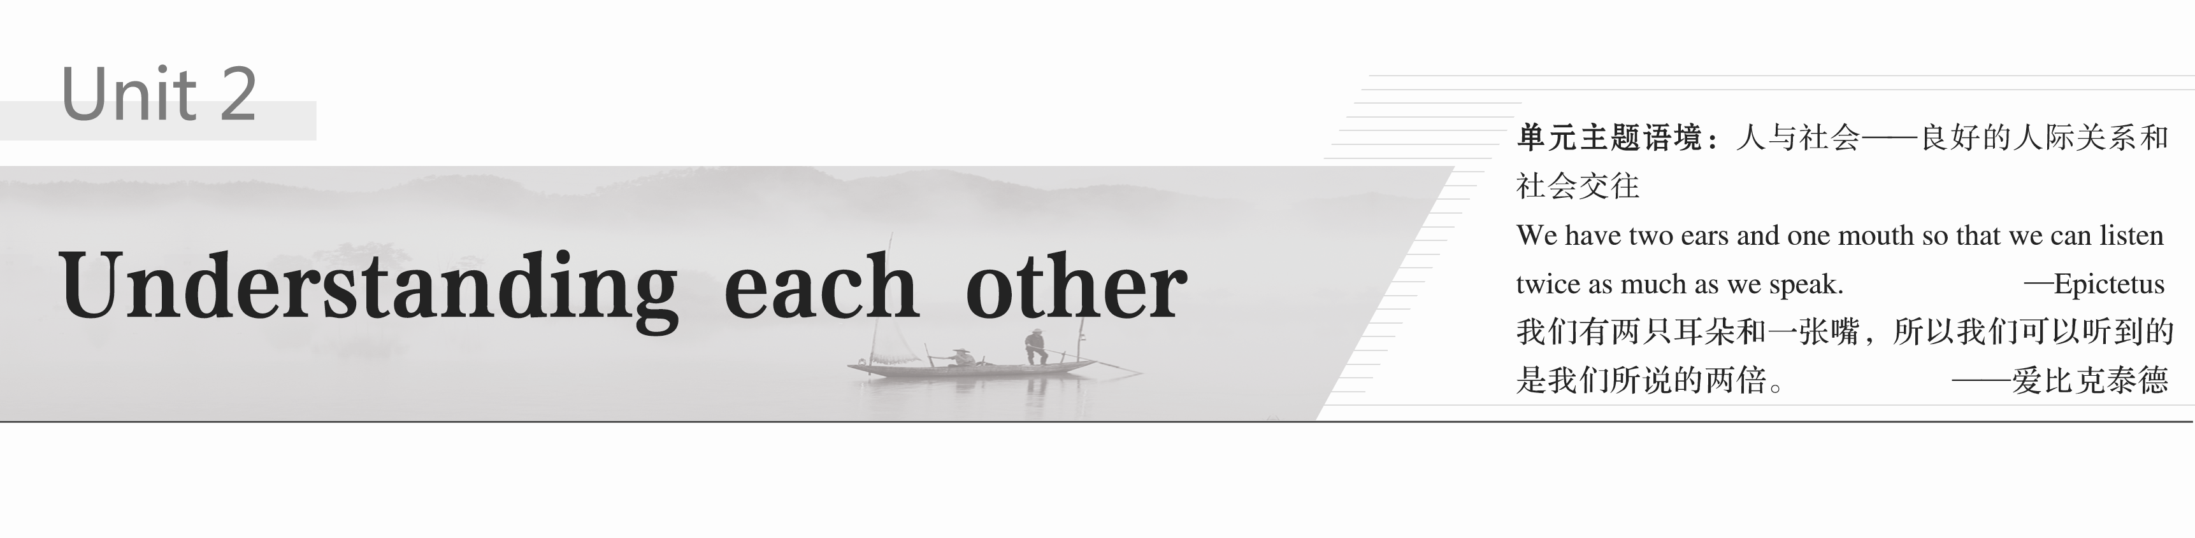

### 类文赏读　话题导入

**HOW DO I KNOW MY STUDENTS?**

As an educator，people often ask me how I know what is going on in the minds of my students.Many students are quite shy and don’t speak all that much.At the same time，in a classroom of more than forty students，it is hard to have many one-on-one conversations with each person.So，how can I really know what makes each student tick?

My answer？I look at their body language.

It is easy to recognise when students are interested in a lesson.Most tend to look up and make eye contact.When I make a joke，they smile.When I talk about something difficult，they look confused.I know when students are really interested，however，because they lean forward and look at me.People have a **tendency**1 to lean towards whatever they are interested in.So if a student has his head lowered to look at his watch，it **implies**2 he is bored and just counting the minutes for the class to end.If two friends are leaning their heads together，they are probably writing notes to each other.Of course，not everyone who looks up is paying attention in class.Some students look up，but there is an absence of eye contact.Their eyes barely move，and they always have the same distant expression on their faces.It is as though they are asleep with their eyes open.

Some students are amused by something else.They spend all their time looking anywhere but at me.Then again，some students’ favourite activity is daydreaming.With their chins on their hands，they **occupy**3 themselves by staring out of the window or up at the ceiling.They are certainly interested in something，but who knows what.The main thing is reminding **distracted**4 students that they need to pay attention in class.

While it is easy to **perceive**5 when students are interested，bored，or distracted，it is sometimes much harder to **distinguish**6 when students are troubled.Students who are angry，afraid，or experiencing anxiety may have their arms crossed in front of their chests and their legs closed or crossed，like they are guarding their bodies.Students who are sad or worried will nearly always wear a frown.They may also hide their faces in their hands like they are embarrassed or ashamed.Some students act this way merely because they are afraid of being called on by the teacher.However，if a student does not bother to brush her hair and her eyes are red from weeping，then I can infer that there are deeper issues at work.It could be that she is having serious conflicts with other students or at home.Whatever it is，I know I need to inquire and assess what is going on.

**Ultimately**7，my duty is helping every student to learn.Their body language lets me know when to **adjust**8 class activities，when to intervene，and when to talk to students individually，so they can all get the most out of school.Reacting to body language is an important component of being a teacher.(选自人教版新教材选择性必修第一册**UNIT 4**)



1．tendency /'tendənsi/ *n*．趋势；倾向

2．imply /ɪm'plaɪ/ *vt*.意味着；暗示

3．occupy /'ɒkjupaɪ/ *vt*.占据；占用

4．distracted /dɪ'stræktɪd/ *adj*.注意力分散的；思想不集中的

5．perceive /pə'siːv/ *vt*.察觉；看待；理解

6．distinguish /dɪ'stɪŋɡwɪʃ/ *vi*.& *vt*.区分；辨别

7．ultimately /'ʌltɪmətli/ *adv*.最终；最后

8．adjust /ə'dʒʌst/ *vt*.调整；调节



1．As an educator，people often ask me how I know what is going on in the minds of my students.

作为一名教师，人们经常问我，我怎么知道自己的学生在想什么。

[句式分析]　how引导宾语从句，从句中又含有what引导的宾语从句。

2．With their chins on their hands，they occupy themselves by staring out of the window or up at the ceiling.

他们两手托着下巴，忙着盯窗外或天花板。

[句式分析]　With their chins on their hands是with复合结构作状语。

3．While it is easy to perceive when students are interested，bored，or distracted，it is sometimes much harder to distinguish when students are troubled.

尽管学生们何时(对讲课)感兴趣、何时感到无聊或精力不集中是容易察觉的，但要发现学生何时有困扰有时会难得多。

[句式分析]　while 引导让步状语从句；it is easy to perceive和it is sometimes much harder to distinguish中，it是形式主语，真正的主语是后面的不定式；句中的两个when引导的从句都是宾语从句。

## Period One　Welcome to the unit & Reading—Comprehending

**Learning Aims**(学习目标)

1．Learn some new words

2．Grasp the general idea of the passage(重点难点)

3．Learn some important sentences(重点)



阅读下列课文原句，写出句中加黑词汇的汉语意思

1．If you heard someone shout “Hey you！” from across the room，how would you **react**？

对……作出反应

2．The sender **encodes** a message and sends it face to face，or through video，telephone，mail or social media.This message is then received and **decoded** by the receiver.In response，the receiver sends an encoded message back，which is referred to as **feedback**.

把……编码　解(码)，破译　反馈，反应

3．Once you have **obtained** this information，you can use it to determine how best to communicate with them.获得，赢得

4．For example，if you are a business person **negotiating** with a large **enterprise** about a deal，you should do it face to face，using formal language in a **straightforward** manner.

谈判　公司，企业　坦诚的

5．If someone looks at you with a confused expression，this could indicate that they have not completely understood your point.Then you will need to **clarify** your message before moving on.

使更清晰易懂，阐明

6．While being **knowledgeable** about body language is vital，the value of **empathy** should not be understated.Seek to understand the other person’s emotions，by **putting yourself in their shoes** and looking at the situation from their perspective.博学的　同感　处于某人的境地

7．Only when you give serious consideration to their points of view will you be able to see what **accounts for** their emotions and **empathize** with them.是……的说明(或原因)　有同感

8．You may not **approve of** their ideas but at least you will see where they are coming from，which means you can make adjustments to your own **tone** and choice of words accordingly.

赞成，赞同　语气，腔调



**Task 1**　宏观架构　整体理解

Ⅰ.Read the passage quickly and then fill in the blanks.

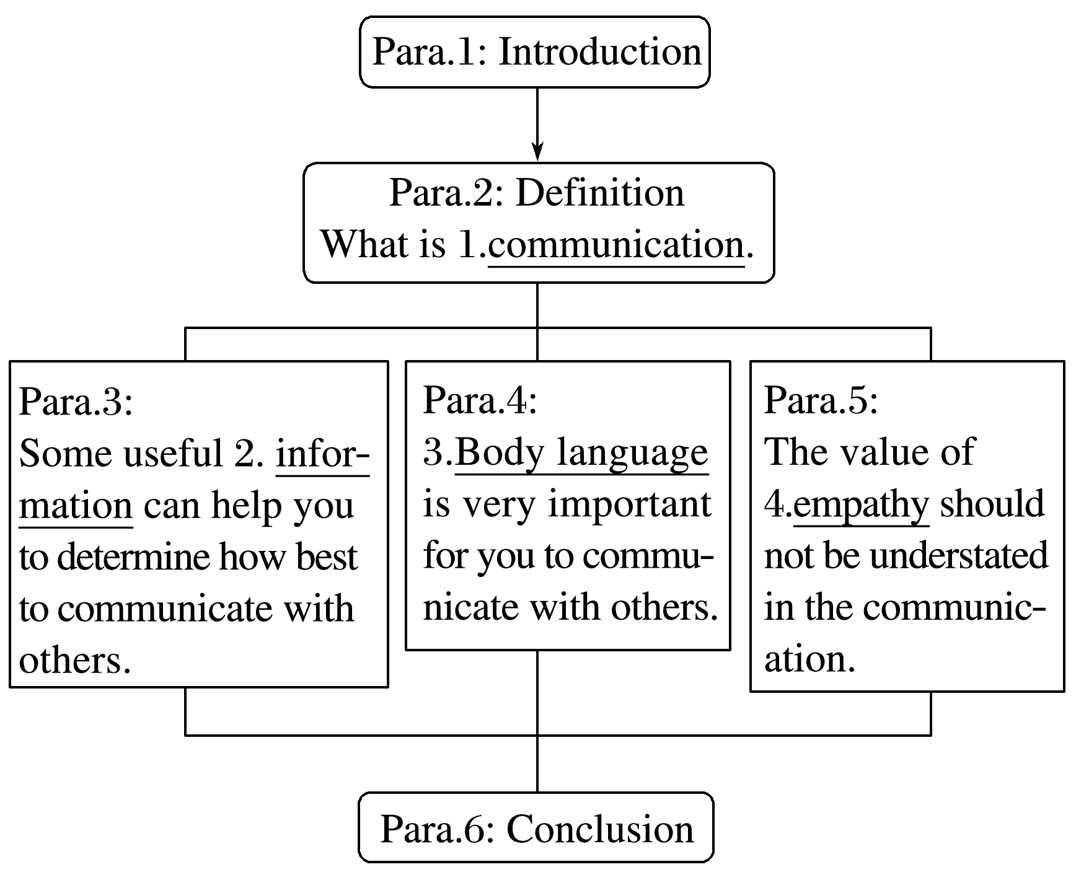

Ⅱ.The main idea of the passage is how to improve communication skills and the importance of effective communication.

**Task 2**　微观剖析　细节把握

Read the passage carefully and choose the best answer.

1．What information can help you determine how best to communicate with others?

A．Their age.

B．Their relationship with you.

C．Their relevant personal information.

D．Their cultural background and expectations.

答案　C

2．Which kind of language and manner should you use when dealing with a large enterprise?

A．Informal language in a straightforward way.

B．Formal language in a straightforward way.

C．Formal language in a gentle way.

D．Casual language in a straightforward way.

答案　B

3．Why should you pay attention to the other person’s body language?

A．Because it can show his/her personality.

B．Because it can show his/her likes and dislikes.

C．Because it can show his/her thoughts and attitudes.

D．Because it can show whether your conversation is going well.

答案　D

4．How can you understand the other person’s emotions?

A．By looking at the situation from your point of view.

B．By looking at the situation from their points of view.

C．By learning about all their personal information.

D．By having a conversation with them in depth.

答案　B

5．What’s the main idea of the last paragraph?

A．The importance of effective communication.

B．Communication skills.

C．The entire circle of communication.

D．The importance of body language.

答案　A

**Task 3**　读后升华　思维品质

**Activity 1**　词汇学习**——**词语搭配

在这篇演讲稿中使用了“communicate”和“communication”不同的词语搭配，阅读下面的例子并添加更多这两个词的词语搭配。

|  |  |
| --- | --- |
| communicate | |
| communicate＋*adv*. | communicate clearly |
| communicate＋*n*. | 1.communicate an idea |
| communicate＋*prep*. | 2.communicate with |
| communication | |
| *adj*.＋communication | effective communication |
| communication＋*n*. | 3.communication skills |
| *v*.＋communication | 4.influence communication |

**Activity 2**　演讲技巧**——**通过举例介绍主题

举例子是在讲座中介绍主题时常用的技巧，它能吸引观众的注意力，让他们更积极地思考问题。在这篇演讲稿中演讲者用一个例子来介绍有效沟通的主题。找到例子，并尝试通过举例来介绍一个话题。

答案　主题：Furthermore，you will need to determine the appropriate style to use and how complex your choice of words should be.

例子：For example，if you are a business person negotiating with a large enterprise about a deal，you should do it face to face，using formal language in a straightforward manner.

**Activity 3**　文本讨论

1．How can we apply the ideas mentioned in the lecture transcript to cross-cultural communication？Give some examples.

2．What other suggestions can you give on how to become an effective communicator?

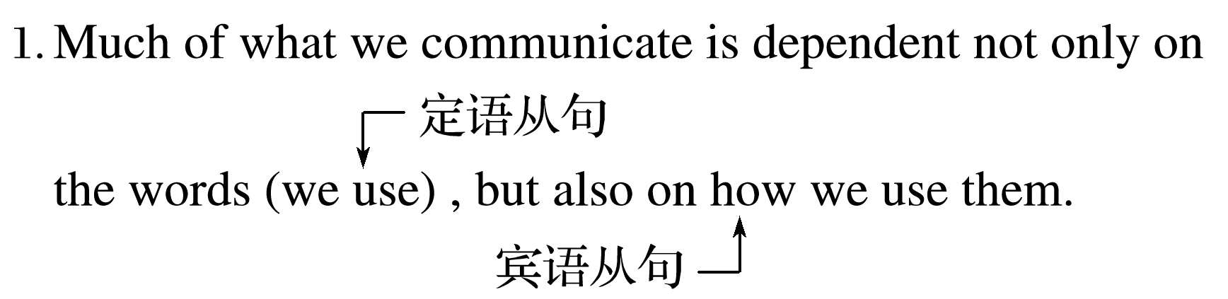

译文：我们交流的很多东西不仅取决于我们使用的词汇，还取决于我们如何使用它们。

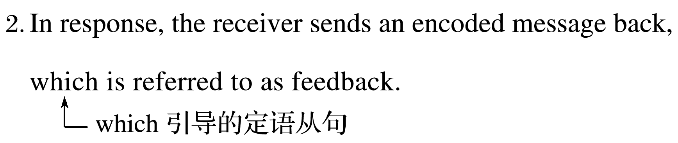

译文：作为回应，接收者发送一个编码信息回送，这被称为反馈。

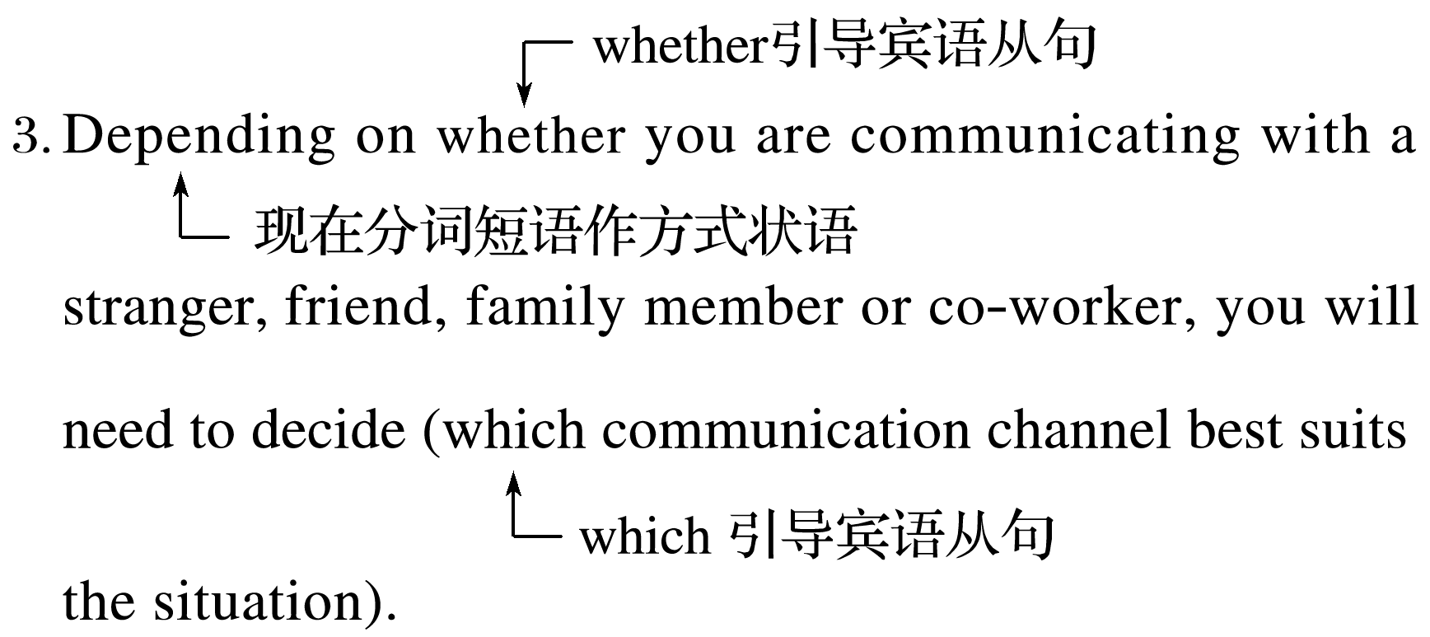

译文：根据你是和陌生人、朋友、家人还是同事交流，你需要决定哪种交流方式最适合当前的情况。

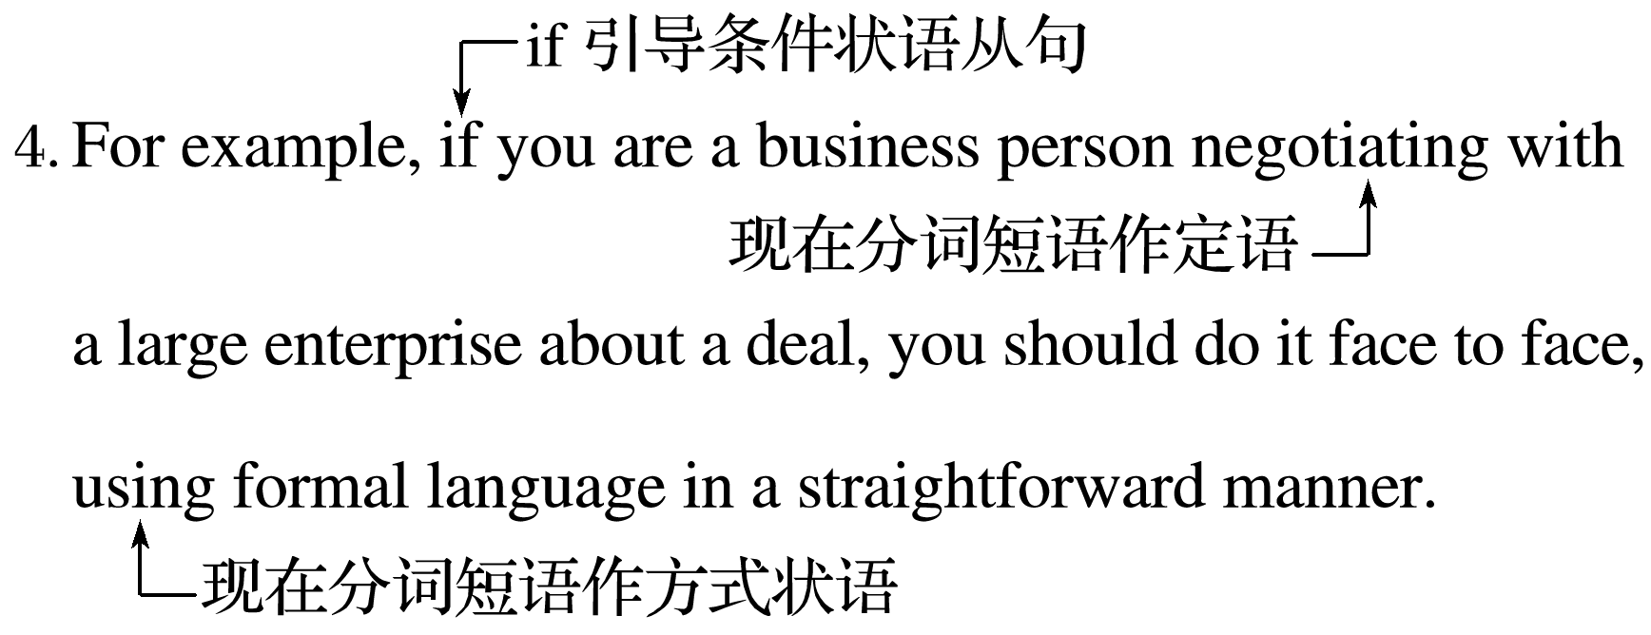

译文：例如，如果你是一个商人，正在与一家大企业洽谈一笔生意，你应该面对面地，用正式的语言，以直截了当的方式进行沟通。

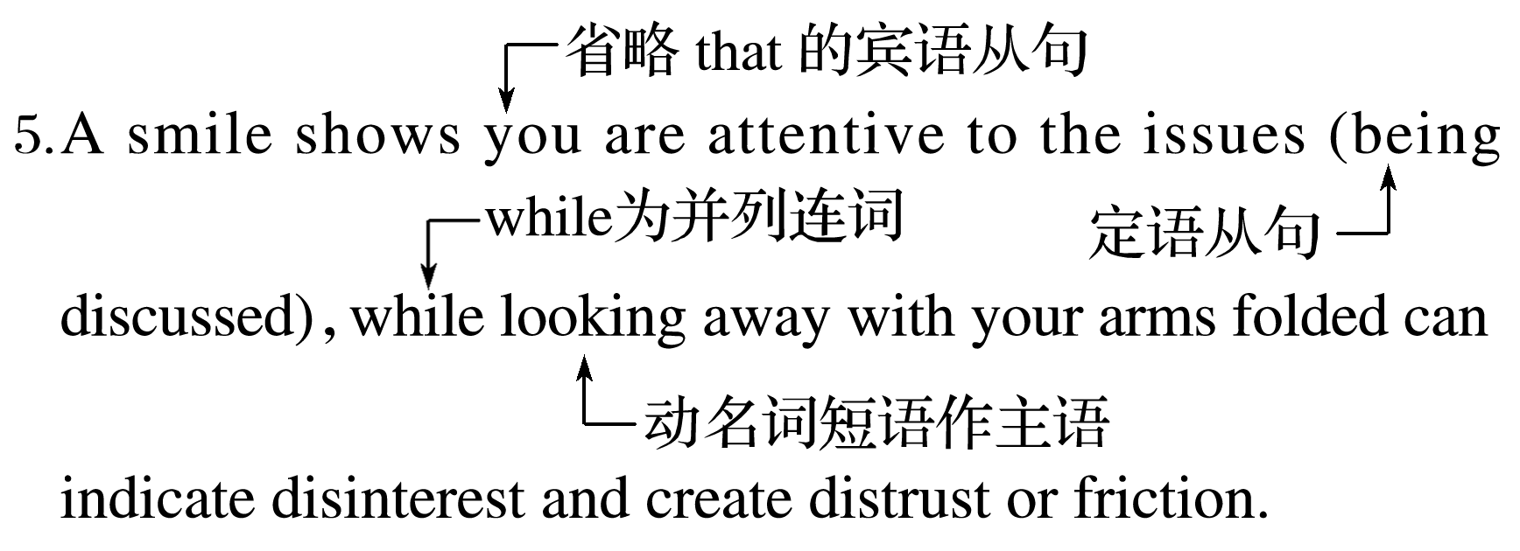

译文：微笑表明你在关注正在讨论的问题，而双臂交叉、看向别处可能表明你不感兴趣，这样会造成不信任或摩擦。

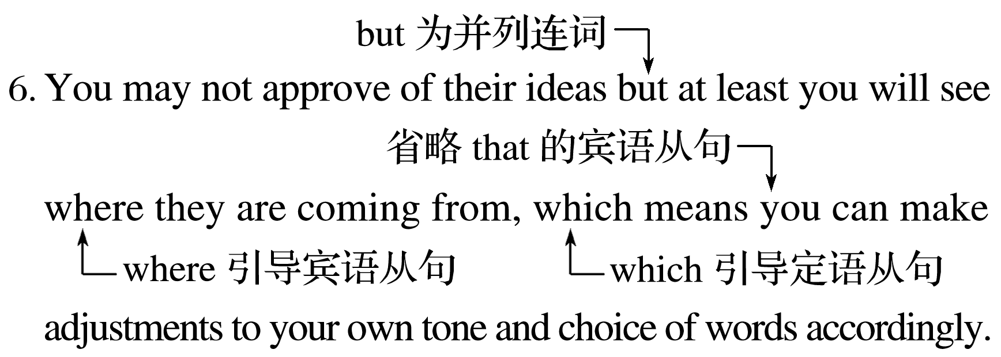

译文：你可能不赞成他们的想法，但至少你会明白这些想法从何而来，这意味着你可以相应地调整自己的语气和措辞。



课文语法填空

As we all know，communication is the exchange of information 1.between a sender and a receiver，whose entire circle involves the encoding，decoding and feedback of information.

Most of what we communicate 2.relies(rely) not only on the words we use，but also on how we use them.

3．To be(be) a competent communicator，firstly it’s necessary that you should obtain as much their personal information as you can,4.which is helpful for you to decide the best communication channel according to different situations.Furthermore,5.judging(judge) from the communication objects，you need to determine the language styles and communication manners.Apart from the details mentioned above，you should also keep in mind that body language plays 6.an important part in communication since it accounts for over 50% in communication.You should pay attention to your own body language，and at the same time，you ought to keep a close eye on the other person’s body language，which will help the communication to go 7.smoothly(smooth)．Last but not least，the value of empathy should not 8.be understated(understate)．To ensure a smooth communication，you should put 9.yourself(you) in their shoes and look at the situation from their perspective.

In conclusion，good communication 10.skills(skill) will help you build trust and gain other people’s respect，allowing relationships to become more positive and productive.

## 课时跟踪练一

Ⅰ.阅读理解

**A**

Mom and I were putting the finishing touches on dinner，and my little niece Jessica came in to set the table.Instead of going to the dish cabinet，she went into the pantry where there was a stack of old，mismatched dinner plates on the bottom shelf.

When she had set all six plates，she stood back and sighed，“Oh，Grandma，your plates are so beautiful.Ours are all alike！” We had a good laugh at her innocent remark，but as I think back to all those years ago，I believe she was right.Those plates were beautiful.

Mom worked for the local council on aging as a housekeeper.She did many of the little things that allowed elderly people to stay in their own homes.Most of her clients got Meals on Wheels，a service in the 1970s.They received a hot lunch and a cold snack to have later in the evening.This is really not very much food.Every evening Mom would make to-go meals on these mismatched plates covered with aluminum foil，and then deliver them to the people who she knew didn’t get enough to eat.

This was about ten years before microwave ovens became common so it was important that the food be on a plate that could be reheated in a regular oven.Instead of a cold sandwich and macaroni salad，Mom’s clients dined on Beef Manhattans，pan-fried chicken or meatloaf，along with veggies and a piece of pie or cake.Mom and Dad did this even after Mom left her job，and Mom continued after Dad’s death until all her former clients had either passed away or moved out.

When I was cleaning our Mom’s house after her death，I kept one as a souvenir(纪念品)．That plate is a sweet reminder of the lessons of generosity and caring for one’s neighbor that were modeled for me by my parents.

|  |
| --- |
| 语篇解读　这是一篇记叙文。文章讲述了妈妈在职务之外为他人提供帮助的故事。父母的慷慨和关心邻居为作者树立了榜样。 |

1．Why did the author think those plates beautiful?

A．They were not all alike.

B．They were little Jessica’s pride.

C．They were collected from different places.

D．They were symbols of the parents’ kindness.

答案　D

解析　推理判断题。根据最后一段最后一句可知，这些盘子是父母善良的象征，所以它们很美。故选D。

2．What did the author’s mother do to earn a living in the 1970s?

A．She was a housewife.

B．She ran Meals on Wheels.

C．She delivered food to houses.

D．She did housework for the old.

答案　D

解析　细节理解题。根据第三段前三句可知，作者的母亲在20世纪70年代是靠为老人做家务谋生的。故选D。

3．Why did the author’s mother make to-go meals?

A．Because it was her job.

B．Because she was good at cooking.

C．Because she wanted to help beyond her duty.

D．Because her family didn’t have enough to eat.

答案　C

解析　推理判断题。根据第三段中“Every evening Mom would make to-go meals on these mismatched plates covered with aluminum foil，and then deliver them to the people who she knew didn’t get enough to eat.”可推知，作者的母亲之所以做外卖，是因为她想在她的职责之外给人提供帮助。故选C。

4．What is the best title for the text?

A．Plates of Sympathy

B．A Precious Souvenir

C．Services for the Senior

D．A Kind-hearted Mother

答案　A

解析　标题归纳题。根据第三段最后一句以及最后一段可知，A项Plates of Sympathy是最佳标题。plates是文章的焦点。故选A。

**B**

Chimpanzees(黑猩猩) enjoy watching movies together，scientists have discovered in research that suggests social bonding through shared experiences has deep evolutionary roots.

It is widely known that humans can bond over group activities such as watching a movie or playing board games.But it has been unclear whether the underlying psychology behind this effect is present in other species.

In the research，chimpanzees were placed in pairs and shown a short video.The researchers then measured how long it took them to approach their partners，how close they got and how long they remained in proximity (靠近)—two measures of social bonding.

Chimpanzees who had viewed the video with either another of their own species or a human approached their partner faster or spent longer in proximity to them，compared with those who had watched the video on their own，the scientists found.

The finding indicates that social bonding created by shared experiences may have deeper evolutionary roots than previously thought.

“Animals can stand together and watch a waterfall，but they don’t seem to seek out those kinds of experiences，” said Wolf，an author on the study.“So for a long time we thought they weren’t capable of processing that way or they weren’t feeling any psychological consequences from doing so.”

“It’s exciting that at least some parts of the psychology that we need to connect through shared experiences may actually have a slightly older evolutionary history than previously suspected.”

The animals were tracked for only three minutes after they had watched the film，so it is not clear whether shared experiences strengthen social bonds in the long term.The research used animals in captivity(圈养)，and scientists said it was not known whether the same effects would be observed in the wild.

|  |
| --- |
| 语篇解读　这是一篇说明文。文章主要介绍了一项针对共同经历加强社交联系的研究。该研究让我们知道通过共同经历形成社交联系的这一心理活动的进化历史可能比我们想象的更久远。 |

5．What does the underlined part in Paragraph 2 mean?

A．Experiencing social bonds.

B．Sharing evolutionary roots.

C．Humans bonding over group activities.

D．Chimpanzees watching movies together.

答案　C

解析　词义猜测题。根据文章第二段中的“It is widely known that humans can bond over group activities such as watching a movie or playing board games.”可知，这种影响是指通过团队活动形成的人与人之间的情感纽带。故选C项。

6．How did the researchers get the findings?

A．By making a comparison.

B．By introducing a concept.

C．By using an expert’s words.

D．By referring to another study.

答案　A

解析　推理判断题。根据文章第四段的介绍可知，研究人员将实验对象的大猩猩分成两组，对比分析独自观看视频或与同伴或人类一同观看视频之后的不同。故选A项。

7．What did Wolf think of the research findings?

A．Imperfect. B．Encouraging.

C．Groundless. D．Doubtful.

答案　B

解析　推理判断题。根据倒数第二段的内容可知，沃尔夫认为这项研究使我们在研究社交情感联系的心理进化史的研究上又前进了一步，是鼓舞人心的。故选B项。

8．What does the last paragraph mainly talk about?

A．Approaches to future studies.

B．New perceptions of other scientists.

C．The aspects which need further tests.

D．The application of the research findings.

答案　C

解析　段落大意题。根据尾段中的“The animals were tracked for only three minutes after they had watched the film，so it is not clear whether shared experiences strengthen social bonds in the long term.”可知，研究者需要进行一些长期观察大猩猩社交行为的研究，以便确定共同经历是否对社交联系具有长期效力。故选C项。

**C**

Nostalgia(怀旧) has become increasingly common in our current climate of accelerated，unexpected change.More and more Americans are turning back with longing to what feels like simpler，sweeter times.They collect cassette tapes，manual typewriters even decades-old video games.

Is it a mistake to get too obsessed with the past？Some psychologists warn that too much devotion to the so-called good old days is an escape from reality；it can indicate loneliness or that a person is having a difficult time coping in the present.Psychologist Stephanie Coontz argues that nostalgia distracts us from addressing the problems of modern life and contributes to anxiety，depression，insomnia，etc.

But new studies suggest that a modest dose of nostalgia is not only harmless，but actually beneficial.They suggest it helps strengthen our sense of identity and makes us feel more optimistic and inspired.It is also a tool for self-discovery and memories are a psychological immune response that is triggered when you want to take a break from negativity.Interestingly，those happy memories can be particularly beneficial both to kids in their teens and to society’s elders.“Recalling our childhood reminds us of the times when we were accepted and loved unconditionally，” says Krystine Batcho，a psychologist.“That is such a powerfully comforting phenomenon，knowing that there was a time in life when we didn’t have to earn our love.” Nostalgia can transform even the most ordinary past into legends which warm the heart and the body.Let’s not forget that nostalgia has been a source of inspiration to innumerable American writers.Mark Twain recalled his boyhood，writing，“after all these years，I can picture that old time to myself now，just as it was then：The white town drowsing in the sunshine of a summer’s morning.”

So go ahead，daydream a little about your best childhood friend，your first car，a long-gone family pet.As Dr.Sedikides says，“Nostalgia is absolutely central to human experience.”But at the same time，keep these words of wisdom from the great inventor Charles Kettering in mind as well，“You can’t have a better tomorrow if you are thinking about yesterday all the time.”

9．What did some psychologists in Paragraph 2 probably agree?

A．Nostalgia will cause some mental problems.

B．Nostalgia makes us devoted to the good old days.

C．Nostalgia shows you are trying to get rid of loneliness.

D．Nostalgia helps us cope with the difficult time we are going through.

答案　A

解析　推理判断题。根据第二段中的“Some psychologists...depression，insomnia，etc.”可知，第二段中的一些心理学家可能同意怀旧会导致一些心理问题的说法。故选A。

10．There are many benefits of nostalgia except that .

A．it can enable us to know ourselves better

B．it can bring us some comfort when we recall

C．we are likely to gain attention if we recall the happy childhood

D．we can sometimes break away from negativity with happy memories

答案　C

解析　细节理解题。根据第三段第三句“It is also a tool for self-discovery and memories are a psychological immune response that is triggered when you want to take a break from negativity.”可知，选项A和选项D是怀旧的好处。根据第三段第七句“Nostalgia can transform even the most ordinary past into legends which warm the heart and the body.”可知，当我们回忆时，它可以给我们带来一些安慰，所以选项B是怀旧的好处。选项C(如果我们回忆起快乐的童年，我们很可能会引起注意)在文中没有提及。故选C。

11．What will be talked about in the following paragraph?

A．The bad influence of too much devotion to nostalgia.

B．The reasons why we should avoid nostalgia.

C．The bad memories that always stick around you.

D．The great changes nostalgia will bring to you.

答案　A

解析　推理判断题。根据最后一段最后一句“You can’t have a better tomorrow if you are thinking about yesterday all the time.”可知，下面一段将会讨论过分沉溺于怀旧的不良影响。故选A。

12．What’s the best title of the passage?

A．We All Have a Soft Spot for Nostalgia

B．Nostalgia Is Actually Good for You

C．Don’t Be Carried Away by Nostalgia

D．There Are Many Times When We Like to Recall

答案　B

解析　标题归纳题。根据第三段第一句“But new studies suggest that a modest dose of nostalgia is not only harmless，but actually beneficial.”可知，文章主要是讲怀旧的好处。故选B。

Ⅱ.七选五

Being able to communicate effectively with others is an essential skill for people of all ages. 1 People who want to develop those skills can learn how to do this from self-help books，workshops，and from the advice of other people.

2 Active listening involves a person listening carefully and attentively to the person speaking，restating what the other person has said—or what comes across—in a brief and nonjudgmental manner. 3 Becoming effective at active listening is one way to increase trust and understanding in a relationship，whether it is a personal or professional one.

Another tip on developing and improving interpersonal communication skills is to use feedback for different types of communication.Before giving speeches and presentations，it is always well advised to practice them before an audience and to ask for feedback before giving the real speech or presentation. 4

It is also essential in developing communication skills to use appropriate body language and eye contact. 5 For example，using direct eye contact and body language that indicates openness，such as uncrossed arms，can help to get across that a person is ready and willing to listen and to speak openly.

A．It is essential to learn how to communicate politely.

B．These nonverbal signals can convey the true feelings.

C．Most people can benefit from improving their communication skills.

D．Active listening doesn’t mean people have to employ it continuously.

E．This kind of listening focuses more on understanding than on giving advice.

F．By doing so，we can ensure the messages are easily understood and come across as intended.

G．One of the best tips for developing communication skills is to learn and practice effective listening.

|  |
| --- |
| 语篇解读　本文是一篇说明文，主题语境为人与社会。文章介绍了与他人有效交流是一项非常重要的技能，提升方式包括有效倾听、适时利用反馈、恰当的身势语和眼神交流。 |

1．答案　C

解析　根据空格前句子“Being able to communicate effectively with others is an essential skill for people of all ages.”和空格后句子“People who want to develop those skills can learn how to do this from self-help books，workshops，and from the advice of other people.”可知，C项“大多数人都能从提高他们的沟通技巧中获益”符合题意，空后的those skills指的就是C项中的communication skills。

2．答案　G

解析　空格句子为本段首句，由本段中的Active listening和Becoming effective at active listening，以及第三段首句“Another tip on developing and improving interpersonal communication skills is to...”可知，G项“培养沟通技巧的最好方法之一就是学习和练习有效的倾听”符合题意。

3．答案　E

解析　空前一句讲，积极倾听是指一个人仔细而专注地倾听对方所说的话，以简短而不带评判的方式重述对方所说的话或遇到的情况。空后一句讲，在积极倾听方面变得有效是在人际关系中增加信任和理解的一种方式，无论是个人关系还是职业关系。E项“这种倾听更注重理解而不是给出建议”连接上下文。

4．答案　F

解析　根据空格前句子“Before giving speeches and presentations，it is always well advised to practice them before an audience and to ask for feedback before giving the real speech or presentation.”可知，F项“通过这样做，我们可以确保信息易于被理解并按预期传达”符合题意。

5．答案　B

解析　根据空格前的句子“It is also essential in developing communication skills to use appropriate body language and eye contact.”可知，B项“这些非语言信号可以传达真实的感情”中提到的“这些非语言信号”指的就是上一句的“恰当的肢体语言和眼神交流”。故B项符合题意。