## Period Three　Grammar and usage

**Learning Aims**(学习目标)

1．Learn the grammar—Overview of relative clauses(重点难点)

2．Learn the following language point：behave(重点难点)

3．Learn the following language points：embarrassed，tolerate(重点)

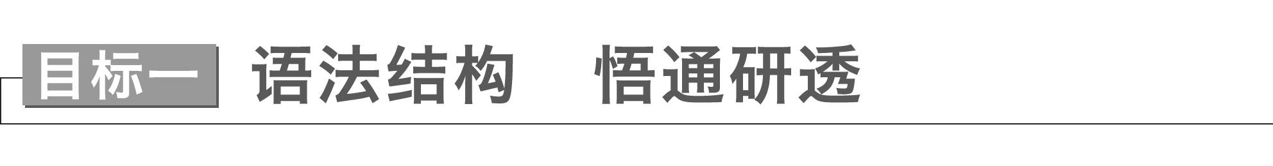

**Activity 1**　读文探究

阅读教材短文P20，请找出文中含有的定语从句。

|  |  |
| --- | --- |
| Restrictive relative clauses | 1....two countries **that are separated by a common language**.  2.There were times **when questions like...would be met with the reply**... |
| Non-restrictive relative clauses | 1.I spent one term in the **UK**，**where the greatest challenge was the indirect manner of speaking**.  2....a common opinion is “It’s not bad”，**which usually translates as “It’s awful”．**  3.Now，when speaking to Americans，**who have a preference for the direct style**，I found that I often failed to get straight to the point.  4.**As my experiences clearly show**，learning a language is just the beginning！ |

**Activity 2**　感悟规律

1．限制性定语从句用来修饰名词、代词或名词短语，并提供有关它的必要信息。在从句中，关系代词或关系副词前没有逗号。

2．非限制性定语从句提供关于句子或主句中名词或名词短语的附加信息。从句用逗号和主句分开。我们不能用that来引导非限制性定语从句。

**Activity 3**　语法精析

一、定义

在复合句中，修饰名词、代词或整个句子的从句叫作定语从句。被定语从句所修饰的词或句子叫先行词，作先行词的可以是一个词(通常是名词，也可以是代词)，一个短语，一个分句或一个完整的句子。引导定语从句的词叫关系词。关系词包括关系代词和关系副词。关系词有三大作用：连接主句和从句，替代先行词，在从句中充当句子成分。

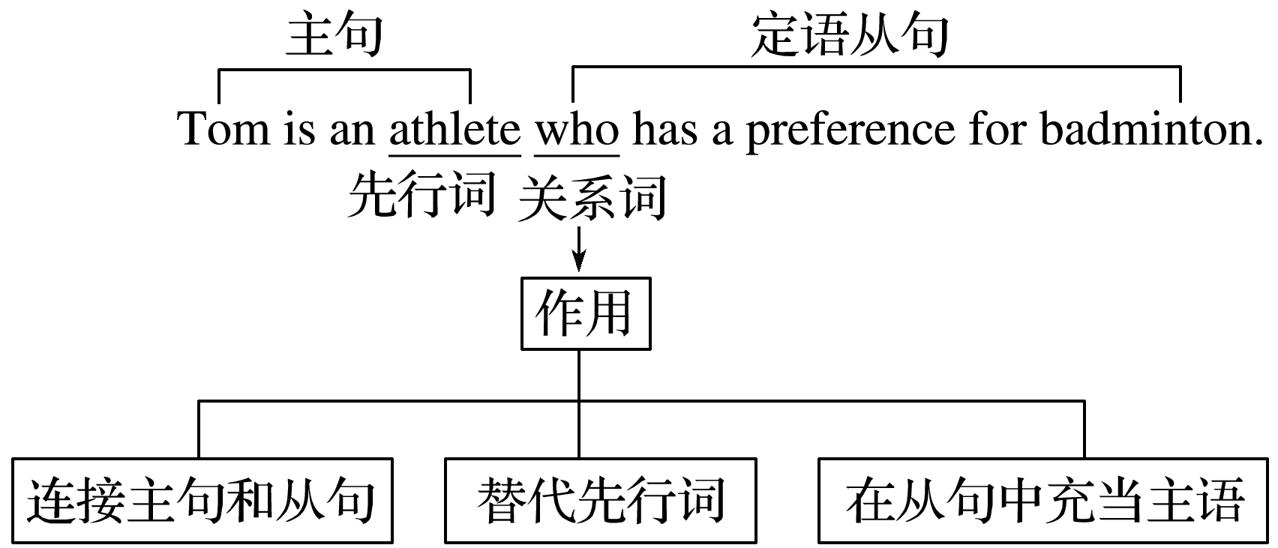

二、定语从句的分类

定语从句可以分为限制性定语从句和非限制性定语从句，其区别如下：

|  |  |  |
| --- | --- | --- |
|  | 限制性定语从句 | 非限制性定语从句 |
| 形式不同 | 不用逗号与主句隔开 | 用逗号与主句隔开 |
| 功能不同 | 是先行词不可缺少的定语，如果删除，主句则失去意义或意思表达不完整 | 只是对先行词的补充说明，如果删除，主句仍能表达完整的意思 |
| 翻译不同 | 一般把定语从句翻译在它所修饰的先行词之前，“……的” | 通常把定语从句翻译主句的并列句 |
| 关系词的使用不同 | ①关系词作宾语时可省略  ②可用 that和why  ③可用 who 代替 whom | ①关系词一律不可省略  ②不用 that和why  ③不可用 who 代替 whom |
| 先行词不同 | 只能是名词或代词 | 可以是名词或代词，也可以是短语或句子 |

People **who take physical exercise** live longer.

进行体育锻炼的人寿命长些。

His daughter，**who is in Boston now**，is coming home next week.

他女儿现在在波士顿，下星期回来。

三、关系代词的用法

(一)关系代词的基本用法

|  |  |  |
| --- | --- | --- |
| 关系代词 | 先行词 | 句法功能 |
| who | 人 | 作主语、宾语 |
| whom | 人 | 作宾语 |
| whose(＝of whom/of which) | 人或物 | 作定语 |
| that | 人或物 | 作主语、宾语、表语 |
| which | 物 | 作主语、宾语 |
| as | 人或物 | 作主语、宾语 |

However，because of poverty，Nolan has to leave high school and find a job，**whose life is full of ups and downs**.

然而，由于贫困，诺兰不得不从高中辍学去找工作，他的生活充满了起起落落。

We’ll reach the sales target in a month **which/that we set at the beginning of the year**.

我们将在一个月内完成年初定下的销售目标。

This woman has set a good example to her son，**who is a really lucky guy**.

这位女士给她的儿子树立了一个好榜样，他是一个非常幸运的家伙。

(二)关系代词that与which的用法

1．限制性定语从句中只用that不用which的情况：

(1)先行词是不定代词或者先行词被不定代词所修饰时，关系代词通常只用that。

Do you have **anything that** you want to say for yourself?

你有什么要为自己说的吗？

(2)先行词被序数词，形容词最高级，the only，the very，the last等修饰时，关系代词通常只用that，不用which。

This is one of **the most exciting** basketball games **that** my nephew has ever seen.

这是我侄子看过的最激动人心的篮球比赛之一。

(3)先行词既有人又有物时，关系代词只用that，不用which。

**The geophysicist and his achievements that** you told me about are admired by us all.

我们所有人都钦佩你告诉我的那位地球物理学家和他所取得的成就。

(4)定语从句出现在which或who的特殊疑问句中时用that。

Which is the kindergarten **that** you used to be studying in?

你以前就读的那家幼儿园是哪一家？

(5)有两个定语从句时，其中一个关系代词宜用which，另外一个宜用that。

They secretly built up a small factory，**which** produced things **that** could cause pollution.

他们偷偷地建了一家小工厂，这家工厂生产可能会造成污染的东西。

(6)当先行词在主句中作表语，而关系代词在从句中作表语时。

Nanjing is no longer **the city that** it used to be.

南京不再是过去的那座城市了。

2．只用which不用that的情况：

(1)引导非限制性定语从句。

The hungry bear followed his nose to our camp，**which** was surrounded by a high wire fence.

饥饿的熊顺着鼻子来到我们的营地，营地四周都是高高的铁丝篱笆。

(2)关系代词充当介词的宾语，且介词位于关系代词之前。

It was hard for him to learn English in a family **in which** neither of the parents spoke the language.

对他来说在一个父母都不会英语的家庭中，学英语很难。

(3)引导的定语从句修饰前面的整个主句，代替主句所表示的整体或部分概念。

Father helped them adjust the fire，**which** was the key to success.

父亲帮助他们调整火，这是成功的关键。

(三)which与as引导非限制性定语从句的区别

|  |  |  |
| --- | --- | --- |
|  | which | as |
| 位置上 | 只能放在主句的后面 | 位置灵活，可放在主句前也可放在主句后，有时还可插入主句中。 |
| 搭配上 | 无动词的限制 | ①谓语动词通常是表示感觉或心理活动的动词，如see，hear，know，expect，remember等。  ②当先行词被the same，such所修饰时。 |
| 意思上 | 意为“这一点” | 意为“正如……，正像……的那样”。 |

The award-winning book was written by a teenager，**which** was，indeed，beyond all expectations.

这本获奖的书是一个十几岁的孩子写的，这确实出乎所有人的意料。

**As** is known to us all，failure usually results from laziness while diligence can result in success.

众所周知，失败通常源于懒惰，而勤奋可以导致成功。

I have **the same** difficulty **as** you had last year.

我也有和你去年一样的困难。

[温馨提示]

as引导的定语从句，常见的结构有：

as is often the case情况常是如此

as often happens这种情况常发生

as has been said before正如以前所说的

as is known to all＝as we all know众所周知

as the saying goes 俗话说

as is reported/said正如所报道/说的那样

(四)whose的用法

whose是表示所属关系的代词，在定语从句中作定语修饰人或物，相当于 my，his，her，its，their 等。of which 可以代替whose 修饰物，词序一般是“the＋名词＋of which”或“of which＋the＋名词”。of whom 可以代替 whose 修饰人，词序是“the＋名词＋of whom或of whom＋the＋名词”。

The newly-built cafe，**whose walls/the walls of which/of which the walls** are painted light green，is really a peaceful place for us，especially after hard work.

这家新建的墙体被涂成浅绿色的咖啡厅对我们而言确实是个安静的场所，尤其是在辛苦工作之后。

I will talk to those students **whose homework/the homework of whom/of whom the homework** hasn’t been done on schedule.

我要和那些没完成作业的学生谈话。

四、关系副词的用法

|  |  |  |
| --- | --- | --- |
| 关系副词 | 先行词 | 句法功能 |
| when | 表时间 | 时间状语 |
| where | 表地点 | 地点状语 |
| why | 表原因 | 原因状语(只引导限制性定语从句) |

We live in an age **when** more information is available with great ease than ever before.

我们生活在一个比以前更容易获得更多信息的时代。

Ancient China was a place **where** states were often at war with each other.

古代中国是各诸侯国之间经常发生战争的地方。

The reason **why** my favourite sport is playing basketball is that it has been giving me strength to face the challenges in my life.

我最喜爱的体育运动是打篮球，原因是它一直给我力量来面对生活中的挑战。

[温馨提示]

where引导定语从句时，先行词除了可以是表示具体地点的名词(如 place，home，school，village 等)外，还可以是表示抽象地点的名词(如 job，life，situation，point，case，stage，activity 等)。

Sales director is a position **where** communication ability is just as important as sales skills.

在销售总监这个职位上，沟通能力和销售技巧一样重要。

To learn English effectively，you should not only have a good command of the grammar，but understand the culture **where** it is spoken.

要想有效地学习英语，你不仅要掌握好语法，还要了解说英语的国家的文化。

五、“介词＋关系代词”引导的定语从句

1．介词和关系代词的确定

若介词放在关系代词之前，关系代词指人时常用whom，指物时常用which。另外，whose也可以放在介词后，即“介词＋whose＋名词”结构。一般来说，确定关系代词前的介词，可以从以下三方面入手：①先行词的意思；②从句中动词或形容词与先行词的固定搭配；③句子的意思。

The man (**who/whom/that**) I talked with at the meeting is from Beijing University.

＝The man **with whom** I talked at the meeting is from Beijing University.

在会议中与我谈话的那个人来自北京大学。

Trading leather shoes is the business **to which** the Greens are devoted.

皮鞋生意是格林一家所致力于的事业。

We’ll climb Mangshan Mountain in the morning，on **whose** top we’ll have a picnic at noon.

我们上午去爬莽山，中午在山顶上野餐。

注意：但是在下面这类句子中for不可以提前，因为look for是固定的动词词组。

This is the diamond (**that/which**) the policemen are looking for.

这就是警察正在找的那颗钻石。

2．“of＋关系代词”引导的定语从句

在some，any，few，little，none，all，both，neither，many，most，each 等代词或数词的前、后表示整体与部分的关系可以用“of which/whom”。

He has a lot of friends，some **of whom** will offer help to him when he is in trouble.

他有许多朋友，当他遇到麻烦时有一些朋友会给他提供帮助。

六、先行词为**way**的情况

当先行词是way(意为“方式，方法”)时，定语从句的关系词有下列三种形式：

What surprised me was not what he said but the way (**that/in which**) he said it.

让我吃惊的不是他说的话，而是他说话的方式。

注意下面两个句子中关系词的不同，试比较：

The way (**that/which**) he explained to us was quite simple.

他向我们解释的那种方法很简单。

The way (**that/in which**) he explained the sentence to us was not difficult to understand.

他向我们解释这个句子的方式并不难理解。

七、定语从句中关系代词和关系副词的比较

引导定语从句的关系代词和关系副词除了起连接主句和从句的作用外，它们还有一个重要的作用——在定语从句中作成分。具体地说，关系代词在定语从句中作主语、宾语、定语或表语，而关系副词在定语从句中作状语。因此，在选择关系词时，最重要的是分析定语从句中所缺的成分，若从句中缺主语、宾语、定语或表语，则用关系代词；若从句中缺状语，则用关系副词。

试比较下面的句子：

Do you still remember the days (**that/which**) we spent in Qingdao?

你还记得我们在青岛度过的日子吗？

Do you still remember the days **when** we spent the summer holidays in Qingdao?

你还记得我们在青岛过暑假的日子吗？

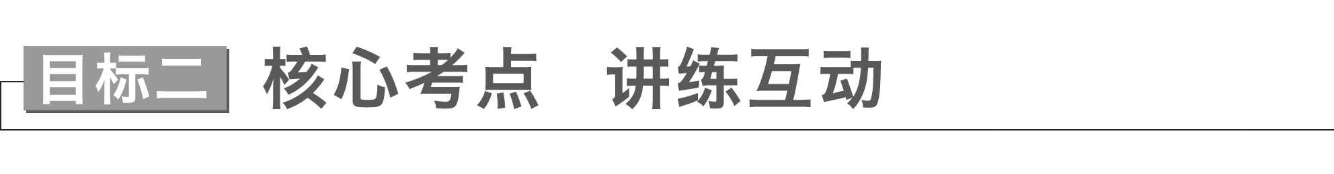

If you know what to avoid and how to behave，you will spare yourself embarrassment.(教材P21)

**behave *vi*.& *vt*.**表现得体，有礼貌

|  |
| --- |
| (1)behave well/badly to/towards sb.对待某人好/差  behave oneself守规矩；表现得体  (2)well behaved表现好的  badly behaved表现差的  (3)behaviour *n*．举止；行为  good/bad behaviour良好/恶劣的行为 |

[佳句赏读]　感悟句意·背诵

①They **behaved badly to/towards** the guests，which made us very disappointed.

②Much to my surprise，he **behaved** as if nothing had happened.In general，I was quite pleased with his **behaviour**.

③Some of them spoke pleasantly and were **well behaved**，while others were impolite and insulting.

[单句语法填空/完成句子/句型转换]

①It wasn’t surprising that the photographer was dismissed for his criminal behaviour(behave)．

②He disliked it when his nephew behaved badly(bad) in front of his mother.

③(应用文写作之建议信)To help you behave well when visiting your Chinese friend，I’d like to offer you some information concerning table manners.

为帮助你在拜访中国友人时行为得体，我想给你一些关于餐桌礼仪的信息。

④Though he was a little boy，he behaved well at the dinner party.

→Though he was a little boy，he behaved himself at the dinner party.

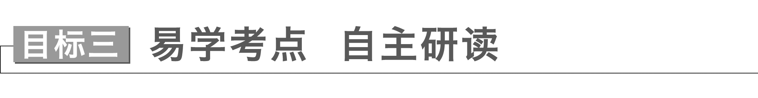

...are likely to feel upset or embarrassed even if they have no intention of hurting others...(教材P21)



**embarrassed *adj*.**窘迫的，尴尬的；拮据的

|  |
| --- |
| (1)be embarrassed at/about...对……感到尴尬  be embarrassed to do...对做……感到尴尬  (2)embarrassing *adj*.令人尴尬的  (3)embarrassment *n*．窘迫，难堪；使人为难的人或事物  to one’s embarrassment 令某人感到尴尬的是 |

①On no account should you **be embarrassed at/about** your failures.You should learn from them and try again.

你决不应该对自己的失败感到羞愧。你应该从失败中吸取经验，然后再尝试一次。

②Some women are too embarrassed to consult their doctors about the taboo problem.

有些妇女太害羞，不愿就禁忌问题向她们的医生咨询。

③It can be embarrassing for children to tell complete strangers about such incidents.

对孩子们来说，把这类事件告诉完全陌生的人是很尴尬的。

④Much to her embarrassment，she realized that everybody had been listening to her singing.

她意识到大家一直在听她唱歌，感到很不好意思。

Some behaviour that was not tolerated before might be accepted now.(教材P21)



**tolerate *vt*.**忍受，容忍；容许，允许；能经受

|  |
| --- |
| (1)tolerate (sb.) doing sth.容忍/忍受(某人)做某事  (2)tolerance *n*．宽容；容忍，忍受  (3)tolerant *adj*.宽容的；容忍的 |

①I can’t tolerate working(work) with Kate in the same office，for she always behaves badly to others.

我不能容忍和凯特在同一个办公室工作，因为她总是对别人不好。

②Instead of blaming the child who had broken the jade，she gave him a tolerant(tolerate) smile and let him go.

她没有责备那个打碎了玉的孩子，而是给了他一个宽容的微笑，让他走了。

③Tolerance(tolerate) means that you should respect the differences in others and not try to make them change.

宽容意味着你应该尊重他人的差异，而不是试图让他们改变。

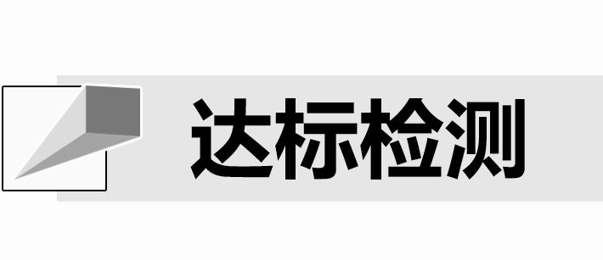

Ⅰ.语法填空(用关系词填空)

There was a time 1.when I was tired of learning English and disliked speaking English.And this was the reason 2.why my father forced me to join in a 30-day training in an English club before I went to senior high school.When I first came to the club,3.where I met many strangers，I missed my parents very much.So I packed up my things and wanted to go home.Fortunately，my guide,4.whose teacher was Yu Minhong，communicated with me face to face，from 5.whom/which I gained some useful instructions.He also introduced a good partner to me，and we got along well with each other.Gradually I adapted to the life there.Every day I would talk to other teenagers and set down a series of activities 6.(that/which) we did.I should be grateful to my father and the guide,7.who encouraged me to fall in love with English.Now I feel it interesting to learn English，into 8.which I put my entire energy.Every day I read my words and passages aloud.In class I join in English discussions.Before I go to sleep，I recall the passages，through 9.which I can memorize a large number of new words.10.As our English teacher says，“As long as you form the habit of learning English every day and have perseverance，you will master English sooner or later.”

Ⅱ.完成教材**P21 B**部分

## 课时跟踪练三

基础巩固



Ⅰ.用适当的连词填空

1．Can you still remember the time (that/which) we spent together in our childhood?

2．We have entered into an age when dreams have the best chance of coming true.

3．They were well trained by their masters who had great experience with caring for these animals.

4．He was late for the opening ceremony，which was very surprising to me.

5．All the presents (that) your friends gave you on your birthday should be put away.

6．She is such a girl as is always finding fault with other people.

7．Many young people，most of whom were well-educated，headed for remote regions to chase their dreams.

8．Scientists have advanced many theories about why human beings cry tears，none of which has been proved.

9．The number of smokers，as is reported，has dropped by 17 percent in just one year.

Ⅱ.单句写作

1．当我感到沮丧的时候，我经常选择阅读小说，它包含了很多富有想象力的故事。

When feeling depressed，I often choose to read a novel which includes a lot of imaginative stories.

2．我们计划这个周末去海淀公园散步，在那里我们可以欣赏早春的美丽景色。

We have planned to go for a walk in Haidian Park this weekend，where we could enjoy the beautiful scenery of early spring.

3．错过了我渴望已久的旅行，真是太遗憾了。

It is a pity for me to miss this trip that I have been longing for.

4．你知道中国有很多传统艺术形式，其中剪纸是最受欢迎的。

You know there are many traditional art forms in China，of which paper-cutting is one of the most popular.

5．我们都知道，亲近大自然对我们的健康有益。

As we all know，getting close to nature is beneficial to our health.

能力提升



Ⅲ.阅读理解

**A**

A young Mexican-born stood up for her community and fought for a cause that many thought was worthless because of whom she was going up against.Her name is Erica Fernandez.

Erica was born and raised in Michoacán，Mexico until the age of 12.At that time，her family migrated to the United States to the agricultural city of Oxnard，California.After a few years of living there，she developed a strong sense of community through familiar experiences and relationships with the people in Oxnard.

One day，Erica got word of the proposal of BHP Billiton，the richest mining corporation in the world，to build a natural liquefied gas facility off the Coast of Ventura County.This proposal would have had a 36-inch pipeline routed through low-income neighborhoods in Oxnard.The proposal was first presented to richer communities but was rejected.The company then added 10 miles to the project so that it can go around the richer communities and only affect Oxnard.This pipeline，had it gone through，would have caused 280 tons of air pollution each year，not only affecting the health of Oxnard residents，but also causing their crops and farmland to be affected largely.

Seeing that her community was going to be taken advantage of，Erica decided to do something about it.Erica joined forces with local community organizations to stand up to BHP Billiton and stop this proposal from going through，organized protests at the BHP Billiton offices，led marches through the neighborhoods that were going to be affected the most，and reached out to the media to get coverage on this injustice.

All of Erica’s efforts became worthwhile after her passionate speech before the California State Lands Commission.The project was asked to be vetoed and the Commission urged the Governor to do the same.It also led to the creation of SB41 2，a bill introduced in the California Senate that entitles(给予权利) communities to have a say in coastal construction proposals.

|  |
| --- |
| 语篇解读　这是一篇记叙文。文章记叙了墨西哥裔女子在移民美国后，为所在社区居民的利益而致力于反对一个对本社区造成很大危害的项目，最终这个项目被否决。 |

1．Why was Erica against the proposal of BHP Billiton?

A．She wanted her neighborhood protected.

B．She wanted rich neighborhoods influenced.

C．She wanted a sense of community developed.

D．She wanted a natural liquefied gas facility built.

答案　A

解析　推理判断题。根据文章第三段最后一句可知，如果这条管道穿过奥克斯纳，每年会造成280吨的空气污染，不仅影响奥克斯纳德居民的健康，还会对他们的庄稼和农田造成巨大影响。结合第四段第一句讲述Erica为反对天然液化气设备从她的社区通过所做的一系列事情，由此可以推断她反对这个提议的原因就是保护她所在的社区。故选A项。

2．What made Erica’s efforts pay off finally?

A．Delivering a speech.

B．Reporting the proposal.

C．Leading marches.

D．Organizing protests.

答案　A

解析　细节理解题。根据第五段第一句“All of Erica’s efforts became worthwhile after her passionate speech before the California State Lands Commission.”可知，Erica在加州土地委员会前所做的激情演讲使得她的所有付出得到了回报，“Erica’s efforts became worthwhile”呼应题目“Erica’s efforts pay off”。故选A项。

3．What does the underlined word “vetoed” in the last paragraph probably mean?

A．Allowed. B．Refused.

C．Completed. D．Created.

答案　B

解析　词义猜测题。根据最后一段第一句中的“All of Erica’s efforts became worthwhile...” 及最后一句“It also...proposals.”可知，这也导致了SB41 2法案的产生，该法案在加州参议院提出，赋予社区在海岸建设提案中有发言权。由此可推知Erica的抗议取得了预期的效果，即该项目的提案被否决。故选B项。

4．Which of the following can best describe Erica?

A．Ambitious and careful.

B．Humorous and considerate.

C．Courageous and determined.

D．Responsible and easy-going.

答案　C

解析　推理判断题。根据第四段主要讲述Erica不畏强权联合当地组织阻止提议通过，组织抗议行动，带领游行示威，勇于维护自己社区的权益，并为此坚持不懈的努力最终取得成功的故事。由此判断出，Erica勇敢而坚定。故选C项。

**B**

Finding a job is difficult.But what might be even more untoward is figuring out how to get used to the new environment that you are working in when you do finally manage to get a new job.Here are some tips for dealing with the adjustment period.

Be friendly to people.Any job is better when you are friends of the people that you are working with.You should be friendly to everyone that you are meeting.Actually listen to what these people tell you.Most people like making friends with those who are willing to listen.

Stay positive.One of the things that makes it difficult to adjust to a new job is negativity.If you automatically make judgments about things at the office that you aren’t going to like，then you’re going to find it difficult to approach the job with a positive attitude.Try to focus on the things that you like about the work and stay away from anyone that is saying negative things on the job.

Keep relaxed.Accept the fact that you probably aren’t going to get used to the new job immediately.You are going to make some mistakes.You are going to get confused or you’re going to confuse others by doing things more differently than what they’re used to.Be relaxed.The thing that you really need to get used to a new job is just time.

Getting used to a new job or a new work environment isn’t easy，but it doesn’t have to be particularly difficult either.Get to know the people that you are working with and the unspoken rules of the place by paying attention to what is going on around you and accepting that it’s going to take some time to get used to it all！After you have adjusted to your new job，the way to do the job well is coming to the first question.

|  |
| --- |
| 语篇解读　本文是一篇说明文。文章主要讲述的是如何适应新的工作环境。 |

5．The underlined word “untoward” in Para.1 probably means “ ”．

A．difficult B．impressive

C．important D．shocking

答案　A

解析　词义猜测题。根据画线词上文的“Finding a job is difficult.”以及画线词前的“even more”可推断，画线词所在句意为“获得新工作之后，如何适应新的工作环境更难”。即画线词的含义是“困难的”。

6．In the author’s opinion，you can learn unspoken rules by .

A．asking for others’ help

B．copying others’ behavior

C．following others’ instructions

D．noticing what’s going on in the workplace

答案　D

解析　细节理解题。根据最后一段倒数第二句可知，通过注意你周围发生的事来了解与你一起工作的人和潜规则。

7．If the passage continues，what may be talked about?

A．How to keep relaxed.

B．How to do your job well.

C．How to make fewer mistakes in your job.

D．The importance of adjusting to your new job.

答案　B

解析　推理判断题。根据最后一段最后一句可知，适应了新工作之后，如何做好这份工作就成为随之而来的首要问题。由此推断，文章接下来会阐述如何做好你的工作。

8．What would be the best title for this passage?

A．What to Do in an Interview

B．Ways to Find a Satisfactory Job

C．Tips for Adjusting to a New Job

D．How to Get Along Well with Others

答案　C

解析　标题归纳题。根据全文内容，尤其是第一段最后一句“Here are some tips for dealing with the adjustment period.”可知，本文主要讲述的是如何适应新的工作环境。

Ⅳ.语法填空

Tea or coffee？Sometimes we choose one over the other based on the belief that it’s 1.________(healthy)，better for keeping us alert(警觉的) or for calming us，or has fewer side effects.But is there any real reason to choose between tea and coffee，other than personal 2._______(prefer)?

The amount of caffeine in tea and coffee varies，3. depends on the strength，variety and brewing method，but coffee tends 4. (contain) more than tea.Purely based on the 5. (assume) that caffeine equals increased alertness，coffee wins at waking us up.But some research suggests it’s not that simple.

There’s evidence the effects of caffeine in a cup of tea are enhanced by an amino acid called L-theanine，if it is drunk 6. (regular)．The research finds “L-theanine may interact with caffeine to enhance performance 7. terms of attention switching and the ability to ignore distraction.” So if you find tea has 8. more positive effect on keeping you alert，you might be right!

What’s the price of all this extra alertness？After 5－6 hours，around half the caffeine you 9.______(drink) will still be in your system，and after 10－12 hours，a quarter of it could still be there，according to sleep scientist Matt Walker.This means you may have trouble 10. (stay) asleep.

|  |
| --- |
| 语篇解读　这是一篇说明文。文章主要从咖啡和茶中咖啡因含量的不同，来进一步介绍喝茶和喝咖啡对人的不同影响。 |

1．答案　healthier

解析　考查形容词的比较级。提示词healthy为形容词，意为“健康的”；分析句子结构及句意可知，设空处与下文better和fewer构成并列成分，意为“更健康的”，所以此处应用比较级；healthy的比较级形式是healthier。故填healthier。

2．答案　preference

解析　考查名词。空格处应用名词形式，personal preference意为“个人喜好”。故填preference。

3．答案　which

解析　考查非限制性定语从句。分析句子可知，此处为一个非限制性定语从句；在非限制性定语从句中，关系词指物，作主语，应用关系代词which。故填which。

4．答案　to contain

解析　考查不定式。分析句子结构及句意可知，此处考查固定结构tend to do sth.意为“倾向于做某事”，故填to contain。

5．答案　assumption

解析　考查名词。提示词assume是动词，意为“假设”；分析句子结构可知，设空前有定冠词the，设空后有that引导的同位语从句，所以设空处应用名词；assume的名词形式是assumption。故填assumption。

6．答案　regularly

解析　考查副词。分析句子成分可知，设空处用于修饰动词drunk，修饰动词应用副词；regular的副词形式是regularly。故填空regularly。

7．答案　in

解析　考查介词。in terms of 意为“就……而言；在……方面”。故填in。

8．答案　a

解析　考查冠词。分析句子结构及句意可知，此处考查固定结构have an effect on...，意为“对……有影响/作用”；设空后的more是以辅音音素开头的单词，所以应将结构中的冠词an换成a。故填a。

9．答案　have drunk

解析　考查动词的时态。提示词drink是动词，意为“喝”；分析句子成分可知，you作主语，提示词作谓语；根据句意可知，此处指过去发生的事情对现在造成的影响或结果，所以应用现在完成时态；主语you是第二人称，所以助动词应用have，drink的过去分词是drunk。故填have drunk。

10．答案　staying

解析　考查动名词。提示词stay是动词，意为“保持”；分析句子结构及句意可知，此处考查固定结构have trouble (in) doing sth.，意为“做某事有困难”，所以设空处应用动名词形式。故填staying。