## Period Five　Extended reading & Other parts

**Learning Aims**(学习目标)

1．Grasp the main idea of the passage on P25－26(重点难点)

2．Learn the following language points：integrate，oppose，tendency(重点难点)

3．Learn the following language points：cooperate，broaden one’s mind，slip，given that...(重点)

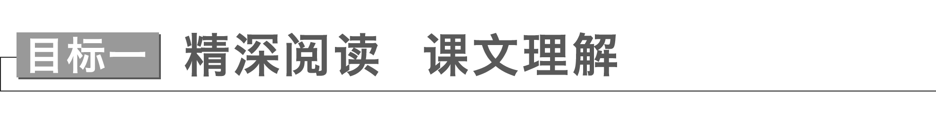

**Task 1**　宏观架构　整体理解

Ⅰ.Read the passage quickly and then fill in the blanks.

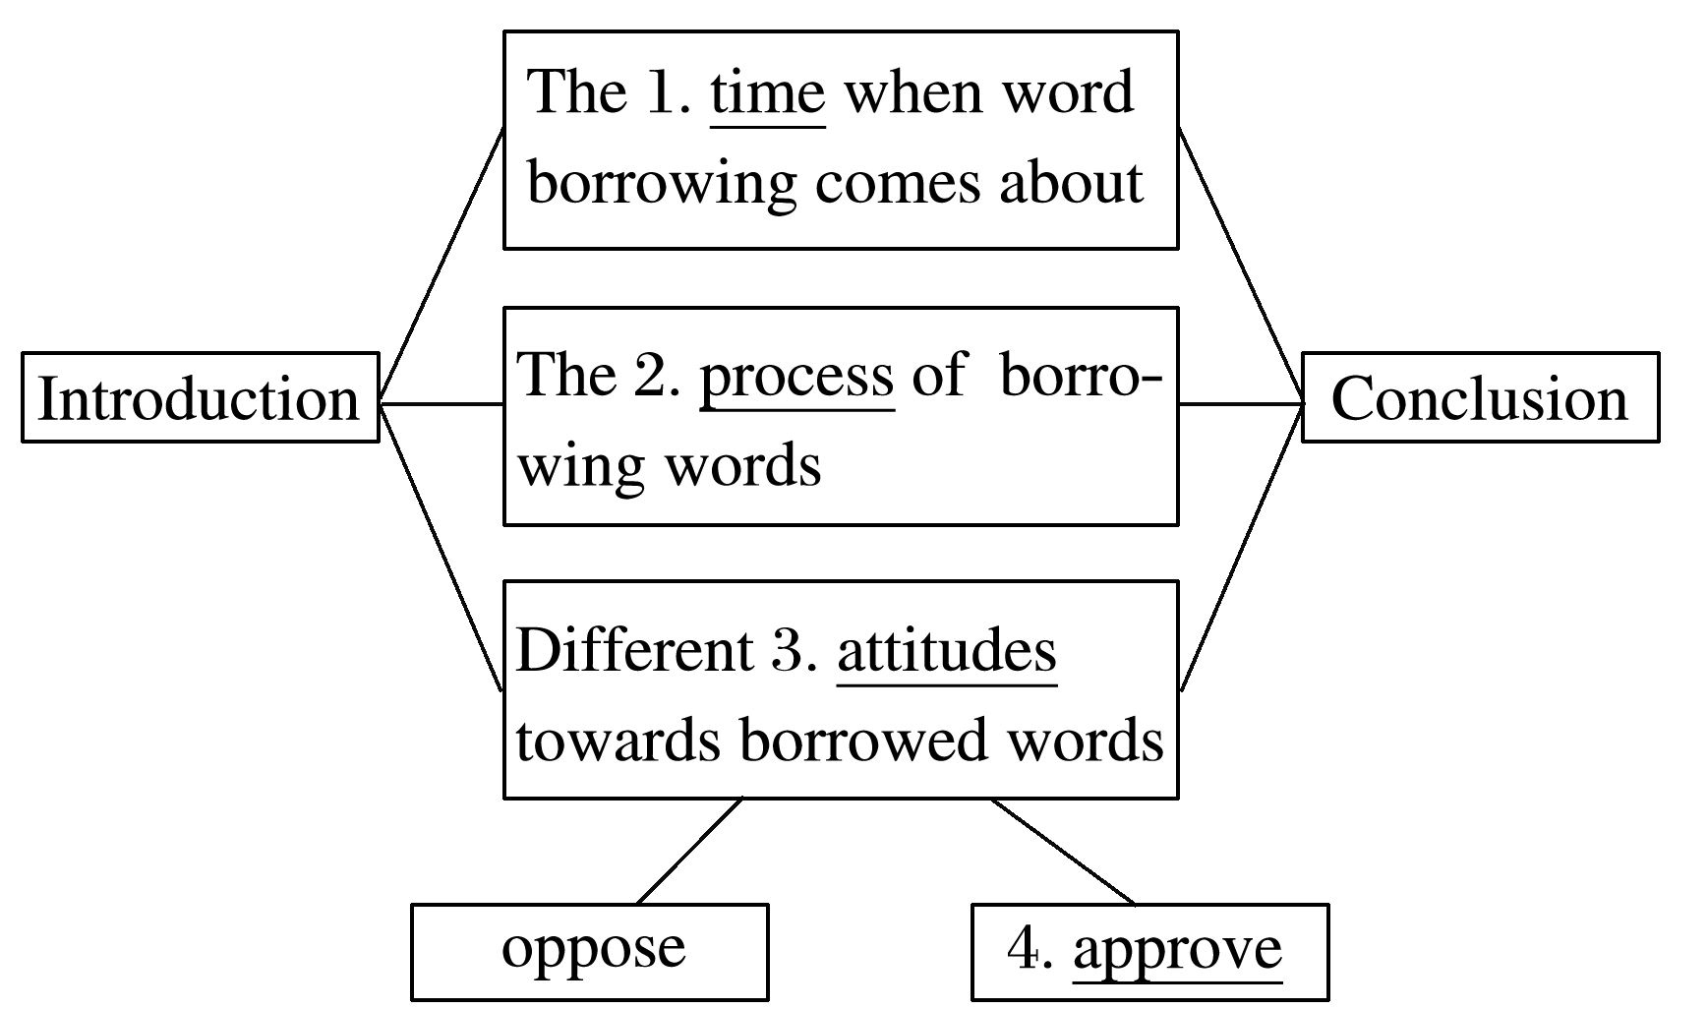

Ⅱ.The main idea of the passage is about borrowed words.

**Task 2**　微观剖析　细节把握

Read the passage carefully and choose the best answer.

1．Why does the author use some borrowed words as examples?

A．To show that many Chinese words are originally from the English language.

B．To show that English has borrowed words from more than 300 different languages.

C．To show that these borrowed words are interesting and useful.

D．To show that borrowing words is a common phenomenon in many languages.

答案　D

2．What makes it possible to borrow words directly from the source language faster than ever before?

A．The rapid development of communication technology.

B．The rapid development of culture.

C．The rapid development of languages.

D．The rapid development of human beings.

答案　A

3．Who was the first to use borrowed words?

A．The native speakers.

B．The bilingual speakers.

C．The people who do not know the original language.

D．The government officials.

答案　B

4．How does France avoid borrowed words?

A．By launching a boycott.

B．By setting up a non-government organization that creates new words.

C．By setting up an official organization that creates new words.

D．By resisting learning other languages.

答案　C

5．What is the author’s attitude towards word borrowing?

A．Negative. B．Positive.

C．Indifferent. D．Critical.

答案　B

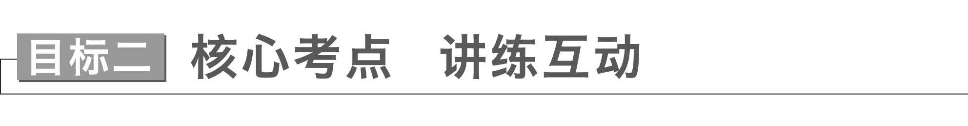

Though borrowing words has become faster，the process is still complex，and it takes time before new words are integrated into everyday speech.(教材P25)



**integrate *vt*.& *vi*.**(使)合并；(使)加入

|  |
| --- |
| (1)integrate A into/with/and B使A与B结合，使A与B成为一体  integrate A into B使A加入B，使A融入B  (2)integration *n*．整合，结合；一体化；融合 |

[佳句赏读]　感悟句意·背诵

①(应用文写作之报道一次活动)Those buildings **integrated** Chinese and western architectural styles，which left a deep impression on us.

②It was astonishing that they had begun to **integrate** teamwork and cooperation **into** their games.

③As has been reported，the aim of these enterprises is to promote closer economic **integration**.

[单句语法填空/完成句子]

①His music is an integration(integrate) of tradition and new technology，which gains popularity among people.

②It’s disappointing that these programs can barely be integrated(integrate) into your existing software.

③The policy is to integrate children with special needs into ordinary schools.

这项政策旨在使有特殊需要的儿童融入普通学校。

Borrowed words are an outcome of language development that can hardly be avoided，but some language communities oppose adopting words from other cultures.(教材P25)



**oppose *vt*.**反对，抵制；与**……**对垒

|  |
| --- |
| (1)oppose sth./doing sth.反对(做)某事  oppose sb./sb.’s doing sth.反对某人做某事  (2)opposed *adj*.反对的；对立的  be opposed to反对……；与……对立 |

[佳句赏读]　感悟句意·背诵

①The captain firmly **opposed** (them/their) cooperating with the opponents while the players approved.

→The captain **was** firmly **opposed to** cooperating with the opponents while the players approved.

② It was disappointing that Harry agreed with our plan，while Jim **opposed/was opposed to** it.

[单句语法填空/句型转换]

①The senior students are strongly opposed to being treated(treat) unfairly by others.

②Although we were opposed(oppose) to littering，some visitors ignored us and behaved badly.

③(应用文写作之环境保护)In order to protect the environment，I firmly object to using disposable chopsticks.

→In order to protect the environment，I firmly oppose/am firmly opposed to using disposable chopsticks.

For better or for worse，the tendency to borrow words has never gone out of style.(教材P26)



**tendency *n*．**趋势，趋向；倾向，偏好

|  |
| --- |
| (1)have a tendency to do sth.倾向于做某事  (2)tend *vi*.& *vt*.趋向；易于；照顾  tend to do sth.倾向于做某事  tend (to) sb./sth.照料；照管；护理 |

[佳句赏读]　感悟句意·背诵

①Recent years have seen a **tendency** in China that tourism is growing fast.

②He **has a tendency to be** pessimistic when faced with difficulties.

→He **tends to be** pessimistic when faced with difficulties.

③It’s privileged for me to **tend** (**to**) your pet dog when you are on duty.

[单句语法填空/句型转换]

①As is often the case，students tend to be judged(judge) by their performance in exams.

②Children tend to behave properly in the presence of strangers.

→Children have a tendency to behave properly in the presence of strangers.

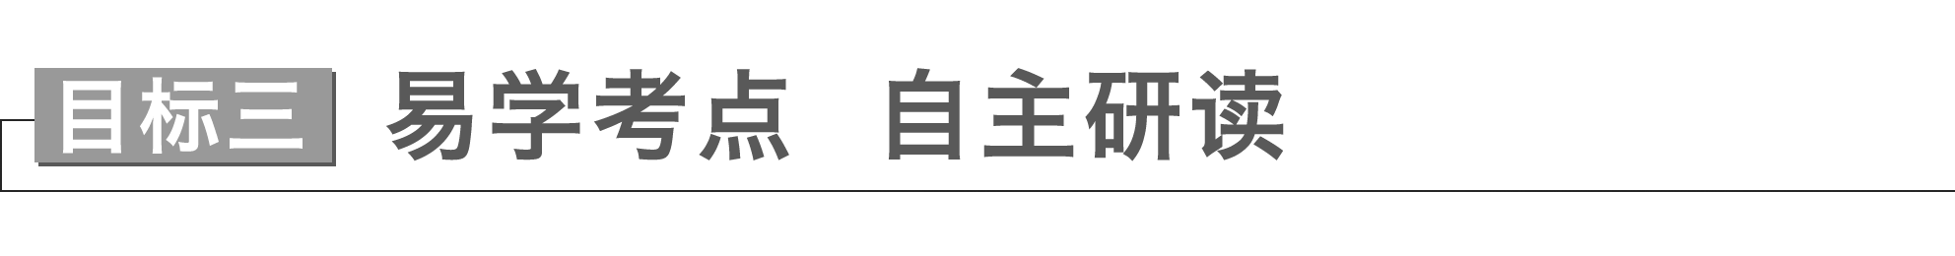

For example，there is China’s Belt and Road Initiative，which motivates many countries along the Silk Road to cooperate more closely.(教材P23)



**cooperate *vi*.**合作，协作；协助，配合

|  |
| --- |
| (1)cooperate with与……合作  (2)cooperation *n*．合作，协作  in cooperation with与……合作 |

①Only if the players trust each other can they **cooperate** well in the match.

只有队员们互相信任，他们才能在比赛中合作得很好。

②Now we focus more on finding the best way to solve the core problems by cooperation.

现在我们更注重通过合作找到解决核心问题的最佳方法。

③Our company has established a good reputation in cooperation with other enterprises.

我们公司在与其他企业的合作中建立了良好的信誉。

④We will cooperate closely with the international community to arrest international criminals.

我们将与国际社会密切合作，逮捕国际罪犯。

Learning Chinese helps them see life from a new perspective and broaden their minds to the outside world.(教材P23)



**broaden one’s mind**拓展视野，开阔眼界

|  |
| --- |
| make up one’s mind to do sth.决心做某事  change one’s mind改变主意  bear/keep sth.in mind记住某事  never mind不要紧；没关系 |

①(利弊对比的议论文)While travelling can **broaden your mind**，I don’t think it’s a good idea to spend substantial time and money on it.

尽管旅游能够增长见识，但是我认为在这方面花费大量的时间和金钱不是一个好主意。

②There is no possibility that the linguist will give up the plan once he has made up his mind to carry it out.

这位语言学家一旦下定决心实施计划，就不可能放弃。

③It never occurred to me that you could succeed in persuading him to change his mind.

我从未想过你会成功地说服他改变主意。

④As students，we should bear/keep in mind that it is worthwhile to take exercise.

作为学生，我们应该牢记锻炼是值得的。

⑤Never mind who told me.That’s of no importance.

谁告诉我都没关系，那不重要。

When I was trying out your skateboard，I slipped.(教材P27)



**slip *vi*.**滑倒；滑落；溜；陷入***n*.**差错；纸条；滑跤

[一词多义]

①Unfortunately，the photographer **slipped** over on the ice and broke her leg.滑倒

②The fish **slipped** out of the fisherman’s hand and swam into the deep sea.滑落

③It was because he **slipped** into debt that he was eager to make his fortune.陷入

④To our surprise，my nephew recited the whole poem without making a single **slip**.差错

⑤I was ashamed of what I had done so I wrote an apology down on a **slip** of paper.纸条

|  |
| --- |
| (1)slip in悄悄溜入；偷偷溜进去  slip into...悄悄溜入……  slip out of...悄悄溜出……  (2)slippery *adj*.滑的；狡猾的；靠不住的 |

⑥Mrs Green was woken up and she found a criminal **slipping into her room** to try his luck.

格林太太被惊醒，她发现一个罪犯溜进她的房间想碰碰运气。

⑦The rain made roads slippery，which often resulted in car accidents.

雨使道路湿滑，经常导致车祸。

This comes as no surprise，given that English has borrowed words from more than 300 different languages，including Latin，Greek，French and Chinese.(教材P25)



**given that...**

|  |
| --- |
| (1)句中given that...为独立成分作状语，不受逻辑主语的影响，given意为：考虑到，鉴于。  (2)常见的独立成分作状语的还有：  considering that...鉴于……；考虑到……  generally speaking总的来说  judging by/from...从……来看；依据……来判断  supposing that...假定……  providing that...假定……  to tell the truth实话实说  to be honest老实说 |

①**Given/Considering that** his state of health，his son took him over and was in charge of the company.

考虑到他的身体健康状况，他的儿子接替了他主管公司。

②Judging from his accent，he is from Hong Kong.

从口音判断，他是香港人。

③To tell you the truth，I am a little tired and need more sleep.

说实话，我有点累，需要多睡会觉。

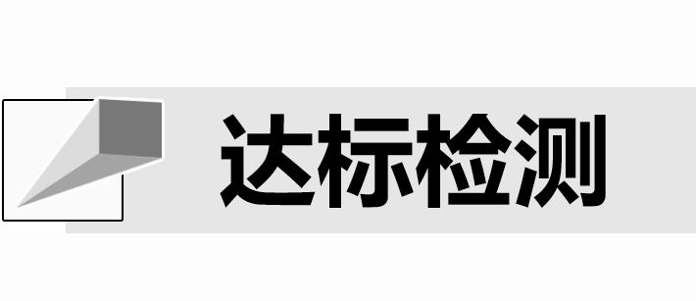

Ⅰ.单句语法填空

1．All governments are paying great attention to this issue，but to stop terrorism is indeed a complex project，which requires substantial effort，wisdom and cooperation(cooperate)．

2．After being released，the criminal found it difficult to integrate(integrate) into society.

3．Neither the alarm nor her dog made a sound when the criminal slipped(slip) in.

Ⅱ.完成句子

1．(应用文写作之报道一次活动)This visit not only broadened my mind，but also aroused my interest in science.

这次访问不仅开阔了我的视野，而且激发了我对科学的兴趣。

2．(利弊对比的议论文)Another reason why I oppose going abroad for studies is that it costs a substantial sum of money.

我反对出国留学的另一个原因是它需要花费很多钱。

3．Just as importantly，we tend to associate fresh air with health care.

同样重要的是，我们倾向于将新鲜空气与医疗保健联系起来。

4．Given that he had never earned so much money，he was so happy that he could hardly speak.(2020·新高考全国Ⅰ，读后续写)

鉴于他从未挣过这么多钱，他高兴得几乎说不出话来。

## 课时跟踪练四

基础巩固



Ⅰ.单词拼写

1．You should recite more passages to have your vocabulary enriched，which is of vital importance to English learning.

2．He was disappointed when the result didn’t correspond(相一致) with what he desired.

3．They behaved very badly towards the geophysicist，which aroused public anger.

4．It is worthwhile cooperating(合作) with other countries to build a peaceful world.

5．I’m strongly opposed to tearing down these ancient buildings，which are part of the culture.

6．The two criminals slipped(溜) out of the diamond shop，disappearing in the darkness.

7．My teacher approved of me taking part in the speech contest to be held by my school next Friday.

8．Judging from the linguist’s accent(口音)，he must be from southeast of Shandong Province.

Ⅱ.选词填空

1．I had intended to sign up for the English speech contest，but I gave up in the end.

2．Theory should be based on practice，which is the basic principle I stick to.

3．There is no doubt that taking part in the golf contest has broadened my mind and increased my confidence.

4．I’m sure he is competent to finish the task because he has a preference for challenging work.

5．In my opinion，we can share information with each other to broaden our minds.

Ⅲ.单句写作

1．这就是为什么我反对参加这个活动。(be opposed to)

That’s why I am opposed to participating in the activity.

2．我最大的挑战是学习如何在餐桌上举止得体。(behave oneself)

My biggest challenge is learning how to behave myself at the dinner table.

3．这是我第一次因为太尴尬而无法发表演讲。(be embarrassed to do...)

This is the first time that I have been too embarrassed to deliver a speech.

4．女性往往花更多的时间照顾孩子和做家务。(tend to do...)

Women tend to spend more time taking care of their children and doing housework.

5．我参加过几次类似的活动，使我获得了相关经验。(现在分词短语作结果状语)

I have participated in several similar activities，enabling me to obtain relevant experience.

能力提升



Ⅳ.七选五

Imagine a child standing on a diving board four feet high and asking himself the question：“Should I jump？”This is what motivation or the lack of it can do.Motivation and goal setting are the two sides of the same coin. 1 Like the child on the diving board，you will stay undecided.

2 More than that，how should you stay motivated to achieve the goal? First，you need to evaluate yourself，your values，your strengths，your weaknesses，your achievements，your desires，etc.Only then should you set your goals.

You also need to judge the quality and depth of your motivation.This is quite important，because it is directly related to your commitment.There are times when your heart is not in your work. 3 So，slow down and think what you really want to do at that moment.Clarity(清晰) of thoughts can help you move forward.

Another way of setting realistic goals is to analyze your short and long term objectives，keeping in mind your beliefs，values and strengths.Remember that goals are flexible. 4 They also need to be measurable.You must keep these points in mind while setting your goals.

Your personal circumstances are equally important.For example，you may want to be a pilot but can’t become one because your eyesight is not good enough. 5 You should reassess your goals，and motivate yourself to set a fresh goal.

You will surely need to overcome some difficulties，some planned，but most unplanned.You cannot overcome them without ample motivation.Make sure that you plan for these difficulties at the time of setting your goals.

A．This can affect your work.

B．So how should you motivate yourself?

C．However，this should not discourage you.

D．So why should we try to set specific goals?

E．They can change according to circumstances.

F．Motivation is what you need most to do a good job.

G．Without motivation，you can neither set a goal nor reach it.

|  |
| --- |
| 语篇解读　本文是一篇说明文，主要介绍了动机和目标的关系以及如何激发动机并设定切实可行的目标。 |

1．答案　G

解析　根据空前一句可知，此处在讲动力和设定目标之间的关系，故G项“没有动力，你既无法设定目标，也无法实现目标”符合语境。

2．答案　B

解析　第一段阐述了动力和设定目标之间的关系，结合空后一句可知，空处与空后内容形成递进关系，故B项符合语境。

3．答案　A

解析　空前讲有时候你的心思并不在工作上，由此可知空处应选A项“这会影响你的工作”。

4．答案　E

解析　根据空前一句中的“goals are flexible”可知，目标是可变动的，因此E项“它们可以根据情况而改变”符合语境。

5．答案　C

解析　空前一句说你可能想当飞行员，但因为视力不够好，你的目标不能实现。再结合空后一句中的“reassess your goals...set a fresh goal”可知，C项“然而，这不应该让你气馁”符合语境。

Ⅴ.完形填空

I have a degree in business.But it was my father’s 1 for me to seek to attain a business major.He thought that having a business major would 2 me more available choices and make me more 3 in entering a global labor market.I took his advice.However，even though my college experiences were 4 ，I had no interest in any 5 of commerce，let alone having a long-term career(职业) as a businesswoman.

After I 6 ，I worked as a marketing planner at a computer company.My 7 and working environment were great；yet I 8 didn’t feel happy doing something that held little 9 for me.After two months of working there，I made up my mind to 10 and decided to do what I love，namely teaching history.I have now been doing this job for over twenty years.I am 11 of being with my students.

If you are in a 12 where you don’t love what you are learning or doing，please ask yourself what you are really 13 about.Take some time to think about what career could bring 14 to you.

I like this motto “Success is not the key to happiness. 15 ，happiness is the key to success.” If you love what you are doing，you will be successful.

|  |
| --- |
| 语篇解读　本文是一篇夹叙夹议文。作者的父亲替作者做出了攻读商科专业的决定，但作者始终对商科不感兴趣；工作后，从商优厚的薪水并没有让作者开心。作者最终决定辞职去做自己感兴趣的教学工作。 |

1．A.ambition B．commitment

C．decision D．response

答案　C

解析　从下文“He thought that having a business major would me more available choices and make me more in entering a global labor market.I took his advice.”可知，攻读商科是父亲的决定(decision)。故选C项。

2．A.guarantee B．save

C．leave D．pass

答案　A

解析　根据“...more available choices and make me more in entering a global labor market.”可知，作者的父亲认为主修商科能够保障(guarantee)作者未来的就业。故选A项。

3．A.independent B．competitive

C．energetic D．flexible

答案　B

解析　根据“more available choices”可知，作者的父亲认为主修商科，就业面广，有更多的选择机会，即更有竞争力(competitive)。故选B项。

4．A.fantastic B．awkward

C．painful D．plain

答案　A

解析　根据句中出现“even though”及“I had no interest in any of commerce”可知，句意出现了转折，因此推断出，作者大学里学的商科，成绩很棒(fantastic)，但是她对商科不感兴趣。故选 A项。

5．A.paper B．field

C．college D．job

答案　B

解析　根据下文“...yet I didn’t feel happy doing something that held little for me.”可知，她对从事有关商业的任何领域(field)都不感兴趣。故选B项。

6．A.matured B．graduated

C．succeeded D．trained

答案　B

解析　根据“My and working environment were great...”可知，作者毕业(graduated)后参加了工作。故选B项。

7．A.future B．dream

C．scholarship D．pay

答案　D

解析　根据“and working environment were great”可知，该空与“工作环境”构成并列，由此可推知，作者的薪水(pay)和工作环境都很棒。故选D项。

8．A.only B．also

C．still D．even

答案　C

解析　根据“...I made up my mind to and decided to do what I love，namely teaching history.”可知，作者后来决心做自己喜欢的事情，当了一名历史老师。因此，尽管薪水和工作环境很好，她仍然(still)不高兴，才下决心做出改变。故选C项。

9．A.advantage B．appeal

C．chance D．trouble

答案　B

解析　根据“didn’t feel happy”可知，这些事情对她来说，没有吸引力(appeal)。故选B项。

10．A.quit B．continue

C．consider D．wait

答案　A

解析　根据“namely teaching history”可知，作者辞职(quit)以后，当了一名历史老师。故选A项。

11．A.fond B．tired

C．proud D．careful

答案　A

解析　根据上一句“...I made up my mind to and decided to do what I love，namely teaching history.”可知，作者辞掉了不喜欢的工作，转而去做她喜欢的事情，做了一名历史老师。因此，她喜欢(fond)和学生在一起。故选A项。

12．A.firm B．game

C．story D．place

答案　D

解析　分析句子结构可知，这是一个定语从句，从句“where you don’t love what you are learning or doing”修饰的先行词指的是在一个你不喜欢学或者不喜欢做事情的地方(place)，故选D项。

13．A.anxious B．optimistic

C．enthusiastic D．nervous

答案　C

解析　根据下一句“Take some time to think about what career could bring to you.”可知，作者建议如果你不喜欢学你正在学的东西或做的事情，就要考虑换一个职业，而且换职业要根据自己的爱好，看看自己热衷(enthusiastic)于什么。故选C项。

14．A.love B．joy

C．confidence D．knowledge

答案　B

解析　根据上一句可知，作者建议如果你不喜欢学你正在学的东西或做的事情，就要考虑换一个职业，而且，换职业要根据自己的爱好，看看哪种职业能够给自己带来快乐(joy)。故选B项。

15．A.As a result B．On the whole

C．In the meanwhile D．On the contrary

答案　D

解析　根据 “happiness is the key to success”可知，幸福是成功的关键，与上一句“Success is not the key to happiness.”构成正反关系，即：恰恰相反，相反地(On the contrary)。故选D项。

Ⅵ.读后续写

阅读下面材料，根据其内容和所给段落开头语续写两段，使之构成一篇完整的短文。

Desiree，a 4-year-old girl，was sobbing quietly over her father，Ken，who had died nine months earlier.She was hugging a photograph of her father with her fingers running around his face.“Daddy，”she said softly，“Why won’t you come back？”

Instead of gradually adjusting to her father’s death，Desiree refused to accept it.“Daddy will be home soon，” she’d tell her mother.“He’s at work.” When she played with her toy telephone，she pretended she was chatting with her father.“I miss you，Daddy，”she’d say，“When will you come back？” Desiree’s situation made her mother worried.

Days later，it was Ken’s birthday.“How will I send him a card？” Desiree asked her mother.“How about if we tie a letter to a balloon，” her mother said，“and send it up to heaven？” Desiree’s eyes immediately lit up.

Her mother took her to a store and Desiree picked out a balloon with HAPPY BIRTHDAY above a drawing of The Little Mermaid(美人鱼)．Desiree and her father had often watched it.The child’s eyes shone as they were on the way to Ken’s grave.Then Desiree dictated a letter to her dad.“Tell him，‘Happy birthday，I love you and miss you，’” she rattled off(快速说)．“‘I hope you get this and can write to me on my birthday in January.’”

Her mother wrote the message and their address on a small piece of paper，which was then wrapped in plastic and tied to the end of the string on the balloon.Finally，Desiree released the balloon.For almost an hour，they watched the shining spot of silver grow smaller and smaller till disappear.“Now Dad’s going to write back to me，” Desiree declared confidently.

Every day since they’d released the balloon，Desiree had asked her mother，“Do you think Daddy has my balloon yet？” Several weeks passed，and she stopped asking.

注意：续写词数应为150左右。

One day,3,000 miles away，Wade was on a duck hunt when suddenly something in the bush caught his eyes.

Desiree’s fifth birthday came and later on the afternoon，a package arrived.

参考范文



One day,3,000 miles away，Wade was on a duck hunt when suddenly something in the bush caught his eyes.Curious，he approached to find a silver balloon，with a piece of paper at the end of the string，wrapped in plastic.Taking it home，Wade read the touching lines to his wife Donna.She was deeply moved.With tears in her eyes，Donna decided to help Desiree.The couple went to buy a birthday card and a book of *The* *Little* *Mermaid*，and then she began to write a letter to Desiree.

Desiree’s fifth birthday came and later on the afternoon，a package arrived.Looking at the unfamiliar return address，Desiree’s mother was confused.Suddenly an idea struck her: the balloon! She opened the package and found a card with “For a Dear Daughter...” Her heart raced.She rushed to Desiree’s room and showed her the letter.“It’s from Daddy！” Desiree jumped with joy，asking her mother to read it for her.“ ‘Happy birthday’，my little angel ...” Her mother began.Tears began to trickle down Desiree’s cheeks.