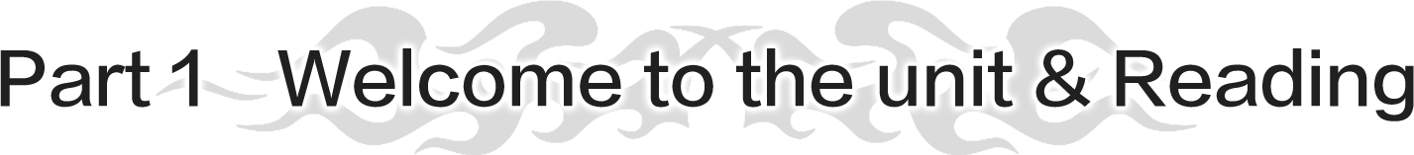

## Period one　Welcome to the unit & Reading—Reading comprehension(0.5课时+1.5课时+1课时练习)

1. 了解小说的基本要素，学会欣赏欧·亨利的写作风格。

2. 理解诚信与责任的意义。

3. 思考在诚信与责任相冲突时应如何抉择，形成正确的价值观。

阅读策略点拨

文学作品阅读

“文学与艺术”是高中新课标中的24个话题之一。该话题主要包括各种文学类型、艺术形式、文化名人、艺术家等方面。因此，同学们在日常生活中应关注文学与艺术的相关信息，多涉足文学与艺术领域，亲自去感受文学与艺术的魅力，从而开阔视野，提升文学素养。

阅读文学作品策略：

1. 六要素阅读策略

阅读一篇文学作品时，同学们需关注setting、 characters、 plot、 feeling、 symbolism及theme六要素，进行整体把握。

2. 情节发展阅读法

情节指故事发展中的一系列事件，通常按时间、空间等顺序逐步推进。要把握故事情节，同学们需关注以下五个主要方面：beginning、 rising action、 climax、 falling action及resolution。

Homework: English Weekly26 A2 1+B123

## Period Two　Welcome to the unit & Reading—Language points（2课时）

**Learning Aims**(学习目标)

1．Learn the following language points：appointment，reliable，worthwhile，anyhow(重点难点)

2．Learn the following language points：make one’s fortune，arm in arm，suspect，arrest(重点)

Homework: English Weekly26 A2 1+B123



**(2课时）**

1. 了解状语从句的类型和使用规则。

2. 能够在真实语境中正确使用状语从句。

3. Learn the following language points：ashamed，forgive(重点难点)

**Activity 3**　语法精析

一、定义

1．状语定义：状语是用来修饰谓语、形容词或副词，或是整个句子的成分。

2．状语从句：当充当状语的部分是一个句子时，该句子就是状语从句。

二、状语从句的分类

(一)时间状语从句

1．when，while和as引导的时间状语从句

2.before和since引导的时间状语从句

|  |  |  |
| --- | --- | --- |
| 连词 | 词义 | 常用句式 |
| before | 在……之前；还没有来得及……就……；  趁着……；……才…… | ①It will be/was＋一段时间＋before...  要过/过了……时间才……  ②It won’t be＋一段时间＋before...过不了多久就会……  ③It wasn’t＋一段时间＋before...没过多久就……了 |
| since | 自从……以来 | It is/has been＋一段时间＋since从句(从句用一般过去时) |

3．till/until引导的时间状语从句

(1)until/till用于肯定句时，其主句谓语动词为延续性动词；(2)not...until/till...所在的主句的谓语动词为非延续性动词；(3)until可用于句首，而till不能；(4)not until 置于句首，主句要用部分倒装；(5)it is/was not until...that...强调句型。

4．表示“一……就……”的连词引导的时间状语从句

(1)as soon as，the moment/minute/instant，immediately/directly/instantly等。

(2)在hardly...when...，no sooner...than...结构中，主句用过去完成时，when或than所在的从句用一般过去时。

。

5．其他连词引导的时间状语从句

every time/each time(每次)，(the) next time(下次)，any time(随时)，(the) last time(上次)，the first time(第一次)，by the time(当……的时候)

到你回来的时候，我们将已完成这项工程。

(二)原因状语从句

|  |  |  |
| --- | --- | --- |
| 连词 | 意义和用法 | 例句 |
| because | because表示人们不知道的直接的原因或理由，通常用于回答why引出的疑问句，语气最强 | He didn’t take in what he read because his mind was focused on something else.  他看不懂所读的东西，因为他的心思都集中在别的事情上了。 |
| as | as引导的原因状语从句所引出的理由在说话人看来已经很明显，或已为听话人所熟悉而不需要强调 | As it is snowing，we shall not climb the mountain.由于在下雪，我们不去爬山了。 |
| since/now that | 表示人们已知的事实，不需要强调的原因，故常译为“既然……” | Now that/Since you’ve grown up you must learn to stand on your own two feet.  你既然已经长大成人，就得学会独立生活。 |
| seeing (that) | 鉴于；由于 | Seeing (that) the weather is bad，we’ll stay at home.鉴于天气不好，我们将待在家里。 |
| in that | “因为；基于……的理由”，可以和because换用 | I wonder whether his hearing is okay in that he has turned the television up very loud.  我不知道他的听力否还好，因为他把电视声音开得很大。 |

(三)结果状语从句

结果状语从句常由so that(因此)，so...that...，such...that...等引导。

so...that...和such...that...引导结果状语从句，表示“如此……以至于……”。结构形式如下：

(四)让步状语从句

让步状语从句一般翻译为“尽管……，即使……”，就是我们日常生活中用的“退一步说……”的感觉。

1．although/though引导的让步状语从句

although/though，意为“虽然；尽管”，可与yet，still，nevertheless连用，但不能和but连用。

2．while引导的让步状语从句

while意为“虽然；尽管”，多用于正式文体，且多位于句首，相当于although。

3．as引导的让步状语从句

as意为“尽管，虽然”，从句多位于主句之前，而且必须使用倒装语序，此时可与though换用。

**Child as/though** he was，he helped me a lot.

尽管他是个孩子，他却帮了我很大的忙。

4．even if/though引导的让步状语从句

even if/though意为“即使，尽管”。

5．疑问词-ever与“no matter＋疑问词”引导的让步状语从句

疑问词-ever表示“无论……”，引导让步状语从句时，相当于“no matter＋疑问词”。

6．whether...or...引导的让步状语从句

whether...or...意为“无论……还是……”，提供两种对比情况。

自从洪灾以来，所有的人，无论他们是年老还是年幼，富有还是贫穷，都在尽他们最大的努力去帮助那些需要帮助的人。

(五)其他类型的状语从句

|  |  |
| --- | --- |
| 状语从句 | 连词 |
| 地点状语从句 | where，wherever等 |
| 目的状语从句 | so that(为了)，in case(以免，以防)，for fear that(唯恐，以防)，in order that等 |
| 条件状语从句 | if，unless (除非)，as/so long as(只要)，on condition that(只要)，in case (假使)，providing/provided (that)，supposing (that)(假使，倘若)等。 |
| 方式状语从句 | as，as if/as though等 |
| 比较状语从句 | as...as...，the same as，比较级＋than，the＋比较级...，the＋比较级...等 |

Homework:





1. 通过听、说、读、看、写加深对善意的谎言的认知。

2. 辩证思考善意的谎言的意义。

3. 学会使用不同词汇和不同句式来丰富书面表达。

策略指导

英语听力测试不只是考查学生的英语听力，同时还会考查学生的临场应变能力、猜测能力和记忆能力等。平时还要多积累一些常见的话题词汇和话题句式。本单元的话题是善意的谎言。

常见话题词汇：

1．white lies善意的谎言

2．benefit 利益；好处

3．cheat 欺骗，蒙骗

4．disappointed 失望的，沮丧的

5．discouraged灰心的，泄气的

6．honest 诚实的

7．truth事实

8．hurt 伤害

9．depress使压抑/沮丧

10．lead to 导致

11．frankly speaking 坦白地说

12．a crisis of trust 信任危机

13．protect...from...保护……免受……

常见话题句式：

1．We all know that honesty is an important value and that lying is wrong.

我们都知道诚实是一项重要品质，也知道说谎是不对的。

2．Perhaps we comfort ourselves with the knowledge that most of the lies we tell are “white lies”．

也许我们会这样来安慰自己：我们所说的大部分谎言都是“善意的谎言”。

3．We’ve all surely had the experience that...

我们一定都有过这样的经历……

4．One of the main reasons for telling a white lie is to try to make others feel better.

说善意谎言的一个主要原因是为了让别人感觉好一些。

5．How would you expect others to truly understand your emotions if you only shared good news instead of bad news?

如果你只分享好消息而隐瞒坏消息，你又怎么能指望别人真正理解你的情绪呢？

6．To sum up，one should think before speaking，even when it means deciding between the truth and a lie.

总之，一个人在开口说话之前应该先思考，即使这意味着要在真相和谎言之间做出决定。

听力集训

**Do listening exercises in the book.**

Tim is listening to an interview on white lies.Listen and finish the exercises below.

1．Listen to the interview and decide whether the following statements are true (T) or false (F)．Circle the incorrect information in the false statements and correct it in the blanks.(教材P9)

2．Listen to the interview again and complete the notes below.(教材P9)

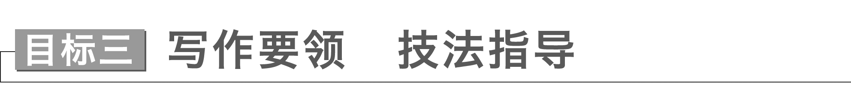

本单元的写作任务是写一篇关于自己对善意谎言的理解的说明文，在此类文章写作过程中，应注意在写作中使用多样的表达方式。首先，你可以尝试选择使用不同的词汇。例如，当你想表达撒谎时，你可以用tell a lie，cheat，make up，take in等。其次，你可以使用不同的句子结构。例如：She told a lie to him./He was cheated by her.传达了几乎相同的意思，但使用了不同的结构。

[常用表达]

1．Actually，the question about whether we should tell white lies in our daily life has always been an intense debate over these years.

2．In terms of white lies，they would not be bad as long as the original intention is good.

3．I think telling some lies can prevent people from being embarrassed or injured.

4．People may feel betrayed when they know the truth eventually.And more seriously，it can ruin a precious relationship.

5．When we tell a white lie，we had better take into consideration what the occasion at that time is and what the result it brings about.

6．So I hold the idea that it is necessary to tell white lies in some special situations.

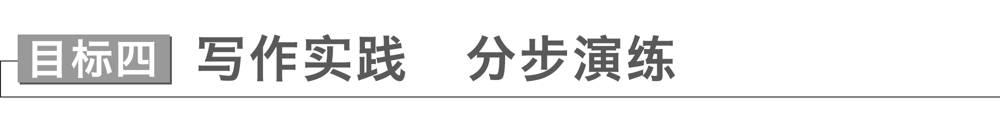

假如你是李华，你校英文报为了庆祝创刊十周年，现正在进行征稿启事，请你以“White lies”为话题写一篇短文，向英文报投稿，内容包括：

1．解释什么是善意的谎言；

2．分析人们会说善意的谎言的原因；

3．对善意的谎言总能带来好的结果的观点提出质疑，并给出理由；

4．阐明你会不会说善意的谎言，并解释原因。

注意：可以适当增加信息，以使行文连贯。

第一步　审题谋篇

[审题]

本单元的写作任务是写一篇关于善意的谎言的文章，写作时应注意下面几点：

1．确定文体：这是一篇说明文，写作时注意这类文章的写作特点。

2．主体时态：文章应以一般现在时为主。

3．主体人称：人称以第一、三人称为主。

[谋篇]

第一段：用举例形式给善意的谎言下定义；

第二段：说明人们为什么会说善意的谎言的原因；

第三段：对善意的谎言总能带来好的结果的观点提出质疑，并给出理由；

第四段：阐明你会不会说善意的谎言，并解释原因。

第二步　遣词造句

[核心词汇]

1．指的是refer to

2．糟糕的awful

3．避免avoid

4．魔力magic power

5．温暖和鼓励warmth and encouragement

6．有助于contribute to

7．沮丧的现状the depressing situation

8．感到被骗feel cheated

9．信任危机a crisis of trust

10．总之in conclusion

11．支持in favor of

12．和谐的harmonious

[连词成句]

1．善意的谎言指的是我们为了保护他人不被真相所伤害而撒的小谎。

White lies refer to the little lies that we tell to protect others from the truth.

2．我们告诉朋友他的新发型很酷，即使我们认为它很糟糕。

We tell a friend his new haircut is cool even if we think it’s awful.

3．说善意的谎言不仅可以避免伤害别人的感情，而且它还有魔力，可以给人温暖和鼓励。

Telling a white lie can not only avoid hurting others’ feelings，but also it has magic power to give people much warmth and encouragement.

4．说善意的谎言有助于让别人不受我们沮丧处境的影响。

Telling white lies contributes to keeping others from being affected by our depressing situation.

5．被欺骗的人可能会感到被欺骗和沮丧。

People being lied to may feel cheated and depressed.

6．这可能会导致信任危机。

It may lead to a crisis of trust.

7．我赞成适当地说些善意的谎言。

I am in favor of telling white lies appropriately.

8．善意的谎言是无害和有用的，它们使这个世界成为一个更和谐的地方。

White lies are harmless and useful and they make this world a more harmonious place.

第三步　句式升级

1．把not only 放在句首，用部分倒装改写句3。

Not only can telling a white lie avoid hurting others’ feelings，but also it has magic power to give people much warmth and encouragement.

2．用which引导的非限制性定语从句改写句5和句6。

People being lied to may feel cheated and depressed，which may lead to a crisis of trust.

3．用because引导的原因状语从句改写句7和句8。

I am in favor of telling white lies appropriately because white lies are harmless and useful and they make this world a more harmonious place.

第四步　组句成篇

用适当的过渡词语，把以上词汇和句式，再加上联想内容，组成一篇英语短文。

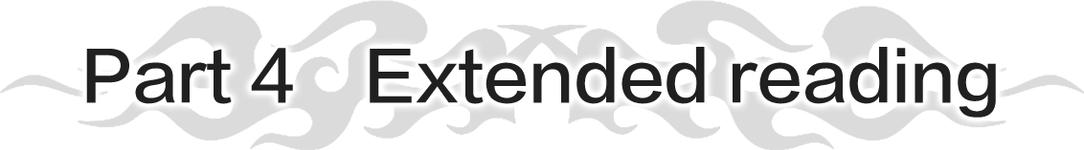



1. 感知责任对自我、对社会的重要意义。

2. 认识到担负起责任的必要性。

3. 在语境中学习词汇、句型及规范的表达。

**Learning Aims**(学习目标)

1．Grasp the main idea of the passage on P11－12.(重点难点)

2．Learn the following language points：disappointed，pretend，privilege，not...but...(重点难点)

3．Learn the following language points：mercy，discouraged(重点)

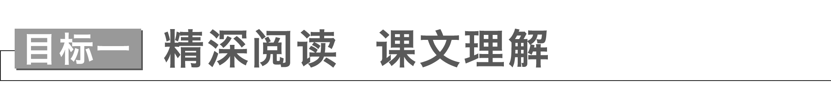

**Task 1**　宏观架构　整体理解

Part 1 (Paras.1-2) Introduction: The opening of the speech

Part 2 (Paras.3-5) Main body: The importance of responsibility and taking responsibility for oneself and society

Part 3 (Para.6) Conclusion

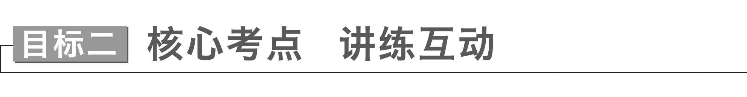

 Frankly speaking，I was disappointed but I smiled as broadly as I could.(教材P8)

**disappointed *adj*.**失望的，沮丧的

|  |
| --- |
| (1)be disappointed at/by对……感到失望  be disappointed to do...对做……感到失望  be disappointed that...对……失望  (2)disappointing *adj*.令人失望的  (3)disappoint *vt*.使失望  (4)disappointment *n*．失望，沮丧  to one’s disappointment令某人感到失望的是 |

[佳句赏读]　感悟句意·背诵

①My nephew behaved badly to/towards the guests，which made us very **disappointed**.

②Her decision to cancel the concert is bound to **disappoint** her fans.

③Hearing the **disappointing** news，the geophysicist was too sad to contain himself.

④(读后续写之表情描写)Andy’s face paled with **disappointment**；perhaps with anger as well.

 Then I walked away，pretending not to have heard anything.(教材P8)

**pretend *vi*.& *vt*.**假装；装扮；扮作；自诩，自认为

|  |
| --- |
| pretend to do sth.假装做某事  pretend to be doing sth.假装正在做某事  pretend to have done sth.假装做过某事  pretend to be sb./sth.假装是某人/某物  pretend that从句　假装…… |

[佳句赏读]　感悟句意·背诵

①The boy **pretended to be studying** hard when his teacher came in.

②The photographer **pretended to have** **made** his fortune while being interviewed.

③The criminal **pretended to be** an innocent witness when the police got to the spot.

④We **pretended** (**that**) nothing had happened but our teacher suspected our honesty.

 Honoured guests，teachers and students，it is my pleasure and privilege to welcome you here today and present my thoughts on this very special occasion.(教材P11)

**privilege *n*．**荣幸；特殊利益***vt*.**给予特权，特别优待

|  |
| --- |
| (1)have the privilege of doing/to do sth.有做某事的特权；有幸做某事  it is a privilege to do sth.有幸做某事  (2)privileged *adj*.有特权的；受特别优待的；荣幸的；幸运的  be privileged to do sth.有幸做某事 |

[佳句赏读]　感悟句意·背诵

①(应用文写作之议论文)As we all know，education should be a universal right and not a **privilege**.

②I hope to **have the privilege of working/to work** with the specialist again.

③We **are privileged to welcome** Mr Wang，a famous socialist，as our speaker this evening.

 Hopefully，you have learnt to treat responsibility not as a weight that burdens you，but rather as a foundation which will support your future development.(教材P11)

**not...but...**不是**……**而是**……**

|  |
| --- |
| (1)not...but...连接两个并列的句子成分，前后形式一致。  (2)not...but...连接并列的两个主语时，谓语动词单复数遵循就近原则。 |

[佳句赏读]　感悟句意·背诵

①To our disappointment，the geophysicist is **not** knowledgeable **but** ill-informed.

②My nephew was **not** doing his homework **but** playing computer games when his mother came in.

③As far as I know，**not** he but **you** are to blame for the accident.

④It was **not** the videos **but** what doctors did during the epidemic that moved us.

影响你未来的不是你说什么，而是你做什么。

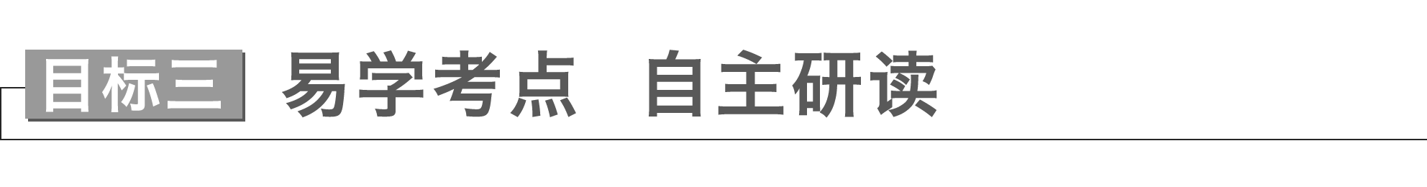

 A ship without an anchor is at the mercy of the waves and the winds...(教材P11)

**mercy *n*．**仁慈，宽恕

|  |
| --- |
| (1)at the mercy of 任……处置；对……无能为力  beg for mercy请求宽恕，求饶  have mercy on sb./sth.可怜某人/某物  without mercy毫不怜悯地  (2)merciful *adj*.仁慈的；怜悯的  (3)merciless *adj*.残忍的；无情的 |

①Having lost engine power, the boat’s crew found themselves **at the mercy of** the wind.

失去引擎动力后，船员们发现自己任凭风的摆布。

②It was reported that the suspect was a merciless (mercy) killer，which shocked all the people present.

据报道，嫌疑犯是个残忍的杀手，这使在场的所有人都感到震惊。

③It was because of this merciful(mercy) act that the specialist was honored by all of us.

正是因为这一仁慈的行为，这位专家受到我们所有人的尊重。

④It is widely acknowledged that to have mercy on others is at the core of human kindness.

人们普遍认为，怜悯他人是人性善良的核心。

⑤(读后续写之场景描写)The blistering noonday sun beat down on them without mercy but they didn’t give up.

午间酷热的阳光无情地蒸烤着他们，但他们没有放弃。

 However，the boy was not discouraged，believing that he could make a difference to the ones that he saved.(教材P12)

**discouraged *adj*.**灰心的，泄气的

|  |
| --- |
| (1)discourage *vt*.阻止；使气馁  discourage sb.from doing sth.劝阻某人不要做某事，打消某人做某事的念头  (2)discouraging *adj*.使人沮丧的；令人气馁的 |

①(应用文写作之建议信)If you allow yourself to be **discouraged** by current obstacles，you might not have great achievements.

如果受阻于眼前的困难而踯躅不前，那你可能无法取得成就。

②His words were discouraging，which made many people discouraged.(discourage)

他的话令人泄气，这使得很多人灰心丧气。

③To his disappointment，his parents tried to discourage him from being an actor.

令他失望的是，他的父母试图阻止他去当演员。