Period 3 Grammar and usage
INCLUDEPICTURE "G:\\10.15\\三言两语A3.TIF" \* MERGEFORMATINET INCLUDEPICTURE "三言两语A3.TIF" \* MERGEFORMAT 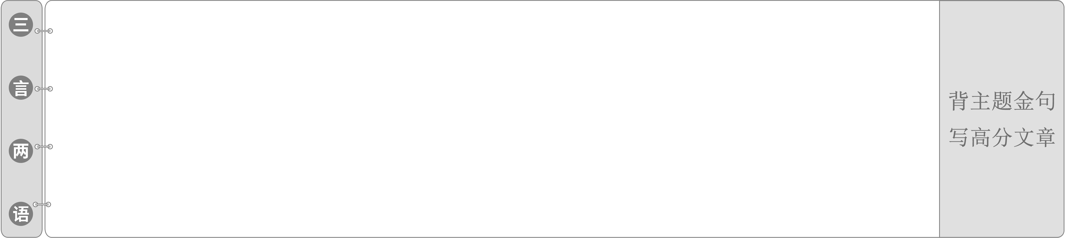
1.The Forbidden City draws visitors because of its rich history and cultural significance, but perhaps it should add one more thing to its list of attractions: earthquake shelter.
故宫因其丰富的历史和文化意义吸引游客，但或许它应该在景点列表中再加一项：地震避难所。
2.While most structures aren't made to survive natural disasters, the Forbidden City seems to withstand anything.
虽然大多数建筑都不是为了抵御自然灾害而建造的，但故宫似乎能抵御任何灾害。
表语从句
INCLUDEPICTURE "G:\\10.15\\自主领悟LLL.TIF" \* MERGEFORMATINET INCLUDEPICTURE "自主领悟LLL.TIF" \* MERGEFORMAT [学生用书P72]
观察句子 | 自主感知
①China is no longer what she used to be.  ②The truth is that it is too foggy for the bus to run that far.  ③The question is whether he should do it.  ④My advice is that you (should) practise speaking English as often as possible.  ⑤That's why we've given you the letter.  ⑥Li Lei is now in a new jacket. He looks as if he were an American boy. | 1.上述例句中黑体部分都是表语从句。  2．句①含有由连接代词 what引导的表语从句，what在从句中作表语。  3．句②中从属连词that引导表语从句，无意义。  4．句③中从属连词whether引导表语从句，意为“是否”，不作句子成分。  5．句④中that引导的表语从句使用了虚拟语气。  6．句⑤中why引导的表语从句强调结果。  7．句⑥中as__if引导的表语从句使用了虚拟语气。

INCLUDEPICTURE "G:\\10.15\\要义详析LLL.TIF" \* MERGEFORMATINET INCLUDEPICTURE "要义详析LLL.TIF" \* MERGEFORMAT [学生用书P72]
一、表语从句的定义
在复合句中作表语的从句叫表语从句。引导表语从句的连接词与引导主语从句和宾语从句的连接词大体相同，有时也用as if引导；表语从句位于系动词之后。
◆The problem is who can get there to take the place of Ben.
问题是谁能到那儿接替本的位置。
◆It looks as if it is going to rain.
看起来像是要下雨了。
[即时演练1]——单句语法填空
(1)The problem is what we can get from him.
(2)My idea is that we should start making preparations as soon as possible.
(3)The question is whether we can finish our work by tomorrow evening.
二、引导表语从句的连接词
1．从属连词
(1) 由 that 引导的表语从句 (that 有时可以省略)。
◆The truth is (that) he was very shy.
事实是他很害羞。
◆The trouble is that I have lost his address.
麻烦的是我把他的地址丢了。
(2)由连接代词引导的表语从句。
◆That's not what I said.
那不是我说的。
◆What I want to know is which road we should take.
我想知道的是我们应该走哪条路。
◆The problem was who could do the work.
问题是谁能做这项工作。
(3)由连接副词引导的表语从句。
◆Go and get your coat. It's where you left it.
去把雨衣拿来。就在你原来放的地方。
(4)由because引导的表语从句。
◆That's because you can't appreciate music.
这是因为你不能欣赏音乐。
◆That's because we never thought of it.
这是因为我们从未想过此事。
(5)由whether引导的表语从句。
◆What we want to know is whether he will come to speak to us tomorrow.
我们想知道的是他明天是否来给我们讲话。
(6)由like引导的表语从句。
◆She acts like she owns the place.
她很霸道，就好像那地方都是她的。
◆She felt like she was addicted to the Internet.
她觉得她好像有网瘾。
(7)由as if/as though引导的表语从句。
◆At that time, it seemed as if I couldn't think of the right word anyhow.
当时， 我似乎怎么也想不出一个恰当的字眼来。
◆It looked as if it was going to snow.
看起来好像要下雪了。
(8)由as/just as引导的表语从句。
◆Things are not always as they seem to be.
事情并不总像表面上看来的那样。
◆It may be as you say.
此事可能像你说的那样。
2．连接代词
who/whom/whose/what/which/whoever/whatever/whichever/whomever在表语从句中作主语、宾语、表语和定语。
◆Tom is now finally what he dreamed to be.(what作表语)
汤姆现在终于成为他曾梦想的样子了。
◆This is what I want to tell you.(what作宾语)
这就是我想告诉你的。
◆The problem is whose work is the best.(whose作定语)
问题是谁的作品最好。
3．连接副词
when/where/how/why在表语从句中作状语。
◆The question is how he did it.
问题是他是如何做此事的。
◆The question is where we can live.
问题是我们能住在哪儿。
[即时演练2]——单句语法填空
(1)I didn't phone her, and that's because I got angry with her.
(2)The most pleasant thing of the rainy season is that one can be entirely free from dust.
(3)You say that study is our most important thing at school. This is where I don't agree with you.
(4)The question remains whether they will be able to help us.
三、表语从句中的注意事项
1．连接词that一般不能省略，但在口语或非正式文体中有时也可省略。
◆My idea is (that) we should do it right away.
我的意见是我们应该马上做这件事。
◆The trouble is (that) he is ill.
糟糕的是他病了。
2．当主句中含动词do的某种形式时，that可以省略。
◆What I want to do is (that) I can go up to him and thank him.
我想做的事是走到他身边去感谢他。
3．当句子的主语是advice、demand、decision、desire、idea、insistence、instruction、order、plan、proposal、recommendation、request、requirement、suggestion、wish等名词时，表语从句用虚拟语气，即“should ＋动词原形”，其中should可以省略。
◆My advice is that you should go to apologize to him.
我的建议是你应该去向他道歉。
4．表语从句一定要用陈述语序。
False: The question is when can he arrive at the hotel.
Right: The question is when he can arrive at the hotel.
问题是他什么时候可以到达宾馆。
5．在有表语从句的复合句中，主句时态和从句时态可以不一致。
◆ The question is who will travel with me to Beijing tomorrow. 问题是明天谁将跟我一起去北京旅行。
◆ The question is why he cried yesterday.
问题是昨天他为什么哭了。
[即时演练3]——单句语法填空
(1)My suggestion is that we (should)__start (start) early tomorrow.
(2)The doctor's advice was that you (should)__stop(stop) smoking.
INCLUDEPICTURE "G:\\10.15\\课堂微练LLL.TIF" \* MERGEFORMATINET INCLUDEPICTURE "课堂微练LLL.TIF" \* MERGEFORMAT [学生用书P74]
Ⅰ.用适当的连接词填空
1．I gave my plants just a little bit of water, so their roots had to grow deeper to find more by themselves. That's why my plants survived.
2．Without his support, we wouldn't be where we are now.
3．This is what my father has taught me—to always face difficulties and hope for the best.
4．A ship in harbor is safe, but that's not what ships are built for.
5．That's why people should eat more fruit and vegetables in their daily life.
6．The thick smog covered the whole city. It was as__if a great black blanket had been thrown over it.
7．That's what we set out to really investigate: Can we design things in such a way that kids are able to teach their parents about climate change?
8．Charles Dickens described the life in the middle of the 19th century, a period that is when Queen Victory ruled the Britain.
9．By boat is the only way to get here, which is how we arrived.
10．The best moment for the football star was when he scored the winning goal.
Ⅱ.选词填空
that, why, whether, what, as if, because, when, how
1．That must be what you're looking for.
2．The trouble is that I lost the key to my room.
3．What I don't understand is how he was able to finish the work by himself.
4．I am a bit sleepy; it's because I was up all night.
5．I will go to pick him up at the airport, but the problem is when he will arrive.
6．What I'm wondering is why you are always late for class.
7．The question discussed at the meeting was whether it was worth trying.
8．All this was over twenty years ago, but it is as__if it were only yesterday.
INCLUDEPICTURE "G:\\10.15\\课下小练LLL.TIF" \* MERGEFORMATINET INCLUDEPICTURE "课下小练LLL.TIF" \* MERGEFORMAT
[层级一 小题夯基练][学生用书P158(单独成册)]
维度一 单句语法填空
1．It seems as if she were(be) the students' mother.
2．His desire is that he(should)__travel(travel) in space in Shen Zhou X.
3．My recommendation is that you(should)__take(take) over his position.
4．He just receives little education but he acts as if he were (be) really a scholar.
5．Is that why you don't want to go home?
6．She looks so happy. That's because she has won the competition.
7．The reason why I fell asleep so quickly is that I was tired.
8．The problem is who is really fit for the hard job.
9．The point at issue is whether we go to the party.
10．This is where I worked with my parents one year ago.
维度二 语法与写作
1．事实是他没有真的努力。
The fact was that__he__didn't__really__try．
2．问题是这部电影是否值得看。
The question is whether__the__film__is__worth__seeing．
3．那是我第一次遇见她的地方。
That's where__I__first__met__her．
4．那是我想让你在这儿工作的原因。
That is why__I__want__you__to__work__here．
5．今天早上我上学迟到了。那是因为我昨晚睡得太晚了。
I was late for school this morning. That's__because__I__stayed__up__too__late last night.
维度三 语篇练习
Everyone knew 1.that Wendy was a famous writer, but no one knew 2.where she came from and 3.whether she was born in 1961 was still a mystery. 4. What they did know was 5.that she was loved by poor people because she always helped 6.whoever was in need of money. Wendy was generous and helpful，but some people thought she was chasing fame. Wendy said she didn't understand 7.why they were so narrowminded, but it didn't matter 8.what others thought of her. She just wanted to do 9.what(ever) she thought was right. She thought that was 10.where the meaning of life lay.
维度四 书法与写作
请临摹之后再利用课余时间背诵。
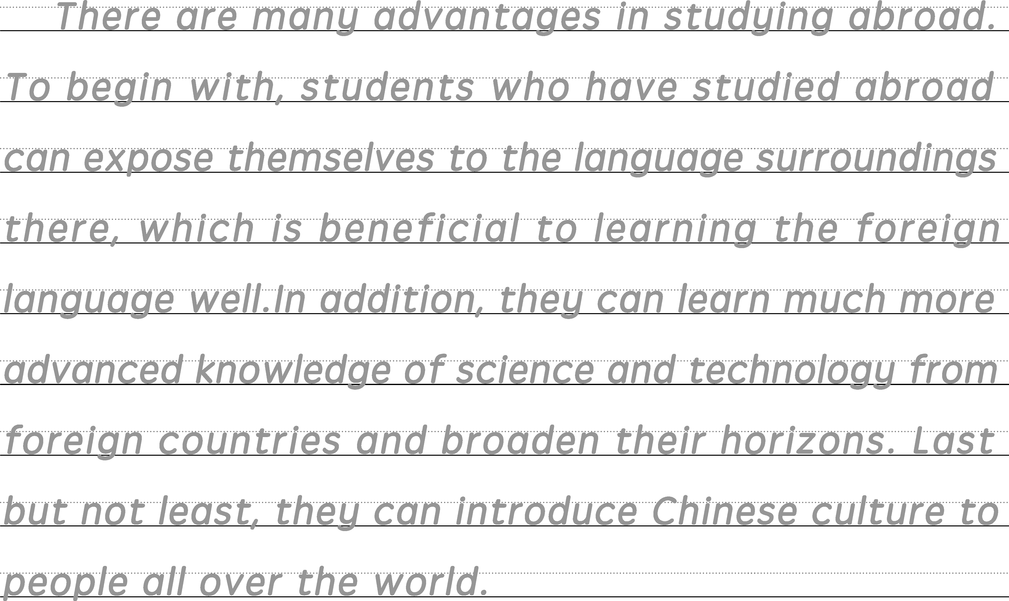
提醒：①每个字母圆润饱满，压线书写；②宜用0.5或0.7 mm中性笔。
[层级二 语篇提能练][学生用书P159(单独成册)]
Ⅰ.阅读理解
A
Avi Wortis，known simply as Avi，writes historical novels.Historical novels mix historical facts with storytelling skills.These stories took place in the past.The main characters are not always real; they exist only in stories.
Avi decided to become a writer when he was a student in senior high school.This was quite a decision because he did not write well in school.He had a problem called dysgraphia, a writing disability.The problem caused people to spell words wrongly.Avi always enjoyed reading.He read many types of books as a child.Avi believed that reading is the most important activity for a person who wants to be a writer.
Avi also believes that strong characters make strong stories.He creates characters that can help to bring his ideas to life.His books often deal with questions about life.Writing stories lets him explore many sides of a subject.His favorite part is to make improvements in his writing.For him the hardest part is writing the first draft (草稿).
Avi's first book was published in 1970.He has written more than 45 books ever since.Most of them are for young adult readers.Besides historical novels，he writes comedies, short stories about adventures, animals and so on. Fighting Ground，which was published in 1984，is an example of Avi's historical novels.This attractive story took place during the American Revolutionary War.
【解题导语】 本文向我们介绍了历史小说作家阿维·沃蒂斯是怎样成为作家的，以及他对于写作的观点及主要作品。
1．What can we learn from paragraph 2?
A．How Avi developed characters.
B．Why Avi liked reading.
C．How Avi became a writer.
D．Why Avi decided to become a writer.
C 解析：推理判断题。根据第二段“Avi decided to become a writer...who wants to be a writer.”可知，阿维高中时就想成为一名作家，他读了大量的书，他坚信阅读是成为作家最重要的活动。这些都是讲述他是怎样成为作家的。故选C。
2．What can we learn from the text about Avi?
A．He published his first story in 1984.
B．He thinks reading is not the most important for writers.
C．He seldom changes his first drafts when writing.
D．He believes in the importance of good characters in stories.
D 解析： 推理判断题。根据第三段中的“Avi also believes that strong characters make strong stories.”可知，阿维相信强大的人物塑造出强大的故事，即他相信故事中优秀人物的重要性。故选D。
3．According to Avi，what's the most difficult thing in writing?
A．Making improvements.
B．Writing the first draft.
C．Finding an attractive character.
D．Writing the first part of a novel.
B 解析：细节理解题。根据第三段中的“For him the hardest part is writing the first draft.”可知，阿维认为写作中最难的是写初稿。故选B。
4．What is the author's purpose of writing the text?
A．To discuss how to become a writer.
B．To introduce a writer of historical novels.
C．To describe an important historical novel.
D．To show how a historical novel is written.
B 解析：写作意图题。文章开头点出“Avi Wortis, known simply as Avi, writes historical novels.”，接下来介绍了他是怎样成为作家的、他对于写作的观点及主要作品。作者通过文章向我们介绍了一位历史小说作家。故选B。
B
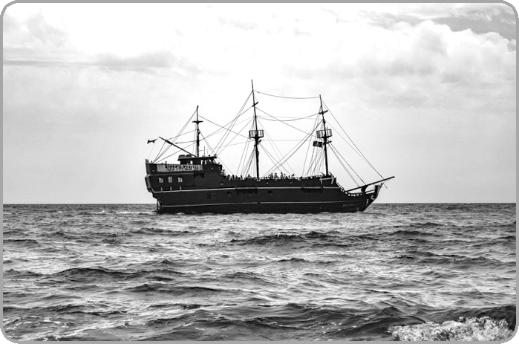
A crew (全体船员) of six teenage girls completed a nineday sailing trip in the US recently, after braving seasickness and strong winds.
For the past three years, the Sea Cadet teenagers who set sail were all male. Roger Noakes, who captained the boat, said this was the first time he'd taken out an allfemale crew.
The girls asked for an allgirls trip in August this year. The crew set sail along with three adults, Noakes and two Sea Cadet representatives. The plan was for the girls to sail 24 hours a day in rotating shifts (轮流换班) along the coast and then return. Things turned out differently, however.“The first night was difficult because the wind was really hard. The waves were going up and down，” said Abby Fairchild, 16. “Everybody got seasick.” Noakes gave the girls the choice of just sailing in the bay and not going into open water. “But they decided they were going.”
The teenagers then sailed a long way overnight and slept in shifts. “We've learned everything from controlling the boat to putting up the sails while we have rough seas，” said 15yearold Olivia Wilcox.
The teenagers stopped on land in Massachusetts. They didn't make it to their destination in Maine, where they were supposed to have a celebratory dinner, due to the weather and winds. They said they weren't disappointed, however, as they'd learned a lot. “They learned about boating, and above all, they built confidence and character，” said Noakes.
【解题导语】 本文是一篇记叙文，主要讲述了一次长达九天的航海旅行。这是第一次船员全是青少年女孩的航海旅行，尽管海上环境恶劣，但是她们意志坚定，不仅学会了很多航海知识，还培养了良好的性格。
5．What was special about the Sea Cadet trip this year?
A．It was the longest sailing trip ever.
B．It was the first allfemalecrew sailing trip.
C．It was the most dangerous sailing trip ever.
D．It was the first sailing trip for teenagers.
B 解析：细节理解题。根据第二段中的“this was the first time he'd taken out an allfemale crew”可知，这是第一次船员全是青少年女孩的航海旅行。故选B。
6．What happened on the first night of the trip?
A．The crew all felt sick on the boat.
B．The crew wanted to give up the sail.
C．The boat went through a storm.
D．The boat went into open water.
A 解析：细节理解题。根据第三段中的“‘The first night was difficult because the wind was really hard. The waves were going up and down，’ said Abby Fairchild, 16. ‘Everybody got seasick.’”可知，第一天大家都晕船了。故选A。
7．Which of the following best describes these young sailors?
A．Strongminded.
B．Hardworking.
C．Understanding.
D．Creative.
A 解析：推理判断题。根据第三段中的“Everybody got seasick.” “But they decided they were going.”以及第四段的内容可知，这些年轻的船员虽然晕船，但仍然坚持出海并航行了很长一段距离，这说明她们意志坚定。故选A。
8．What did the sailors get from the trip?
A．They knew the sea better.
B．They made many friends.
C．They got excellent sailing skills.
D．They developed good personalities.
D 解析：推理判断题。根据最后一段中的“They learned about boating, and above all, they built confidence and character”可知，在这次航海旅行中，船员最大的收获是培养了性格。故选D。
Ⅱ.七选五
Quick Ways to Fight September Blues
September can be an exciting time of year with school starting, fall sports coming back, and the cooling of weather. However, this can also start a difficult season. 1.________． If you are struggling with the September blues, here are some tips you can do to help you go through this time of year.
Get yourself moving
This might not be what you want to hear, but exercising is an excellent way to keep both your body and mind in good shape. If you feel yourself down or anxious, try exercising can help clear your mind and give you a chance to identify what exactly is causing your stress. Do not worry if you do not have time for an hourlong workout. 2.________．
Spread your social butterfly wings
3．________. You do not need to admit your feelings or bring up your blues, just talk. Invite a friend for coffee, a walk, or dinner. Not sure you want to talk? You could always try a movie. Leaving the house and socializing will help you reset how you feel. If you do not feel comfortable social contact, try sending a text or email.
Get flexible
Yoga is a great way to help reduce stress and get fit. Yoga practice involves learning how to breathe and thinking about your body as you enter each pose. If you are not sure about your balance or flexibility, considering trying a recovering class that focuses on training and recovery. 4.________， so you can relax as they do the work. 5.________. It is a common problem affecting both children and adults. If you feel extremely down or begin to feel helpless and worthless, seek out professional help. A licensed therapist (理疗师) can help you work through your feelings so you can get back to feeling like yourself.
The tips above will help you.
A．Pressure always forms in September
B．Some studios will offer recovering classes
C．When you are feeling low, find a friend or two to talk to
D．It is hard to deal with the pressures of a new school year
E.Developing some hobbies is a good way to get rid of stress
F.Just get 10－20 minutes of movement and you will still benefit
G．If you have realized that September blues are something you struggle with, do not be ashamed
【解题导语】 每到九月开学季，面对新学期，人们总会出现一些忧郁、郁闷的感觉。针对这些状况，文章列举了三个重要的解决方法。
1．D 解析：根据上文“However, this can also start a difficult season.(然而这也会开始一段艰难的时光)”可知，下文应举例说明艰难时光的表现有哪些，D项“新学年的压力很难应付”承接上文，是对上句的进一步补充和延伸。故选D。
2．F 解析：根据上文“Do not worry if you do not have time for an hourlong workout.(如果你没有时间进行一小时的锻炼也不必担心)”可推知本空承接上文继续说明，就算没有时间进行一个小时的锻炼，那么仅仅十分钟到二十分钟也是有益的，F项“仅仅是十到二十分钟的运动对你也仍然有利”是对上一句的衔接，符合上下文的逻辑联系。故选F。
3．C 解析：根据下文“You do not need to admit your feelings or bring up your blues, just talk.(你不需要承认你的感受或提起你的忧郁，只要随便说点什么)”可知在论述倾诉的重要性。C项“当你感到情绪低落时，找到一两个朋友去倾诉”符合上下文的逻辑联系，且C选项中的“talk”和空后的“talk” 是原词复现。故选C。
4．B 解析：根据上文“If you are not sure about your balance or flexibility, considering trying a recovering class that focuses on training and recovery.(如果你不能确定自身的平衡能力或灵活性，考虑尝试去上一个专注于训练和康复的恢复性课程)”以及下文“so you can relax as they do the work(所以当他们给你上课时，你可以放松自己)”可知本句为论述工作室也会提供康复课程，B项“有的工作室会提供康复课”与上下文衔接自然。故选B。
5．G 解析：根据下文“It is a common problem affecting both children and adults.(这是一个影响儿童和成人的常见问题)”可知，即使意识到新学期的压力对自己产生的影响，也不必难为情，因为这是一个常见问题。G项“如果你已经意识到你正在与新学期压力做斗争，也不必难为情”在逻辑和语意上与下文衔接自然。故选G。
Ⅲ.语法填空
The ancient town of Fenghuang is a place with idyllic(平和美丽的) village life in rural China. Having travelled directly from the busy city, I regard Fenghuang as a better 1.____________(choose) to have a breath of the fresh air.
When I paid 2.____________ visit to Fenghuang, it was July. My friend and I 3.____________(excited) explored, walking along the ancient wall and crossing the beautiful, old bridges. People there were very 4.____________(relax). They were neither troubled by the hot weather nor by the tourists, walking, eating and playing outdoors. 5.____________ the first evening we bought spicy, cold noodles and ate on the riverbank as we watched the sunset.
We stayed in a small hotel 6.____________ was similar to many of the traditional 7.____________(building) in the village. Our room was built on high stilts(桩子) over the banks of the river. From our window we could hear the rush of the water and the sounds of excited tourists 8.____________ (travel) in small boats downstream. We saw people at work busy catching fish and young children playing in shallow waters.
There 9.____________(be) many visitors to Fenghuang during our stay. After several days, I was still unwilling 10.____________(leave).
【解题导语】 本文介绍了凤凰古城的特色以及作者游凤凰古城的经历和感受。
1．choice 解析：考查词性转换。分析句子结构可知，空前有a better修饰，故此处要用名词作介词as的宾语。
2．a 解析：考查冠词。pay a visit to意为“参观，访问”，是固定短语。
3．excitedly 解析：考查词性转换。空处修饰动词explored，要用副词，故填excitedly。
4．relaxed 解析：考查形容词。分析句子结构可知，空处在句中作表语，且主语为People，故应用ed形式的形容词作表语。relaxed意为“放松的”。
5．On 解析：考查介词。表示在具体某一天的晚上要用介词on。
6．which/that 解析：考查定语从句。分析句子结构可知，先行词是hotel，空处引导限制性定语从句，且在从句中作主语，故用which/that。
7．buildings 解析：考查名词复数。根据空前的many of可知，此处应用名词复数。
8．travelling 解析：考查非谓语动词。tourists和travel之间是逻辑上的主谓关系，故用动词ing形式作定语。
9．were 解析：考查动词的时态和主谓一致。此处是there be句型，主语是many visitors，故用复数形式。根据上下文的时态可知，此处陈述的是过去的事情，故用一般过去时。
10．to leave 解析：考查非谓语动词。be unwilling to do sth.意为“不愿意做某事”，为固定用法。

