Period 4 Writing
INCLUDEPICTURE "G:\\10.15\\三言两语A4.TIF" \* MERGEFORMATINET INCLUDEPICTURE "三言两语A4.TIF" \* MERGEFORMAT 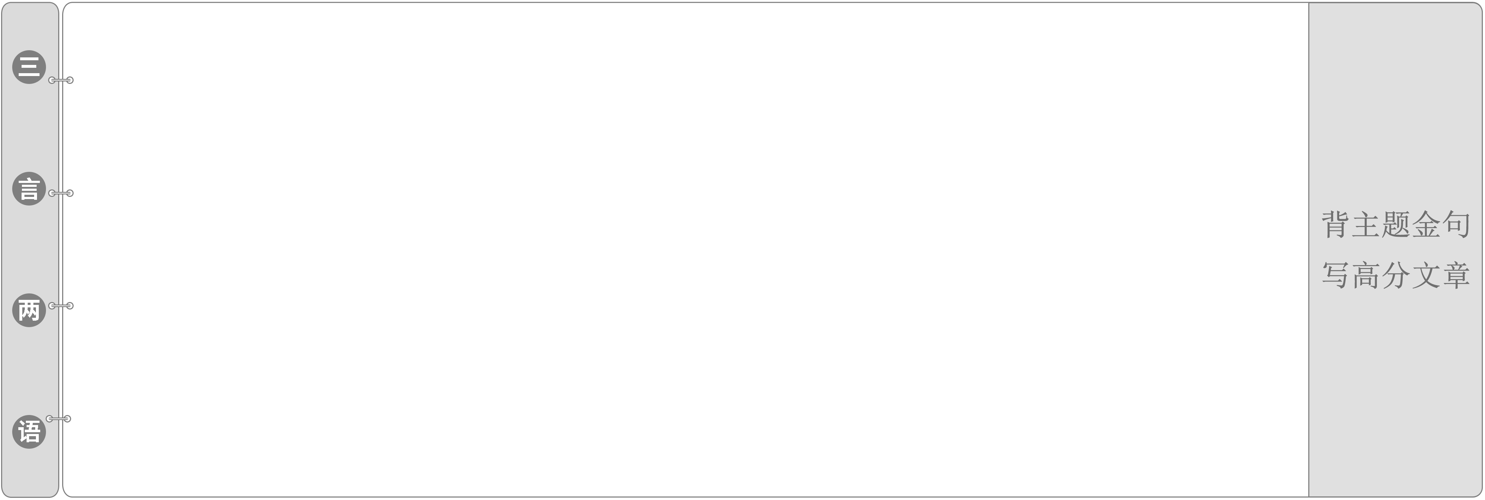
1.The Statue of Liberty was a gift to the people of the United States from the people of France in 1876 as an expression of friendship and the goal of liberty shared by the people of both countries.
自由女神像是1876年法国人民送给美国人民的一个礼物，它表达了两国人民之间的友谊及共同的自由目标。
2.Standing 93 metres high including its pedestal, the Statue of Liberty represents a woman holding a torch in her raised right hand and a metal tablet bearing the adoption date of the Declaration of Independence in her left.
连同基座，自由女神像高达93米，它展现的是一位女士右手高举火炬，左手捧着刻有《独立宣言》签署日期的金属板。
写一篇关于一次历史事件的短评
INCLUDEPICTURE "G:\\10.15\\集腋成裘LLL.TIF" \* MERGEFORMATINET INCLUDEPICTURE "集腋成裘LLL.TIF" \* MERGEFORMAT [学生用书P75]
文体感知
本单元的写作任务是写一篇关于一次历史事件的短评。写作时需要注意以下几点：
1．简要介绍事件发生的时间、地点、人物；事件发生的起因、经过、结果；
2．对历史事件中的人物进行评论；
3．最后阐述你对这一历史事件的感受并解释你的感受。
增分佳句
1．Once upon a time, there was a．..
2．Unfortunately, they were stuck in the...
3．They were very brave in face of...
4．They never gave up and...
5．Later, they managed to...
6．From this story, we learned that...
7．All of us were moved by the great hero...
8．We should learn something from the great...
INCLUDEPICTURE "G:\\10.15\\高屋建瓴LLL.TIF" \* MERGEFORMATINET INCLUDEPICTURE "高屋建瓴LLL.TIF" \* MERGEFORMAT [学生用书P75]
INCLUDEPICTURE "G:\\10.15\\典题示例lll.TIF" \* MERGEFORMATINET INCLUDEPICTURE "典题示例lll.TIF" \* MERGEFORMAT 
写作要求
请根据下面的提示写一篇短评。词数80左右。
1．欧内斯特·沙克尔顿(Ernest Shackleton)和他的船员们(crew)一起登上了名为“坚忍号(Endurance)”的大船。途中“坚忍号”被冰山困住，大家弃船后逃到了大象岛(Elephant Island)。沙克尔顿驾船去寻求帮助。最后，尽管困难重重，船员们还是活了下来。
2．在这个故事中船员之间真诚的关心和爱以及他们在困难面前的忍耐力和毅力使人深受鼓舞。
3．从这个故事中学到的教训：无论遇到任何困难，都不要放弃！
审题谋篇
第一步：审题构思很关键
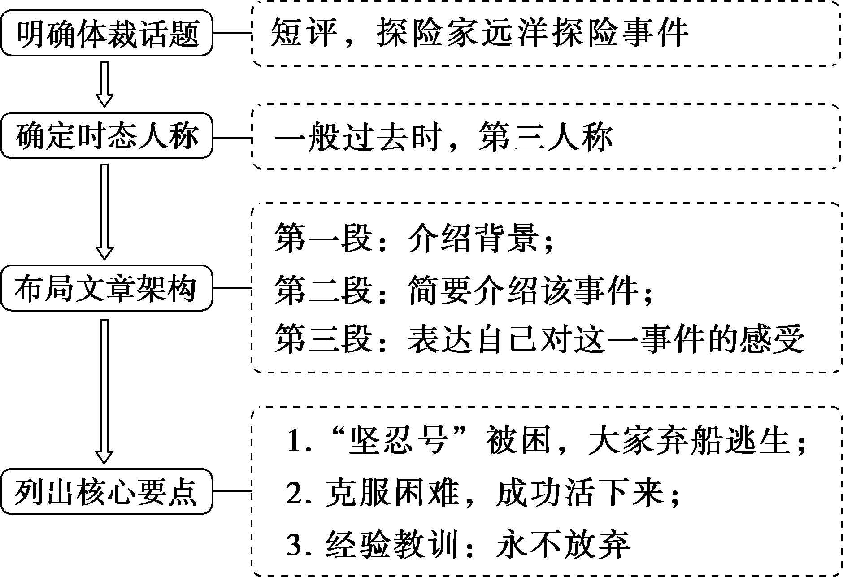
第二步：核心词汇想周全
1. go__aboard 上船
2．on__the__way 在途中
3．be/become__stuck__in 被……困住
4．sink__into 沉入
5．abandon vt. 放弃，抛弃
6．escape v. 逃跑
第三步：由词扩句雏形现
1．欧内斯特·沙克尔顿和他的船员们登上了名为“坚忍号”的大船。
Ernest Shackleton and his crew went__aboard__the__ship__whose__name__was__Endurance．
2．不幸的是，途中“坚忍号”被冰块困住，沉进了大洋中。
Unfortunately, on the way Endurance became__stuck__in__the__ice__and__sank__into__the__ocean．
3．在放弃那艘船后，他们逃到了大象岛上。
After they had abandoned the ship，they__escaped__to__Elephant__Island．
第四步：句式升级造亮点
1．用非谓语动词改写第三步中的句1
Ernest__Shackleton__and__his__crew__went__aboard__the__ship__named__Endurance.
2．用非谓语动词改写第三步中的句2
Unfortunately,__on__the__way__Endurance__became__stuck__in__the__ice,__sinking__into__the__ocean.
3．用非谓语动词改写第三步中的句3
Having__abandoned__the__ship，they__escaped__to__Elephant__Island.
第五步：过渡衔接连成篇
_______________________________________________________________
_______________________________________________________________
_______________________________________________________________
_______________________________________________________________
_______________________________________________________________
_______________________________________________________________
_______________________________________________________________
_______________________________________________________________
One possible version：
This story is about a great expedition in history.
Ernest Shackleton and his crew went aboard the ship named Endurance. Unfortunately，on the way Endurance became stuck in the ice，sinking into the ocean. Having abandoned the ship，they escaped to Elephant Island. Shackleton left them to seek help. The crew were able to survive in spite of so many difficulties.
I was deeply moved by the concern and love between them and I'm also inspired by their endurance and perseverance in face of difficulties. In a word, I have learned an important lesson from the inspiring story. That is，whatever difficulties we meet, never give up.
INCLUDEPICTURE "G:\\10.15\\课下小练LLL.TIF" \* MERGEFORMATINET INCLUDEPICTURE "课下小练LLL.TIF" \* MERGEFORMAT [学生用书P161（单独成册）]
Ⅰ.阅读理解
A
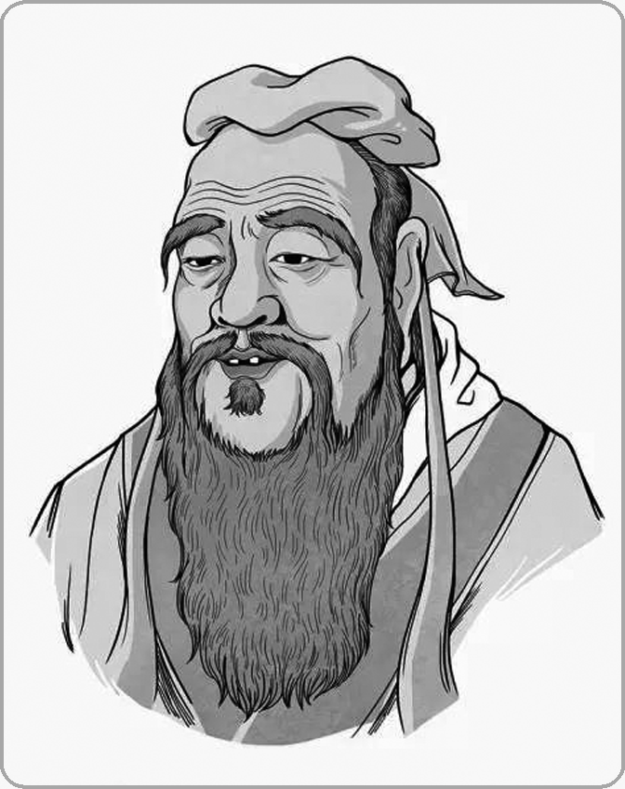
Kong Zi, also called Confucius (551－479 B．C.E.), and Socrates (469－399B．C.E.) lived only a hundred years apart.During their lifetimes there was no contact between China and Greece, but it is interesting to look at how the world that each of these great philosophers came from shaped their ideas, and how these ideas, in turn，shaped their societies.
Neither philosopher lived in times of peace，though there were more wars in Greece than in China.The Chinese states were very large and feudal, while the Greek citystates were small and urban.The urban environment in which Socrates lived allowed him to be more radical (激进的) than Confucius.Unlike Confucius，Socrates was not asked by rulers how to govern effectively.Thus，Socrates was able to be more idealistic，focusing on issues like freedom, and knowledge for its own sake.Confucius, on the other hand, advised those in government service, and many of his students went on to government service.
Confucius suggested the Golden Rule as a principle for the conduct of life.“Do not do to others what you would not want others to do to you.” He assumed that all men were equal at birth, though some had more potential (潜能) than others，and that it was knowledge that set men apart.Socrates focused on the individual，and thought that the greatest purpose of man was to seek wisdom.He believed that some had more potential to develop their reason than others did.Like Confucius，he believed that the superior class should rule the inferior (下层的) classes.
For Socrates, the family was of no importance，and the community of little concern.For Confucius，however，the family was the centre of society，with family relations considered much more important than political relations.
Both men are respected much more today than they were in their lifetimes.
【解题导语】 本文主要阐述了孔子与苏格拉底两位伟大哲学家的哲学思想对社会的影响以及两者思想观点的异同。
1．Which of the following is TRUE according to the first paragraph?
A．Socrates and Confucius had much in common.
B．Confucius had much influence on Socrates' ideas.
C．The societies were influenced by the philosophers' ideas.
D．There were cultural exchanges between China and Greece.
C 解析：细节理解题。根据第一段最后一句中的“...and how these ideas, in turn，shaped their societies.”可知C项正确。
2．What idea did Socrates share with Confucius?
A．All men were equal when they were born.
B．The lower classes should be ruled by the upper class.
C．The purpose of man was to seek freedom and wisdom.
D．People should not do to others what they did not want others to do to them.
B 解析：细节理解题。根据第三段最后一句“Like Confucius, he believed that the superior class should rule the inferior classes.”可知答案。
3．What made some people different from others according to Confucius?
A．Family. B．Potential.
C．Knowledge. D．Community.
C 解析：细节理解题。根据第三段中的“...and that it was knowledge that set men apart.”可知答案。
4．How is this passage organized?
A．In the pattern of time and events.
B．In the pattern of comparison and contrast.
C．In the pattern of cause and effect.
D．In the pattern of definition and classification.
B 解析：写作手法题。文章的谋篇布局主要是以比较和对照的方式来阐述伟大哲学家孔子与苏格拉底的哲学思想对社会的影响以及两者思想观点的异同。
B
Australia is proud of a unique history that has been shaped by the diversity of her inhabitants. The three main elements that have been central to the creation of Australia's population composition contain the diversity of her native population, colonization by the British in the past and the extensive immigration from diverse cultures.
Australia is home to the world's cultures and inhabitants who can identify with more than 270 ancestries(祖先). From the year 1945, the number of people who have immigrated to Australia from different parts of the globe is approximately seven million. The country considers the rich cultural diversity as its main strength which embodies its national identity.
In 1945, there was the racial discrimination (歧视) act, which meant that discrimination in the country was against the law. Later in 1995, the act was extended to ensure that any acts of racial hatred (仇恨) were against the law. To date, the act has been used in ensuring that Australia sends a strong message on the collective commitment to promoting racial equality and the significance of fairness for all.
On a range of measures, Australia is a multicultural success story. On educational attainment, studies show that children of immigrants in Australia get better average results than children of nativeborn Australians. This is significant because according to research conducted by the OECD, the successful integration of immigrant students is an important indicator of a country's success in its education system and equity and broader socially combinative policies.
The success in educational performance is mirrored in the broader economy of Australia as it attracts a significant proportion of skilled migrants annually who have a high labour market participation rate. In the years between 2016－2017, skilled migrants accounted for 67.3 percent of the total immigration program outcome that year. The net effect of a multiculturalism policy for Australia has been a brain gain for Australia and this is expected to continue growing.
5．What is paragraph 1 mainly about?
A．The history of Australia.
B．The customs of Australia.
C．The character of Australians.
D．The population structure of Australia.
D 解析：段落大意题。根据第一段中的“The three main elements that have been central to the creation of Australia's population composition contain the diversity of her native population... from diverse cultures.”可知，本段主要介绍了澳大利亚的人口结构。故选D。
6．What does the underlined word “embodies” in paragraph 2 mean?
A．Maintains. B．Represents.
C．Assesses. D．Predicts.
B 解析：词义猜测题。根据画线词所在句“The country considers the rich cultural diversity as its main strength which embodies its national identity.”可知，这个国家认为丰富的文化多样性体现了它的民族特色，是它的主要优势。所以画线词意为“体现”。故选B。
7．From which can we see Australia's success in education?
A．The higher educational standards.
B．The better overall grades of students.
C．The increasing number of immigrant children.
D．The better performance of immigrant children.
D 解析：细节理解题。根据第四段中的“children of immigrants in Australia get better average results than children of nativeborn Australians. This is significant because... the successful integration of immigrant students is an important indicator of a country's success in its education system.”可知，澳大利亚在教育上的成功体现在移民孩子在学习成绩上比本土孩子表现得好。故选D。
8．In which aspect does educational success benefit Australia?
A．Bringing in more skilled migrants.
B．Reforming the immigration policy.
C．Developing immigration programs.
D．Making a booming labour market.
A 解析：细节理解题。根据最后一段中的“The success in educational performance is mirrored in the broader economy of Australia as it attracts a significant proportion of skilled migrants annually who have a high labour market participation rate.”可知，澳大利亚在教育上的成功吸引了很多有技能的移民。故选A。
Ⅱ.七选五
If your family or friends love to bike, then a bike trip makes a perfect vacation.1.________ Because you move more slowly on a bike, you have a chance to really sink into your environment, observing wildlife and views that you might miss otherwise.
As you plan your trip, the biggest decision to make is how far you'd like to travel each day. If you have unskilled bikers or kids in your group, you'll probably all be happiest if you keep your mileage (英里里程) goals fairly modest. 2.________
3．________You can book campsites ahead of time at campgrounds along the way, and ride into camp as late as you like. Keep in mind that some camping equipment is heavy. Invest in a lightweight tent, and lightweight inflatable pads (充气垫) for your sleeping bag. Dehydrated food also helps keep the weight down.
If you're going to be traveling on trails, you'll want to ride a mountain bike during your trip. 4.________ Or, you can put heavierweight tires on the street bike. Check in with your local bike shop for suggestions on tire weight.
Biking is a great way to see the country, and if you have a lot of time, you can cover quite a bit of distance. Over the course of a multiweek trip, you'll get stronger and you'll be able to go further in one day. 5.________ If your trip is a long one, you might want to rest a day or two early in your travels to give your body some rest.
A．An easy way to travel is to camp along the way.
B．Taking a bike trip is really beneficial to our health.
C．Be sure to bring the contact information of each campground.
D．If your whole route is on the road, you can ride a lighter street bike.
E．Seeing the world from a bike is a wonderful way to experience new places.
F．But early in the trip you'll start every day feeling more tired than the day before.
G．But a group of more experienced bikers can make more serious mileage goals.
【解题导语】 本文就如何计划自行车旅行、自行车的选择等问题提出了一些建议。
1．E 解析：根据空后一句可知，因为你骑自行车走得比较慢，所以你有机会真正融入你的环境。空处是在说明坐在自行车上看世界这种体验方式，下文则说明了这一方式的优点。故E项“从自行车上看世界是一种体验新地方的很棒的方式”符合语境，故选E。
2．G 解析：根据空前两句可知，本段是关于骑行目标的设定问题。G项“但是一群更有经验的自行车骑手可以设定更多里程的目标”承接上文，故选G。
3．A 解析：根据空后内容可知，本段说明的是露营这种旅行方式。故A项“一个容易的旅行方式是沿途露营”适合作本段的总起句，故选A。
4．D 解析：根据空前一句及空后一句可知，本段是在说明关于自行车选择的问题，D项中的“a lighter street bike”和空后的“the street bike”相照应。故选D。
5．F 解析：根据空前和空后内容可知，本段主要说明旅途中休息的问题。在旅途的初期，你会觉得每一天都比前一天更累，所以最好在旅行时提前休息一两天。故F项符合语境。
Ⅲ.应用文写作
根据下列提示，写一篇关于马克·吐温(Mark Twain)及其作品《哈克贝利·费恩历险记》(The Adventures of Huckleberry Finn)的评论。词数80左右。
1．马克·吐温，美国作家，本名萨缪尔·兰亨·克莱门(Samuel Langhorne Clemens)(1835－1910)，马克·吐温是其笔名；出生于密西西比河(the Mississippi River)河畔小城。
2．代表作(masterpiece)之一是《哈克贝利·费恩历险记》。这部小说讲述了白人小孩哈克贝利·费恩从家中逃走，和黑奴吉姆在密西西比河流浪的故事。
3．哈克贝利·费恩遇见的人物涵盖了社会各个阶层(walk)，因此这部小说生动地反映了当时的社会状况。
4．《哈克贝利·费恩历险记》在美国文学史上一直被称为最伟大的作品之一。
_______________________________________________________________
_______________________________________________________________
_______________________________________________________________
_______________________________________________________________
_______________________________________________________________
One possible version：
Mark Twain, whose real name is Samuel Langhorne Clemens (1835－1910), is an American writer, famous for his stories.
He grew up in a small town on the banks of the Mississippi River, one of whose brilliant masterpieces is The Adventures of Huckleberry Finn. The novel tells Huckleberry Finn runs away from home and wanders down the Mississippi River with Jim, a slave who he soon makes the acquaintance of. If he hadn't met Jim, there could never have been such extraordinary things later on. With the people Huckleberry Finn meets covering all walks of the society, the novel vividly reflects the society at that time.
Generally speaking, considered in many aspects, The Adventures of Huckleberry Finn is a classic novel in American literature.

