
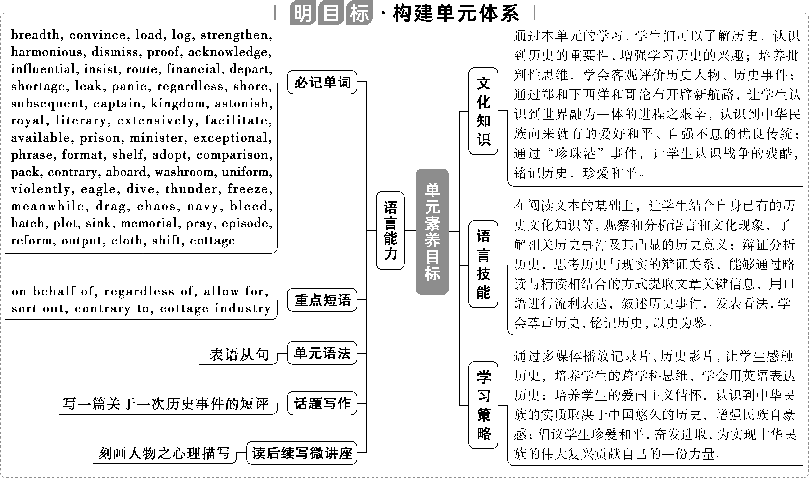

【话题导入】  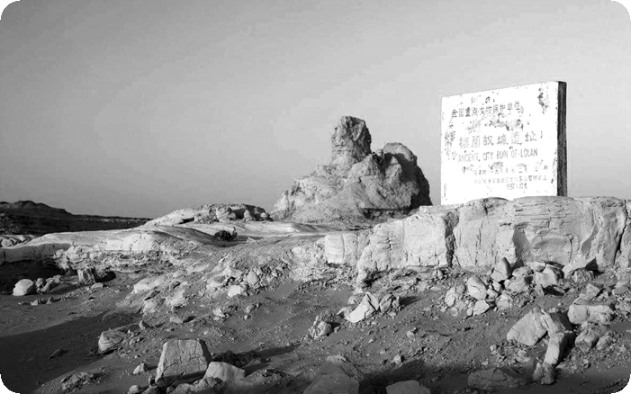  The ancient Loulan City lies on the west bank of Lop Nur Lake （罗布泊） in Xinjiang region. The city was founded in the 2nd century BCE in an oasis （绿洲） on the Silk Road. But it became less powerful and strong after its 800 years of development， and disappeared suddenly in the middle of the 6th century. At the beginning of last century， a Swedish explorer Sven Hedin discovered the city buried in the desert， which attracted attention from all over the world.  The city has already totally turned into dust. But archaeologists believe there was a water tunnel running through the city and dividing it into two different functional parts. Large numbers of potsherds（陶瓷碎片），wood pieces， coins， pieces of jewellery and wood slip documents provide us with plenty of information about the ancient city before it disappeared.  The study of the materials of the ruins of Loulan City perhaps can tell us why it disappeared. The archaeologists found that the Loulanese preferred Sun tomb which consisted of 7 circles of logs which became thicker and thicker from center to the outer circle， just like the sun shining. The unique but spectacular burying form was quite popular at that time but sped up the disappearance of Loulan City. A large amount of forest was cut down， which made Loulan City destroyed by the sandstorms at last. | Ⅰ. 词汇积累  1.oasis [əʊ'eIsIs] n. 绿洲  2.archaeologist [ˌaːki‘ələdʒIst] n．  考古学家  3.ruin ['ruːIn] n. 废墟  4.consist of 由……组成  5.spectacular [spek'tækjələ®] adj. 壮观的  6.speed up 加速  Ⅱ.根据短文内容判断下列句子对（T）或错（F）  1.Loulan City was destroyed by the nature rather than human beings.（F）  2.Archaeologists can tell us the reason why the ancient Loulan City disappeared.（T）
Period 1 Welcome to the unit & Reading—Comprehension

1.Beijing's Forbidden City is a place full of wonders. From its thousands of rooms to its many beautiful artifacts, it's no wonder that it is one of China's most popular scenic spots.
北京的紫禁城是一个充满奇迹的地方。从成千上万的房间到许多美丽的文物，难怪它是中国最受欢迎的景区之一。
2.130 meters above the Lhasa River Valley, the Potala Palace rises a further 170 meters and is the greatest monumental structure in all of Tibet.
位于拉萨河谷之上130米处的布达拉宫，其高度为170米，是全西藏最大的纪念性建筑。

①voyage ['vɔɪɪdʒ] n．航海，航行，航天 vi.航行，远行
②fleet [fliːt] n．舰队；捕鱼船队；车队
a fleet of一队；一支舰队
③navigate ['nævɪɡeɪt] vt.航行；导航 vi.导航
④on behalf of 代表(或代替)；为帮助；为了
⑤load [ləʊd] vt.& vi.装上，装入 n．负载；承载量；大量
⑥log [lɒɡ] n．航海日志，正式记录；原木 vi.& vt.伐木
⑦strengthen ['streθn] vt.& vi.加强；增强
⑧harmonious [hɑː'məʊniəs]
adj.友好和睦的；协调的，和谐的
⑨dismiss [dɪs'mɪs] vt.不予考虑，对……不屑一提；去除，摒除；解雇；解散
⑩proof [pruːf] n．证据，证明
⑪acknowledge [ək'nɒlɪdʒ]vt.承认(权威、地位); 承认(属实)；(公开)感谢
be widely acknowledged被广泛认可
⑫influential [ˌɪnflu'enʃl]adj.有很大影响力的，有支配力的
⑬insist [ɪn'sɪst]vi.& vt.坚决要求，坚持；坚持说
insist on...坚持……
⑭route [ruːt] n．路线，路途；途径，渠道
⑮financial [faɪ'nænʃl] adj.财政的，金融的，财务的
⑯shortage ['ʃɔːtɪdʒ] n．不足，短缺
⑰leak [liːk] vi.漏，渗漏；渗入 vt.漏，渗漏；泄露 n．漏洞
⑱panic ['pænɪk] n．惊恐，恐慌vi.& vt.(panicked，panicked)(使)惊慌，(使)惊慌失措
in panic惊慌失措
⑲regardless [rɪ'ɡɑːdləs]
adv.不顾，不加理会
regardless of 不管，不顾
⑳shore [ʃɔː(r)] n．岸，滨
subsequent ['sʌbsɪkwənt]adj.随后的，后来的
captain ['kæptɪn] n．船长，机长；上校；队长
allow for 使成为可能；考虑到，把……计算在内

Sailing the oceans
Zheng He
In the summer of 1405, Zheng He, one of China's greatest explorers, set sail from Taicang on his first voyage^{①} . A fleet^{②} of over 200 ships navigated^{③} the blue seas, with almost 28，000 people on board, which was a splendid scene. It would take 500 years before a larger fleet sailed the seas. ^{[1]}According to some records, the largest ships were over 140 metres in length, demonstrating the advanced technology and special skills used in constructing ships.
[1]本句中According to some records是介词短语作状语；demonstrating the advanced technology and special skills used in constructing ships是动词ing形式短语作状语，其中used in constructing ships是过去分词短语作定语。
Between 1405 and 1433, on behalf of^{④} the Ming Dynasty, Zheng He made a total of seven voyages. His ships were loaded^{⑤} with china, silk, tea and other treasures as gifts for foreign rulers, and the fleet paid friendly visits to more than 30 countries and regions. He even sailed as far as the east coast of Africa. As they sailed, the navigators took compass readings, kept logs^{⑥} of their voyages and charted the coast. Later the detailed maps became Zheng He's Navigation Map.
Zheng He's seven voyages had a farreaching impact on China and its neighbours. In the countries and regions where Zheng He set foot, legends have been passed on about this great explorer. Zheng He's efforts helped develop and strengthen^{⑦} harmonious^{⑧} relations with these countries and regions, exposing foreign people to Chinese culture, and allowing the Chinese to better understand overseas lands.
For many years, some historians dismissed^{⑨} the records of these voyages as legends. The final proof^{⑩} came when an enormous shipyard was discovered in Nanjing, where the fleet had been built. Zheng He's accomplishments are now widely acknowledged^{⑪}， and he is remembered as one of China's most influential^{⑫} explorers.
Christopher Columbus
^{[2]}Those who make great discoveries must often overcome many challenges along the way—as was the case with the explorer Christopher Columbus. Columbus was born in a port city of Italy in 1451.^{[3]} As a teenager, he loved sailing, and he showed great interest in geography, which inspired him to begin his career as a seaman.
[2]本句中who引导定语从句；as引导非限制性定语从句，补充说明前面整个句子。
[3]本句中As a teenager是介词短语，相当于一个时间状语；which引导非限制性定语从句。
Columbus insisted on^{⑬} searching for a direct sea route^{⑭} to the East Indies by sailing across the Atlantic Ocean. After continuous attempts, he received financial^{⑮} support from the King and Queen of Spain. On 3 August 1492, he departed from Spain with three ships carrying about 90 crewmen. The journey was full of challenges: it took longer than expected, they faced a shortage^{⑯} of food, and one of the ships was leaking^{⑰} badly, which put everyone on this ship in grave danger. The men on board were in panic^{⑱}. Regardless of^{⑲} all the challenges, Columbus managed to keep everyone out of danger with his knowledge and bravery across the ocean. Finally, on 12 October, the crew spotted land in the distance. ^{[4]}Columbus called the natives living on the islands Indians because he was convinced that he was in the East Indies. However, the shores^{⑳} they had reached were of the Caribbean, not the East Indies.
[4]本句中living on the islands是动词ing形式短语作定语；because引导原因状语从句，其中that引导宾语从句。
Between 1493 and 1504, Columbus found more land over the course of his three subsequent voyages. The major contribution of this great explorer is that he “discovered” the New World. His discovery inspired explorers such as Captain James Cook to explore and discover more vast areas of the world. His voyages opened a new chapter of the Age of Exploration, a period which witnessed many important geographical findings. This period also allowed for an international exchange of ideas and cultures.

航 海
郑和
1405年夏天，中国最伟大的探险家之一郑和从太仓起锚，开始首次航海之行。一支由200多艘船只组成的船队在蓝色的海洋上航行，船上有近28 000人，这是一个壮观的景象。直到500年后才有比这更大的船队在海上航行。根据记载，当时最大的船只长度超过140米，显示了建造船只所采用的先进技术和特殊技能。
1405年至1433年间，郑和代表明朝总共进行了七次航行。他的船只装载了瓷器、丝绸、茶叶和其他珍品，作为送给外国统治者的礼物，船队对30多个国家和地区进行了友好访问。他甚至远航到非洲东海岸。航行时，航海家们读取罗盘读数，记录航行日志，绘制海岸图。后来这些详细的地图成为《郑和航海图》。
郑和的七次航行对中国及其邻国产生了深远的影响。在郑和踏上的国家和地区，一直流传着关于这位伟大的探险家的传说。郑和的努力有助于发展和加强与这些国家和地区的友好关系，让外国人了解中国文化，也让中国人更好地了解海外国家。
多年来，一些历史学家将这些航行记录视为传说而不予理会。最后的证据是在建造船队的南京发现了一个巨大的造船厂。郑和的成就现在被广泛认可，他作为中国最有影响力的探险家之一而被世人铭记。
克里斯托弗·哥伦布
那些有重大发现的人必须经常克服途中许多挑战，就像探险家克里斯托弗·哥伦布一样。1451年，哥伦布出生于意大利的一个港口城市。十几岁时，他热爱航海，对地理表现出极大的兴趣，这激励他开始他的航海生涯。
哥伦布坚持通过横渡大西洋来寻找一条直达东印度群岛的航线。经过不断的尝试，他得到了西班牙国王和王后的财政支持。1492年8月3日，他带着三艘船离开西班牙，船上约有90名船员。旅程充满了挑战：时间比预期的要长，他们面临食物短缺，其中一艘船严重漏水，这使这艘船上的每个人都处于严重的危险之中。船上的人惊慌失措。不论挑战如何，哥伦布设法凭借自己的知识和勇敢确保每个人都平安越过海洋。最后，10月12日，船员们发现远处有陆地。哥伦布称岛上的土著人为印第安人，因为他确信自己在东印度群岛。然而，他们到达的海岸是加勒比海的海岸，而不是东印度群岛的海岸。
1493年至1504年间，哥伦布在随后的三次航行中发现了更多的陆地。这位伟大的探险家的主要贡献是他“发现”了新世界。他的发现鼓舞了詹姆斯·库克船长等探险家去探索和发现世界上更广阔的地区。他的航海开启了大航海时代的新篇章，这一时期见证了许多重要的地理发现。这一时期也实现了思想和文化的国际交流。
Ⅰ.明主旨大意
What's the main idea of the text?
A．Two famous people in the history in the world.
B．The voyages of two famous explorers in the world.
C．The ocean explorations of two famous people.
D．Dangers that the explorers faced in the past.
答案：B
Ⅱ.知层次结构
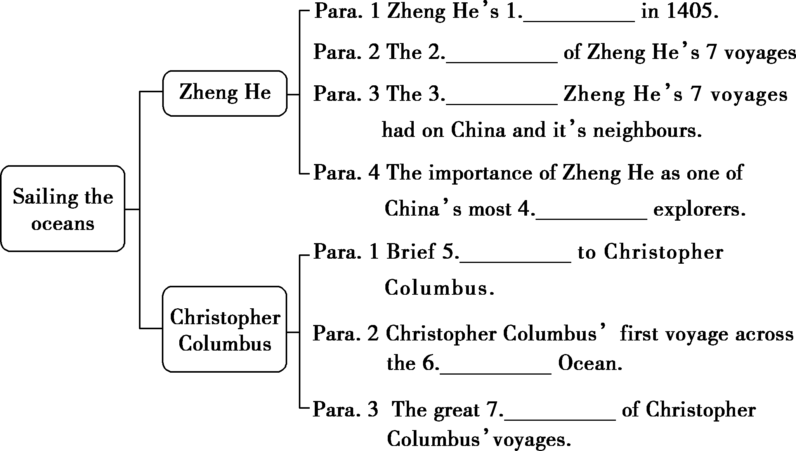
答案：1.first voyage 2.achievements 3.influence
4．influential 5.introduction 6.Atlantic 7.significance
细读课文，完成下列各题
1．Which of the following statements is TRUE according to the text?
A．All Zheng He's ships were over 140 meters in length.
B．About 2，800 people were on board on Zheng He's first voyage.
C．For 500 years Zheng He's fleet was the largest one sailing the seas.
D．In 1405, Zheng He's fleet set sail from Nanjing on his first voyage.
2．What helped prove that the records of Zheng He's voyages were not legends?
A．Zheng He's Navigation Map.
B．The discovery of a big shipyard in Nanjing.
C．The countries and regions that Zheng He's fleet paid visits to.
D．The fact that Zheng He's ships were loaded with china, silk, tea and other treasures.
3．Which of the following about Columbus is TRUE according to the text?
A．The New World he “discovered” was India.
B．Columbus and his crewmen finally arrived at the East Indies.
C．Columbus received financial support from the King and Queen of Italy.
D．Columbus and his ships set sail from Spain and finally reached the shores of the Caribbean.
4．Which was NOT one of the challenges that Christopher Columbus and his crew encountered?
A．They lacked financial support.
B．They faced a shortage of food.
C．One of the ships was leaking badly.
D．The journey took longer than expected.
答案：1－4.CBDA
1．A fleet of over 200 ships navigated the blue seas, with almost 28，000 people on board, which was a splendid scene.

本句是一个复合句。with almost 28，000 people on board是with复合结构，其中on board作宾补；which引导非限制性定语从句。
[翻译] 一支由200多艘船只组成的船队在蓝色的海洋上航行，船上有近28__000人，这是一个壮观的景象。
2．Zheng He's efforts helped develop and strengthen harmonious relations with these countries and regions, exposing foreign people to Chinese culture, and allowing the Chinese to better understand overseas lands.

本句中exposing foreign people to Chinese culture与allowing the Chinese to better understand overseas lands为并列的动词ing形式短语作结果状语。
[翻译] 郑和的努力有助于发展和加强与这些国家和地区的友好关系，让外国人了解中国文化，也让中国人更好地了解海外国家。
Zheng He
Between 1405 and 1433, Zheng He made seven voyages 1.on behalf of the Ming Dynasty. In the summer of 1405, he set sail from Taicang on his first voyage. At that time, his fleet was the 2.largest(large) one in the world. His ships were loaded 3.with china, silk, tea and other treasures as gifts for foreign rulers in more than 30 countries and regions. Zheng He's seven voyages had a great impact on China and its neighbours. His efforts helped develop and strengthen 4.harmonious(harmony) relations with these countries and regions, allowing the Chinese to better understand overseas lands. Zheng He's accomplishments are now 5.widely(wide) acknowledged and he is remembered as one of China's most 6.influential(influence) explorers.
Christopher Columbus
Christopher Columbus was born in Italy. When he was young he loved sailing and showed great interest in geography, 7.which inspired him to begin his career as a
seaman. In 1492, after receiving 8.financial(finance) support from the King and Queen of Spain, he departed from Spain with 3 ships 9.carrying(carry) about 90 crewmen. They overcame many difficulties all the way and finally reached the shores of the Caribbean. Between 1493 and 1504, Christopher Columbus made another 3 voyages. The major 10.contribution(contribute) of this great explorer is that he “discovered” the New World. His voyages opened a new chapter of the Age of Exploration.

Ⅰ.词汇匹配
1．convince______ A．become stronger; make sb. or sth. stronger
2．load______ B．make sb. believe that sth. is true
3．strengthen______ C．facts/information/documents that show that sth. is true
4．dismiss______ D．put a large quantity of things or people into/onto sth.
5．proof______ E．decide that sb./sth. is not important and not worth thinking
6．influential______ F．demand that sth. happens or that sb. agrees to do sth.
7．insist______ G．leave a place especially to start a trip
8．depart______ H．surprise sb. very much
9．panic______ I．having a lot of influence on sb./sth.
10．astonish______ J．a sudden feeling of fear
答案：1－5.BDAEC 6－10.IFGJH
Ⅱ.短语互译
1．on__behalf__of 代表(或代替)；为帮助；为了
2．regardless__of 不管，不顾
3．allow__for 使成为可能；考虑到，
把……计算在内
4．as__far__as 远至
5．have an impact on 对……有影响
6．insist on 坚持……
7．a total of 总数，总计
8．pay a visit to 拜访/参观/访问某地
Ⅰ.阅读理解
A
A valuable sketch from World War Ⅰ has turned up in a garage sale in Perth. It's a sketch of soldiers playing soccer with a tin can during an unofficial truce (停战期) between German and Allied soldiers on the Western Front in 1914. The artwork was drawn by an unnamed German soldier during the war on the Western Front.
The artwork was given to Private Jack Shelley, a British soldier, when he was defending the town of Frelinghien, France. The sketch is an important historical document, as it provides evidence that the tales of both sides at war socializing together are true. But for Jack's family it has even greater value, since it was his prized possession.
Jessie Shelley, Jack's greatgranddaughter, has fond memories of the old man sharing stories about his experiences in the war. The family lost track of the artwork after Jack's possessions were moved during the sale of his house when he died in 1984. “Greatgrandpa had a tobacco tin with a dozen or so buttons from the uniforms of men from both sides. He told us all the details of every one of those buttons. To greatgrandpa they represented real people he had known, some of whom couldn't come home from the war. He had at least two buttons from German uniforms that he told us were exchanged between the men involved in the truce.” Jessie Shelley said.
On the day of truce in 1914, the soldiers came out of their trenches (战壕) into noman'sland and shared food, drinks and cigarettes. Some even exchanged small gifts. The men even played football games together. Later, this spirit of cooperation continued in unofficial agreements between the sides to stop shooting at mealtimes and even at times when soldiers were working in the open.
This fascinating image of peace and humanity during the war has continued through the years. The sketch is a symbol of the potential for humanity, hope and kindness to exist in even the most violent circumstances.
【解题导语】 本文介绍了一幅一战期间交战双方的士兵一起踢足球的素描画，以及背后的历史信息和意义。
1．In what situation was the sketch done?
A．In a garage.
B．On the front line.
C．At a special sale.
D．During a soccer match.
B 解析：细节理解题。根据第一段中的“It's a sketch of soldiers playing soccer...during the war on the Western Front.”可知，这幅画是在前线完成的。故选B。
2．Why is the sketch an important historical document?
A．It explains the reason for the war.
B．It indicates that the war came to an end.
C．It shows soldiers could adapt to society.
D．It proves warring sides could live in peace.
D 解析：细节理解题。根据第二段中的“The sketch is an important historical document, as it provides evidence that the tales of both sides at war socializing together are true.”可知，这幅素描证明了交战双方的士兵会彼此来往这一传言是真的。故选D。
3．What did Private Jack Shelley say about the buttons in the tobacco tin?
A．They were collected in 1914.
B．They were from German uniforms.
C．Some of them represented his honor.
D．Some of their owners didn't survive the war.
D 解析：推理判断题。根据第三段中的“He told us all the details...whom couldn't come home from the war.”可知，其中一些纽扣的主人没能平安回家，死在了战场上。故选D。
4．What impact did the day of truce have?
A．It brought about more truces.
B．It resulted in more celebrations.
C．It led to more official agreements.
D．It started wide information exchanges.
A 解析：推理判断题。根据第四段中的“Later, this spirit of cooperation continued...when soldiers were working in the open.”可知，停战日之后，这种合作精神在非官方的协议中继续发扬，后期有了更多的停战。故选A。
B
The Maoris are the local Polynesian people of New Zealand. The Maoris originated with settlers from eastern Polynesia, who arrived in New Zealand by boat around 1150 AD. Over several centuries in separation, the Polynesian settlers developed a unique culture, with their own language and special crafts and performing arts. The early Maoris formed tribal (部落的) groups based on eastern Polynesian social customs and organizations.
The arrival of Europeans, starting in the 17th century, brought great changes to the Maori way of life. The Maoris gradually learned from the Western society and culture. The primary relations between the Maoris and Europeans were largely kind, and the two cultures coexisted peacefully. Rising stress over land sales led to conflict in the 1860s. Great social changes, decades of conflict and introduced diseases made the number of the Maoris fall greatly. By the start of the 20th century, the Maori population had begun to recover, and efforts had been made to increase their standing in wider New Zealand society and achieve social justice. Traditional Maori culture therefore enjoyed a great revival.
In 2013, there were about 600，000 Maoris in New Zealand, making up 15% of the national population. They are the secondlargest ethnic group in New Zealand, after European New Zealanders. In addition, more than 120，000 Maoris live in Australia. The Maori language is still spoken to some degree by about a fifth of all Maoris, representing 3% of the total population. Many New Zealanders regularly use Maori words and expressions, such as “kia ora”， while speaking English.
Many Maoris face big economic and social problems, with lower life expectancies and incomes compared with other New Zealand ethnic groups. They suffer higher levels of crime, health problems, and educational underachievement. Some measures have been taken to aim at closing the gap between the Maoris and other New Zealanders.
【解题导语】 本文主要介绍了毛利人的历史和相关情况。
5．Which is mentioned in paragraph 1?
A．The Maoris come originally from New Zealand.
B．The Maoris differ from Polynesians.
C．The Maoris have their own culture.
D．The Maoris like to live in separation.
C 解析：细节理解题。根据第一段中的“developed a unique culture, with their own language and special crafts and performing arts”可知，毛利人有他们自己的文化。
6．What caused the fighting between the Maoris and Europeans?
A．The culture difference.
B．The social changes.
C．The introduced diseases.
D．The land problem.
D 解析：细节理解题。根据第二段中的“Rising stress over land sales led to conflict in the 1860s.”可知，土地销售问题在19世纪60年代导致了毛利人和欧洲人的冲突。
7．What can we know about the introduced Maori language?
A．Not all Maoris speak the Maori language.
B．It's unusual for New Zealanders to speak it.
C．It's spoken by about a fifth of people worldwide.
D．It's the secondlargest language in New Zealand.
A 解析：推理判断题。根据第三段中的“The Maori language is still spoken to some degree by about a fifth of all Maoris, representing 3% of the total population.”可知，现在只有大约五分之一的毛利人说毛利语，即并不是所有的毛利人都说毛利语。
8．What's the text mainly about?
A．The characteristics of the Maoris.
B．The problems the Maoris face.
C．The language the Maoris use.
D．The history of the Maoris.
D 解析：主旨大意题。文章主要讲述了毛利人的历史和相关情况，故D项最能概括本文大意。
C
Can robots be creative? British art gallery owner Aidan Meller thinks so. He hopes to begin answering this question with a robot called AiDa. Meller is overseeing the building of all her parts by engineers at Engineered Arts, a company based in Cornwall, England. The engineers believe the robot will be able to make pictures of people in sight with a writing instrument in her hand. Meller wants the robot to perform like a human artist.
He spoke to the Reuters News Agency after seeing AiDa's head being carefully brought to life by specialists who were connecting individual hairs to form eyebrows. He said, “She's going to actually be drawing and we're hoping to then build technology for her to paint.” “But also as a performing artist, she'll be able to engage with audiences and actually get messages across, asking those questions about technology today，” he added.
AiDa's skeletal robotic head may still be separate from her body, but her movements are very alive. Cameras in each of her eyeballs recognize human body parts. AiDa will make eye contact and follow you around the room, opening and closing her mouth as you do. If you get too close, the robot will back away, closing and then opening her eyes as if in shock.
The specialists are using the company's Mesmer lifelike robot technology to create her head. Once finished, AiDa will have a mixedrace appearance, with long dark hairs and rubberlike skin made from silicone. The teeth and skin inside her mouth will come from a 3D printer. Marcus Hold works at Engineered Arts. He said, “Mesmer brings together the development of software mechanics and electronics to produce a lifelike face with lifelike gestures in a small humansized package.”
AiDa will make her first public appearance at an exhibit called “Unsecured Futures” at the University of Oxford. Some of her pictures are expected to appear at another show in London later.
【解题导语】 本文主要通过介绍机器人爱达来证明机器人也可以有创造力。
9．What does Meller want AiDa to be?
A．A photographer.
B．An engineer.
C．A professional painter.
D．A robot artist.
D 解析：细节理解题。根据第一段中的“Meller wants the robot to perform like a human artist.”可知，梅勒想要机器人爱达像人类艺术家一样。故选D。
10．Which of the following is AiDa good at?
A．Doing housework.
B．Taking care of the old.
C．Interacting with people
D．Making up like humans.
C 解析：细节理解题。根据第二段中的“But also as a performing artist, she'll be able to engage with audiences and actually get messages across, asking those questions about technology today”可知，爱达擅长和人交流。故选C。
11．What will AiDa do when you get very close to her?
A．Step back.
B．Keep eyes closed.
C．Run away.
D．Follow you around.
A 解析：细节理解题。根据第三段中的“If you get too close, the robot will back away, closing and then opening her eyes as if in shock.”可知，当离爱达太近时，她会退后。故选A。
12．What may be the best title for the text?
A．AiDa, a Creative Robot
B．Meller, a Great Engineer
C．AiDa Makes Painting Easier
D．Meller Makes Robots Cleverer
A 解析：标题归纳题。根据文章的主要内容，尤其是第一段可知，本文主要介绍了爱达，用她来证明机器人也可以有创造力。故选A。
Ⅱ.七选五
Why Gratitude Is Significant
As far as I'm concerned, no matter what you're going through, there is always a reason to be thankful. But not only that—being thankful might just be exactly what you need to do if you're going through a tough time. 1.________
Researchers found that having a grateful attitude helps strengthen one's immune system, lower blood pressure, improve sleep and motivate people to exercise regularly. 2.________ Practicing gratitude also has been associated with better quality of life for individuals who struggle with stress, anxiety and depression.
Having gone through a period of depression myself after cancer surgery 10 years ago, I can tell you this illness can be severe. 3.________ I knew I was in trouble when I couldn't eat or sleep. It took me well over a year to come out of that dark valley.
During that time I sought many forms of treatment for depression, including professional counseling and exercise. One thing recommended to me by a counselor was keeping a gratitude journal.4.________ This simple exercise lifts my sight out of the darkness and helps me see the truth around: there are people who love and care for you and there are purposes in life.
5．________ In reality, there is no single cure for it. If suffering, you may prefer to seek professional counseling and care. Still, I would encourage you to practice gratitude. Think of a few things you can thank life for. You might be surprised by how significant an effect it can have.
A．It itself carries a host of health benefits.
B．Being grateful accounts for your recovery.
C．Gratitude is good for your mind, body and soul.
D．Depression makes you feel as if you were dead inside.
E.For example, I would sincerely convey my gratitude loudly.
F．Every day, I would set down three things I was thankful for in life.
G．Now I realize depression does not go away by practicing a single exercise.
【解题导语】 本文通过研究者的发现和作者自身的故事告诉读者：感恩有益于身心健康。
1．C 解析：根据空前的“But not only that—being thankful might just be exactly what you need to do if you're going through a tough time.”可知，C项“感恩对你的思想、身体和灵魂都有好处”是对空前句的原因说明，起到了承上启下的作用。
2．A 解析：本段讲述研究者发现感恩对人们的健康有益。A项“It itself carries a host of health benefits.”是对空前句“Researchers found that having a grateful attitude helps...to exercise regularly.”的总结。
3．D 解析：根据空前的“Having gone through a period of depression myself after cancer surgery 10 years ago, I can tell you this illness can be severe.”可知，10年前，作者在癌症手术后也经历了一段时间的抑郁，这种病可能会很严重。D项“Depression makes you feel as if you were dead inside.”是进一步的说明。
4．F 解析：根据空前的“One thing recommended to me by a counselor was keeping a gratitude journal.”可知，一位顾问向作者推荐写感恩日记。F项“Every day, I would set down three things I was thankful for in life.”是举例说明具体做法。
5．G 解析：根据全文内容以及本段大意可知，本段既是上一段的总结，也是全文的总结。G项“Now I realize depression does not go away by practicing a single exercise.”适合作本段的主旨句。

