读后续写指导
Step 1：Lead in
读后续写的评分标准综述
评分: 主要从续写内容、词汇语法、篇章结构三方面考虑。
1.创造情节的质量、续写的完整性及与原文情境的融洽度。
2.词汇、语法的准确性、恰当性及多样性。
3.上下文的衔接和全文的连贯性。
Step 2：A logical plot
- What is plot?
- Is the following passage logical?
A logical plot?
Twilight merged into darkness. With the class approaching, I got more and more nervous. Despite the hours devoted to it these days, I still felt butterflies in my stomach. The whole night found me turning and tossing in bed, unable to fall asleep. I got up at dawn and opened the window. The air was so fresh, and the lovely birds were hopping from branch to branch, singing beautiful songs merrily. Suddenly, I sensed the smell of spring, with everything coming back to life. After breakfast, I took my cellphone and read an article about how China take on the virus. Proud of the efforts China made to keep standing, I felt lucky to have such a big country to fall back on. It's nearly 10 o'clock, which is time for my class. With a trembling hand, I turned on the computer, my heart pumping violently. Taking a deep breath, I managed to calm down and began my class as usual
- PLOT DIAGRAM
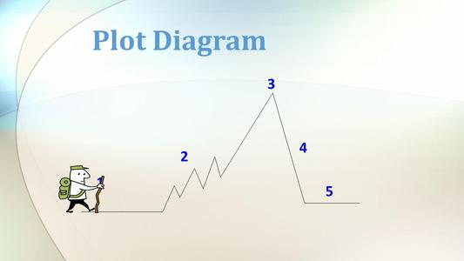
The exposition introduces the characters, describes the setting and establishes the problem in the story.
The rising action is where the suspense builds and the problem gets worse and becomes more complicated.
The climax is the turning point in the story. It is usually the most exciting part in the story and the part that makes the reader eager to keep reading.
The falling action is the events that happen after the climax and lead to a resolution.
The resolution is the outcome of the story. It is how things end up or turn out for the characters.
Step 3：Practice
阅读短文，根据提示进行续写。(150words)
He met her at a party. She was outstanding. Many guys were after her, while he was average looking, shy and awkward. After the party, he invited her for coffee. She was surprised, but out of politeness, she accepted his invitation to go on a date.
As they sat in a nice coffee shop, he was too nervous to say anything and she felt uncomfortable. Suddenly, he asked the waiter, “Could you please give me some salt? I'd like to put it in my coffee."
They stared at him with a strange look! His face turned red, but when the salt came, he put it in his coffee and drank it. Curious, she asked, "Why this unusual habit?" He took a couple of sips and replied, "When I was a little boy, I lived near the sea. I liked playing on the sea. I could feel the taste of the sea, just like the taste of salty coffee. Now every time I have the salty coffee, I always think of my childhood and my hometown. I miss it and my parents, who are still there."
She was deeply moved. A man who can admit that he's homesick must love his home and care about his family. He must be responsible. She talked too, about her faraway hometown, her childhood and her family. That was a really nice talk, also a beautiful beginning of their love story.
They continued to date. She found that he met all her requirements. He was tolerant, kind, warm and careful. He was such a good man and had it not been for the salt in the coffee, she’d never have really known him!
The rest of the story was just like any other beautiful love story---they married and lived happily together. And every time she made coffee for him, she put in some salt, the way he liked it.
After 40 years, he passed away and left her a letter which said: Para 1: My dearest, please forgive me for my cheating you all the time. Do you still remember our first date in the cafe? _______________________________________________________________________________
_______________________________________________________________________________
_______________________________________________________________________________
_______________________________________________________________________________
_______________________________________________________________________________
_______________________________________________________________________________
_______________________________________________________________________________
_______________________________________________________________________________
_______________________________________________________________________________

Para 2: She was shocked by the letter, with the feeling of being cheated. _______________________________________________________________________________________________________________________________________________________________________________________________________________________________________________________________________________________________________________________________________________________________________________________________________________________________________________________________________________________________________________________________________________________________________________________________________________________________________________________________________________________________________________________________________

