Unit 2 Fit for life
Period 1 Welcome to the unit
Teaching aims and demands:
- Enable students to think about people, places and treatments related to medicine.
- Develop students’ listening, speaking, reading, writing and thinking ability.
- Help students to get more knowledge of medicine.
Teaching Important and Difficult Point:
Improve students’ speaking and thinking ability.
Teaching Approaches:
Task-based approaches
Form of Activities:
Individual, pair or group work and topic discussions.
Teaching Aids:
The multimedia and the blackboard
Teaching Procedures:
Step 1. Lead-in
1. Ask and answer the question:
1) As we all know, health is very important to everyone. Do you know how to keep healthy?
2) When people fall ill, what will they do?
3) Can you list as many words as possible that relate to medicine.？
diseases
pharmacy/drug store
pills/tablets/capsules
Chinese /Western medicine
effect/side effect …...
4) Can you list as many jobs as possible that relate to medicine?
chemist
eye doctor/optician
dentist
physician
surgeon……
Step 2. Picture talking
A guessing game:
- a person who prepares and sells medicine
2. a person who examines people’s eyes to see if they need to wear glasses
3. a person who takes care of people’s teeth
4. a person who has general skill to treat physical problems
5. a person who performs medical operations
6. a person who helps doctors to look after patients
Work in groups and discuss the four pictures on the screen.
Picture 1
- Show a picture of a chemist’s selling medicines on the screen.
- Questions:
- What is the man in white?
- What qualities does a person need to be a chemist?
Picture 2
1. Show a picture of acupuncture treatment on the screen.
2. Questions:
1）What is on the woman’s ear?
2）What can acupuncture do?
Picture 3
- Show a picture of an operation in an operating theatre on the screen.
- Questions:
1）What are the doctors and nurses doing?
2）What happens during an operation?
Picture 4
- Show a picture a doctor testing a girl’s eyes of agriculture on the screen.
- Questions:
1）What is the student doing?
2）Do you have good eyesight? How can you protect your eyes?
Step 3 Discussion
- Have you ever seen a doctor? If so, what happened?
2. Have you ever received medical treatments? What was it like?
3. Would you like to do any of the jobs shown in the pictures? Why or why not?
Step 4 Further discussion
1. Do you think medicine only has good effects? Why?
2. What do you know about its side effects?
Step 5 Homework
1. Surf the internet for more information about medicine.
2. Write a short passage about your experience of receiving medical treatments.
Period 2-3 Reading
Two life-saving medicines
Teaching aims and demands:
- Enable the students to master the usage of new words and phrases
- Enable the students to know development of the two medicines .
- To help the students to improve their reading , speaking ability
Teaching important and difficult points:
- Help the students to improve their listening ,reading and speaking ability.
- Help the students master the reading strategy .
- Inform them of more about the two medicines.
Teaching aids:
the multimedia and the blackboard
Teaching methods:
listening and speaking pair work and group work
Teaching procedures:
Step 1.Lead-in:
A free talk with students:
⑴.Have you ever taken aspirin and penicillin?
⑵.How much do you know about the two medicines?
⑶.What other illnesses do they cure?
Step 2.Fast reading
Read the passage again and answer the following questions:
1. What are the two medicines mentioned in the article?
(Aspirin and penicillin)
2. When was penicillin first discovered? (In 1928.)
3. What award did Fleming, Florey and Chain share? (The Nobel Prize.)
Step 3. Detailed reading
Ask the students to read the passage again carefully and answer the detailed questions
1. When did people find that drinking a special tea could reduce fever and pain? (About 2,500 years ago)
2. When was aspirin first made? ( In 1897)

3. What other things can ASA help with besides reducing fever and pain?
(It can also help reduce the risk of heart attacks by thinning blood, prevent a stroke, reduce the risk of colon cancer, increase the length of people’s lives and help with diabetes.)

4. Where did Alexander Fleming find penicillin?
(In the mould that killed bacteria)
5. What illnesses can penicillin be used to treat?
(It can be used to treat bacteria illnesses and other illnesses including pneumonia.)

6. What difficulties did Fleming have in developing penicillin as a drug?
(First he was unable to find a procedure to make penicillin pure enough to work as a medicine. Second, it was difficult to produce penicillin in the ample quantities needed to be effective.)
Step 4. Further reading and fill in the form.

Effects of aspirin | Reduce fever
Effects of aspirin | Help the body to stop pains
Effects of aspirin | Reduce the risk of heart attacks
Effects of aspirin | Prevent a stroke and help diabetes
Effects of aspirin | Reduce the risk of colon cancer
Effects of aspirin | Increase the length of people’s lives
Effects of penicillin | Help in treating wounds and infections
Effects of penicillin | Treat other illness including pneumonia
Step 5

. Learning reading strategy
Ask the students to read the Reading Strategy of the article and ask them to focus on the three major skills of understanding medical terms.
Step 6 Practice
(1)Suppose you are aspirin or penicillin, tell us your development and what influence do you have on our lives according to the passage.
(2)Suppose you are Fleming, describe how you found penicillin.
Step 7 Discussion:
⑴.What would the world be like if the two medicines had not been discovered ?
⑵.Do you believe that ‘wonder drug’ will be invented to treat diseases like AIDs in the future?

Period 4 Language points
1. possess vt. 拥有，具有
如：The province possesses rich mineral resources.
该省拥有丰富的矿藏。
2. trial n. 试验
e.g. The trials show that smoking will do harm to people.
试验显示抽烟对人体有害。
短语in…form/in the form of… 意为“以……形式”。如：
Nowadays, many books are available in electronic form.
如今，很多书都有电子版。
3. vital adj. 极其重要的，必不可少的
当它作表语并后接从句时，从句中的谓语要用“(should)+动词原形”的形式。如：It is vital that every piece of equipment (should) be checked before the experiment.
实验之前检查所有设备是至关重要的。
4. try something out on
意思是“在……上试验某物”。如：
The drug has not been tried out on humans yet.
这种药物尚未进行过人体试验。
5. circulate vi. & vt. 循环；传播，散布；传递，传阅
e.g. The document was previously circulated in New York at the United Nations. 这份文件先前在纽约的联合国总部传阅过。
Cooking odors can circulate throughout the entire house. 做饭的香味可以
传到家里的各个角落 。
6. effective adj. 有效的；实际的，事实上的；生效的
Simple antibiotics are effective against this organism.
一般的抗生素能够有效对抗这种微生物。
They have had effective control of the area since the security forces left.
自从安全部队撤离后，他们实际上控制了该地区。
The new rules will become effective in the next few days.
新规定将在几天后生效。

Homework:

⑴.Write a brief introduction to the two medicines.
⑵.Finish the exercises in the workbook

Period 5 Word power
Hospital and medicine
Teaching aims and demands:
- Enable the students to know some names of the diseases and the causes.
- Have then know different forms of medicines.
- Do some exercises to make the students be familiar with the new words and expressions.
Teaching difficulties:
- The names and causes of the diseases.
- Different forms of medicine.
Teaching methods:
1. Review method to consolidate the words learned in the last two periods.
2. To make the students master the words related to emotion correctly.
3. Individual, pair or group work to make every student work in class.
Teaching Aids:
1. the multimedia
2. the blackboard
Teaching Procedures:
Step 1. Brainstorming
1. Can you name some common medicine?
2. What information do you know about them?
Step 2. Get to know the names of the diseases
Have the students know about the Chinese meanings of the hospital.
ward 病房
emergency room 急诊室
X-ray room X光室
operating theatre 手术室
consulting room 诊室
reception 接待室
ICU 重症监护室
ENT department 耳鼻喉科
pharmacy 药房
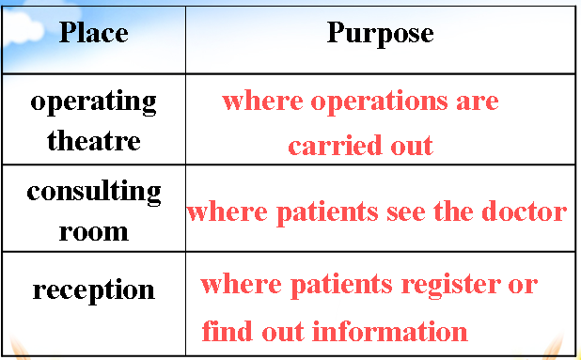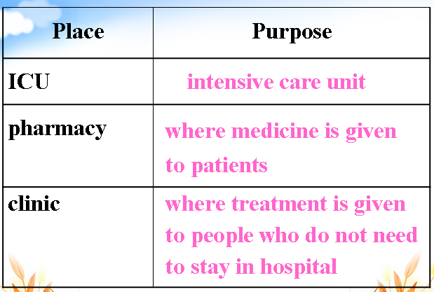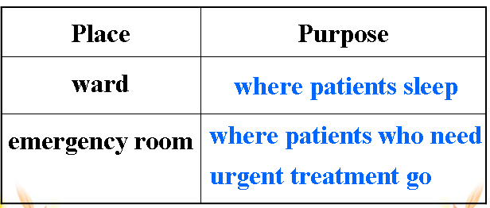
Step 3. Part B
Match the words with the pictures.
Step 4. Part C
Complete the notes in Part C according to the information in Part A and Part B.
Step 5. Part D
Match the places in a hospital with their purposes.
Step 6. Homework
1. Preview “Grammar and usage”.
- Consolidate the names of the medicine.

Period 6 Grammar and usage
Linking verbs
Teaching Aims:
- To learn some basic information about linking-verbs.
- To summarize common and important linking-verbs.
- To apply what they learn to practice by doing some multiple choices.
Teaching Key Points:

The usages of linking-verbs
Teaching Procedure:
Step One:
Words like appear, seem, prove, keep, stay and remain can all be linking verbs.
Words relating to the five senses-sound, taste, feel, look and smell-can also be linking verbs.
Linking verbs like turn, go, fall, grow, get and become usually indicate a change of state.
Linking verbs are most often followed by an adjective. Sometimes, they can also be followed by a noun or a prepositional phrase.

Step Two: Presentation
Deal with the usage of some linking-verbs.
Step Three: Practice
Do some multiple choices.
Step Three:
Do some exercise in the students’ book.
Step Four: Homework

Period 7 Task
Reporting on short-sightedness
Teaching aims and demands:
1. To train the students’ ability of listening and writing.
2. To practise writing a report for a programme on short-sightedness.
Teaching procedure:
Step 1 Brainstorming
- Do you often watch English news on TV?
- How much can you understand?
- What problems do you have in listening to the news about current affairs or situations?
Skills building 1: listening for a present situation
If you are listening to a TV report about a present situation, you will need to listen for the following:
- The present situation (This may be a problem)
- An explanation of the situation (this may include facts and figures to support the explanation, and probably a definition of the topic)
3. Reasons why the situation exists.
4. How the situation can be recognized and the problems solved.
You will also think about the following:
1).Why do you need to understand the information?
2).How will you use the information?
3).Will need to change the information or will use it as it is?
Step 1. Completing notes
A: Listen to a TV programme and take notes to report on the current problems of short-sightedness, which is very common among Chinese teenagers today.
B: Read the following article, and then fill in the table with the measures this school is taking. Write the correct letters in the column on the left.
C: Listen to a radio announcement about what No.9 Secondary School has done to help protect students’eyesight.
Skills building 2: interviewing someone
When you are conducting an interview, you need to structure and organize your interview and your questions in a certain way.
- Introduce yourself and thank your guest for agreeing to be interviewed.
- Say why you are doing the interview and what you want to find out.
- Start to ask questions from general questions to more detailed questions.
Step 2 Interviewing someone
1. Discuss solutions to protect eyesight.
1) Do eye exercises twice every day.
2) Do not read in bed or without good lighting.
3) Take some eyesight supplements such as Vitamins A, C and E.
2. You are interviewing a doctor about what parents and students can do to protect students’ eyesight. Do the interview with your partner according to the information on page 28.
Skills building 3: writing a radio script
When writing a script, you need to include:
- Who you are
- The subject
- The opening
- Explanation of what the topic is
5. Background information, including the current situation
6. Reference to other sources
7. recommendations
8. Closing (thank people for listening)
Step 3. writing a report for the school radio station
Write a radio script for a programme on short-sightedness for your school radio station. Use the information in step 1 and 2 to help you.
Step 4. Homework
- Preview “Project”.
- Write a report on short-sightedness.
Period 8 Project
Exploring Chinese medicine
Teaching aims and demands:
1. Enable students to understand the passage better.
2. Develop students’ listening, reading, writing and thinking ability.
3. Enable the students to prepare and present an oral report on a Chinese medicine.
Teaching Approaches:
Task-based approaches
Form of Activities:
Individual, pair or group work and topic discussions.
Teaching Aids:
The multimedia and the blackboard
Teaching Procedures:
Step 1 Lead-in
- Show a picture of acupuncture treatment on the screen and ask the students a question:
Have you ever experienced an acupuncture treatment?
2. Show another two pictures about different tools used for acupuncture treatment in the past and now.
Step 2 Fast Reading
1.Scan the text and find which of the topics is not mentioned: history, past uses, current uses, disadvantages in the West, benefits and disadvantages
(The disadvantages of Chinese disadvantages are not mentioned.)
2. What medical problems can acupuncture treat?
Bad pains, headaches, injuries, stomach problems, blood pressure problems, addiction to cigarettes, drugs, alcohol and food.
3. How does acupuncture reduce or relieve pain?
It is unclear now. One theory suggests that acupuncture blocks pain signals from reaching the spinal cord or brain. Another theory suggests acupuncture promotes the production of chemicals in the body which reduces pain.
Step 3 Further Reading
1. Listening for further information
Para 1
1. Ask the students the main idea of the paragraph.
(The history of Chinese acupuncture).
2. Ask the students to retell the history of Chinese acupuncture (magic needles).
began—the Stone Age
be developed—2,000 years ago
Paras 2 -3
1. Ask the students the main idea of the paragraph.
(The development of Chinese acupuncture).
- Ask the students to retell the development of Chinese acupuncture.
In the past | Nowadays
stone or pottery needles | metal needles
make holes on swollen areas | put needles into the skin at certain points
365 acupuncture points | about 2,000 acupuncture points
Step 4 Ask some questions in detail:
1. How does an acupuncturist examine a patient?
(First ask the patient’s medical history and lifestyle. And then look at the color of the patient’s skin and tongue, listen to his breathing and check his pulses.)
2. How many pulses are there and what are they connected with?
(There’re twelve different pulses, six on each wrist. Every one is connected with a major body organ or function of an organ.)
3. Why will an acupuncturist check pulses?
(This will help him/her find out which energy channel doesn’t have enough energy.)
Step 5 More information
Show some pictures on the screen to introduce more information about Chinese acupuncture.
1. Different tools for acupuncture
2. Now it is popular that acupuncture is used to help people lose weight .
3. The traditional Chinese acupuncture is becoming more and more popular with foreigners. For example, Oscar king Adrien Brody was keen to try acupuncture treatment. William’s hair is becoming less and less. He is eager to try Chinese acupuncture treatment.
4. Dae jang Deum in the TV play series once used acupuncture to treat patients. But some experts said the plot was not true.
5. Pets also follow the fashion.
Step 6 Discussion
1. What are your thoughts on acupuncture?
2. What are the possible benefits or disadvantages of acupuncture over other treatments?
Step 7 Homework
1. Write an article about traditional Chinese medicine (one herb or treatment).
2. Finish the exercises of this unit.

